
Business Question and Visualization Report

Date | 28 October 2026
Team ID | PNT2022TMIDxxxxxx
Project Name | Electric Vehicle Market Analysis Dashboard using Tableau
Maximum Marks | 5 Marks

Visualization development refers to the process of creating graphical representations of data to facilitate understanding, analysis, and decision-making. The goal is to transform complex datasets into visual formats that are easy to interpret, enabling users to gain insights and make informed decisions. Visualization development involves selecting appropriate visual elements, designing layouts, and using interactive features to enhance the user experience. This process is commonly associated with data visualization tools and platforms, and it plays a crucial role in business intelligence, analytics, and reporting
Business Questions and Visualisation
The process involves defining specific business questions to guide the creation of meaningful and actionable visualizations in Tableau. Well-framed questions help in identifying key metrics, selecting relevant data, and building visualisation that provide insights.
The questions below were defined to guide the nine Tableau worksheets of the EV Market Analysis dashboards used by the Market Strategy Director, BI Manager and Sustainable Mobility Researcher.
1. Which vehicle categories contribute the most to annual sales, and how does price compare?
Visualization: Dual-axis chart: bars for annual sales units and a line for price (USD) by category (Sheet 1).
Insight: Two-Wheeler Scooter, Compact SUV, Hatchback and Sedan lead with roughly 150M+ units each, while Electric Bus, Electric Truck and Pickup Truck sell the least. The price line peaks for low-volume commercial vehicles such as the Electric Bus.
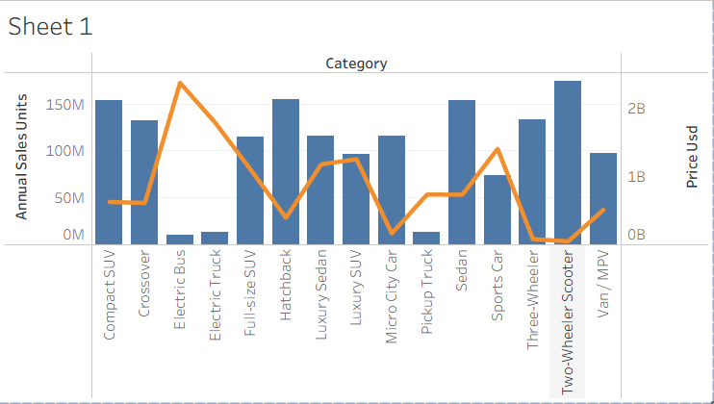
2. Which battery technologies dominate the market, and in which categories?
Visualization: Stacked horizontal bar chart of annual sales units by battery type, coloured by category (Sheet 2).
Insight: NMC and LFP dominate with roughly 450M-500M units each, NCA is in the middle, and Sodium-Ion and Solid-State are still much smaller. The colour split shows which categories use each battery type.
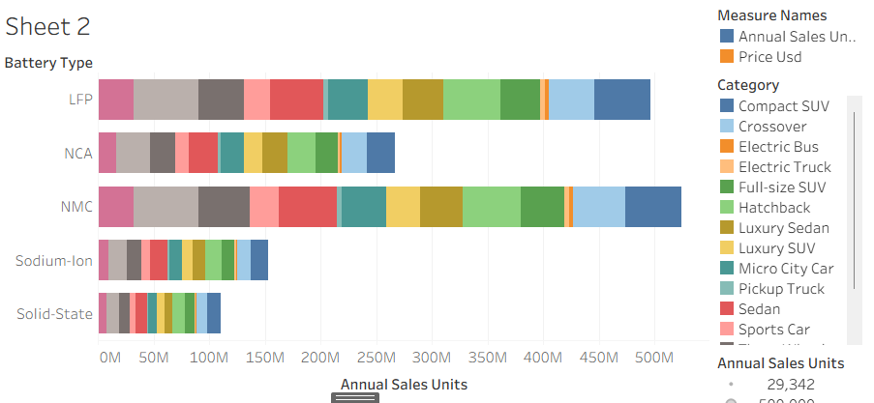
3. How does price relate to driving range across categories?
Visualization: Scatter plot of average price (USD) vs average range (km), coloured by category (Sheet 3).
Insight: Most categories sit below about $100K with a range of 100-500 km, and range rises with price in that group. A few high-priced categories ($150K-$300K) do not offer a proportionally higher range.
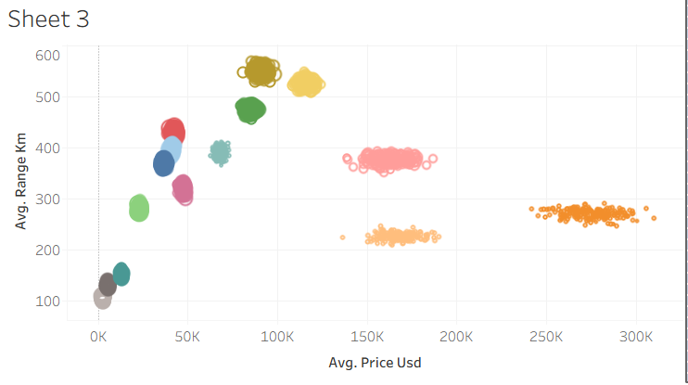
4. Who are the leading manufacturers, and how satisfied are their customers?
Visualization: Horizontal bar chart of the Top 15 manufacturers by annual sales, coloured by average customer rating, with a manufacturer filter (Sheet 4).
Insight: The top 15 manufacturers are close to each other at about 8M-9M units, with AmpereWorks slightly ahead. Average customer ratings are tightly grouped between about 4.07 and 4.12.
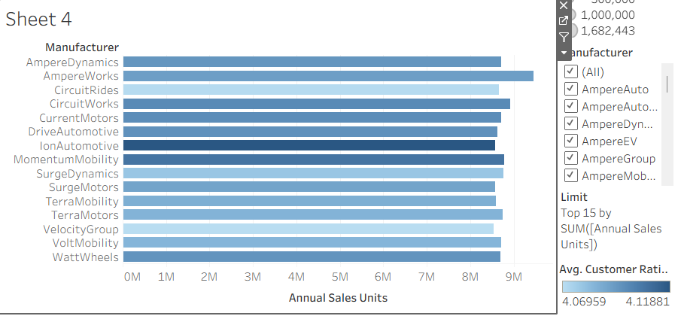
5. How does charging time vary across battery types?
Visualization: Combined bar chart comparing average DC fast-charging time and AC charging time by battery type (Sheet 5).
Insight: Charging time differs clearly by battery type. Solid-State and Sodium-Ion show the shortest fast-charge times in the chart, while LFP and NMC are at the higher end (around 20 minutes).
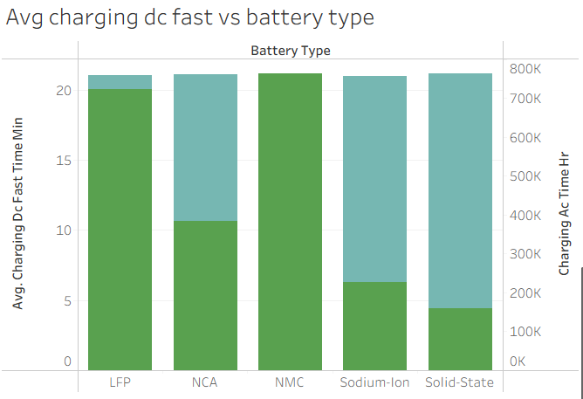
6. Which recommended use cases are the most energy efficient?
Visualization: Dot plot of average efficiency (Wh per km) by recommended use case (Sheet 6).
Insight: Most use cases cluster at about 100-200 Wh/km, while two heavy-duty use cases, commercial delivery and public transport, stand out at roughly 700 and 1,150 Wh/km.
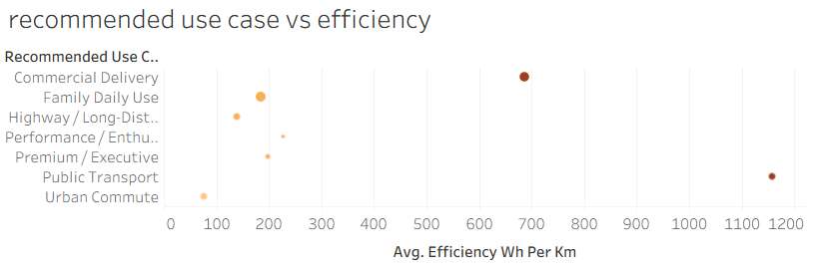
7. Has driving range improved over the model years 2018 to 2026?
Visualization: Multi-line chart of average range (km) by model year, one line per category (Sheet 7).
Insight: Average range for every category stays almost flat from 2018 to 2026, so recent growth is coming from sales volume and category mix rather than range gains.
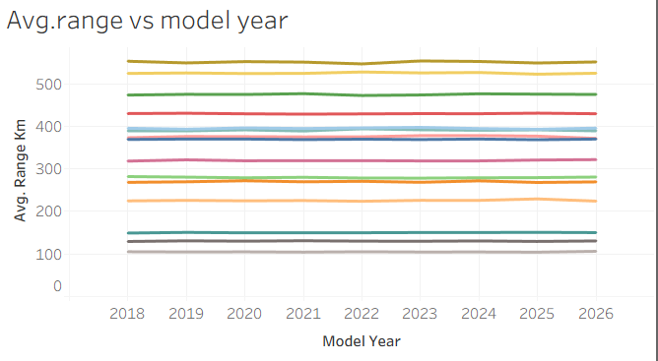
8. How do manufacturers compare on acceleration (0-100)?
Visualization: Heat map / stacked chart of average 0-100 acceleration by manufacturer, with the selected cell highlighted (Sheet 8).
Insight: Acceleration profiles are very similar across the manufacturers shown (AmpereDynamics to WattWheels), so speed is not a major differentiator between them.
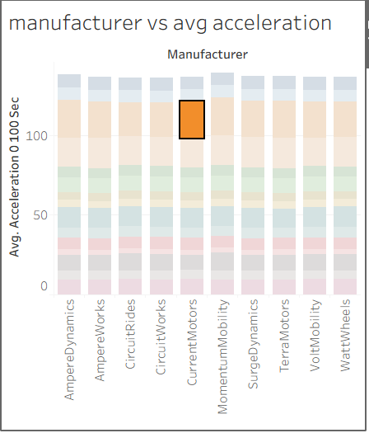
9. How does battery degradation change with maximum DC charging power?
Visualization: Area chart of battery degradation (% after 5 years) vs average max DC charging power (kW), coloured by battery type and sized by CO2 saved (Sheet 9).
Insight: Degradation ranges widely (about 1%-35%) across 0-350 kW. LFP covers most of the range, while Solid-State and Sodium-Ion appear in the lower-degradation band at higher charging power.
