
Dashboard Design

Date | 28 October 2026
Team ID | PNT2022TMIDxxxxxx
Project Name | Electric Vehicle Market Analysis Dashboard using Tableau
Maximum Marks | 5 Marks

Creating an effective dashboard involves thoughtful design to ensure that the presented information is clear, relevant, and easily understandable for the intended audience. Here are some key principles and best practices for dashboard design
Activity 1: Interactive and visually appealing dashboards
Creating interactive and visually appealing dashboards involves a combination of thoughtful design, effective use of visual elements, and the incorporation of interactive features. Here are some tips to help you design dashboards that are both visually appealing and engaging for users so take care of below points
- Clear and Intuitive Layout
- Use Appropriate Visualizations
- Colour and Theming
- Interactive Filters and Slicers
- Drill-Down Capabilities
- Responsive Design
- Custom Visuals and Icons
- Use of Infographics

Dashboard 1: Market Overview
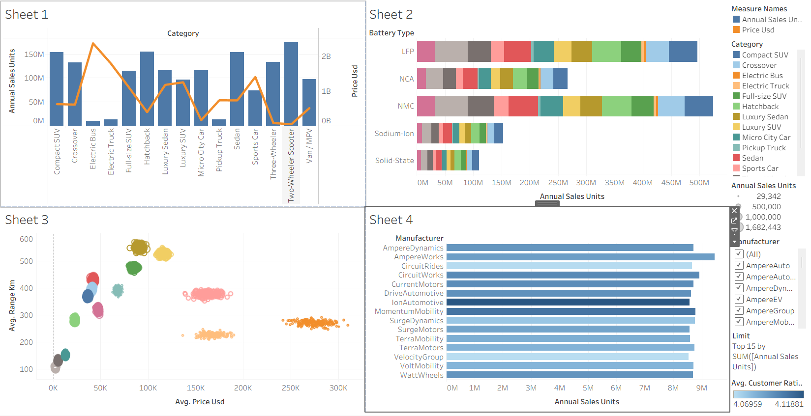
Dashboard 2: Battery & Performance
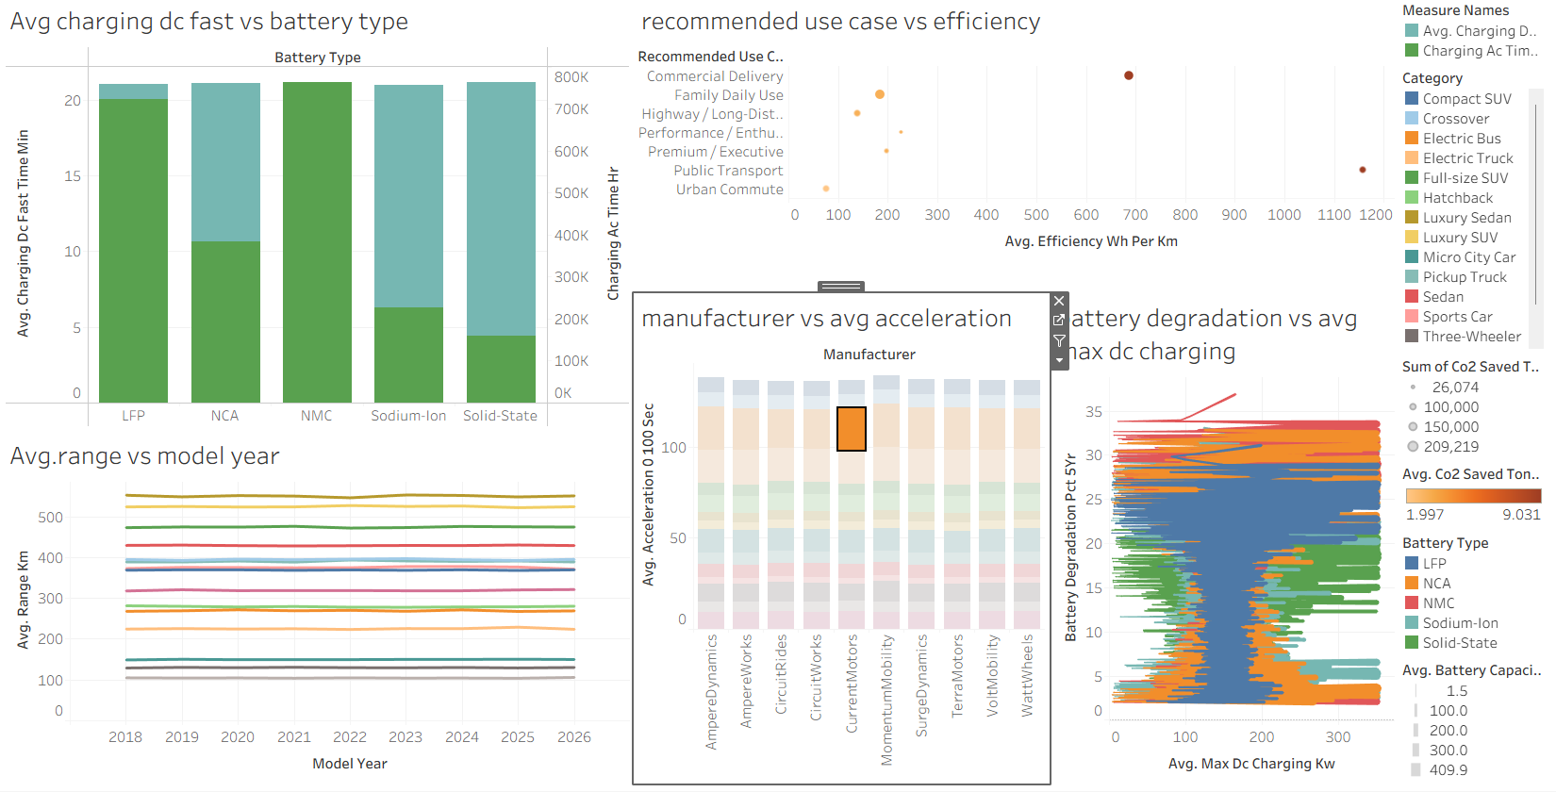
Note: Highlight the major outcomes in form of bullet points
Major outcomes from the dashboards:
- Sales by Vehicle Category: Two-Wheeler Scooter, Compact SUV, Hatchback and Sedan are the top-selling categories at roughly 150M+ units each, while Electric Bus, Electric Truck and Pickup Truck sell the least. This shows that mass-market, affordable segments drive volume.
- Battery Technology Adoption: NMC and LFP batteries dominate annual sales (about 450M-500M units each), NCA follows, and Sodium-Ion and Solid-State are still emerging technologies with much smaller volumes.
- Price vs Range: Most vehicle categories are priced below about $100K with a range of 100-500 km, but a few premium or commercial categories cost $150K-$300K without a matching gain in range.
- Manufacturer Performance and Satisfaction: The top 15 manufacturers sell about 8M-9M units each, with AmpereWorks slightly ahead, and their average customer ratings are very close (about 4.07 to 4.12), so competition is intense.
- Charging, Range and Degradation Trends: Fast-charging time varies by battery type, with Solid-State and Sodium-Ion the shortest. Average range has stayed almost flat from 2018 to 2026, and battery degradation differs by battery type and charging power.

Activity 2
Publish Dashboard on Tableau Public and Paste the Dashboard Public link below:
Tableau Public link: <paste your published dashboard link here>

