
Story

Date | 28 October 2026
Team ID | PNT2022TMIDxxxxxx
Project Name | Electric Vehicle Market Analysis Dashboard using Tableau
Maximum Marks | 5 Marks

By using stories in Tableau, you can effectively communicate complex data in a way that is both interactive and engaging, making it easier for the audience to follow along and understand the insights. It’s a tool for data storytelling, allowing you to present insights in a cohesive, engaging way that takes viewers through a logical progression of findings or analyses.
In Tableau, Story is a feature that allows you to create a sequence of dashboards, visualizations, and text to present data insights in a cohesive and narrative-driven way. It's like a slideshow within Tableau that guides the audience through a series of data points, helping them understand key insights, trends, or outcomes of your analysis.

Story Point 1: Market Overview (sales, battery adoption, price vs range, top manufacturers)
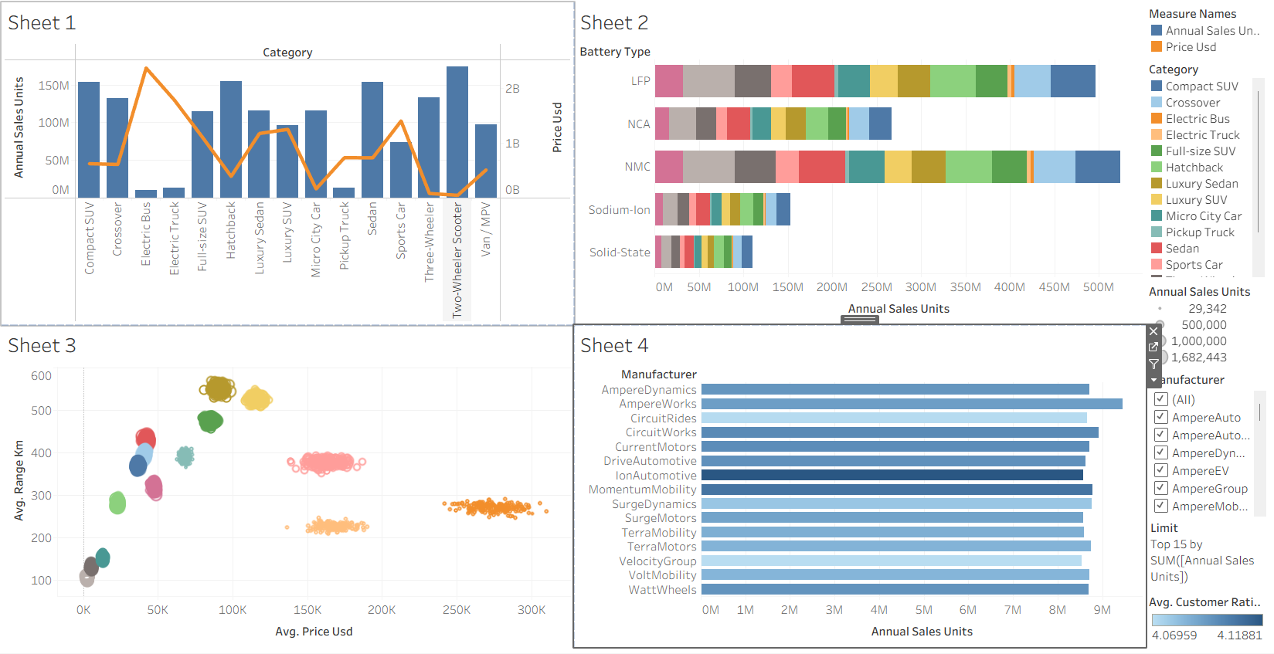
Story Point 2: Battery & Performance (charging, efficiency, range, acceleration, degradation)
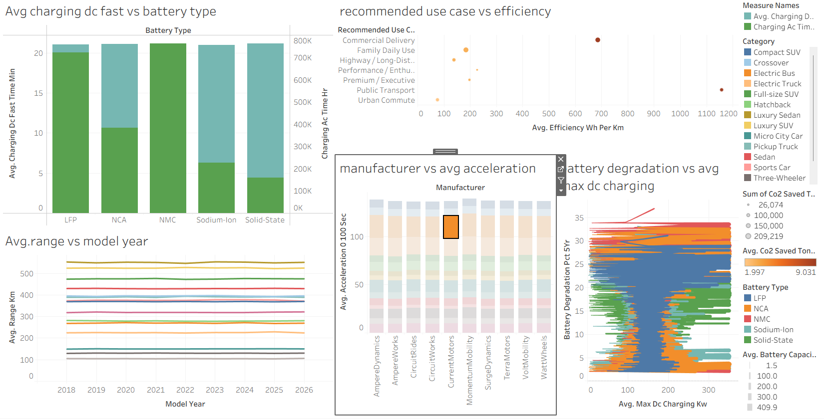

Observations:
- Mass-Market Categories Lead Sales: Two-Wheeler Scooter, Compact SUV, Hatchback and Sedan each sell roughly 150M+ units, while Electric Bus, Electric Truck and Pickup Truck sell the least.
- NMC and LFP Batteries Dominate: NMC and LFP together account for the largest share of annual sales (about 450M-500M units each), with Sodium-Ion and Solid-State still small.
- Manufacturers Are Closely Matched: The top 15 manufacturers sell about 8M-9M units each and their average customer ratings fall in a narrow 4.07-4.12 band.
- Range Is Flat, Charging Differs: Average range has barely changed from 2018 to 2026, while fast-charging time and battery degradation vary clearly by battery type.

Activity 2:
Publish Story on Tableau Public and Paste Public link below
Tableau Public link: <paste your published story link here>

