Project Development Phase
Performance Test

Date | 28 October 2026
Team ID | PNT2022TMIDxxxxxx
Project Name | Project - Electric Vehicle Market Analysis Dashboard using Tableau
Maximum Marks

Project Performance Testing:
Project team shall fill the following information in model performance testing template.
S.No. | Parameter | Screenshot / Values
 | Data Rendered | EV market dataset (CSV/Excel) connected to Tableau Desktop and rendered in the Data Source tab / worksheets.  Fields used: Category, Manufacturer, Battery Type, Recommended Use Case, Model Year, Annual Sales Units, Price (USD), Range (km), Charging DC Fast Time (min), Charging AC Time (hr), Efficiency (Wh/km), Acceleration 0-100, Battery Degradation % (5 yr), Max DC Charging (kW), CO2 Saved (tons), Battery Capacity, Customer Rating.
 | Data Preprocessing | Data was reviewed and cleaned before analysis: null and duplicate records checked, data types set (dimensions vs measures), and the data loaded as a Tableau extract for faster performance.
3. | Utilization of Filters | 1. Manufacturer filter (Sheet 4): list of manufacturers with an (All) option.  2. Top N filter (Sheet 4): Top 15 manufacturers by SUM(Annual Sales Units).  3. Category and Battery Type colour legends used to highlight and filter marks across charts.  4. Dashboard highlight / filter actions linking the worksheets (e.g., manufacturer selection in Dashboard 2).
4. | Calculation fields Used | Aggregated measures used in the worksheets:  SUM(Annual Sales Units); AVG(Price USD); AVG(Range Km); AVG(Customer Rating); AVG(Charging DC Fast Time); AVG(Efficiency Wh per Km); AVG(Acceleration 0-100); AVG(Battery Degradation Pct 5Yr); AVG(Max DC Charging Kw); SUM(CO2 Saved Tons); AVG(Battery Capacity); Measure Names / Measure Values for the dual-axis chart.
5. | Dashboard design | No of Visualizations / Graphs - 9 (Dashboard 1: 4, Dashboard 2: 5), across 2 dashboards.  Dashboard 1: Market Overview  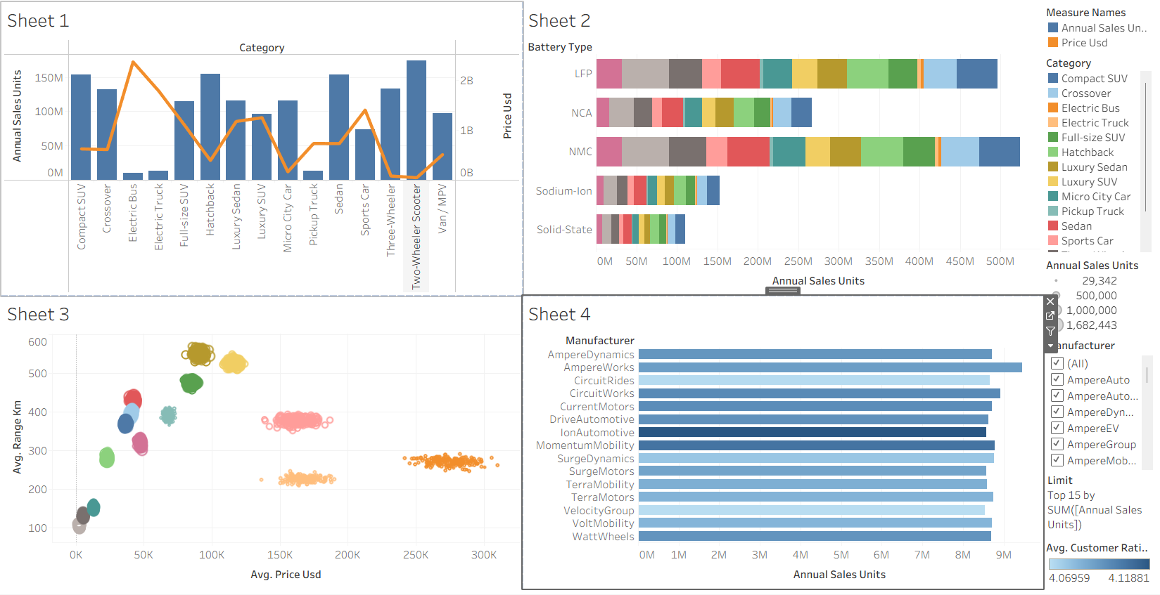  Dashboard 2: Battery & Performance  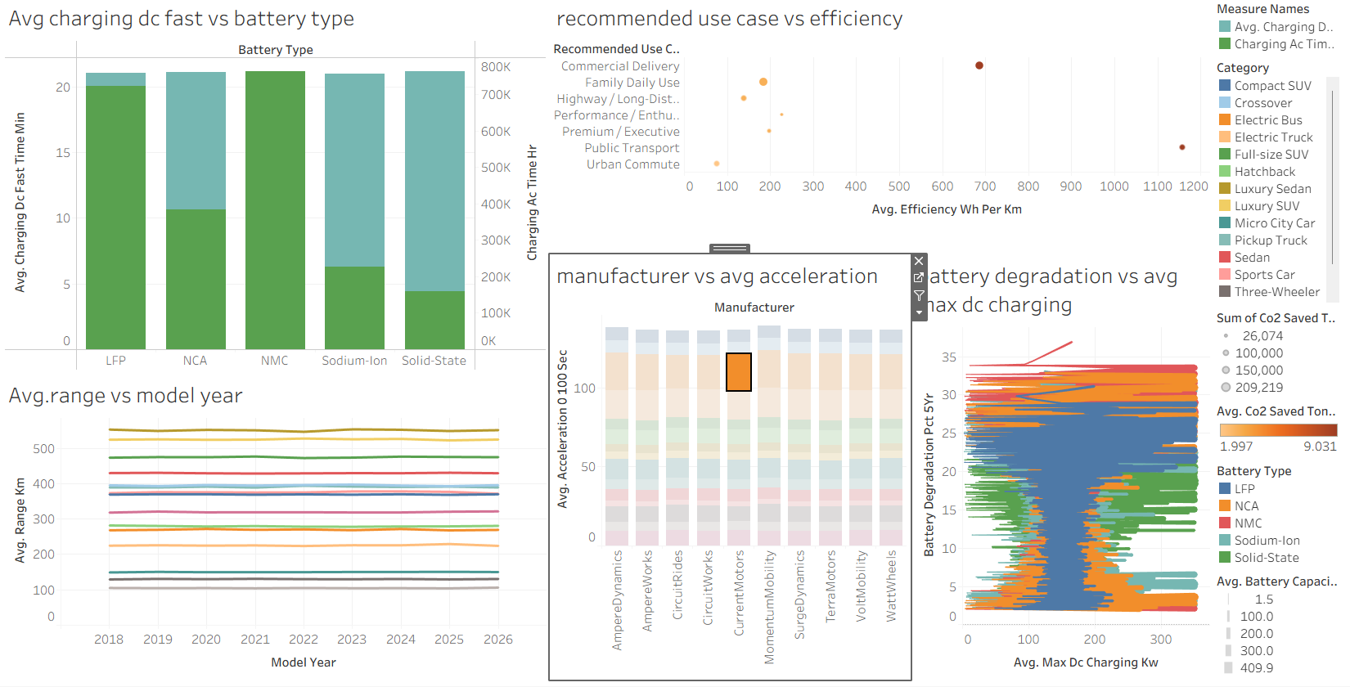
6 | Story Design | No of Visualizations / Graphs - 9, presented as 2 story points (Story Point 1: Market Overview dashboard, Story Point 2: Battery & Performance dashboard).

