PROJECT REPORT
Electric Vehicle Market Analysis Dashboard using Tableau
Interactive insights on EV sales, manufacturers, battery technology, range, charging and customer satisfaction
Team ID | PNT2022TMIDxxxxxx
Project Name | Electric Vehicle Market Analysis Dashboard using Tableau
Tool Used | Tableau Desktop / Tableau Public
Date | 28 October 2026

Table of Contents
1. Introduction
2. Ideation Phase
3. Requirement Analysis
4. Project Design
5. Project Planning & Scheduling
6. Functional and Performance Testing
7. Results
8. Advantages & Disadvantages
9. Conclusion
10. Future Scope
11. Appendix

1. INTRODUCTION

1.1 Project Overview
The electric vehicle (EV) industry is one of the fastest-growing sectors in the global automotive market, driven by environmental awareness, government incentives, better battery technology and demand for sustainable transport. The industry generates large amounts of data on sales, pricing, battery specifications, manufacturing locations, charging performance and customer ratings.
This project turns that data into an interactive Tableau business-intelligence solution. Nine worksheets are combined into two dashboards (Market Overview and Battery & Performance) and a Tableau story. They help users see which vehicle categories drive sales, which manufacturers lead, which battery technologies dominate, and how range, charging and customer satisfaction compare across segments.

1.2 Purpose
The purpose of the project is to give decision-makers one interactive, easy-to-read view of the EV market so they can make faster, evidence-based decisions. The solution is designed for three types of users:
- Emily Johnson, Market Strategy Director: evaluates market performance across categories and regions, and plans the product portfolio.
- David Chen, Business Intelligence Manager: tracks manufacturer market share, sales, battery distribution and ratings to advise clients entering the EV market.
- Dr. Sarah Williams, Sustainable Mobility Research Analyst: studies battery innovation, range, manufacturing and adoption to support policy and sustainability goals.

2. IDEATION PHASE

2.1 Problem Statement
EV sales, pricing, battery, charging and rating data is large and scattered, so strategy, BI and research teams cannot easily see which categories drive sales, which manufacturers lead, which battery technologies dominate, or how range and charging compare across segments. Manual spreadsheets and static reports are slow, cannot be explored interactively and make it hard to compare several measures at once.
Problem Statement (PS) | Details
PS-1 | Emily Johnson, a Market Strategy Director, needs to know which EV categories and manufacturers contribute most to annual sales and how satisfied customers are, but the data is spread across many sources, which makes planning slow and uncertain.
PS-2 | David Chen, a BI Manager, needs to compare manufacturer share, battery technology and ratings for clients, but static reports do not let him explore the data, which limits the advice he can give.
PS-3 | Dr. Sarah Williams, a researcher, needs to compare battery technologies, range and charging, but there is no single view that links them, which weakens evidence for policy.

2.2 Empathy Map Canvas
The empathy map below is for the primary user, Emily Johnson, Market Strategy Director.
SAYS  "Which categories and manufacturers really drive our sales?"  "I need one view I can show leadership." | THINKS  Data is scattered and hard to trust.  Competition is growing fast, so decisions cannot wait.
DOES  Collects reports and builds manual spreadsheets.  Compares manufacturers and categories separately.  Presents summaries to management. | FEELS  Overwhelmed by the volume of data.  Anxious about missing high-growth segments.  Confident when insights are clear.
PAINS  Slow manual analysis and no interactivity.  Hard to compare battery types, range and ratings together. | GAINS  Interactive dashboard with filters.  Faster, evidence-based planning of the product portfolio.

2.3 Brainstorming
The team brainstormed ideas for the dashboard. Each idea was listed first and then grouped and prioritised by impact on the users' decisions.
Theme | Ideas generated | Priority
Sales insight | Annual sales and price by category; top 15 manufacturers by sales; category share | High
Battery technology | Battery type vs sales by category; DC fast and AC charging time by battery type; degradation vs charging power | High
Product positioning | Price vs range scatter; efficiency by recommended use case; acceleration by manufacturer | Medium
Trends | Average range by model year (2018 to 2026) | Medium
Customer satisfaction | Average customer rating shown as colour on the manufacturer chart | High
Interactivity | Manufacturer filter, Top N limit, colour legends, highlight actions, phone layout | High

3. REQUIREMENT ANALYSIS

3.1 Customer Journey Map
Stage | Awareness | Exploration | Analysis | Decision | Sharing
Actions | Learns about the dashboard | Opens the dashboard and uses filters | Compares categories, batteries and manufacturers | Chooses products and markets to focus on | Shares insights with the team
Touchpoints | Team e-mail, Tableau Public link | Dashboard 1 and Dashboard 2 | Worksheets and tooltips | Story view | Presentations, reports
Feeling | Curious | Interested | Confident | Satisfied | Proud
Pain points | Unsure where data is | Too many charts at once | Dense charts can be hard to read | Needs trusted numbers | Needs easy sharing
Opportunities | Single published link | Clear layout and legends | Filters and highlight actions | Story with key findings | Export / publish options

3.2 Solution Requirement
Functional requirements
- Load the EV dataset (CSV/Excel) into Tableau and keep it as an extract.
- Show annual sales units and price by vehicle category.
- Show battery type vs sales, charging time, degradation and efficiency.
- Show price vs range and range by model year.
- Show the top 15 manufacturers by sales with average customer rating.
- Provide manufacturer, Top N and legend-based filters plus highlight actions.
- Present findings as two dashboards and a story, and publish them to Tableau Public.
Non-functional requirements
- Usability: simple, clear layout with colour legends and tooltips.
- Performance: dashboards respond quickly through a Tableau extract.
- Compatibility: works in Default and Phone device layouts.
- Accuracy: chart totals match the source data.
- Accessibility: published link opens in a browser with no installation.

3.3 Data Flow Diagram
Data flows from the EV dataset through connection, cleaning and worksheet creation into dashboards and a story, which are delivered to business users.
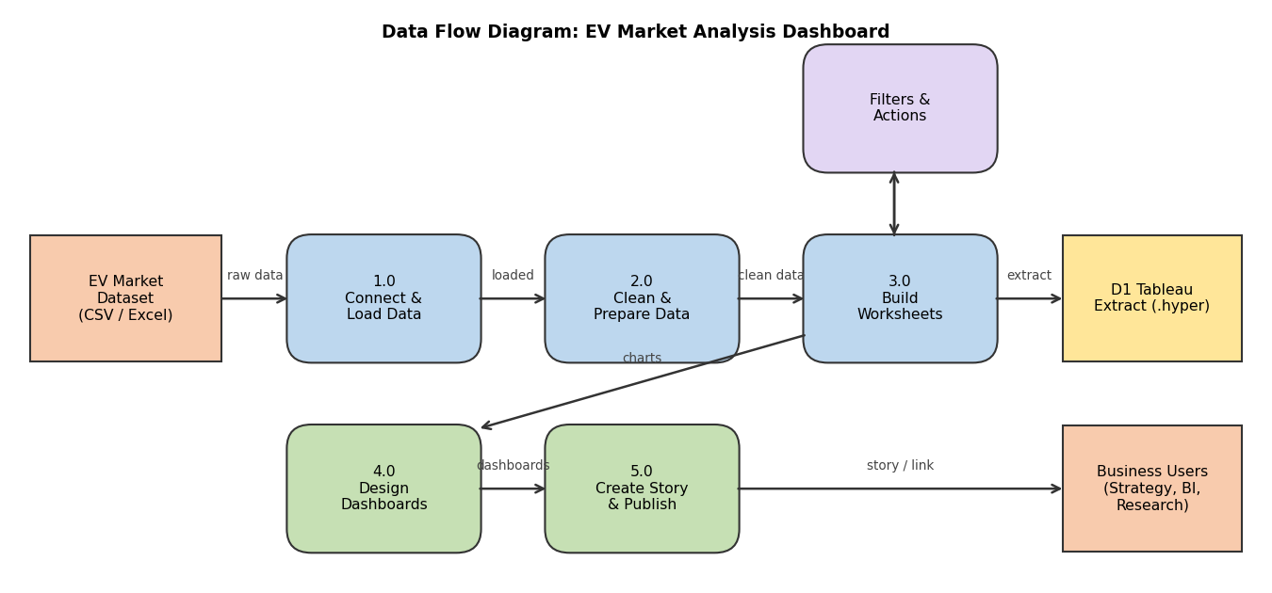
Figure 1: Data Flow Diagram

3.4 Technology Stack
Layer | Technology
Data source | EV market dataset in CSV / Excel format
Data connection and storage | Tableau Desktop data source, Tableau Extract (.hyper)
Data preparation | Tableau Data Interpreter, data type settings, filters
Analytics | Tableau worksheets: bar, dual-axis, stacked bar, scatter, line, heat map and area charts; aggregated measures (SUM / AVG)
Visualization | Tableau dashboards and story with filter and highlight actions
Publishing | Tableau Public / Tableau Server
Version control | Git / GitHub

4. PROJECT DESIGN

4.1 Problem Solution Fit
The Problem-Solution Fit confirms that the dashboard solves a real problem for a defined group of customers. The key points are summarised below.
Canvas section | Summary
Customer segments | EV strategy directors, BI / consulting managers, sustainable mobility researchers and policymakers
Problems | Cannot see sales drivers, battery trends and customer satisfaction in one place
Triggers | Rapid EV market growth, competition, need for fast evidence-based decisions
Emotions | Before: overwhelmed and uncertain. After: informed and confident
Available solutions | Static Excel sheets and costly generic reports (not interactive)
Our solution | Two interactive Tableau dashboards and a story with filters and legends
Root cause | Large, fragmented data and slow manual analysis

4.2 Proposed Solution
- Objective: To design and build an interactive Tableau dashboard that analyses the EV market and supports strategy, BI and research decisions.
- Scope: EV categories, manufacturers, battery types (LFP, NMC, NCA, Sodium-Ion, Solid-State), price, range, charging, acceleration, degradation, CO2 saved and customer ratings. Predictive modelling and real-time feeds are out of scope.
- Approach: collect the dataset, connect it to Tableau, clean it, build 9 worksheets, assemble them into 2 dashboards with filters and actions, build a story, test and publish.
- Key features: Dashboard 1 (sales and price by category, battery type vs sales, price vs range, top 15 manufacturers with rating) and Dashboard 2 (charging time, efficiency by use case, range by model year, acceleration, degradation vs charging power); interactive filters and colour legends.

4.3 Solution Architecture
The solution follows a layered BI architecture, from data source to business users.
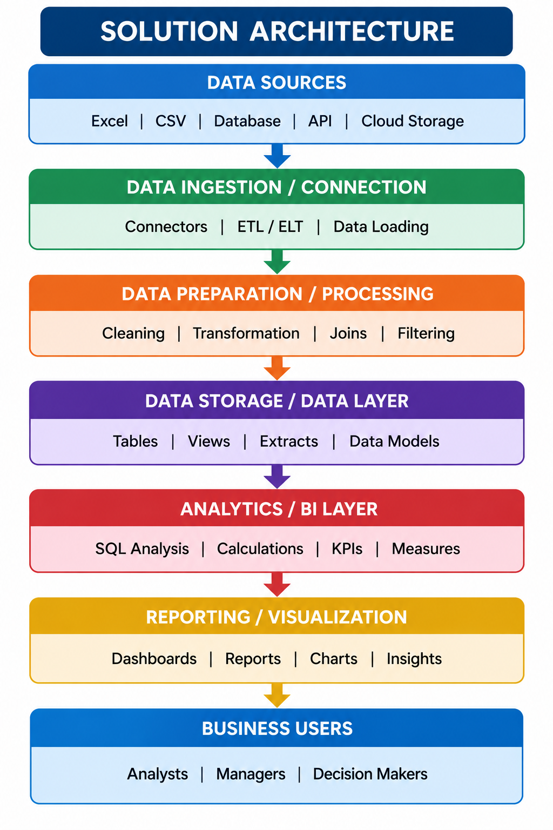
Figure 2: Solution Architecture
Component | Role in architecture | Technology
Data Source | EV dataset with sales, battery, price, range, charging and rating fields | CSV / Excel
Data Connection | Connects and loads the dataset as a live or extract connection | Tableau data source, Extract (.hyper)
Data Preparation | Checks nulls and duplicates, sets data types, applies filters | Tableau Data Interpreter, Filters
Data Model / Storage | Single extract used by all worksheets and dashboards | Tableau Extract
Analytics Layer | Computes KPIs and measures (sales, price, range, rating, charging, efficiency) | Tableau worksheets, SUM / AVG, Top N
Visualization Layer | Two dashboards combining worksheets with filters and actions | Tableau Dashboards
Business Users | Strategy, BI and research users who explore the insights | Tableau Public / Server

5. PROJECT PLANNING & SCHEDULING

5.1 Project Planning
The project was planned in four sprints of six days, each with 20 story points (80 story points in total). Average velocity is 20 / 6 = 3.33 story points per day.
Sprint | Epics | User stories | Points | Dates (planned)
Sprint-1 | Data collection, data preparation, data connection | USN-1 to USN-6 | 20 | 26 Oct to 31 Oct 2026
Sprint-2 | Worksheets: market overview, battery and performance | USN-7 to USN-13 | 20 | 02 Nov to 07 Nov 2026
Sprint-3 | Remaining worksheets, dashboard design, interactivity | USN-14 to USN-18 | 20 | 09 Nov to 14 Nov 2026
Sprint-4 | Formatting, device layout, testing, publishing, reporting | USN-19 to USN-24 | 20 | 16 Nov to 21 Nov 2026

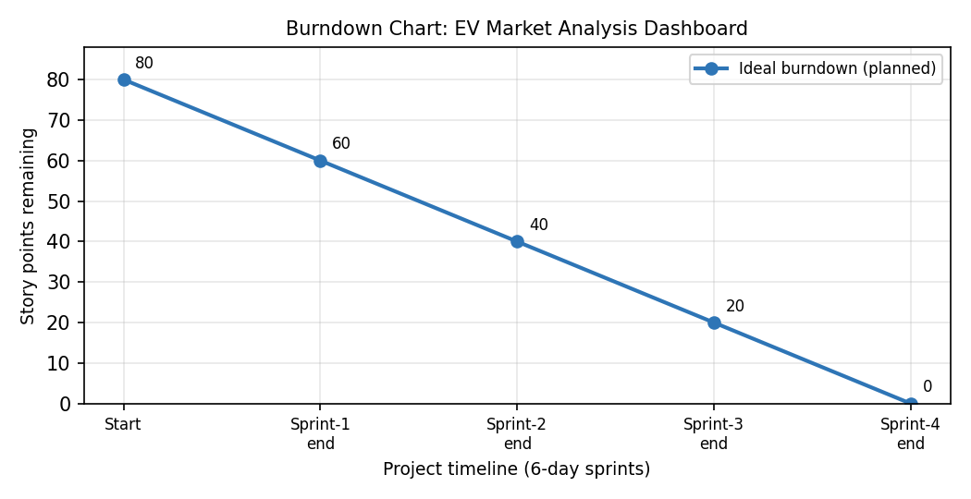
Figure 3: Planned (ideal) burndown chart

6. FUNCTIONAL AND PERFORMANCE TESTING

6.1 Performance Testing
S.No. | Parameter | Values
1 | Data Rendered | EV market dataset (CSV/Excel) rendered in Tableau; fields include category, manufacturer, battery type, sales, price, range, charging, acceleration, degradation, CO2 saved and customer rating.
2 | Data Preprocessing | Nulls and duplicates checked, data types set, data loaded as an extract.
3 | Utilization of Filters | Manufacturer filter, Top 15 by SUM(Annual Sales Units), colour legends, dashboard highlight / filter actions.
4 | Calculation fields Used | Aggregated measures: SUM(Annual Sales Units), AVG(Price), AVG(Range), AVG(Customer Rating), AVG(Charging DC Fast Time), AVG(Efficiency), AVG(Acceleration), AVG(Battery Degradation), AVG(Max DC Charging), SUM(CO2 Saved).
5 | Dashboard design | 9 visualizations across 2 dashboards (Dashboard 1: 4, Dashboard 2: 5).
6 | Story Design | 2 story points covering the 9 visualizations.

7. RESULTS

7.1 Output Screenshots
The two dashboards and the nine worksheets are shown below.
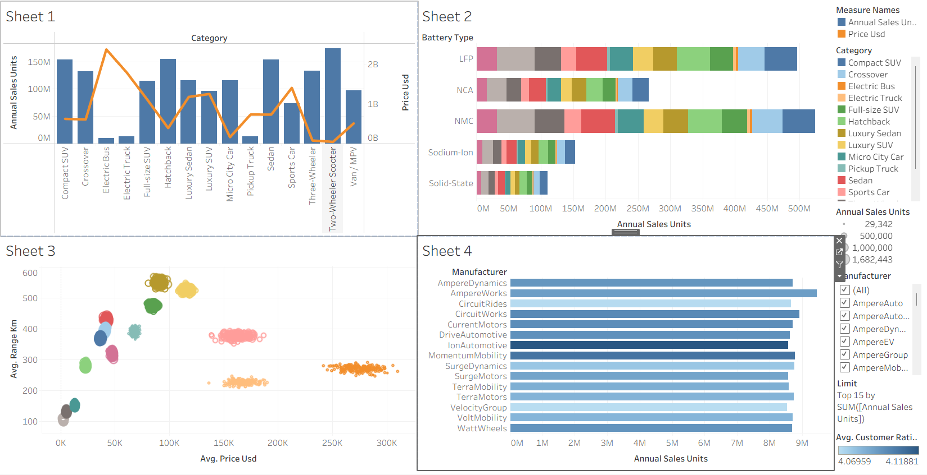
Figure 4: Dashboard 1, Market Overview
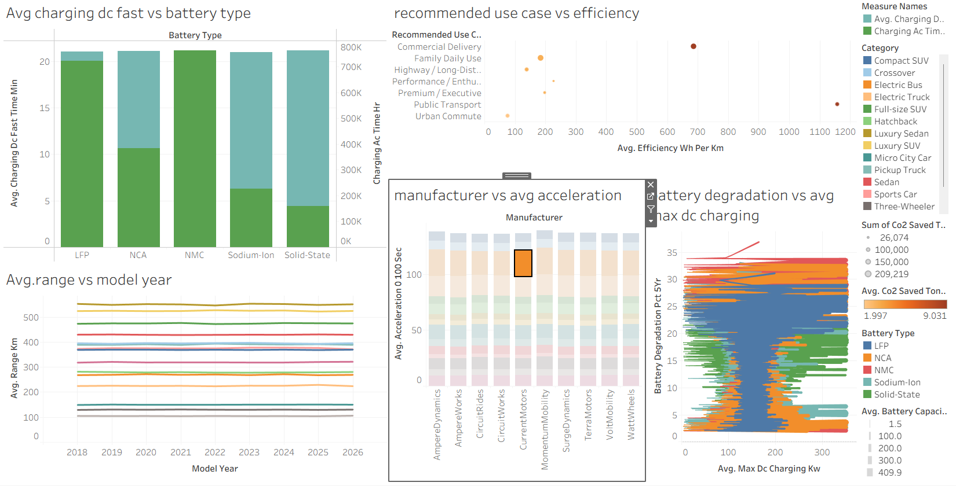
Figure 5: Dashboard 2, Battery & Performance
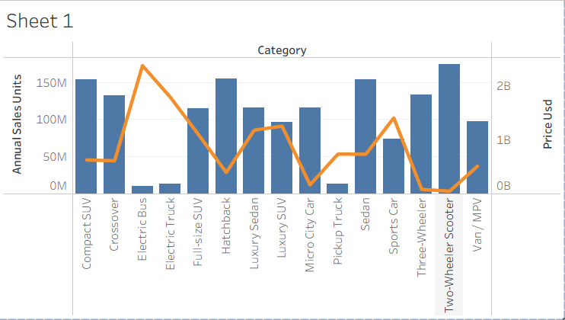
Sheet 1: Annual sales units and price by category
Two-Wheeler Scooter, Compact SUV, Hatchback and Sedan lead in sales (about 150M+ units each); Electric Bus, Electric Truck and Pickup Truck sell the least.
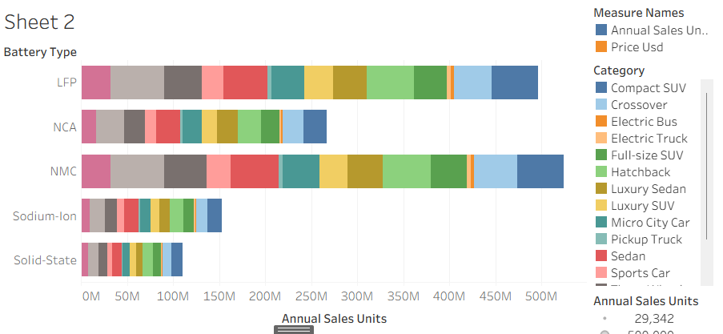
Sheet 2: Battery type vs annual sales
NMC and LFP dominate (about 450M-500M units each); Sodium-Ion and Solid-State are still small.
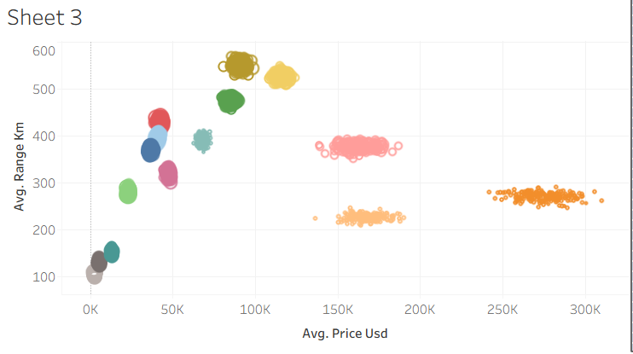
Sheet 3: Average price vs average range
Most categories are below about $100K with 100-500 km range; a few cost $150K-$300K without a matching range.
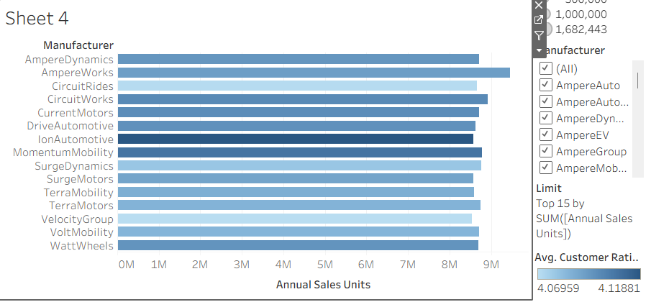
Sheet 4: Top 15 manufacturers by sales
Manufacturers sell about 8M-9M units each; average ratings are close (about 4.07-4.12).
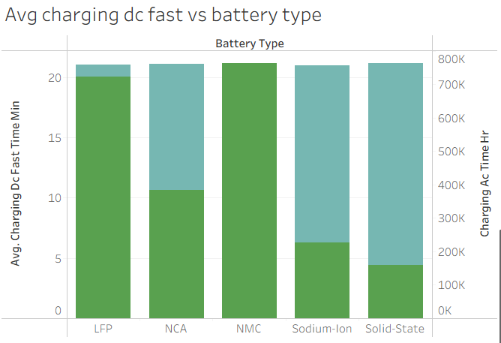
Sheet 5: Charging time by battery type
Charging time differs by battery type; Solid-State and Sodium-Ion show the shortest fast-charge times.
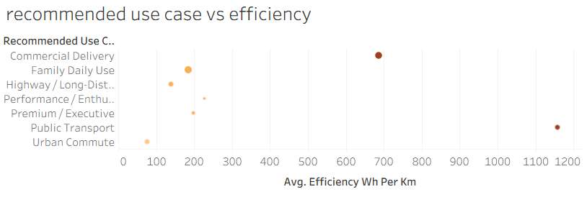
Sheet 6: Recommended use case vs efficiency
Most use cases cluster at about 100-200 Wh/km; two heavy-duty use cases are far higher.
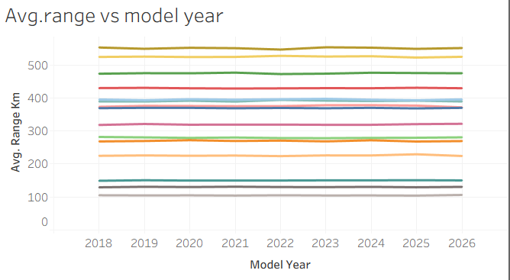
Sheet 7: Average range by model year
Average range is almost flat from 2018 to 2026 for all categories.
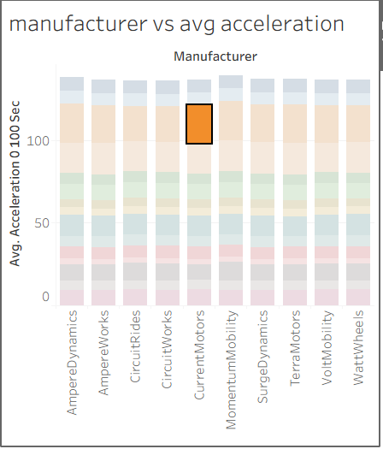
Sheet 8: Manufacturer vs average acceleration
Acceleration profiles are very similar across manufacturers.
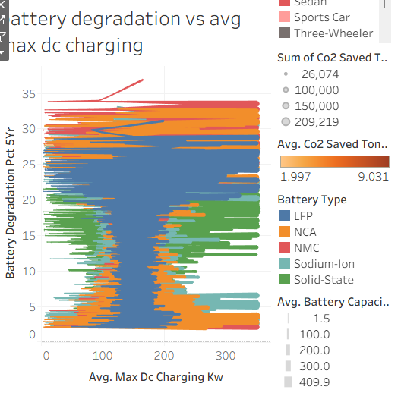
Sheet 9: Battery degradation vs max DC charging power
Degradation spans about 1%-35%; LFP covers most of the range, Solid-State and Sodium-Ion sit in the lower band.

Key findings
- Mass-market categories (two-wheeler scooters, compact SUVs, hatchbacks, sedans) drive most sales.
- NMC and LFP are the dominant battery technologies; Sodium-Ion and Solid-State are emerging.
- Top manufacturers are closely matched in both sales and customer rating.
- Average range has not changed much from 2018 to 2026, while charging time and degradation differ by battery type.

8. ADVANTAGES & DISADVANTAGES
Advantages | Disadvantages
Interactive: filters, legends and highlight actions let users explore the data.  Brings sales, battery, range, charging and rating insights into one place.  Serves several user types (strategy, BI, research).  No coding is needed to build or use it.  Quick to publish and share through Tableau Public. | Uses a static dataset, so it is not real-time unless the data is refreshed.  Limited to the fields available in the dataset.  Some charts (for example degradation vs charging power) are dense and hard to read.  No predictive analytics or forecasting.  Needs Tableau, and some skill, to modify.

9. CONCLUSION
The project delivers an interactive Tableau solution for the EV market. Nine worksheets, two dashboards and a story show which categories and manufacturers lead sales, how battery technologies compare, and how price, range, charging and customer rating relate. The solution meets the needs of the Market Strategy Director, BI Manager and Sustainable Mobility Researcher by replacing slow manual analysis with fast, interactive, evidence-based insight that supports product planning, market expansion and policy decisions.

10. FUTURE SCOPE
- Connect to live or regularly refreshed data sources so the dashboards update automatically.
- Add forecasting and predictive models for sales and battery technology adoption.
- Add map views for manufacturing country and regional sales, and charging infrastructure data.
- Include government incentive, policy and sustainability (CO2) data for deeper analysis.
- Improve mobile layouts and simplify dense charts for non-technical audiences.
- Add user-level security and scheduled sharing through Tableau Server.

11. APPENDIX
Source Code | Not applicable. The solution is built in Tableau (no source code). The workbook file can be provided on request.
Dataset Link | <paste your dataset link here>
GitHub Link | <paste your GitHub repository link here>
Project Demo Link | <paste your Tableau Public dashboard / story link here>

