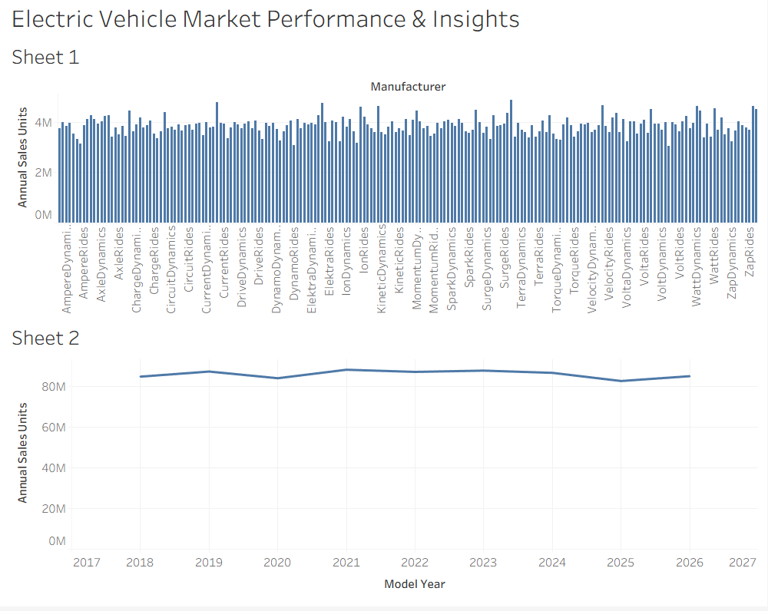
Project Title: Electric Vehicle Market Performance & Insights
Tool Used: Tableau Desktop 2026.3
Dataset: EV Market Dataset(200 records, 37 attributes)
Objective:
To analyze global electric vehicle sales trends, identify top-performing manufactures, and evaluate year-over-year market growth.
Visualization & Insights:
- Top EV Manufacturers: Evaluates total annual sales volume across manufacturers, highlighting volume distribution around the 3M-4M unit range.
- Sales Trend by Model Year: Analyzes market trajectory over time, showing cumulative market sales expansion peaking near 80M-90M units.

