Dashboard Design – F1 Race Intelligence Analysis

Date | 24 September 2026
Team ID | PNT2022TMIDxxxxxx
Project Name | F1 Race Intelligence Analysis
Maximum Marks | 5 Marks

Activity 1: Interactive and visually appealing dashboards
The F1 Race Intelligence dashboard is designed in Tableau, as stated in the project overview. It brings together driver, constructor, tyre, circuit, podium and reliability analysis for three audiences: team strategists, broadcast analysts and technical regulation analysts. The supplied circuit reference file contains 29 circuits; race-level visuals require the separate 6,464-record, 17-season dataset described in the overview.
- Clear and Intuitive Layout – Organize the workbook into three audience-focused stories: Team Performance, Broadcast Insights and Technical Reliability. Keep KPI cards at the top and supporting charts below.
- Use Appropriate Visualizations – Use line charts for championship trends, ranked bars for driver points, stacked bars for DNF categories, heat maps for tyre/circuit comparisons, and maps or symbol maps for circuit locations.
- Colour and Theming – Apply a consistent motorsport-inspired palette. Use stable colours for constructors and tyre compounds across every worksheet; maintain readable contrast and avoid using colour as the only signal.
- Interactive Filters and Slicers – Provide filters for season, driver, constructor/team, circuit, country, circuit type and tyre compound where the underlying data supports them.
- Drill-Down Capabilities – Allow users to move from season to race, constructor to driver, country to circuit and DNF category to detailed status descriptions.
- Responsive Design – Arrange dashboard objects so KPI cards and charts remain legible on presentation screens and smaller browser windows. Test Tableau device layouts before publishing.
- Custom Visuals and Icons – Use restrained F1-related icons for driver, team, podium, tyre, circuit and reliability KPIs. Include clear legends and informative tooltips.
- Use of Infographics – Add KPI cards, podium summaries, season timelines, circuit profile callouts and tyre-compound legends to make key findings easy to scan.

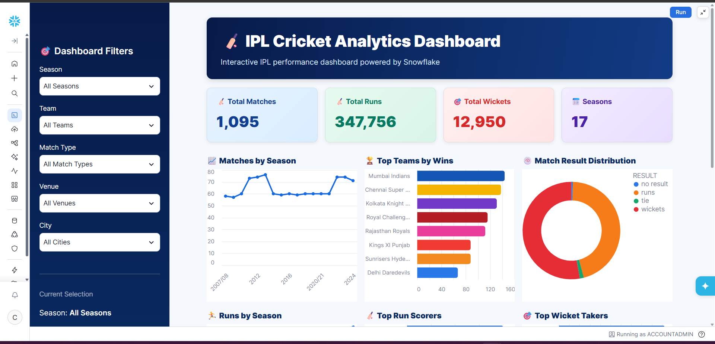
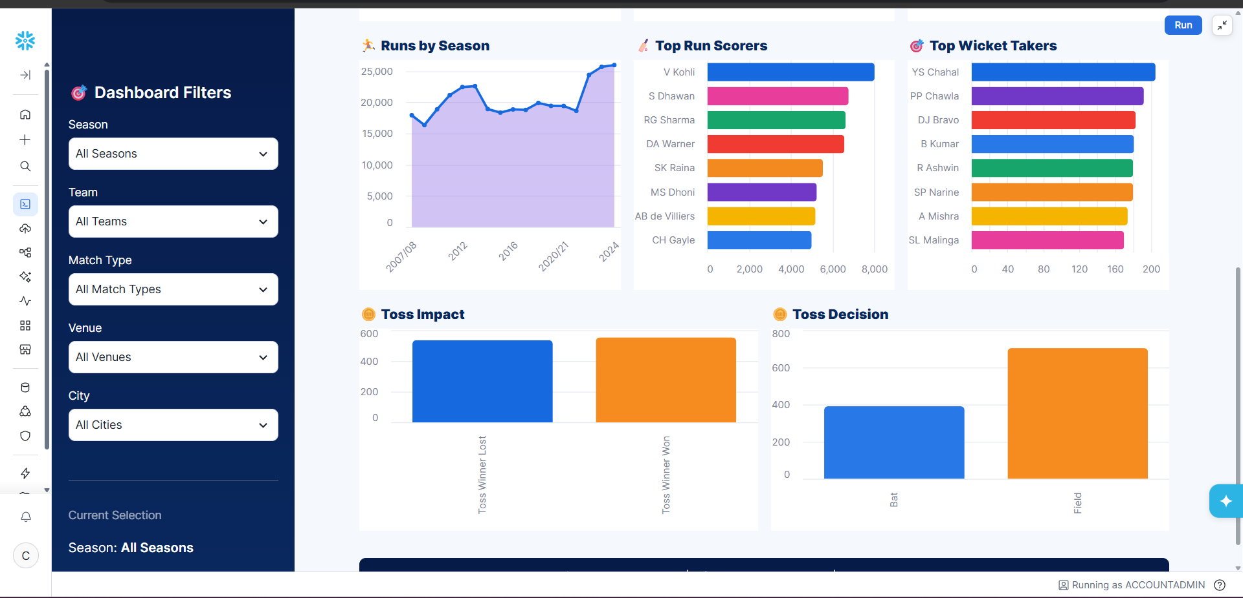
Note: Highlight the major outcomes in form of bullet points
Sample:
Here are five potential outcomes from the dashboard image provided:

Major Outcomes and Insights to Highlight
Constructor championship trajectory: The dashboard compares constructor points across the 17 seasons and benchmarks the project team against Red Bull Racing and Mercedes. The strongest team and any points gaps should be stated from the actual chart, not assumed in advance.
Driver leaderboard and talent pools: A cumulative driver-points leaderboard and nationality breakdown help identify leading drivers and countries represented in the dataset. Rankings must be populated from the driver-results data.
Tyre compound strategy: Comparing Soft, Medium, Hard and Intermediate compounds across circuit types can reveal which strategies are associated with stronger outcomes. The visual should show sample size as well as average result.
Podium distribution: Driver- and constructor-level podium charts show how podium finishes are distributed across the selected seasons and help create broadcast-ready comparisons.
Circuit characteristics: The supplied circuit reference dataset supports comparisons of circuit type, lap count, lap length, altitude, direction and estimated scheduled race distance. It contains 29 circuit records.
DNF and reliability patterns: A stacked bar chart of retirement/failure categories by driver, constructor or circuit can help identify recurring reliability concerns. Interpret these patterns only after checking the underlying status definitions.
Host-country coverage: A country-level chart can show the geographic spread of circuits in the supplied reference file. Historical Grand Prix counts require event-level records, not circuit counts alone.

Overall Outcome
The F1 Race Intelligence dashboard is intended to combine sporting performance, race strategy, circuit context and technical reliability in one interactive Tableau experience. The supplied circuit file supports circuit-level analysis; driver, constructor, tyre, podium and DNF conclusions must be populated and verified using the wider race-level dataset described in the project overview.

Recommended KPI Cards
• Total seasons covered (project overview: 17).
• Race records (project overview: 6,464; confirm against source files).
• Distinct circuits in supplied reference dataset (29 visible records; validate after loading).
• Total driver points, constructor points and podiums (requires race-level results).
• DNF count and completion rate (requires race status data).
• Average finish position by tyre compound (requires tyre-stint linkage).
Evidence note: insert Tableau dashboard and story screenshots in this document. The uploaded overview is a textual description of the dashboard scenarios, not a screenshot of the completed Tableau charts.

