3/30/2018

Milestone 3: More Detailed Requirements, Architecture, and a Vertical Software Prototype

CEN 4010 Principles of Software Engineering, Spring 2018

Group 2, SmartLab

By

Kirk Shields, kshields2012@fau.edu

Nicholas Gacharich

Hunter Craig

Version 2.0

***REVISIONS***

Added actual definitions to the Data Definitions sections based off of feedback from milestone 1.

Removed and added functional requirements based off of our groups progress and experience with the rest of the module.

Modified the initial project description based off our groups’ progress on function requirements.

Changed the contents of the milestone to reflect the current milestone (i.e from milestone 1 to milestone 3).

Added the revisions section because that was feedback from milestone 1.

1. **Executive Summary**

The College of Engineering and Computer Science has proposed a project to streamline students’ access to the labs and lab equipment. The project would aim to create a more secure lab environment by requiring users to verify their credentials in order to access the lab and lab equipment. Through the use of smart power outlets, it is possible to control which lab stations will be able to be used. Our project, titled SmartLab, aims to satisfy and exceed the project requirements. In order for a user to be allowed access to a lab they must either be taking a lab access required class, or demonstrate to an administrator that they are able to use the lab equipment responsibly. Once a user has been given permission to use the lab and lab equipment, the user is then able to use the SmartLab interface to request a workbench. After being assigned to a workbench, the user is required to verify the condition of the workbench. The SmartLab interface will show the user a picture, taken by the previous user, of the workbench and will then ask the user to confirm the workbench was left in an acceptable condition. Only after the user confirms that the workbench was left in an acceptable condition will the user be able to use the workbench. On the SmartLab interface, the user will be constantly reminded of their remaining time and will be able to request more time if needed. After the user is finished using the workstation, the SmartLab interface will require the user to take a picture of the workstation, so the next user will be able to verify the condition. The SmartLab interface will combat the issues of unauthorized lab use and damaged equipment by directly making users accountable for their workstations. SmartLab can also be adapted to suit other labs security needs, making SmartLab very versatile in terms of applications. SmartLab aims to enhance the lab experience by making it more streamlined, safe, and clean for everyone.

2) **Competitive analysis**

|  |  |  |  |  |
| --- | --- | --- | --- | --- |
| Products | SmartLab | Amazon Alexa | Apple Homekit | Google Assistant |
| Key features | Allows control of various wi-fi enabled workstation devices | Allows control of various wi-fi enabled home devices | Allows control of various wi-fi enabled home devices | Allows control of various wi-fi enabled home devices |
| Compatibility | Android, IOs | IOs, Android | IOs, Android | IOs, Android |
| Mobile/ desktop? | both | mobile | mobile | both |

Planned advantages are the simple fact of customized software versus general use. We will be able to tailor and integrate a workstation app instead of working around pre-existing software designed for home. Also must be available through mobile app and desktop use.

3) **Data definition**

SmartLab- As of right now this is the title of our project. Subject to change.

Workbench- A IoT workstation that is controlled and given access to by the website. A workbench will consist of a area that will be given power inside the lab that allows users to work on projects with lab equipment while being monitored.

Take a picture- This feature will allow the user to verify the condition of the workbench they are assigned to by looking at a picture. The website will have the user confirm the condition of the workbench by a picture and will have the user take another picture once they are done for the next user to verify. If the workbench does not match the picture the user can request a new workbench, so they are not held accountable.

Database: The projects database is stored on the server and will be accessed by the website. Students and TA’s will be identified by their znumber and will be given access to different workbenches with their znumbers as well. The database has the following schemea; znumber, name, class name, email.

4) **Overview, scenarios and use cases**

Main Use Cases would include:

User: The user can request permission from a TA or admin for school or personal use, they login to access the bench. The user will verify the bench is in operable condition before beginning work. When they finish or run out of time, they can either request more time or finish use by taking a picture of the bench as it was left.

TA: Receives requests from users to access a bench for school or personal use and sets up class lab time access.

Admin: Receives requests for lab time and can flag students to revoke lab privileges.

Super Admin: Appoints admins, controls access levels

5) **Initial list of high-level functional requirements**

1.) The device shall have the application to confirm access via OIT password

2.) The device shall authorize a student or group access to equipment

3.) The device shall have a time-out and shutoff if the equipment is not reactivated via smart phone before timeout

4.) The device shall provide a photo of the bench/equipment and ask user if the bench looks like the photo. No access granted until answered

5.) The device shall have Locked and Encrypted Wifi Communications

6.) The device shall allow the Access & Time assignments by staff/faculty only

7.) The device shall be available for mobile phones and university computers

6) **High Level Function Requirements**

1) SmartLab will be able to accept two different kinds of requests for access; personal and school.

1.1) Personal use will include using lab stations to work on projects that are not required for any class. In order to use the different stations, the user will first need to be given access by the admin for demonstrating safe lab procedures.

1.2) School use will include using lab stations to work on projects that are assigned by a class. Students will be given access to the lab stations by the TA when they register for the class.

2) The student’s z number will be how the users log into SmartLab.

2.1) The user’s znumber will be checked against a database of authorized users and will determine if the user has access to the lab stations.

3) SmartLab will be polling the devices for their states every 30 seconds in case of an outage. Once the outage is resolved the site will be able to check the conditions of workbenches before the outage and restore power respectively.

3.1) In case of service outages each device will ping their status, so that when service is restored users will not have to log onto the system again.

4) There are four levels of access: User, TA, Admin, Super Admin

4.1) The user level will allow users to request access to a workbench or lab equipment. The user level will also allow users to report workbenches that do not meet the requirements for a usable workbench.

4.2) The TA level will allow the TA’s to request lab times for the students of a class, which will flag the entire class allowing them to work for 2 hours. The TA will also be allowed to revoke user’s lab privileges.

4.3) The Admin level will allow a user to appoint TA’s to a class, allow a user to upload the class roster for allowing the students access, and will also allow individual students to be flagged if they have demonstrated responsible lab procedures. The Admin will also be allowed to revoke a user’s lab privileges.

4.4) The Super Admin level will allow a user (Perry) to appoint other TA’s, Admins, and grant students individual access. The Super Admin will also be allowed to revoke a student's lab privileges.

5) SmartLab will remind users of their remaining time at the 30,15,10,5, and 1 minute mark.

5.1) Periodically the user will be reminded by an alert that will inform the user of the time remaining on the workbench.

6) Users will also be able to be flagged by TA, Admin, Super Admin and lose their lab privileges.

6.1) Each user will be given access to the lab as a privilege.

6.2) In the event of misuse of the lab the user will be able to be flagged and will lose access to the lab until the flag is removed, which can only be done by a TA, Admin, Super Admin.

7) SmartLab should be designed for mobile use, but will also work on University computers.

7.1) Our project will have two layouts. One for a desktop view and one for a mobile view.

7.2) The website will load onto either device just fine, however the desktop version will not require the user to submit a picture of the workbench.

8) SmartLab will be used to control access to roughly 200 devices located in Engineering East and West.

9) It is required to recode the Wifi modules of the devices to be protected from unauthorized use.

9.1) We have to ensure that the website is protected from unauthorized use.

10) SmartLab requires the user to take a picture to verify the condition of the workstation after use.

10.1) Mobile users will make use of their cameras and will have to take a snapshot of the condition of the workbench to make sure that the workbench was left in working conditions.

**7) List of non-functional requirements**

1) SmartLab will be able to accept two different kinds of requests for access; personal and school.

2) The student’s z number will be how the users log into SmartLab.

3) SmartLab will be polling the devices for their states every 30 seconds in case of an outage. Once the outage is resolved the site will be able to check the conditions of workbenches before the outage and restore power respectively.

4) There are four levels of access: User, TA, Admin, Super Admin

5) SmartLab will remind users of their remaining time at the 30,15,10,5, and 1 minute mark.

6) Users will also be able to be flagged by TA, Admin, Super Admin and lose their lab privileges.

7) SmartLab should be designed for mobile use, but will also work on University computers.

8) SmartLab will be used to control access to roughly 200 devices located in Engineering East and West.

9) It is required to recode the Wifi modules of the devices to be protected from unauthorized use.

10) SmartLab requires the user to take a picture to verify the condition of the workstation after use.

1. **High-level system architecture**
2. High level  Architecture of  the code must be  consistent with UML  class diagram (see below).

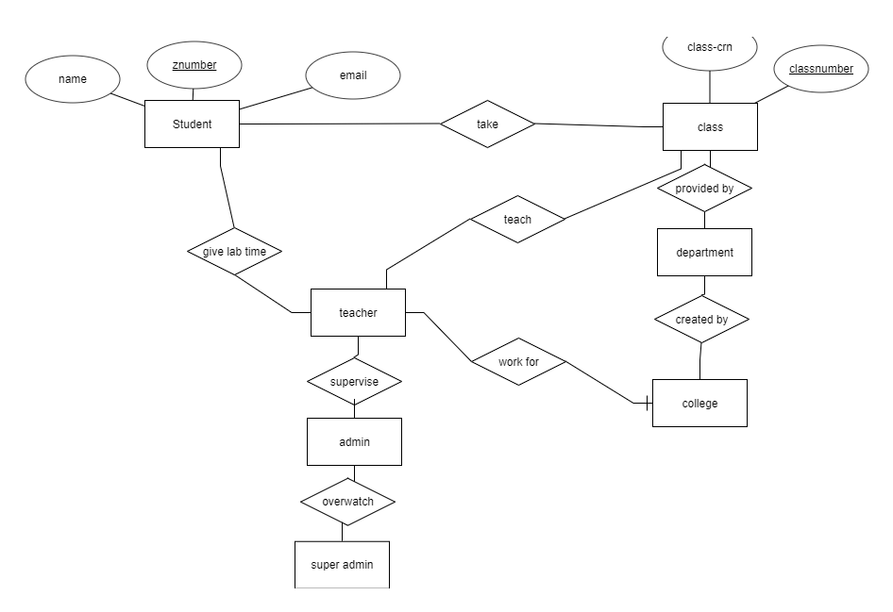

2)   DB organization:  Describe the main  database schema/organization  (high level), e.g. list main DB tables and items in each DB table

The main database will have a table for students with the student’s name, z number, class-crn, college, department, class, class number, class name, and email, and a table for labs with the station number, lab type, lab room, lab building, availability, and last used photo reference

3)   Media storage: Decide if images and video/audio will be kept in file systems or  in DB. Describe any other special data format requirements like for video/audio/GPS etc.

The image of the table after the user has used the lab will be stored in a file system and a reference to it will be in the DB. Any other media used in the project will be stored in file.

4)   Search/filter architecture and implementation: what will be the algorithm for search;  what DB terms will be searched, how it will be coded and organized in the DB. Similarly, say what DB items will be filtered/ sorted

Linear search with MySQL queries using php scripts, will have queries for filtering lab station including building/room location, availability, lab type, and a search function for lab number.

5)   Your own APIs: Describe and define at high level any major APIs that you will create

We will likely be using php as our API language, and any API we create will be solely to interact with and update the class and lab servers, as well as interact with the lab workbenches

6)   Describe any significant non-trivial algorithm or process (like rating, ranking, automatic prioritizing of items etc.)

A randomizer for personal use labs when the user doesn’t specify a station

1. **High-Level UML diagrams**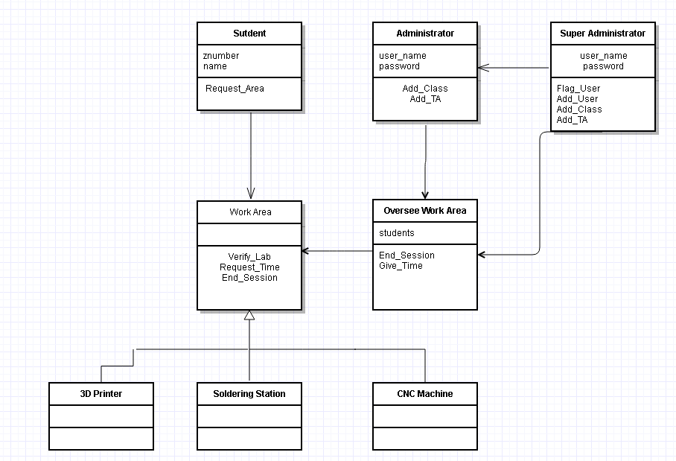

**10) Identify actual key risks for your project at this time**

1)   Skills risks (do you have the right skills)

In our groups experience we all have the necessary background which allows us to complete the tasks, however not one of us is a master in the area and we are all learning new things together.

2)   Schedule   risks (can   you make it   given what you   committed and the resources),

We have been able to have a very consistent schedule for working on the project, however the issue may arise when we get closer to the due date working on the project more may be an issue.

3)   Technical risks (any technical unknowns to solve),

Trying to understand how to get the IoT connected with our LAMP server. None of the group member knows much about this, but we are all learning as we go along.

4)   Teamwork risks (any issues related to teamwork);

Our group works very well together and will say when there is an issue. No teamwork risks are present at this time.

5)   Legal/content   risks (can you   obtain content/SW you   need legally with proper licensing, copyright).

Since our project is non-profit we will not be requiring any business licenses and the only other things we require are permission to use pictures for our website.

**Identifying and resolving risks**

1. Launching the Project. Our group has to decide the best possible way to launch the project. By this we mean implementing the project in a design that meets all the requirements and satisfies all the group members. We are trying to figure this out by trying several different test versions set up in different ways.

**11) Vertical Software Prototype**

**Link to the vertical software prototype:**

[**http://lamp.cse.fau.edu/~CEN4010_S2018g02/module3/**](http://lamp.cse.fau.edu/~CEN4010_S2018g02/module3/)

**Our vertical software prototype is a launch of the registration page that adds users to the database of allowable lab users.**