Introduction
ENGRID is an open-source mesh generation software with CFD applications in mind. ENGRID uses the NETGEN [4] library for tetrahedral grid generation and an in-house development for prismatic boundary layer grids. Internally, ENGRID uses the VTK [2] data structures as well as the *.vtu ﬁle format. To create grids for Currently ENGRID cannot generate surface grids. In order to create a volume grid it is required to import an existing surface mesh. Gmsh [1] is an excellent open-source tool to create surface triangulations for ENGRID . Gmsh is able to import STEP and IGES ﬁles and it can also be used for simple geometry modelling.
The 1.0 release of ENGRID provides native export to OpenFOAM® [3]. For future releases, export capabilities for complete OpenFOAM cases (including boundary conditions) and support for polyhedral cells are planned as well.
ENGRID is released under the GPL and we hope that it is a useful addition to the open-source CFD community. So far the implemented algorithm proved to be quite robust and it does not require much user interaction. Figure 1.1 shows a boundary layer grid that has been created around the geometry of what could be a toy plane.
This manual is very much a work in progress and does not claim to be finished, comprehensive, complete, or anything else. We hope that, even in this early stage, it offers a little help while using ENGRID !
 | This manual is very much a work in progress and does not claim to be ﬁnished, comprehensive, complete, or anything else. We hope that, even in this early stage, it offers a little help while using ENGRID!

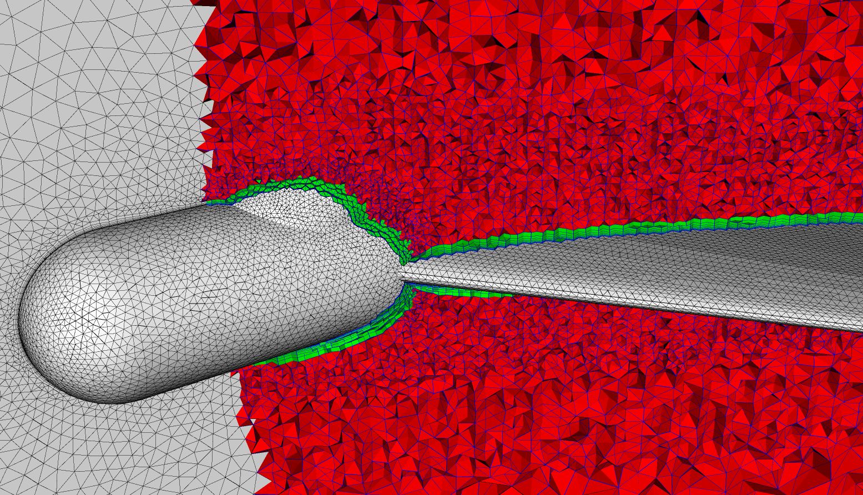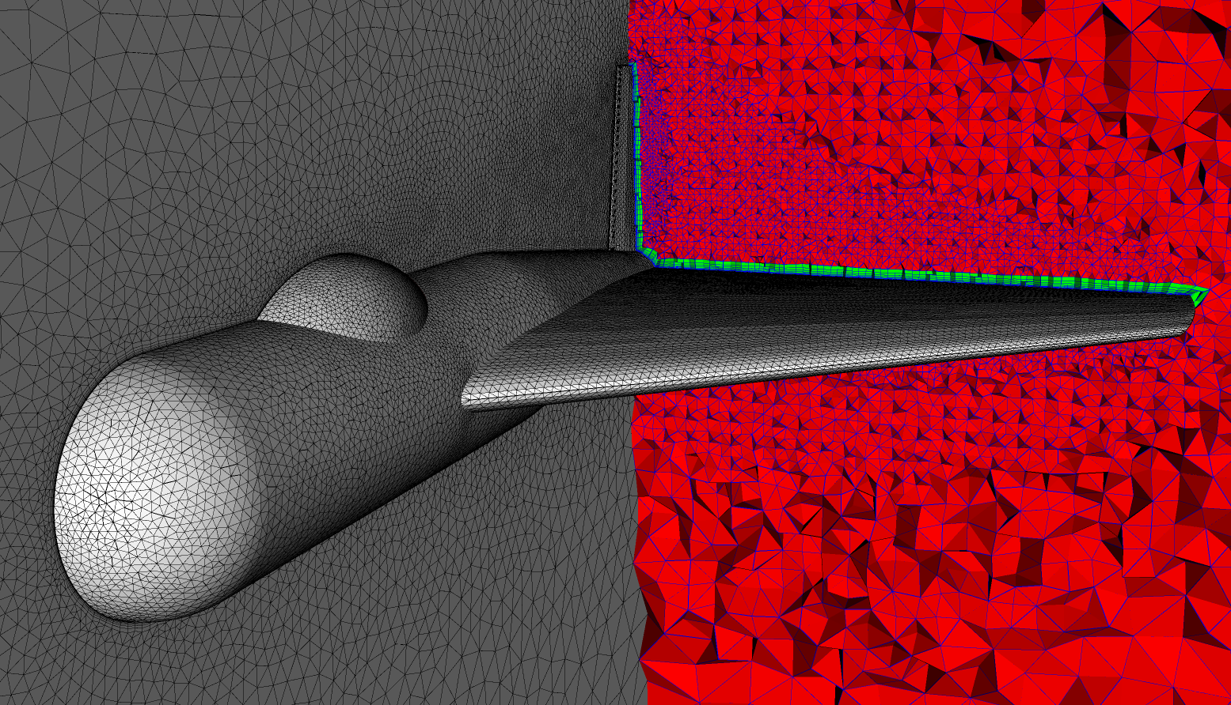
Figure 1: Prismatic boundary layer created by ENGRID

OpenFOAM® is a registered trade mark of OpenCFD® Limited

