

“PROJECT 1”
“Restaurant Table Reservation System”

Done by:
Name: Abhisri E.N
Srn No.: 31230415
A.Y. 2024-2025

Programme Name: BBA-CA
Course Name: Software Project Management
Couse Code: BBACA23605

Under The Supervision of Prof. Umesh Patwardhan Department of Commerce and Management
Faculty of Commerce and Management

TABLE OF CONTENTS

1. PROJECT INTRODUCTION 3
2. PROJECT CHARTER 4
3. FEASIBILITY STUDY (TELOS FRAMEWORK) 5
4. SCOPE STATEMENT 6
5. SMART PROJECT OBJECTIVES 7
6. WORK BREAKDOWN STRUCTURE (WBS) 8
7. EFFORT AND COST ESTIMATION 10
8. STAKEHOLDER REGISTER 11
9. RACI MATRIX 12
10. COMMUNICATION PLAN 13
11. RISK MANAGEMENT 14
12. QUALITY ASSURANCE PLAN 15
13. CONFIGURATION MANAGEMENT 16
14. PROJECT CLOSURE AND LESSONS LEARNED 17
15. SYSTEM DESIGN DIAGRAMS AND USER INTERFACE MOCKUPS 18
15.1.ER Diagram 18
15.2.DFD (Level 0 & Level 1) 18
15.3.UI MOCKUPS 19
15.3.1. Login Page 19
15.3.2. Table Booking Page 19
15.3.3. Booking Confirmation Page 20
15.3.4. Admin Dashboard 20

1. PROJECT INTRODUCTION
The Restaurant Table Reservation System is a web-based software application developed to streamline and automate the process of table booking in restaurants. In the current scenario, many small and medium-sized restaurants rely on traditional reservation methods such as phone calls, manual registers, or walk-in bookings. These methods are often inefficient and prone to errors such as double bookings, lack of proper record management, poor table allocation, and increased customer waiting time. Such limitations negatively impact both operational efficiency and overall customer satisfaction.
To address these challenges, the proposed system aims to provide a digital platform where customers can easily check table availability, make reservations in advance, modify booking details, and cancel reservations if required. The system also enables restaurant administrators to manage bookings effectively, monitor table utilization, and maintain accurate records of reservations. By introducing automation, the system improves accuracy, reduces manual workload, and enhances the overall dining experience for customers.
From a project management perspective, this project is not only focused on the development of a software system but also emphasizes the application of Software Project Management (SPM) principles. As a BBA-CA student acting in the role of a Software Project Manager, the project involves planning, organizing, and controlling all aspects of the software development lifecycle. It includes defining project scope, identifying stakeholders, allocating responsibilities, managing risks, ensuring quality standards, and monitoring project progress through structured methodologies.
Furthermore, this project provides practical exposure to industry-level project management practices such as feasibility analysis, work breakdown structure (WBS), effort and cost estimation, governance frameworks, and configuration management using version control tools. By integrating both technical and managerial aspects, the project aims to develop a comprehensive understanding of how software projects are executed in real-world environments.

2. PROJECT CHARTER
The Project Charter formally authorizes the initiation of the Restaurant Table Reservation System and provides a high-level overview of the project’s purpose, scope, and stakeholders. This document serves as a foundational reference for all project activities and establishes the authority of the Project Manager to plan, execute, and control the project.
The primary problem addressed by this project is the inefficiency and unreliability of traditional reservation methods used by many small and medium-sized restaurants. Manual booking systems, such as phone reservations and walk-ins, often result in issues like double bookings, lack of real-time availability tracking, poor record maintenance, and increased customer waiting time. These challenges highlight the need for a structured and automated system that enhances operational efficiency and improves customer experience.
The proposed system aims to provide a user-friendly and efficient platform that enables customers to register, check real-time table availability, make reservations, receive booking confirmations, and cancel bookings when necessary. In addition, the system includes an administrative interface that allows restaurant staff to manage reservations, monitor table usage, and maintain accurate booking records. The system is designed to be simple, accessible, and effective for both customers and restaurant personnel.
The key stakeholders involved in this project include the restaurant owner (project sponsor), customers (end users), project manager (responsible for planning and coordination), developers (responsible for system implementation), and administrative staff (system operators). Each stakeholder plays a critical role in ensuring the successful completion and usability of the system.
The project is based on certain assumptions, such as the availability of internet connectivity, access to digital devices like smartphones or computers, and basic digital literacy among users. These assumptions are necessary for the effective functioning of the system.
However, the project also operates under specific constraints. These include a limited academic timeline, restricted financial resources, and a controlled project scope suitable for a small-scale academic project. Additionally, the system complexity is intentionally kept manageable to ensure timely completion and effective demonstration of project management concepts.

3. FEASIBILITY STUDY (TELOS FRAMEWORK)
A feasibility study was conducted to evaluate the practicality of developing the Restaurant Table Reservation System specifically for managing table bookings and cancellations in restaurants. The TELOS framework—Technical, Economic, Legal, Operational, and Schedule feasibility—has been applied to ensure that the proposed system can be successfully implemented within the defined academic scope and real-world restaurant environment.
From a technical feasibility perspective, the system is highly feasible as it can be developed using standard web technologies such as HTML, CSS, and JavaScript for the frontend, along with a basic database to store reservation details like customer name, date, time, and table number. The booking and cancellation functionalities can be implemented using simple logic for checking table availability and updating reservation records. Since the system does not require complex integrations like payment gateways or third-party APIs, it remains technically simple and suitable for a small-scale academic project.
In terms of economic feasibility, the project requires minimal financial investment as it relies entirely on open-source tools and development platforms. No additional hardware or licensed software is required, and the system can be developed using existing resources such as personal laptops and free hosting platforms if needed. Therefore, the cost involved is negligible, making the project economically viable for academic purposes.
From a legal feasibility standpoint, the system handles only basic reservation-related information such as customer name and contact details, without involving sensitive data like financial transactions or confidential personal records. As a result, there are no major legal or regulatory concerns associated with the development or usage of this system, provided that basic data privacy practices are followed.
The operational feasibility of the system is strong, as it directly addresses the everyday challenges faced by restaurant staff in managing reservations. The system simplifies the process of checking table availability, recording bookings, and handling cancellations efficiently. Its user-friendly interface ensures that both customers and restaurant staff can easily use the system with minimal training, making it practical for real-world adoption.
Finally, schedule feasibility confirms that the project can be completed within the academic semester timeline. Since the system focuses only on core functionalities such as booking and cancellation, the scope remains manageable. With proper planning, task division, and regular monitoring, all project phases can be completed on time without overloading resources.

4. SCOPE STATEMENT
The scope of the Restaurant Table Reservation System defines the boundaries of the project by clearly identifying what functionalities will be developed and what will be excluded. Establishing a well-defined scope is essential to prevent scope creep, ensure efficient use of time and resources, and maintain focus on the core objectives of the system, which are table booking and cancellation management.
The project primarily focuses on developing a web-based system that enables customers to register and log in, view real-time table availability based on date and time, and make reservations accordingly. Users will also have the ability to modify or cancel their bookings, ensuring flexibility and convenience. The system will maintain a structured database of reservations, including details such as customer information, booking time, and table allocation. Additionally, an administrative interface will be developed for restaurant staff to manage bookings, monitor table occupancy, handle cancellations, and maintain accurate reservation records. The system will also ensure that double bookings are avoided by validating table availability before confirming any reservation.
However, to keep the project within a manageable academic scope, certain advanced features are intentionally excluded. These include online payment integration, food ordering and menu management, customer loyalty or reward programs, real-time notifications (such as SMS or email alerts), and multi-branch restaurant management. The system is designed for a single restaurant environment and focuses only on reservation-related functionalities.
By clearly defining these inclusions and exclusions, the project ensures that development efforts remain aligned with the primary goal of creating a simple, efficient, and user-friendly table reservation and cancellation system, while also ensuring timely completion within the academic schedule.

5. SMART PROJECT OBJECTIVES
The objectives of the Restaurant Table Reservation System are defined using the SMART framework to ensure they are Specific, Measurable, Achievable, Relevant, and Time-bound. This approach helps in setting clear goals and provides a structured direction for successful project execution and evaluation.
The specific objective of this project is to design and develop a web-based reservation system that allows customers to check table availability, book tables, and cancel reservations easily and efficiently. The system will also include an administrative module to manage bookings and monitor table allocation, ensuring smooth restaurant operations.
The measurable objective is to successfully implement all core functionalities of the system, including user registration, table availability display, booking confirmation, and cancellation features. The system’s performance can be evaluated based on criteria such as accurate reservation handling, prevention of double bookings, and successful completion of booking workflows without errors.
The achievable objective ensures that the project can be completed using available resources, knowledge, and tools such as HTML, CSS, JavaScript, and basic database systems. Since the system focuses only on essential reservation features without complex integrations, it remains realistic and feasible for a BBA-CA academic project.
The relevant objective highlights the importance of the system in solving real-world problems faced by restaurants, such as inefficient booking management and poor customer experience. By automating table reservations and cancellations, the system contributes to improved operational efficiency and customer satisfaction in the hospitality sector.
The time-bound objective ensures that the entire project, including planning, design, documentation, and basic implementation, is completed within the academic semester timeline. Proper scheduling and task management will be followed to meet deadlines and ensure timely project completion.

6. WORK BREAKDOWN STRUCTURE (WBS)
The Work Breakdown Structure (WBS) is a hierarchical decomposition of the Restaurant Table Reservation System project into smaller, manageable components, enabling effective planning, task allocation, and monitoring. By breaking the project into structured phases and sub-tasks, the WBS ensures that all activities required for developing the booking and cancellation system are clearly defined and systematically executed.
The project begins with the requirement analysis and planning phase, where system requirements related to table booking, cancellation, and user management are identified and documented. This phase also includes preparing the project charter, defining scope, and planning timelines. Following this, the system design phase focuses on creating the user interface design for customers and administrators, as well as designing the database structure to store reservation details such as customer information, booking date and time, and table allocation.
The development phase is a critical component of the WBS, where the actual system is built. This includes developing the user module for registration and login, implementing the table booking functionality with real-time availability checks, and creating the cancellation feature that allows users to modify or cancel reservations. Additionally, an admin module is developed to enable restaurant staff to view, manage, and update booking records efficiently.
Next, the testing phase ensures that all system functionalities work as intended. Unit testing is conducted to verify individual components such as booking and cancellation logic, while integration testing ensures that all modules work together seamlessly without errors. Special attention is given to validating that the system prevents double bookings and accurately updates table availability.
The project then moves to the deployment phase, where the system is finalized, uploaded (e.g., on GitHub or a local server), and made ready for demonstration. This is followed by documentation preparation, which includes compiling all project management artifacts, reports, and supporting evidence.
Finally, the closure phase involves reviewing project outcomes, documenting lessons learned, and identifying possible future enhancements such as adding payment integration or notification features. Overall, the WBS provides a clear structure that enhances project organization, accountability, and progress tracking throughout the software development lifecycle.

7. EFFORT AND COST ESTIMATION
Effort and cost estimation is an important aspect of software project management, as it helps in understanding the resources, time, and overall investment required to successfully complete the Restaurant Table Reservation System. For this project, estimation has been carried out using the Lines of Code (LOC) approach along with the Basic COCOMO (Constructive Cost Model), which is suitable for small-scale, organic projects with relatively simple requirements.
Based on the functionalities of the system—such as user registration and login, table availability display, booking and cancellation features, and an administrative module—the total size of the project is estimated to be approximately 4,000 lines of code (4 KLOC). Using the Basic COCOMO model for organic projects, where the constants are a = 2.4 and b = 1.05, the development effort is calculated to be around 10 person-months. This estimation reflects the amount of work required to design, develop, test, and document the system.
In terms of effort distribution, a significant portion is allocated to the development phase, as it involves implementing core functionalities like booking validation and cancellation handling. The remaining effort is distributed across planning, design, testing, and documentation activities. Proper estimation ensures that sufficient time is allocated to each phase, reducing the risk of delays and incomplete tasks.
From a cost perspective, the project is economically feasible as it relies entirely on open-source technologies such as HTML, CSS, JavaScript, and basic database systems. Since the project is developed in an academic environment, there are no direct labor costs involved, and the primary investment is in terms of time and effort. Any additional costs, such as hosting or deployment, are minimal and can be managed using free platforms or institutional resources.

8. STAKEHOLDER REGISTER
Stakeholder identification and analysis play a crucial role in the successful management of the Restaurant Table Reservation System project. Stakeholders are individuals or groups who are directly or indirectly affected by the project or have an interest in its outcome. Identifying stakeholders helps in understanding their expectations, influence, and level of involvement, which is essential for effective communication, decision-making, and project governance.
In this project, the restaurant owner acts as the primary stakeholder and project sponsor, having high interest and high influence, as the system directly impacts business operations and customer service. Customers are the end users of the system and have high interest but moderate influence; their satisfaction is a key success factor, as the system is designed to improve their booking experience. The project manager is responsible for planning, organizing, monitoring, and ensuring that the project is completed within scope, time, and quality constraints.
The developers are responsible for the technical implementation of the system, including designing, coding, and testing the booking and cancellation functionalities. They have high involvement in the project execution phase. Administrative staff or restaurant employees interact with the system to manage reservations, monitor table availability, and handle customer requests, making them important operational stakeholders with practical system usage responsibilities.
Each stakeholder has different expectations, such as ease of use for customers, efficiency and accuracy for restaurant staff, and successful project completion for the sponsor. By maintaining a structured stakeholder register, the project ensures that all stakeholder needs are identified, prioritized, and addressed appropriately throughout the project lifecycle.
Stakeholders | Role/Responsibility | Interest Level | Influence Level
Restaurant Owner | Project Sponsor, approves system | High | High
Customer | End users, book and cancel tables | High | Medium
Project Manager (Me) | Planning, monitoring, coordination | High | High
Developers | Design, develop and test the system | Medium | Medium
Administrative Staff | Manage reservations and system operations | High | Medium
Faculty Supervisor | Guide and evaluate the project | Medium | High

9. RACI MATRIX
The RACI Matrix is an important project management tool used to clearly define roles and responsibilities among all participants involved in the Restaurant Table Reservation System project. RACI stands for Responsible, Accountable, Consulted, and Informed, and it helps in avoiding confusion by specifying who is responsible for performing tasks, who is accountable for decision-making, who needs to be consulted, and who should be kept informed about project progress.
In this project, the Project Manager is primarily accountable for overall project planning, monitoring progress, making key decisions, and ensuring that the project is completed within the defined scope, time, and quality standards. The Project Manager also coordinates with all stakeholders and ensures smooth communication throughout the project lifecycle.
The Developers are responsible for executing technical tasks such as designing the system, coding the booking and cancellation functionalities, and performing testing activities. They play a key role in transforming project requirements into a functional system. Developers are also involved in debugging and ensuring that the system works efficiently without errors.
The Restaurant Administrative Staff are consulted during the requirement gathering phase, as they provide practical insights into how table reservations and cancellations are handled in real-world scenarios. Their input helps in designing a system that aligns with actual operational needs. They may also provide feedback during testing and validation stages.
The Faculty Supervisor or project guide is kept informed about the project’s progress at regular intervals. They review the work, provide guidance, and ensure that the project meets academic standards and requirements.
By clearly defining these roles and responsibilities, the RACI Matrix ensures accountability, improves coordination among team members, and minimizes misunderstandings during project execution. This structured approach enhances efficiency and contributes to the successful completion of the project.
Task | Project Manager | Developer | Admin Staff | Faculty
Requirement Analysis | Accountable | Responsible | Consulted | Informed
System Design | Accountable | Responsible | Consulted | Informed
Development (Booking System) | Informed | Responsible | Consulted | Informed
Testing | Accountable | Responsible | Consulted | Informed
Documentation | Accountable | Responsible | Informed | Consulted
Final Review | Accountable | Informed | Informed | Consulted

10. COMMUNICATION PLAN
An effective communication plan is essential for ensuring smooth coordination, transparency, and timely information sharing among all stakeholders involved in the Restaurant Table Reservation System project. Proper communication helps in aligning project activities with objectives, resolving issues quickly, and keeping all participants informed about progress and changes throughout the project lifecycle.
In this project, the Project Manager plays a central role in managing communication between all stakeholders. Regular updates are shared with stakeholders, including the restaurant owner and administrative staff, to keep them informed about the development of key features such as table booking, availability tracking, and cancellation functionality. These updates are typically provided on a weekly basis through progress reports or brief meetings, ensuring that stakeholders are aware of the current project status and any potential risks or delays.
The Developers communicate their daily progress, technical challenges, and task completion status with the Project Manager using communication channels such as messaging platforms, emails, or direct discussions. This ensures that any technical issues related to booking logic, database handling, or system errors are identified and resolved quickly without affecting the project timeline.
The Restaurant Staff (Operational Users) are consulted during specific stages, particularly during requirement validation and testing, to provide feedback on system usability and functionality. Their input is valuable in ensuring that the booking and cancellation processes are practical and aligned with real-world restaurant operations.
The Faculty Supervisor is kept informed at key milestones of the project, such as completion of planning, development, and final documentation. Updates are provided through presentations, report submissions, or review meetings, allowing the supervisor to guide the project and ensure it meets academic standards.
Shareholder | Information Shared | Frequency | Communication mode
Project Manager | Project progress, updates | Weekly | Reports / Meetings
Developers | Task updates, issues | Daily | Chat / Discussion
Admin Staff | System requirements, feedback | As needed | Meetings
Restaurant Owner | Project status, major decisions | Weekly | Email / Report
Faculty Supervisor | Milestone updates, presentations | At milestones | Presentation / Report

11. RISK MANAGEMENT
Risk management is a critical component of the Restaurant Table Reservation System project, as it helps in identifying, analyzing, and controlling potential uncertainties that may negatively impact project success. Since the system involves functionalities such as real-time table booking and cancellation, it is important to anticipate possible risks and implement appropriate mitigation strategies to ensure smooth project execution.
One of the major risks in this project is frequent changes in requirements, especially related to booking rules or table allocation logic, which can lead to rework and delays. This risk is managed by clearly defining and freezing requirements at an early stage and maintaining proper documentation. Another significant risk is development delay, which may occur due to poor time management or unexpected technical challenges. This can be mitigated through proper scheduling, regular progress monitoring, and dividing tasks into manageable components using the Work Breakdown Structure.
Technical errors are also a key risk, particularly in handling booking validation and preventing double bookings. To reduce this risk, thorough unit testing and integration testing are conducted to ensure system accuracy and reliability. Data loss or incorrect data handling is another concern, especially when storing reservation details. This risk is minimized by maintaining proper data backup practices and validating inputs before storing them in the database.
Additionally, user adoption challenges may arise if the system is not user-friendly or if restaurant staff are resistant to shifting from manual processes to a digital system. This risk is addressed by designing a simple and intuitive user interface and ensuring that the system requires minimal training for effective usage.
Each identified risk is evaluated based on its probability of occurrence and potential impact on the project. A Probability–Impact Matrix is used to prioritize risks, allowing the project manager to focus on high-risk areas and implement preventive measures accordingly. Continuous monitoring of risks throughout the project lifecycle ensures that any new risks are identified and managed proactively.

12. QUALITY ASSURANCE PLAN
Quality assurance (QA) is an essential part of the Restaurant Table Reservation System project, ensuring that the developed system meets predefined standards, functions correctly, and satisfies user expectations. Since the system handles important operations such as table booking, availability tracking, and cancellation, maintaining high quality is critical to avoid errors like double bookin0067s or incorrect data handling.
To ensure quality, proper coding standards are followed throughout the development process. This includes writing clean, well-structured, and well-documented code, which improves readability, maintainability, and ease of debugging. Consistent naming conventions and modular coding practices are adopted to ensure that different components of the system can be easily understood and updated.
The project includes a structured testing plan to verify system functionality at different levels. Functional testing is performed to ensure that all features—such as user registration, table availability display, booking confirmation, and cancellation—work correctly as per requirements. Special focus is given to validating that the system accurately updates table availability and prevents duplicate bookings. Integration testing is conducted to ensure that all modules, including user interface, booking logic, and database, work together seamlessly without conflicts or errors.
Additionally, User Acceptance Testing (UAT) is carried out to confirm that the system meets the expectations of end users, including both customers and restaurant staff. Feedback is collected to ensure that the system is easy to use, efficient, and aligned with real-world restaurant operations.
The acceptance criteria for the system include accurate reservation handling, a responsive and user-friendly interface, proper functioning of booking and cancellation features, and error-free performance during normal usage. Any identified defects are resolved before final submission.

13. CONFIGURATION MANAGEMENT
Configuration management is an important aspect of the Restaurant Table Reservation System project, as it ensures proper control over project artifacts, tracks changes, and maintains version history throughout the development lifecycle. It helps in managing updates to system components such as source code, documentation, and design files in a structured and organized manner, thereby improving project transparency and reliability.
For this project, a GitHub repository is created to store all project-related files, including documentation, design materials, and any implementation code related to the booking and cancellation system. GitHub serves as a version control platform that allows tracking of changes over time and provides a clear history of project development activities.
During the project lifecycle, multiple meaningful commits are performed at different stages to reflect progress. These include initial project setup, addition of project charter and planning documents, updates to system design, implementation of booking and cancellation features, and final documentation. Each commit includes a proper message describing the changes made, which helps in understanding the evolution of the project.
To manage modifications effectively, a change request process is followed. Any required change—such as updates in booking logic, user interface improvements, or correction of errors—is documented using a standard change request template. This includes details like change description, reason for change, priority level, and approval status. This process ensures that all changes are properly reviewed and controlled before implementation.
Version control through GitHub also enables easy rollback to previous versions in case of errors, ensuring system stability and reducing risks associated with unexpected issues. It also supports collaboration and accountability by clearly showing who made specific changes and when.

14. PROJECT CLOSURE AND LESSONS LEARNED
Project Closure
The Project Closure phase marks the successful completion of the Restaurant Table Reservation System project. All planned activities have been completed, and final deliverables—including documentation, diagrams, and system design—have been prepared and submitted. The project objectives, such as enabling table booking and cancellation, have been achieved within the defined scope, time, and academic constraints.
All major components, including the Project Charter, Feasibility Study, Scope Statement, Work Breakdown Structure (WBS), Risk Management Plan, Quality Assurance Plan, and Configuration Management using GitHub, have been systematically documented. The system effectively demonstrates functionalities like table reservation, cancellation, and administrative management.
The project has been reviewed to ensure it meets acceptance criteria such as accurate booking, prevention of double bookings, and a user-friendly interface. Additionally, tools like draw.io, SmartArt, and Figma were used to create diagrams and UI mockups, enhancing the clarity and professional quality of the project. The project is now complete and ready for academic evaluation.
Lessons Learned
The project provided valuable insights into both technical and managerial aspects of software development. One of the key learnings was the importance of proper planning and scope definition, which helped prevent scope creep and maintain focus on core functionalities like booking and cancellation.
Time management and task breakdown were also crucial, as using the Work Breakdown Structure (WBS) enabled efficient task division, prioritization, and progress tracking, ensuring completion within the academic timeline. The project further emphasized the importance of risk management, where early identification of risks allowed effective mitigation through monitoring and documentation.
Additionally, the use of version control tools like GitHub highlighted the importance of configuration management in maintaining project history and improving accountability. Effective communication and stakeholder management also played a key role in aligning project outcomes with expectations.
Finally, the project provided hands-on experience with tools like draw.io and Figma, enhancing skills in creating diagrams and UI mockups. This reinforced the importance of visual representation in understanding system design and improved both technical and presentation skills.

15. SYSTEM DESIGN DIAGRAMS AND USER INTERFACE MOCKUPS

15.1.ER Diagram
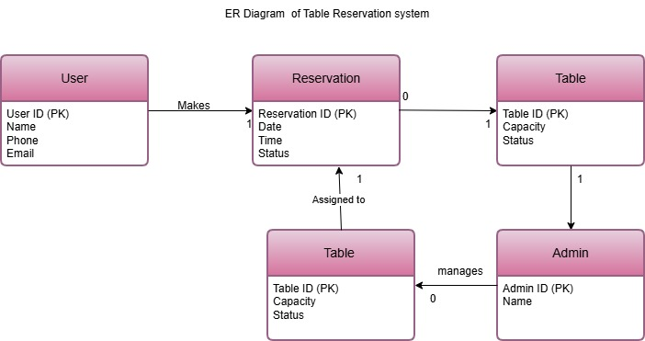

15.2.DFD (Level 0 & Level 1)
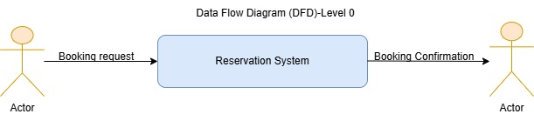
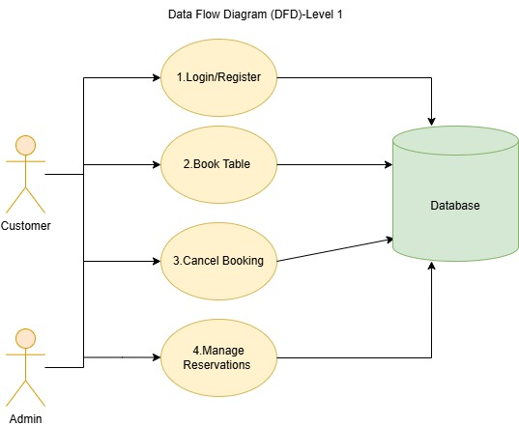
15.3.UI MOCKUPS

15.3.1. Login Page
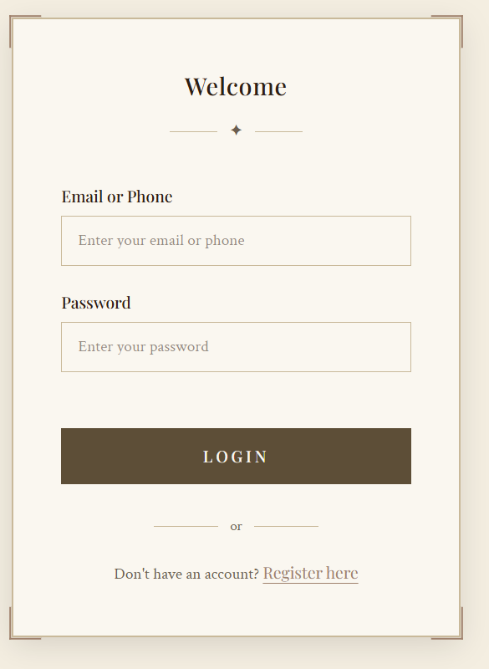

15.3.2. Table Booking Page
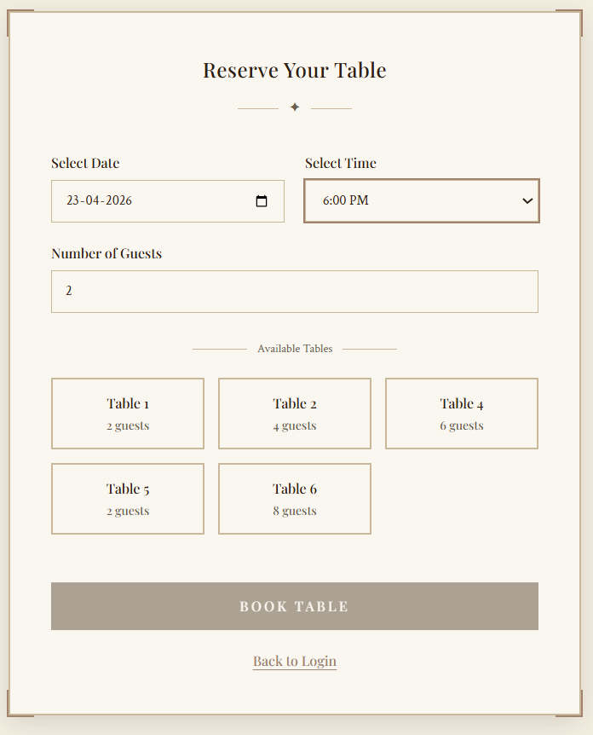

15.3.3. Booking Confirmation Page
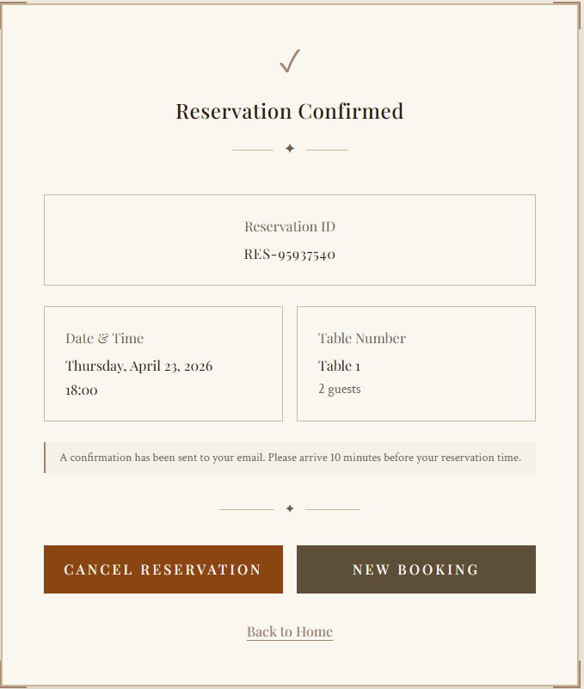

15.3.4. Admin Dashboard
