Architecture

Tenant→workspace→app
How to resolve this question, it is not easy to configure a hierarchy of space without thinking in multiple security and frontier to write inside the final solution.
Kubernetes has a flat name space implementation.
We needs classes to describe this vision. The beginning will have just one hierarchy, but the reality should to use at least on more layer.
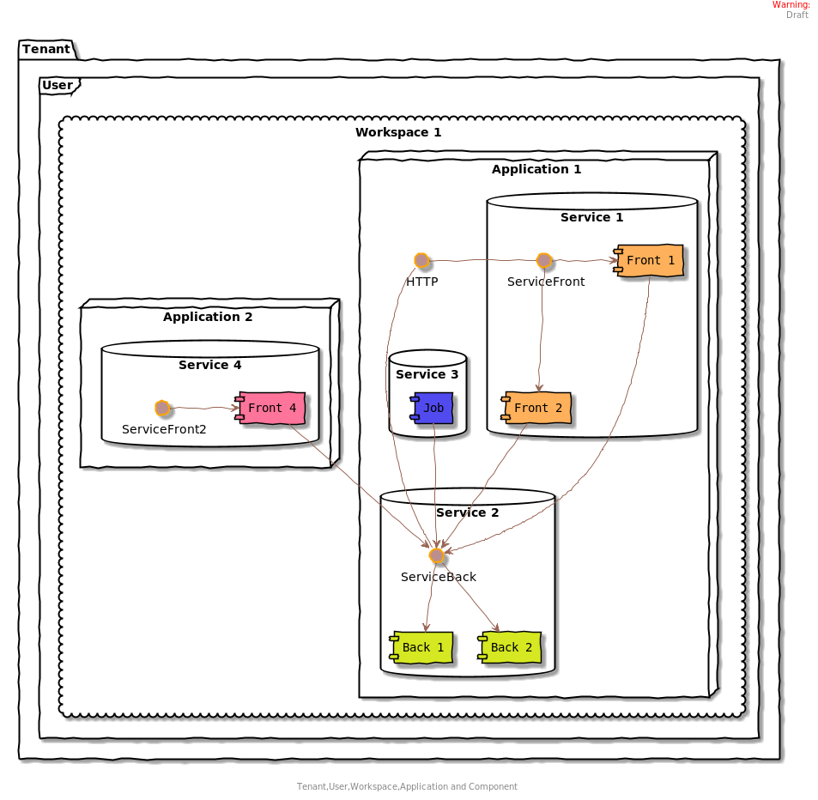
This sample shows different usage on a workspace. One thing clear is to bring together all the element of an application.
In the flat oriented kubernetes name space organization, it could be a simple name space where we deploy the services together. Calling a service inside the name space should be possible by a single name. Now we need a namespace to describe a workspace,an user, a tentn including an object describing the applications that are name space too.
The user could not appear on the hierarchy.
In a name space we can use labels to set the hierarchy organisation. The labels are used to select some component.
We need a model to save the name space hierarchy.

A simple resolution of this question, should be to create a simple name space including the hierarchy description.

Example :
apiVersion: v1
kind: Namespace
metadata:
name: Citadel-SpecAcc-190665
labels:
application: AutomaticTrading
workspace: AsianExotic
user: JohnPaulson
tenant: Citadel

The user is an option.
It is important to understand that the name space in kubernetes need to be unique. But the principal idea is to make something usable for search and description. We can by example search all the name space used by “JohnPaulson”.

Workspace design
Some information will be implicit as the name space creation or the final naming of the application.

apiVersion: v1
kind: Workspace
metadata:
name: Citadel-Workspace-012
labels:
workspace: AsianExotic
user: JohnPaulson
tenant: Citadel
spec:
apiVersion: v1
kind: List
items:
- apiVersion: extensions/v1beta1
kind: Application
metadata:
name: RiskManagement
spec:
services:
- name: reporting
version: 1.0.0
- name: ui
version: 1.1.0
links:
- reporting

A workspace embed an Application. An application can be used separately from a workspace.
Adding a new application should update the status of this workspace description.

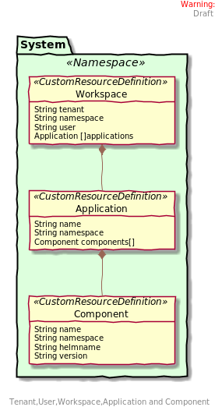

To describe these theme, the creation of CustomResourceDefition is primal.
We have the workspace, the application and the components (of the application). Two application can connect together along connection rule that will be created on the fly.
The CustomResourceDefition are global and will be shared across all the name spaces.

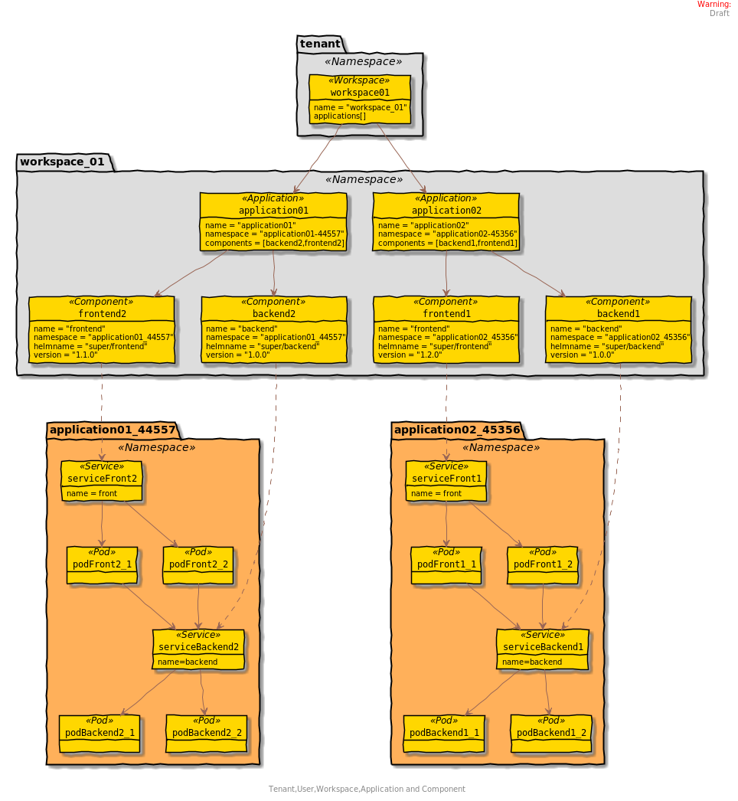
A deployment should correspond to these diagram. One name space to save the workspace name (or not). One name space to save the application and their components. Contains just the declaration.
In this name space a specific pod will deployed to manage all the application of a workspace.

Repository Definition
An helm repository could be usable.
Example of the repository content

apiVersion: v1
entries:
alpine:
- created: 2016-11-18T15:05:51.078570269-07:00
description: Deploy a basic Alpine Linux pod
digest: f44f733d69008e86c3989d3b094a5e6151d168921a09eda61c0897472e2f0399
home: https://k8s.io/helm
name: alpine
sources:
- https://github.com/kubernetes/helm
urls:
- alpine-0.3.0.tgz
version: 0.3.0
Can include other definition as:
keywords:
maintainers:
engine (The name of the template engine)
icon
appVersion
deprecated
tillerVersion

Controllers design

Application controller
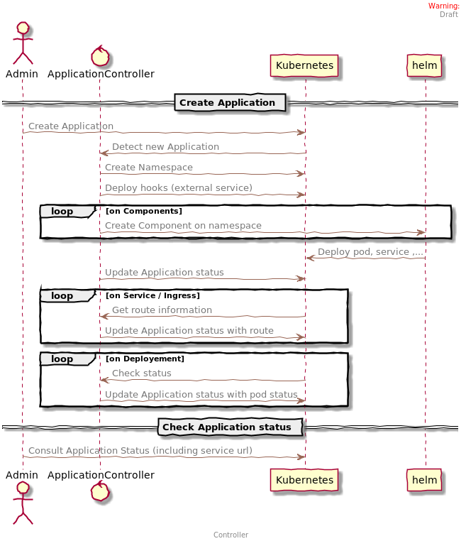

Creator Api
The principal subject of this project is to create an Api to deploy an application and get the urls of the components. The api will be a simple rest server that will create Application/Workspace object and will save it on Kubernetes. It will call Kubernetes to know the status of the application.

The needs are :
- List Services
- Create a new Application
- Get status and available services(urls) on an Application
- Add service to an application
- Package an existing Application (large: need data from services)

The api creator will be the adapter between the application world and Kubernetes world. It will communicate in creating application object that will be managed by Application Controller.
The Api will be inside the name space where the objects will be created.
