**Her is my price imported table   
  
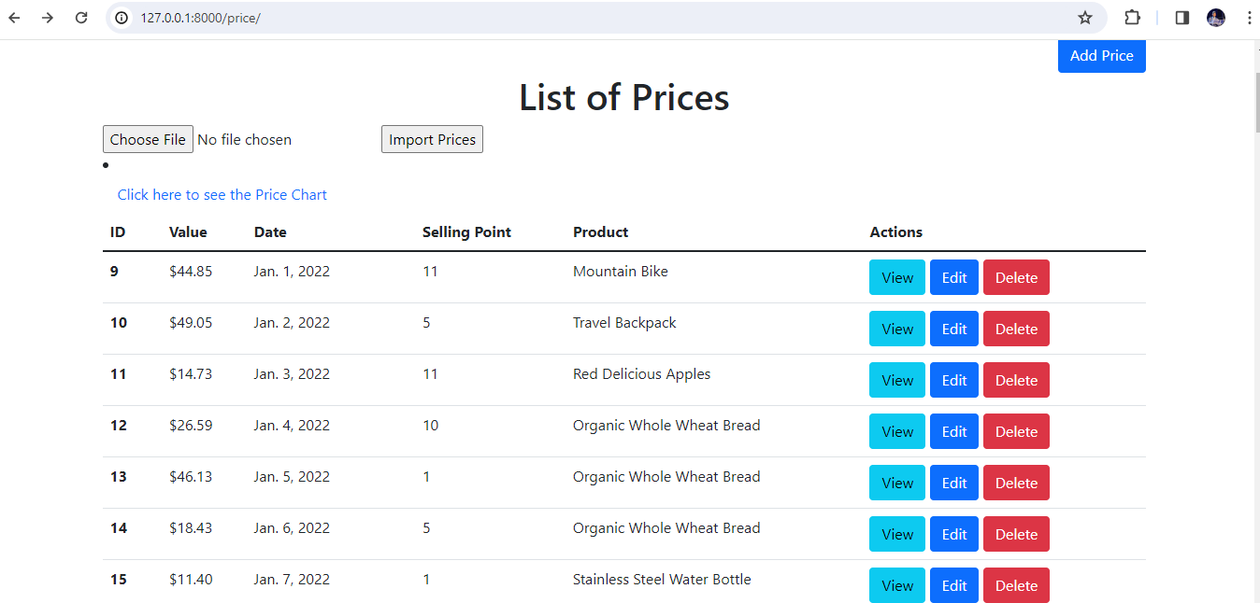  
ChartJSON**

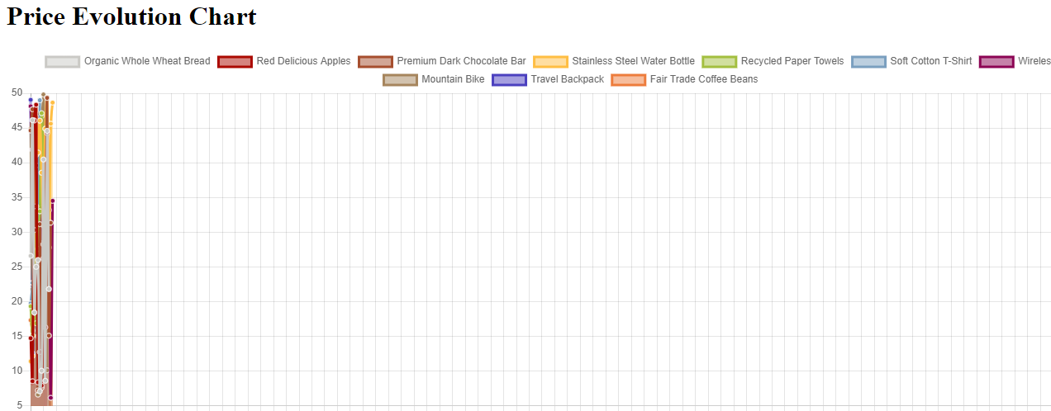

Here I am visualizing the data of price table using chartjs   
I had a problem fixing the width of the graph but working on it