|  |  |  |  |
| --- | --- | --- | --- |
| logo-CvSU-2  Republic of the Philippines  **CAVITE STATE UNIVERSITY**  **Bacoor City Campus**  SHIV, Molino VI, City of Bacoor  **DEPARTMENT OF COMPUTER STUDIES**  **ITEC 106: IT Elective 2 (Web Systems and Technologies 2)**  **Activity Sheet**  **2nd Semester, A.Y. 2021-2022** INTENDED LEARNING OUTCOMES   **After the completion of the unit, students will be able to:**   1. Use PHP elements, concepts and basic algorithm. 2. Explain the PHP basic elements and concepts. | | | |
| **activity 01: PHP BASIC ALGORITHM** | | | |
|  | | | |
| DIRECTION  * Write a PHP program to find the number of integers within the range of two specified numbers and that are divisible by another number. * Sample Data:   For example x = 5, y=20 and p =3, find the number of integers within the range x..y and that are divisible by p.  Output: 5   * Display the sample data and its output in HTML **<h3>** format. * Provide the screenshot and source code of your work. | | | |
| **rubrics for grading:** | | |
|  | | |
| **Category** | **Description** | |
| **Program**  **Execution (25pts)** | Program executes correctly with no syntax or runtime errors. | |
| **Correctness**  **(25pts)** | Program produces correct answers or appropriate results for all  inputs tested. | |
| **Completeness**  **(25pts)** | Program shows evidence of excellent case analysis, and all  possible cases are handled appropriately. | |
| **Logic**  **(25pts)** | Program logic is correct, with no known boundary errors, and  no redundant or contradictory conditions. | |



Republic of the Philippines

**CAVITE STATE UNIVERSITY**

**Bacoor City Campus**

SHIV, Molino VI, City of Bacoor

**DEPARTMENT OF COMPUTER STUDIES**

**ITEC 106: IT Elective 2 (Web Systems and Technologies 2)**

**Activity Sheet**

**2nd Semester, A.Y. 2021-2022**

|  |  |
| --- | --- |
| **Name:** | **Date:** |
| **Course/Yr&Section:** | **Score:** |

|  |
| --- |
| **screenshot** |
|  |

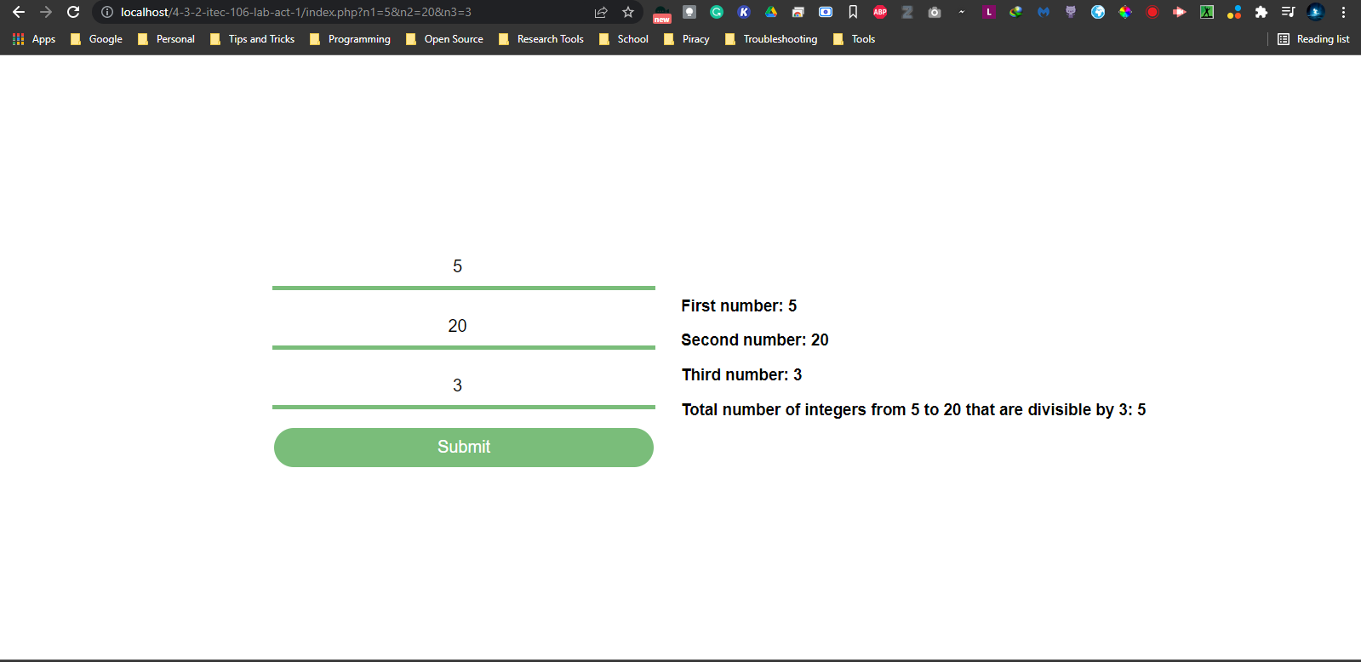

|  |
| --- |
| **source code** |
|  |

<!-- index.php -->

<!DOCTYPE html>

<html lang="en">

<head>

    <meta charset="UTF-8">

    <meta http-equiv="X-UA-Compatible" content="IE=edge">

    <meta name="viewport" content="width=device-width, initial-scale=1.0">

    <link href="style.css" rel="stylesheet">

    <title>BSIT 3-2 - ITEC 106 - Activity 2 - Amolat, Nommel Isanar Lavapie</title>

</head>

<body>

    <?php

        $n1 = $_REQUEST["n1"] ?? "";

        $n2 = $_REQUEST["n2"] ?? "";

        $n3 = $_REQUEST["n3"] ?? "";

    ?>

    <form action="index.php" method="GET">

        <input type="number" placeholder="First Number" name="n1" value="<?= $n1 ?>">

        <input type="number" placeholder="Second Number" name="n2" value="<?= $n2 ?>">

        <input type="number" placeholder="Third Number" name="n3" value="<?= $n3 ?>">

        <input type="submit" value="Submit">

    </form><!--

    --><div>

        <?php

            if($n1 !== "" and $n2 !== "" and $n3 !== "" and $n2 >= $n1) {

                $i = $n1;

                $total = 0;

                while($i != $n2) {

                    if($i % $n3 == 0) {

                        $total++;

                    }

                    $i++;

                }

                echo("<h3>First number: $n1</h3>");

                echo("<h3>Second number: $n2</h3>");

                echo("<h3>Third number: $n3</h3>");

                echo("<h3>Total number of integers from $n1 to $n2 that are divisible by $n3: $total</h3>");

            }

        ?>

    </div>

</body>

</html>

/* style.css */

* {

    box-sizing: border-box;

    font-family: Arial, Helvetica, sans-serif;

}

body {

    margin: 0;

    padding: 0;

    width: 100vw;

    height: 100vh;

    line-height: 100vh;

}

form {

    text-align: right;

    vertical-align: middle;

    display: inline-block;

    width: 50%;

    padding: 10% 30px 10% 20%;

}

form > input {

    display: block;

    width: 100%;

    text-align: right;

    height: 50px;

}

form > input:not(:last-child) {

    margin-bottom: 20px;

    /* border-radius: 25px; */

    outline: none;

    border-style: none;

    border-bottom: 5px solid rgba(0, 128, 0, 0.521);

    font-size: 20px;

    text-align: center;

}

form > input:not(:last-child):focus {

    border-bottom-color: green;

}

form > input:last-child {

    font-size: 20px;

    text-align: center;

    border-radius: 25px;

    background-color: rgba(0, 128, 0, 0.521);

    color: white;

    border-style: solid;

    border-color: white;

}

form > input:last-child:focus, form > input:last-child:hover {

    background-color: green;

}

div {

    display: inline-block;

    width: 50%;

    vertical-align: middle;

}

h3 {

    line-height: initial;

}