

**Technical University Gheorghe Asachi Iasi**

**Faculty of Automatic Control and Computer Engineering**

**Area: Computer Science**

**3rd year**

**COVID-19 App**

Programming Engineering

Petrica Petru – 1306B

Moisii Marin – 1306B

Pascal Dragoș – 1306B

Enachi Vasile – 1308B

**Professor:** Tiberius Dumitriu

# Introduction

## Purpose

Covid19-App is a desktop application for visualization and analysis of data about the effects of COVID-19 virus. This application displays a global map which indicates the level of infection with the new virus in each region on the Earth. Also, this application presents statistics at global level, like as the evolution of infection level on each continent, the global current infection/death/recovery rate and statistics at the level of each country, like as the number of infected/dead/recovered people.

A network connection is required for the application to update the information daily. Otherwise, the application works in offline mode and presents the last downloaded information. Details and

specifications of the functionality of this application are defined in sections 3 and 4. An overview of the application is given in section 2, and a list of requirements is given in section 5. This documentation refers to the release version on this application.

## Document Conventions

This document follows the IEEE standard formatting for software development. The standard specifies that the writing to be done in third-person at the passive voice as a readable and grammatically correct text.

## Intended Audience and Reading Suggestions

This document is intended for both users and developers. Since a user needs information on how to use this application, he should continue to read section 3, 4 and 5. In the case of developers, because they need a detailed and depth understanding about the application, it is recommended to read whole document, with increased attention on section 2.

The document starts off with an overview of the functions and specifications for this game in section 2, then moves on to describe the requirements for interfacing with external hardware and software in section 3. Section 4 describes the application functions in great detail and section 5 lists various requirements the game must respects after completion.

## Product Scope

Covid19-App is a simple ease to use graphic application which offers real-time (if the internet connection is available) information about Covid19 virus spreading. The main goal of this application is to keep the user informed about the current state of the pandemic at two levels of granularity, on worldwide and on each country level. It is strong recommended that the user to ensure a network connection, when run this application, for the best experience. This application is intended to be ease to use, so it contains an interactive worldwide map, very clear and understandable graphs and charts.

# Overall Description

## Product Perspective

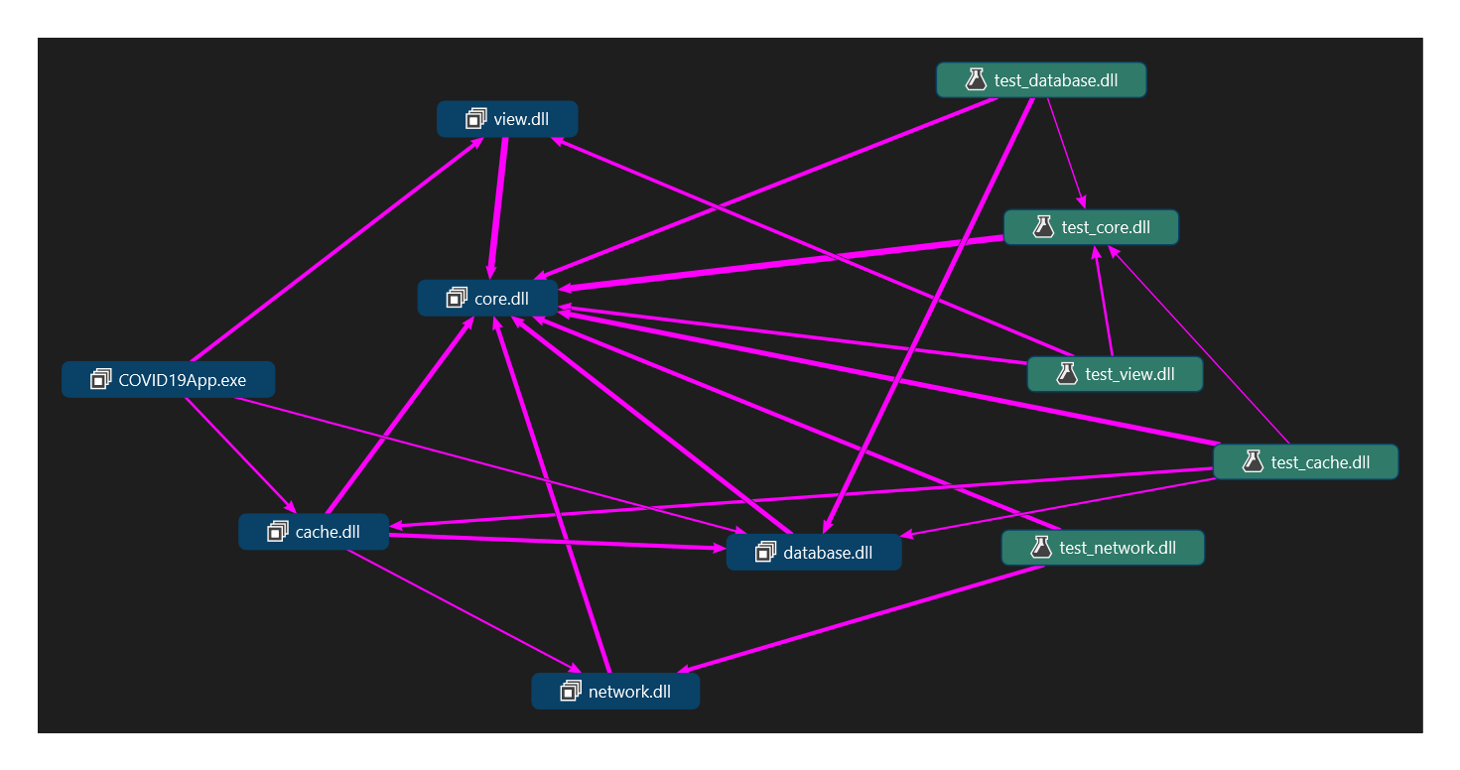Covid19-App is an academic, team project which has been realized to practice with programming engineering concepts. It is implemented as a Windows Forms Application using C# programming language. The data required for this application is stored within a SQLite database. The operations of database handling, like as creating/deleting database and tables, inserting initial and constant data, are realized through scripts written in Python 3.8 programming language. The database relational and logical models are attached to the documentation.

Fig. 1 – Application components

In figure 1 are presented the application components and their dependency relations. Each module has been implemented as a DLL (Dynamic Link Library) file. Core module provides structures, objects abstraction and other basic functionality. Network module defines the functionality to check internet connection, to download data using API requests from a free source and to parse the data into internal structures. Database module handles the cache mechanism and the interaction with SQLite database. Cache module implements the logical mechanism to work with last available data. View module contains the definition of graphical elements. For each functional module is developed an unit test module.

## Product Functions

The major functions the Covid19App must perform for the end user are the following:

* Interactive worldwide map which reflects the state of actual pandemic – each country is colored according to the number of reported active cases of infection; also the map is responsive to the user’s mouse hovering or clicking, displaying relevant information.
* Worldwide statistics – the application presents concrete statistics about the evolution of the SARS-CoV-2 virus spreading and about its effects on global population.
* Country level statistics - the application presents concrete statistics about the evolution and state of the epidemic in a specific country.

## User Classes and Characteristics

This application is designed to be easy to use. Information is presented through graphical elements which provides ease of understanding. So, this application follows to cover a wide range of user classes, from simple people who want to get quickly the latest information about actual pandemic to journalists or researches who want to use a reliable source to carry out their work.

## Operating Environment

Since Covid19App is developed using .NET Framework, it is compatible with only all version of Windows operating system starting with Windows XP Service Pack 3. Also, .NET Framework 4.7.2 or a newer version is required to be installed on the system. It is not mandatory, but for a better user experience is strongly recommended an internet connection during application execution.

## Design and Implementation Constraints

There are no limiting factors in design or implementation of this project.

## User Documentation

Covid19App contains a clear and explicit in-app help, accessible through F1 key press. It provides the user guidance regarding the use of the application and the interpretation of the information.

## Assumptions and Dependencies

Our application uses a public online source to get necessary data about the Covid-19 virus effects. There is been made the assumption that the data are correct and the source will continue to provides information daily. There are no backup data source, so if suddenly the data provider stops, Covid19App will work with the data loaded in database before this incident, like as it is in offline mode.

# External Interface Requirements

## User Interfaces

The user interface appears like as a tabbed window. It contains three tabs, each of them presenting a different view.

The first tab is represented by an interactive worldwide map, on which each country is colored according to the number of reported active cases of infection with new coronavirus. A less rate of infection is reflected with the green color, while a severe rate of infection is reflected by the red color. The gray color means that there does not exist data about respective region. The user can perform zoom in/out using mouse wheel, move on the map holding down the left click and moving the mouse, hover the mouse on a specific country to display the value used to get the logarithmic color interpolation, left click on any country region to move on tab which presents information about its state. Also, on the first tab, below the map is present a scrollbar which allows user to choose the date from which information are loaded on the map. Default, is selected the most recent available date.

The second tab presents the worldwide statistics and is structured in three parts. On the top is the graph that display the evolution of the number of confirmed infected people on each continent. The user can hover the mouse on any point on the graph to get detailed information. In the middle of the view are three gauge charts which shows the percentage of infected, dead and recovered people, reported to the global population. At the bottom, are displayed the countries with the greatest number of confirmed, dead and recovered people.

The third tab presents the country level statistics. It is structured like the previous tab, so the graph display the evolution of the active, death and recovery cases inside the respective country. The gauge charts reflects the total number of infected, dead and recovered people from the respective country.

There no explicit indicator inside user interface to open in-app help, but it is accessible through the standard way –on F1 key press.

## Hardware Interfaces

There is not much heavy hardware needed to run this application. Hardware interfaces include a display monitor, a mouse and a keyboard. The mouse is used to interact through left click, right click and wheel with graphical elements from user interface, which is displayed on the monitor. The keyboard is used to open the in-app help through F1 key press.

## Software Interfaces

To run this application the user’s system must runs any Windows operating system, starting with Windows XP Service Pack 3 and to have installed .NET Framework 4.7.2 or a newer version.

## Communications Interfaces

For the best user experience is required an established internet connection during application execution. Through it Covid19App makes a HTTP request to the data provider to get the latest available data. There are transferred using JSON format and then stored locally in the SQLite database.

# System Features

This application features are covered in-depth in the user guideline.

# Other Nonfunctional Requirements

## Performance Requirements

This application is able to run on all version of Windows, starting with Windows XP Service Pack 3. It is recommended to have at least 512 MB RAM and at least 1 GHz CPU. No dedicated graphics card is needed.

## Safety Requirements

Using this application does not present any safety risks.

## Security Requirements

This application does not gather any information from the user. Also, if an internet connection is established Covid19App does not download dangerous content.

## Software Quality Attributes

Covid19App is thought to be a simple, fast, easy to use and useful tool which provides fresh and correct data regarding to effects of new coronavirus. This application is designed to be used for as long as possible. There are been chosen maintainability and reliability over portability.

## Business Rules

It is the policy of the development team to follow all codes of conduct established by the University.

# UML Diagrams

## Class Diagram

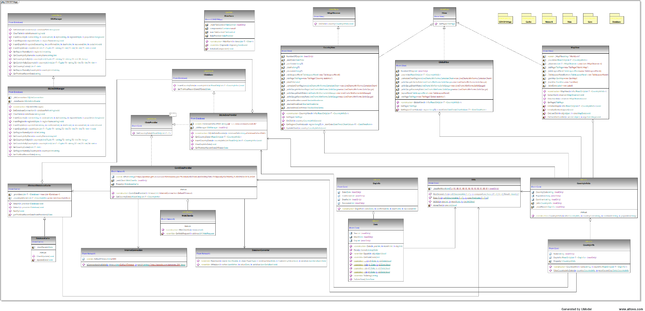

## Activity Diagram

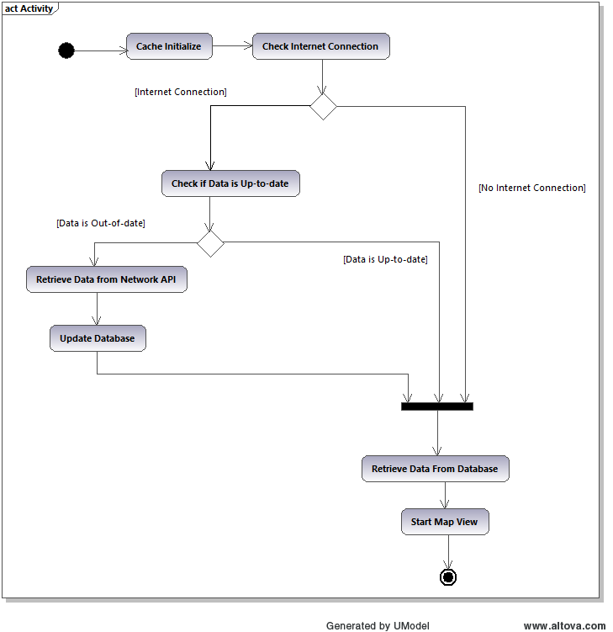

## Sequence Diagram

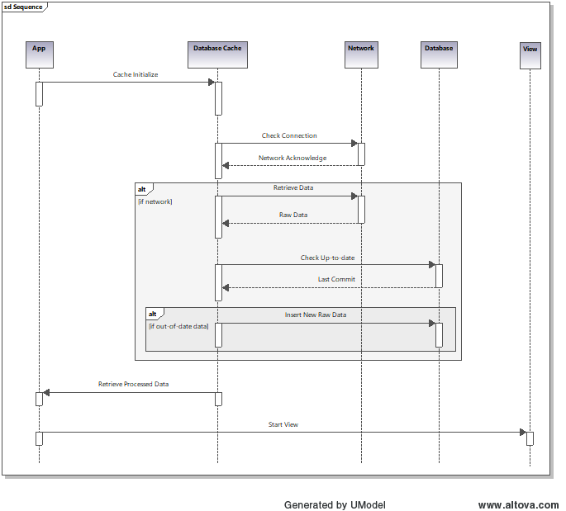

## Use Case Diagram

## Component Diagrams

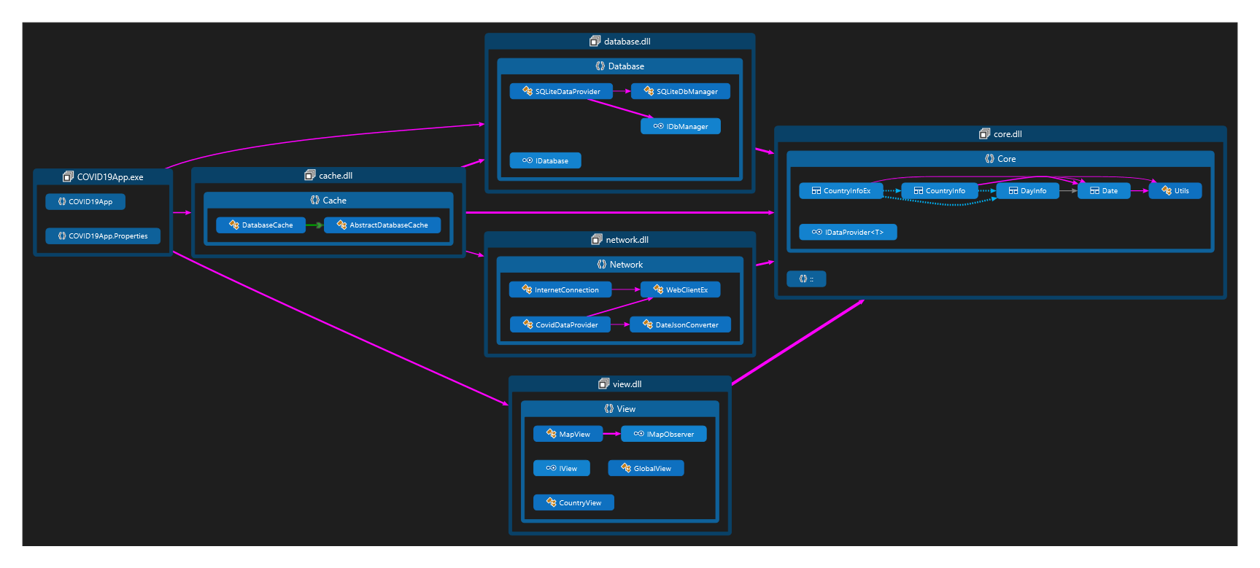

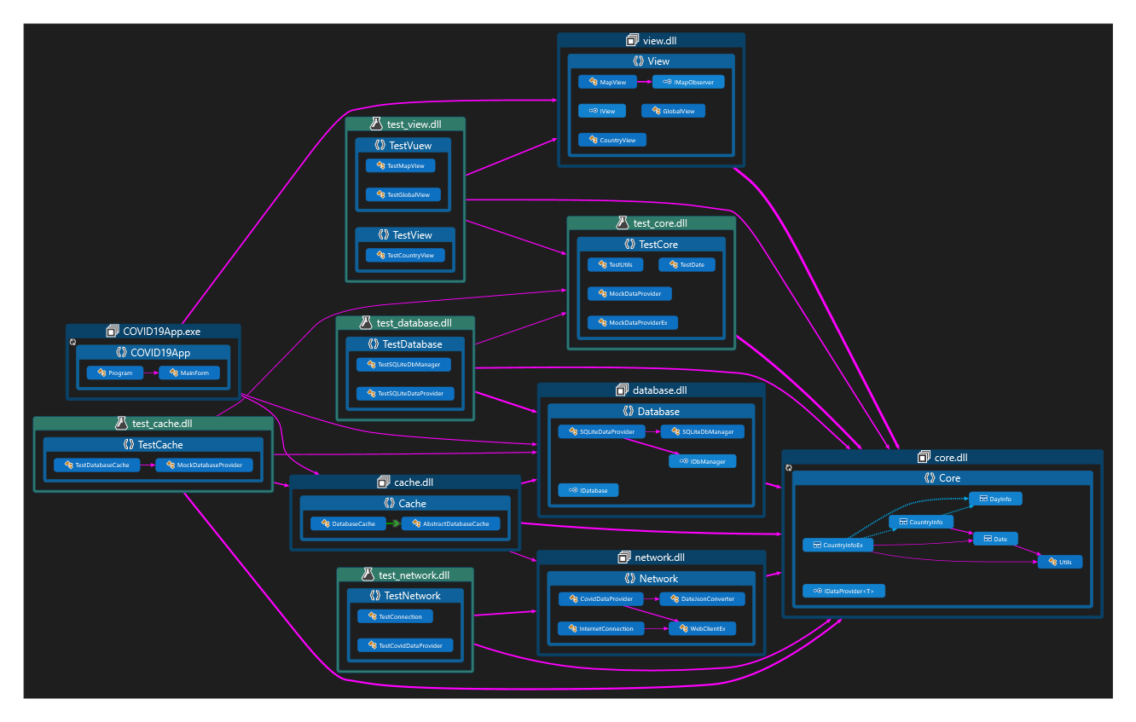

## Database Diagrams

## 

## 

# Instructions

# Overview:

### COVID19App is a program that shows data and statistics about COVID 19 pandemic.

### The information automatically updates in order to maintain content fresh and reliable.

The application uses a local database so it can be used without Internet connection but using it this way many days in a row can lead to obsolete data.

# User interface: The user interface is friendly and can be understand and learned in few seconds.

#### There are 3 principal tabs that you can easily switch by clicking on them.

**Map view tab**

**Overview:**

This view (tab) is global map which graphically indicates a general situation about total cases confirmed.

**Color scheme:**

Starting from 0 to Max:

* Gray - no data provided
* Green - fewest cases confirmed
* Yellow
* Orange
* Red - most cases confirmed

**Scale:**

For a better appearance and a more intuitive overview, map uses logarithmic scale because the numerical data covers a very wide range of values.

Time axis:

By default, the display information corresponds to the most recent date from database (or if available, from Internet).

In the bottom of the screen you can change that by scrolling the track bar.

**Click event:**

You can click on any country for more information. When you do that, the country view tab opens with data and charts about the country you selected.

**Global view tab**

**Overview:**

This view (tab) is chart which graphically indicates a general situation about total cases confirmed grouped by continent.

**The Chart:**

The chart shows total cases confirmed, group by continent.

On the X-axis is time, starting from 22.01.2020 until the most recent day in the database (most of the times, this will be today date).

On the Y-axis is number of people affected by virus.

**The Gauges:**

* The first gauge shows the percentage of people infected (number of people infected / population of all countries * 100).
* The second gauge shows the mortality rate of COVID 19 (number of deaths cause by virus / number of people infected * 100).
* The third gauge shows the healing rate of COVID 19 (number of deaths healed/ number of people infected * 100).

**Country view tab**

**Overview:**

This view (tab) is chart which graphically indicates a country situation.

This view differs according to country is displayed. You can change the country by going to map view tab and click on another country.

**The Chart:**

The chart indicates a country situation over time. You can see the trend of infections, deaths and healing.

On the X-axis is time, starting from 22.01.2020 until the most recent day in the database (most of the times, this will be today date).

On the Y-axis is number of people affected by virus. By adding death, active and recovered you obtain total cases confirmed.

**Color Scheme:**

* Red - deaths
* Yellow - active cases
* Green - recovered

**The Gauges:**

* The first gauge shows the absolute value of people infected.
* The second gauge shows the absolute of deaths.
* The third gauge shows the absolute of recovered people.

# Screenshots

## Map View

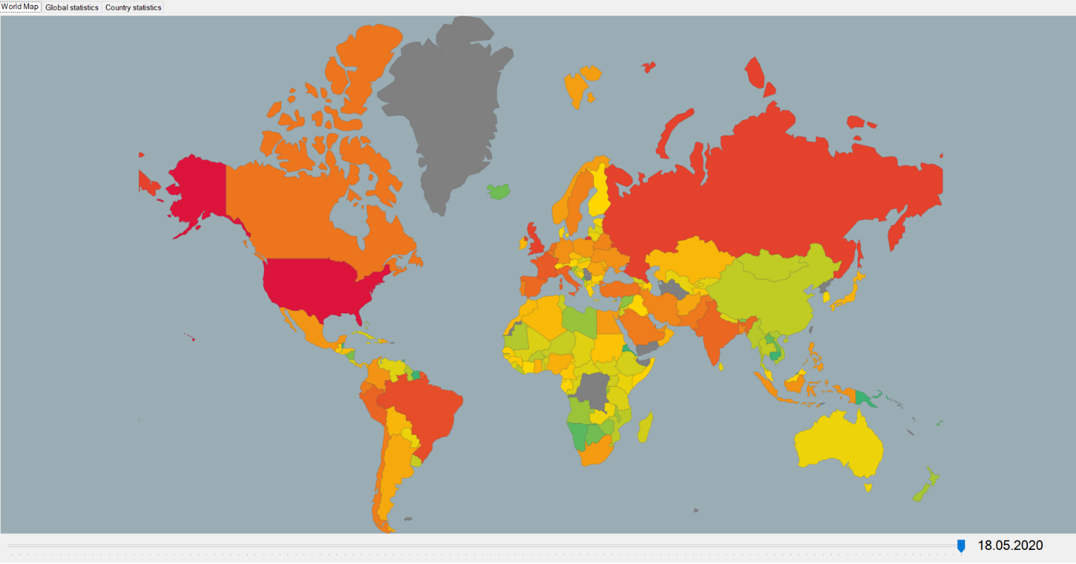

## Global View

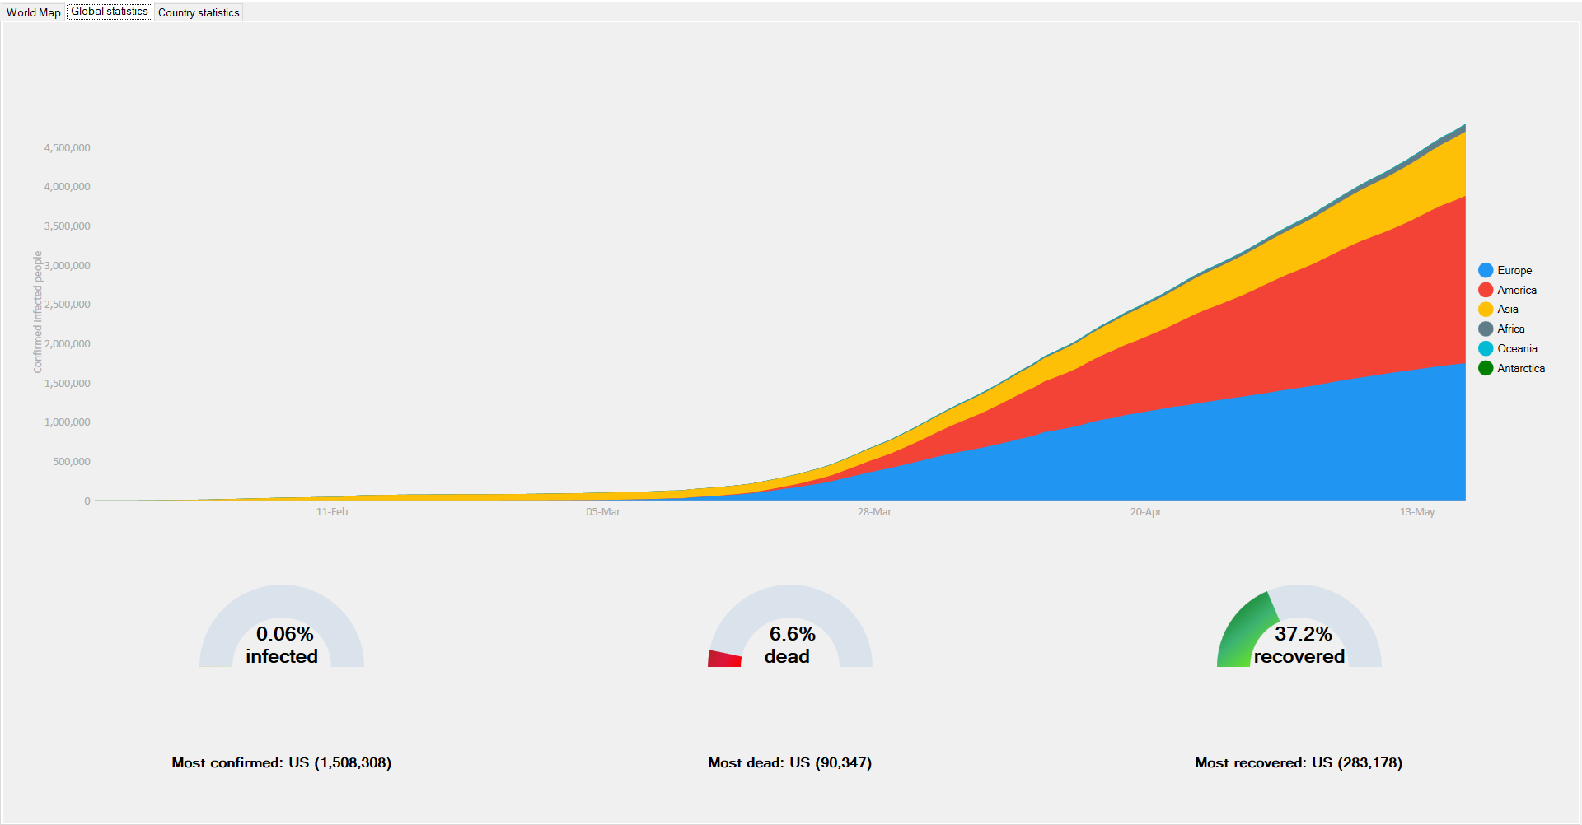

## Country View

