Jira Service Desk 184741

Current version: Jira service desk 5.14.0, which includes Jira core 9.14.0, Postgres 15.6 database, and Ubuntu 22.04 OS.
Description: Jira service desk, from a high-level view to GM and our developers, is essentially a ticket management system, for several applications in our organization. Our end users, Entrega contractors and other business-related users, create and submit problem tickets whenever an issue is encountered. This allows the business and GM IT to address problems in a direct and swift manner. As the administrator, you have access to all projects and can view problems tickets as they come in. Sometimes, resolving a problem for an end user only requires elevating their permissions or giving them access to a project or group. For the most part, we maintain the application.
Support entitlement number: SEN-13650855
The following account’s passwords can be found in Hashi Vault! You will need to obtain access to the vault through a Galileo Service Request and request an access token for authorization once there.

USER ACCOUNTS
Prod accounts:
SI_NAM_184741_P_1: Active directory account used for Jira mail service to connect to mail server.
SI_NAM_184741_P: Postgres database account to connect to the database.
Test accounts:
SI_NAM_184741_T_1: Active directory account used for Jira mail service to connect to mail server.
SI_NAQ_184741_D: Postgres database account to connect to the database.

Unix accounts:
jira: Application sudo user that owns Jira home directory and everything in it. Ex. sudo su – jira

DATABASES

NEW Production Database: TAKE OUT PASSWORD BEFORE UPLOADING
Name: jsdpro1p
Host: dcwipavpgs1506.edc.nam.gm.com
Port: 5432
Username: si_nam_184741_p
C-Name: jsdpro1p-cn.edc.nam.gm.com
Password: Ddl0ewx67Noi4QtLJR8SZumVyTsMcg

NEW Test database:
Name: jiradb1d
Host: dcwidavpgs1177.epg.nam.gm.com
Port: 5432
Username: si_naq_184741_d
Password: 8Newokym71H3BJbsd0Xaqx9DYhT6jC

SERVERS
Production servers:
dcwipavjra001.edca.nam.gm.com: 10.120.132.105
dcwipavjra002.edca.nam.gm.com: 10.120.132.106
dcmipavjra001.edca.nam.gm.com: 10.125.193.126
dcmipavjra002.edca.nam.gm.com: 10.125.193.127
Test servers:
dcmitavbrd0016.epga.nam.gm.com: 10.126.195.102
dcmitavbrd0017.epga.nam.gm.com: 10.126.195.103
GTM:
dive-support.gm.com
dive-support.nam1.lbi.gm.com
LTM:
dive-support-prdwi.gm.com: 10.120.82.247
dive-support-prdmi.gm.com:10.125.180.53
Mail Servers
Test
Incoming Mail
Name: NAMQA\SI_NAMQA_JIRA_DDSPP
Host: IMAP.GM.COM
Username: NAM\SI_NAM_JIRA_DDSPP\dive.support@gm.com

Outgoing Mail
From: dive.support@gm.com
Prefix: Dive Support
Host: auth-forwarder.gm.com
SMTP Port: 25
Username: SI_NAM_184741_P_1
Prod
Incoming Mail
Name: NAMQA\SI_NAMQA_JIRA_DDSPP
Host: IMAP.GM.COM
Username: NAM\SI_NAM_JIRA_DDSPP\dive.support@gm.com

Outgoing Mail
From: dive.support@gm.com
Prefix: Dive Support
Host: auth-forwarder.gm.com
SMTP Port: 25
Username: SI_NAM_184741_P_1

UI
Login to production using your GMID and password.
https://dive-support.autopartners.net/
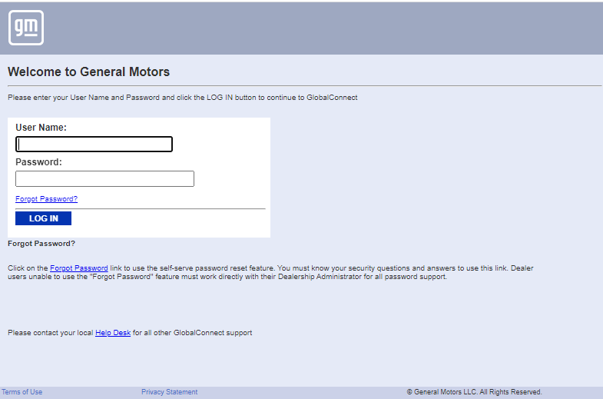
Home screen
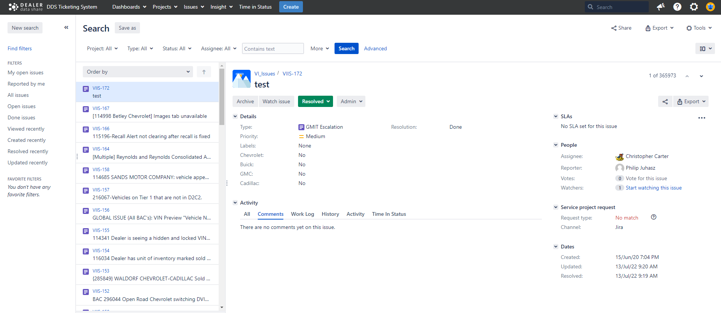
Log into the test environment using your GMID. Accounts are created and set up by business owner David Lazar. Once created, ask to be added to all projects and groups as administer. To visit the test UI, use https, host name, and port number. We access these directly.
Ex. https:// dcmitavjsd1000.epg.nam.gm.com:8443

Application server access using PUTTY
Before you can access servers using your GMID you must request access to all servers using a Galileo service request. I have Putty and WinSCP installed to help me with accessing and working on the server.
In WinSCP click new session.
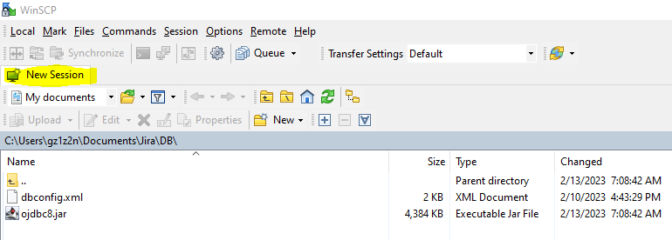

Set up connections like this. Click save, then either login down below or right click the connection and click open in putty.
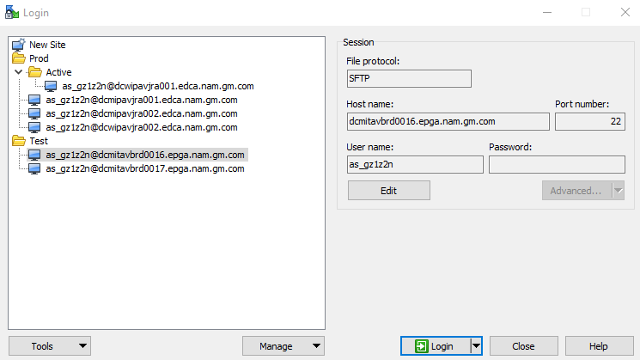

Open in Putty.
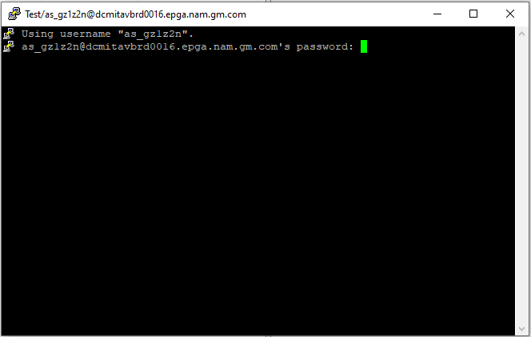
On success
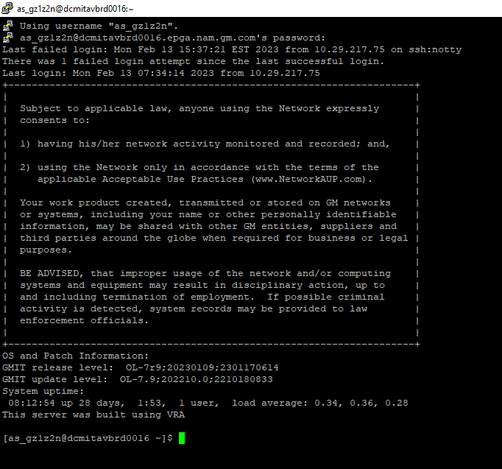
Sudo into jira application Unix user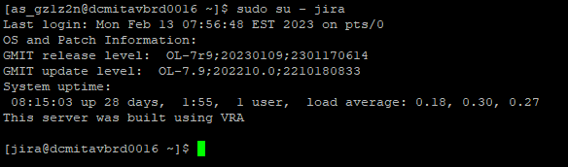
Now that you are sudo-ed into jira, you can manage all application files! You have successfully logged into the test server and sudo-ed into the jira application Unix account. Remember! You can only start and stop Jira if you are sudo-ed under this Unix account.

IMPORTANT APPLICATION DIRECTORIES

/opt – This is where all Jira related directories are held.
/opt/atlassian – This is where most of the configuration and operational files are held. This is where you will go to change logging levels, connection information, and to start and stop the application.
/opt/atlassian_jira_data – This is where most of the log files and backups are stored. There is a database configuration file here as well that needs to be modified after password rotation.
/opt/atlassian_jira_install – This will typically only be used during installations or upgrades. This is where the installation files exists and where you would run it.
/opt/atlassian/jira/bin – This contains most of the shell scripts you will want to run as the jira user. Contains start-jira.sh and stop-jira.sh.
/opt/atlassian_jira_data/tomcat-logs – This is where the Tomcat server logs can be found.
/opt/atlassian_jira_data/logs – This is where other logging information will be found.
/opt/atlassian/jira/logs – This is where the application logs will be found.
For the most part, you will be in those directories and mainly starting and stopping Jira. In one of the following sections, Upgrading Jira, the subsequent directories and files are very import.
/opt/atlassian/jira/atlassian-jira/WEB-INF/web.xml
/opt/atlassian/jira/conf/server.xml, logging.properties
/opt/atlassian/jira/bin/setenv.sh, catalina.sh
/opt/atlassian/jira/lib/ojdbc8.jar

Starting Jira

To start this section, we will start and stop the Jira application. Log into the server through Putty and get to this step, like we did before.

Once you have sudo-ed into jira, move to the bin directory.
Once inside the bin directory, either run ls -ltr to list directories, or start/stop jira. We will stop, then start since our server is already running.
In the bin directory run ./stop-jira.sh
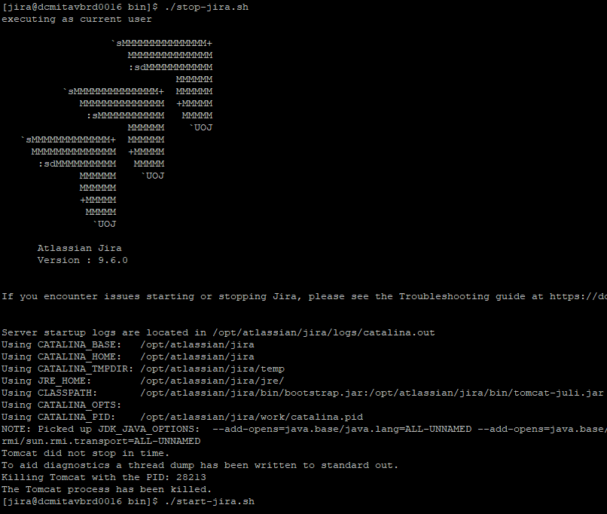

Start jira back up by running ./start-jira.sh
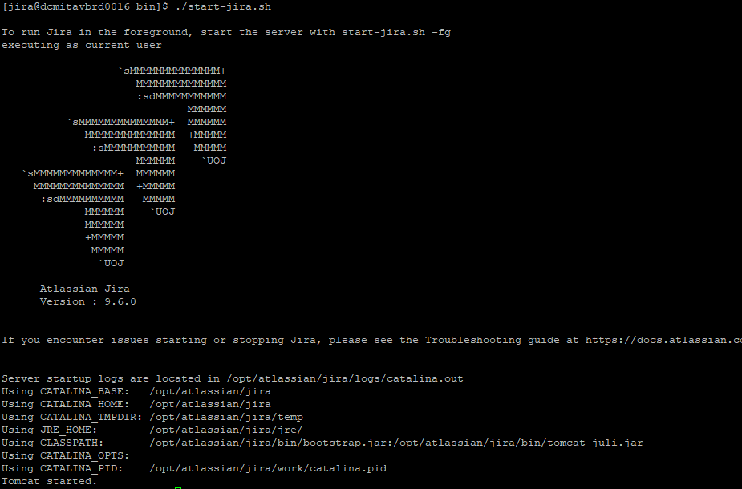
You have successfully started and stopped the Jira service desk application!
Visit the URL like we did for the test environment using https://hostname:portnumber
You should see the Jira load screen.
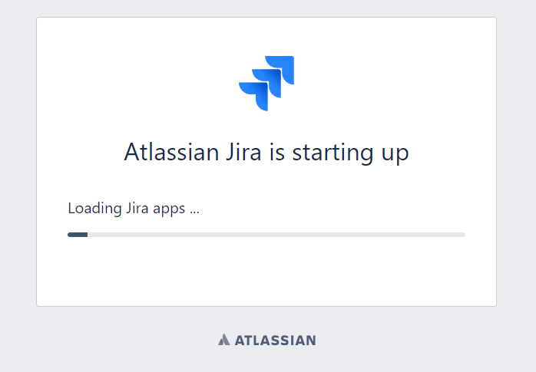

After this loads, it will take you straight to the home page if you’re in production, if you’re in the test environment you will be required to log in like follows.
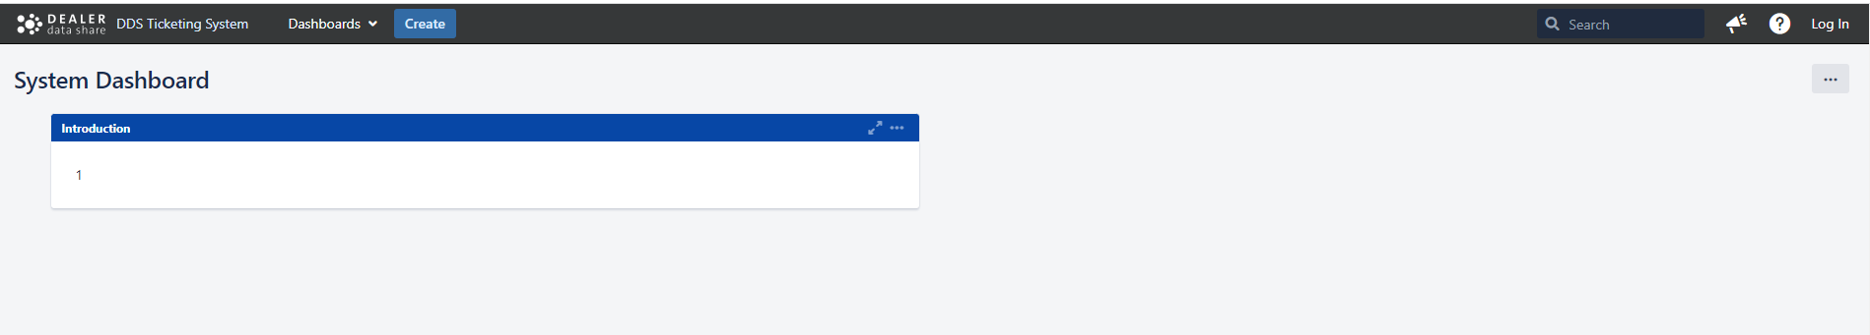

Click log in, in the top left corner, login, and you will see the home screen like we showed you in the beginning of the document or something like it depending on what you have access to like projects, issues, etc.
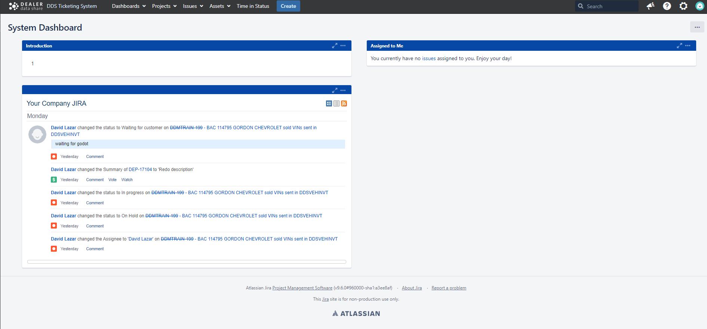
Congratulations, you started Jira, logged in, and verified that it’s working.

Upgrading or installing Jira
First, before we can run the Jira installer, you must request privileged access to the server. This can be done by submitting a Galileo service request for all servers that need work. Log into the server and sudo into root like we did with jira. For upgrades, back up the database before completing the installation.
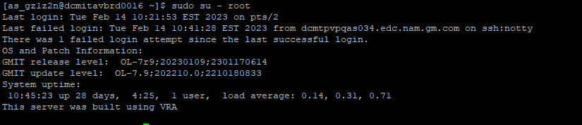
Move to the directory which holds the installer. It’s under /opt/atlassian_jira_install and run ls -ltr.
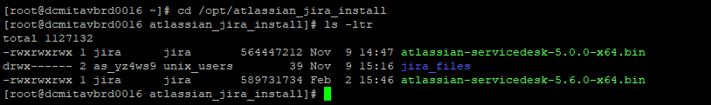
atlassian-servicedesk-5.6.0-x64.bin is the most recent installer and has already been installed. We will run through a reinstallation of the application so you see the process and the files stated earlier that would be important in subsequent sections.
Run the installation ./atlassian-servicedesk-5.6.0-x64.bin
A few things, we use option 3 because we have a current installation.
The current installation directory is in fact /opt/atlassian/jira. I wanted to double check when I ran the installer.
Next, we do NOT want to back up the Jira home directory. This will create a zip file or backup file inside the directory in which it exists, which eventually gets so big it crashes the installation. Next it checks for local modifications. This is where the important directories and files come into play.
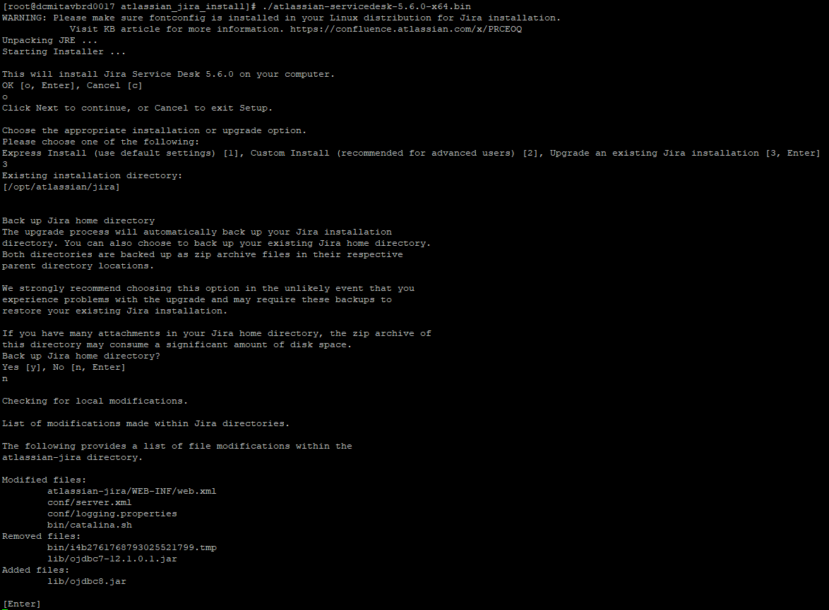
Under the modified files section are the configuration files that contain specific lines that we need for our Jira version to work correctly. BEFORE COMPLETING THE RUN, if you haven’t already backed-up these files, do so, because you will need to compare the backed-up files to the new files that the installation creates and add in certain lines that the old files had into the new files. I would just back them up initially before running the installation but in newer versions there may be new files, so running the installation halfway through, to see these modified files list is a good idea to see what you may have to compare. If you do this, REMEMBER to cancel the installation so you can back up the files! In this case, they are backed-up. So, we will continue! Press enter.
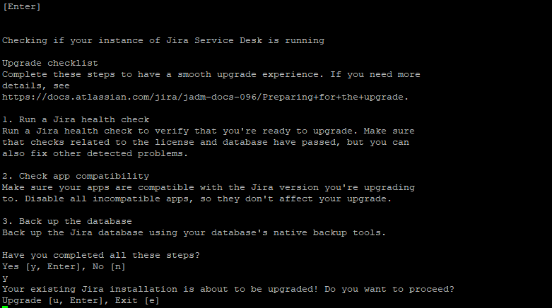
So, after we have backed-up the configuration files and the database, we can proceed with the installation. Press u. Follow the steps but at the last prompt to start Jira say no.
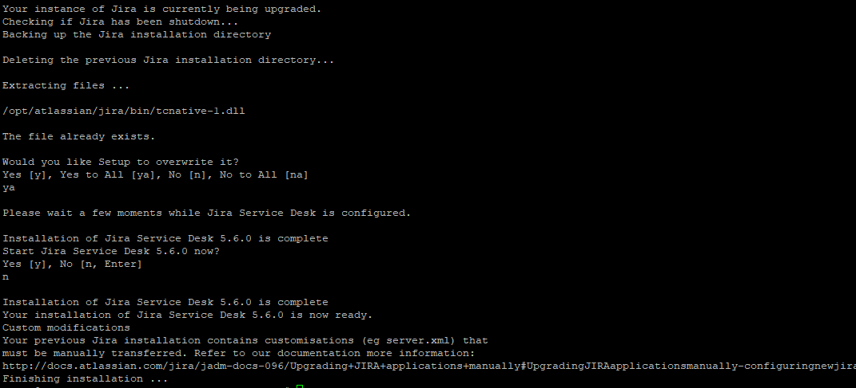
At this point, do not start Jira!!! There is more to be done. We need to manually add back the lines of text needed in those specified configuration files that we backed-up. After that, make sure that Jira is using the correct Oracle jdbc driver! This version can only work with ojdbc8 so we must have the jar in the correct location. Make sure you see ojdbc8.jar in /opt/atlassian/jira/lib. If not, download the driver and manually add it in there and remove any other similar driver.
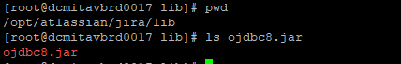
Once that is done, go to /opt/atlassian and make sure the jira directory is owned and grouped to the jira Unix user, recursively.
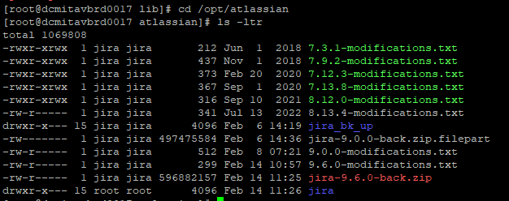
In this case it’s not, so run chown -R jira jira and chgrp -R jira jira.
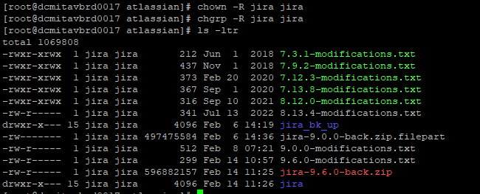
Now, exit root user and sudo into jira user like we did before and start the Jira application. This should be all that is required for the installation process, congratulations, you installed and started Jira!

Manually applied configuration changes.

These are the changes that you will most likely need to manually apply to the new configuration files after the installation has taken place. Starting from most significant.
server.xml
For the test environment, you may have an extra connector that may need to be added. Production only has one from my memory.
Path: /opt/atlassian/jira/conf
EX.
<Connector port="8443" protocol="org.apache.coyote.http11.Http11NioProtocol"
relaxedPathChars="[]|" relaxedQueryChars="[]|{}^&#x5c;&#x60;&quot;&lt;&gt;"
maxHttpHeaderSize="8192" SSLEnabled="true"
maxThreads="150" minSpareThreads="25"
enableLookups="false" disableUploadTimeout="true"
acceptCount="100" scheme="https" secure="true"
sslEnabledProtocols="TLSv1.2"
clientAuth="false" sslProtocol="TLSv1.2"
ciphers="HIGH:!aNULL:!eNULL:!EXPORT:!DES:!RC4:!MD5:!kRSA:!3DES:!DHE" useBodyEncodingForURI="true"
keyAlias="dive-support-test-vsp" keystoreFile="/opt/atlassian_jira_data/dive-support-test-vsp.jks"
keystorePass="Test#JIRA$0217" keystoreType="JKS" />

web.xml
This file is very big and only required adding a security-constraint tag at the end of the file. Place this right above the web-app closing tag.
Path: /opt/atlassian/jira/atlassian-jira/WEB-INF
Ex.
<security-constraint>
<web-resource-collection>
<web-resource-name>all-except-attachments</web-resource-name>
<url-pattern>*.jsp</url-pattern>
<url-pattern>*.jspa</url-pattern>
<url-pattern>/browse/*</url-pattern>
<url-pattern>/issues/*</url-pattern>
<url-pattern>/*</url-pattern>
</web-resource-collection>
<user-data-constraint>
<transport-guarantee>CONFIDENTIAL</transport-guarantee>
</user-data-constraint>
</security-constraint>

logging.properties
This file just sets absolute paths for our logs. The changes usually go from using ${catalina.base} to using an absolute path like /opt/atlassian_jira_data/tomcat-logs. You will have to change four lines. This path refers to our NAS or network attached storage.
Path: /opt/atlassian/jira/conf

1catalina.org.apache.juli.AsyncFileHandler.directory =/opt/atlassian_jira_data/tomcat-logs
2localhost.org.apache.juli.AsyncFileHandler.directory =/opt/atlassian_jira_data/tomcat-logs
3manager.org.apache.juli.AsyncFileHandler.directory =/opt/atlassian_jira_data/tomcat-logs
4host-manager.org.apache.juli.AsyncFileHandler.directory =/opt/atlassian_jira_data/tomcat-logs

catalina.sh
This file should only have one change on line 229. This is because we want to reference our NAS.
Path: /opt/atlassian/jira/bin
CATALINA_OUT=/opt/atlassian_jira_data/tomcat-logs/catalina.out

The setenv.sh file should not need a change. Previous documents referenced it but from my findings, there doesn’t seem to be a change there. This goes for check-java.sh as well. If there are any issues refer to older configurations or previous owners.

Monthly security patching

Every month, middleware teams run processes to patch our servers. Here is a link for all the detail.
https://share.gm.com/sites/hdsrelease/MPSPatchWindows/SitePages/Monthly%20Security%20Patching.aspx
You can export excels and view activity on your servers whether that’s completed or current. For some reason, after patching, our servers do not automatically restart. So, each month, we must restart our production server after patching completes. The business will start using the application by 7am, 8am EST, somewhere around that time. So, restart Jira using start-jira.sh and make sure the application comes up. That is all that is required, just monitor your emails and ask business if things are working as usually. For the test environment a restart or reinstallation may be required.

Password rotation

Jira has been onboarded to LEO self-service automation. Here, you can onboard applications and perform other application administration and maintenance tasks like rotating passwords.
https://leo-sso.cpi.gm.com/app-home-ui/
Rotating passwords is easy once you follow the steps after selecting your application and environment. More notes will be added for that later. The important part is, is that when you do rotate you will have to modify a database configuration file and add the new password for the mail server connection, done through the UI.
Database configuration file
/opt/atlassian_jira_data/dbconfig.xml
dbconfig.xml – use vi editor to replace the old password with the new.

Mail server connection
Log into the UI and click the gear icon in the top right corner then click system.
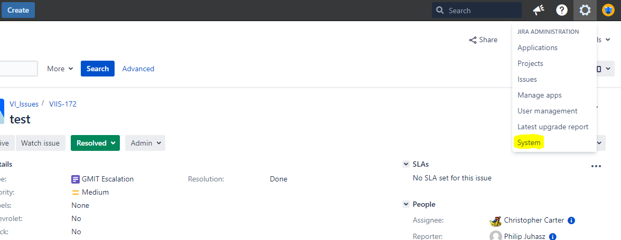
In the next page, in the highlighted rectangle, scroll down to outgoing mail.
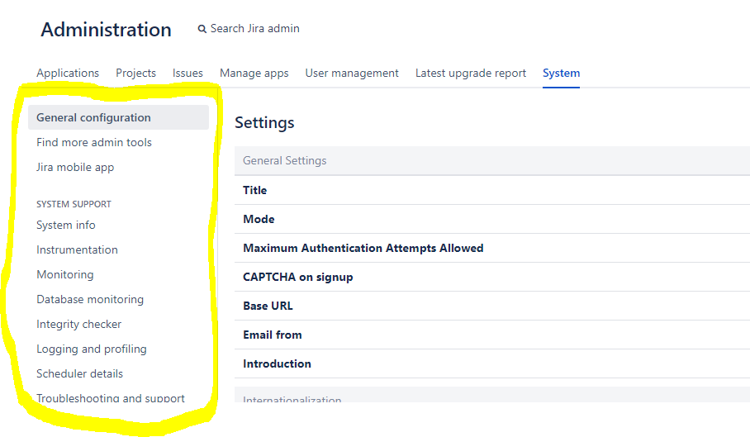

Click outgoing mail, once there click edit so you can modify the connection.
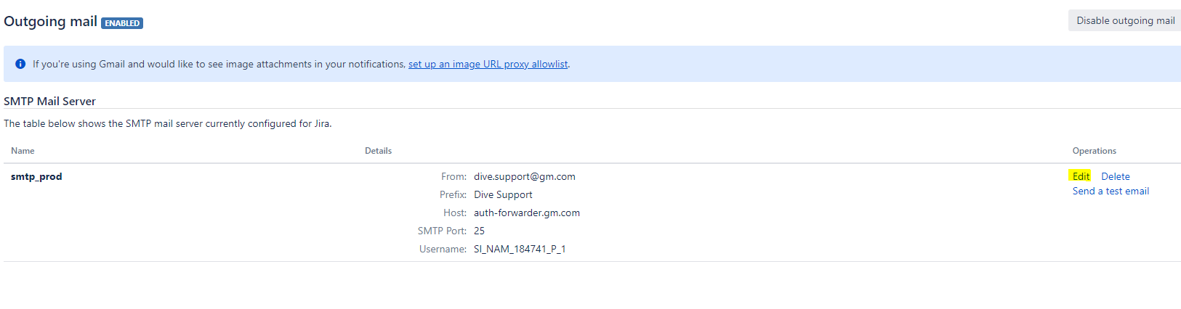
On the next page, check Change Password, add the new password in the next text box and test the connection. If the connection is successful, then this step is completed and you have successfully rotated the applications passwords.
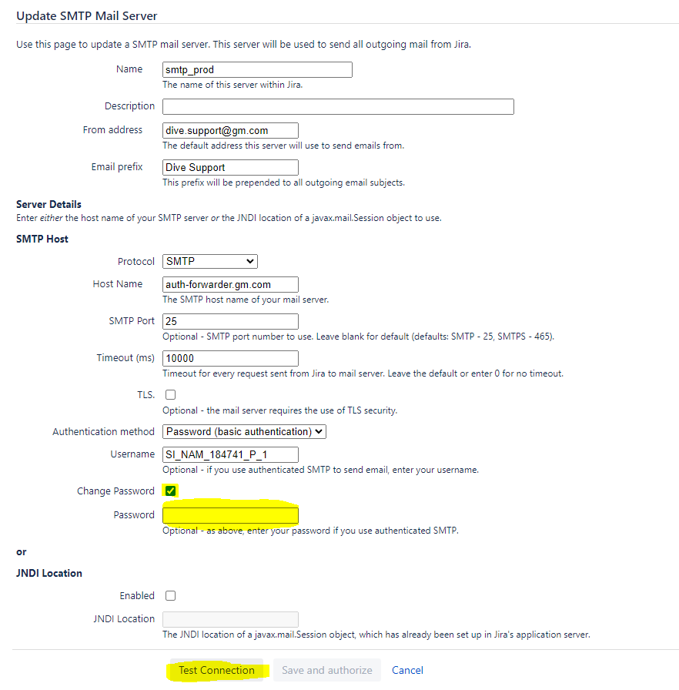
Bypass SAML authentication using AUTH fallback

If you have found yourself locked out from Jira due to disabling the product login form when testing alternate login option mechanisms, then you can configure Jira to allow bypassing SAML authentication. You can query Jira using a special auth_fallback parameter. This can be done using the CURL or by updating a record in the database.
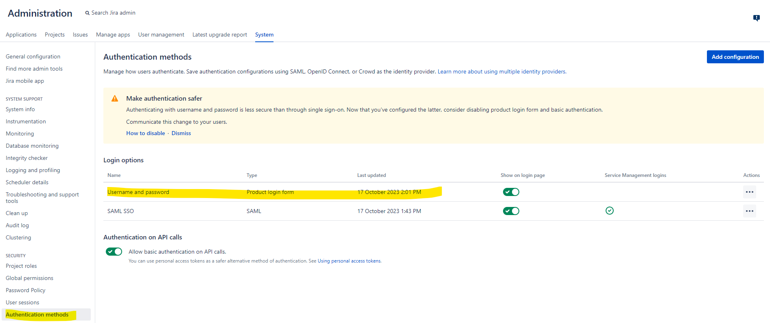
If you know the admin user credentials, then you can use the following CURL command. Update the admin user and it will prompt you for the password.
curl -vvv -k -L -u adminUser -X PATCH https://yourHostName.epga.nam.gm.com:8443/rest/authconfig/1.0/sso \
-H 'Content-Type: application/json'\
-d '{"enable-authentication-fallback": true}'

Or use this database query to get the propertyentry.id
select propertyentry.id from propertyentry join propertystring on propertyentry.id=propertystring.id where property_key like 'com.atlassian.plugins.authentication.sso.config.enable-authentication-fallback';
Then update the propertystring table using the id you retrieved from the last query.
update propertystring set propertyvalue = 'true' where id= '';

This should enable authorization fallback which is accessible through this URL.
https://yourHostName.epga.nam.gm.com:8443/login.jsp?auth_fallback

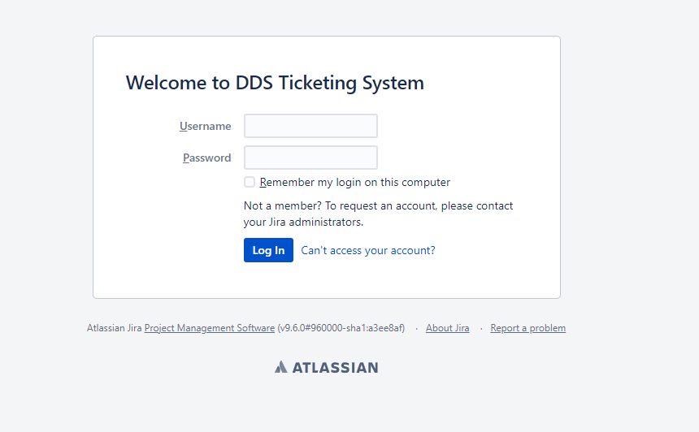

Atlassian support

We have support from Atlassian representatives. https://support.atlassian.com/contact/#/. You can open a support ticket and a representative will reply within one to two days. They will often ask for a support zip. Support zips can be created from inside the application or through the UI.
To create a support zip
log into https://dive-support.autopartners.net/ with an administrator account.
Once in, press the G key twice, this will bring up a search box. Search “Troubleshooting and support tools”. From there you can select the “Create support zip” tab. You’ll be able to download the support zip through your browser.
Opening a support ticket.

Once you’ve visited the support link above you will see this.
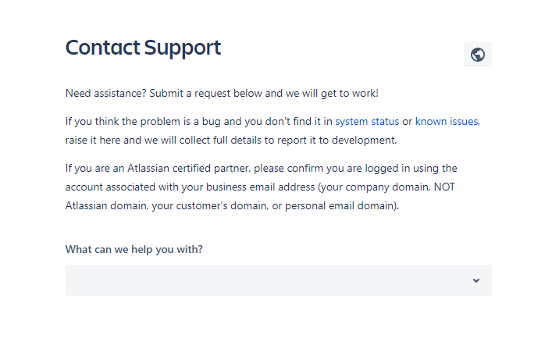
Click the drop down and select technical issues or bugs.
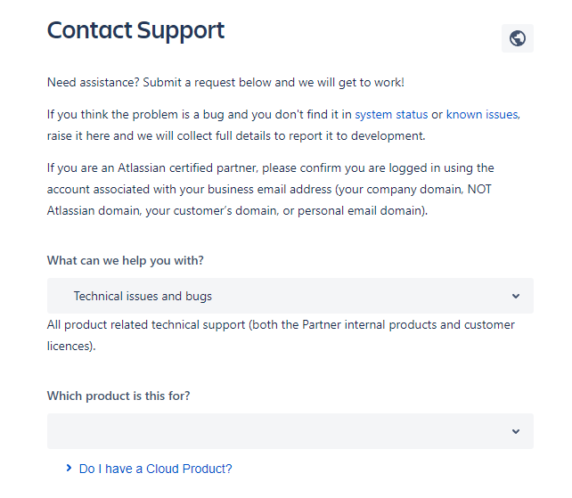
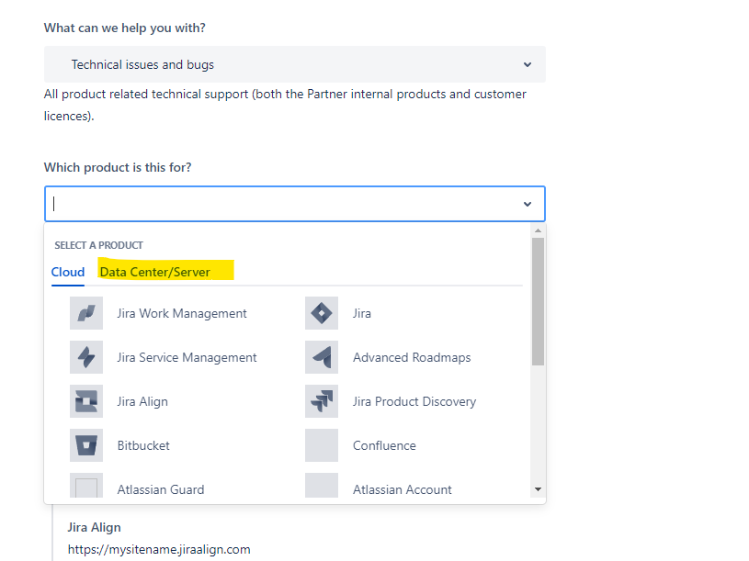
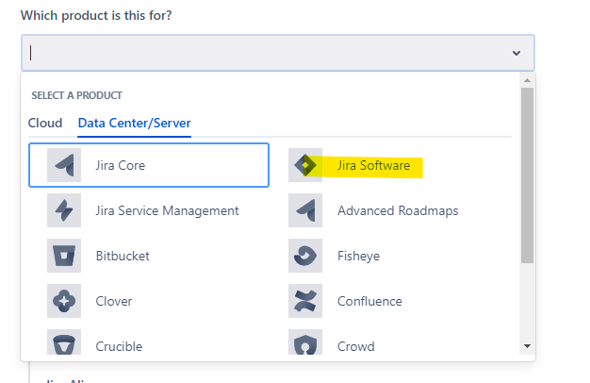
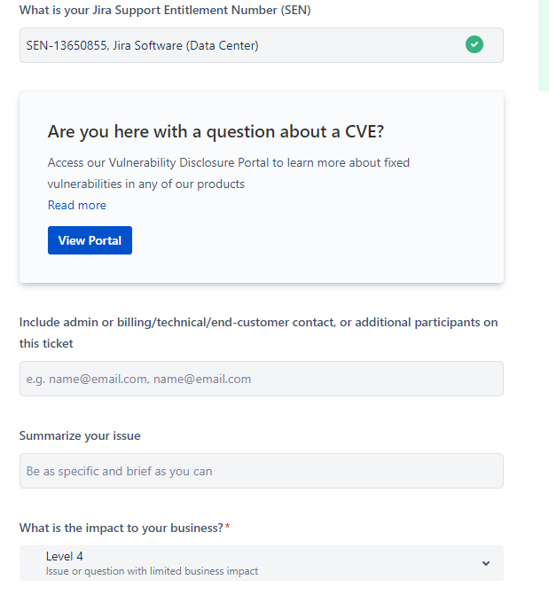
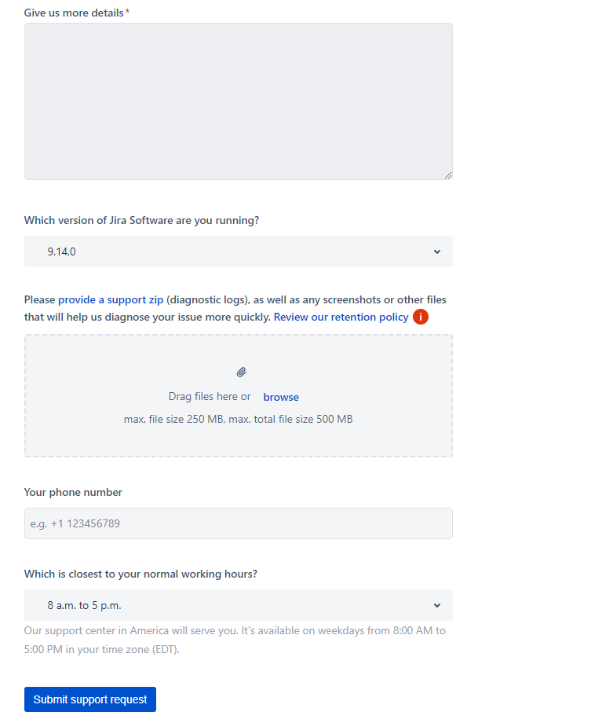

Server certificate renewal
KeyStore password: Test#JIRA$0217
KeyStore path: /opt/atlassian_jira_data/dive-support-test-vsp.jks
Key alias: dive-support-test-vsp-184741

In Galileo search for this request.
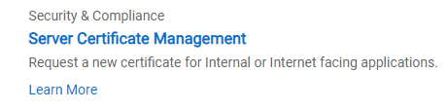
Enter application information.
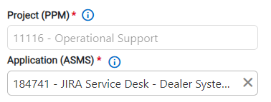
Click next and select no for having a CSR(Certificate signing request) and External for CA (Certificate Authority) then enter in load balancer domain for Common Name and the backend servers for SANs.
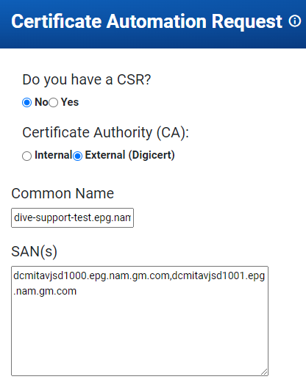
Click next and on the next screen submit the request. This is automated so it will provision a certificate immediately.
Find your submitted request and download the java keystore file which contains the certificates.
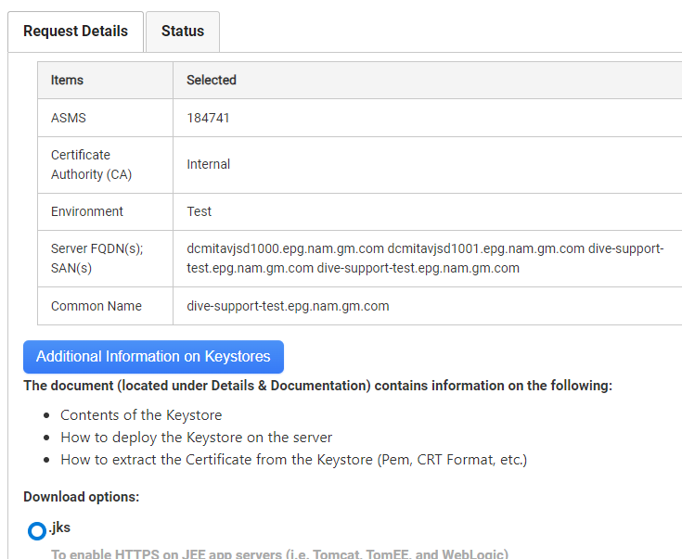
Download the keystore and the keystore credentials on the bottom of the page.

Example key store credentials
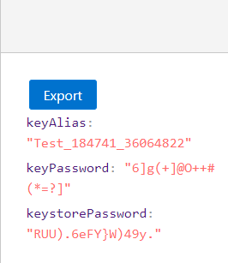
Example JKS in your file explorer
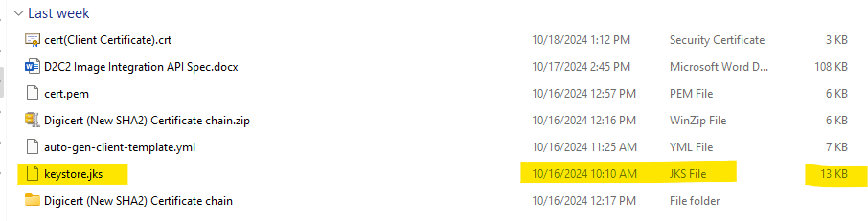
Now move that keystore.jks to the server and this path for our case. /opt/atlassian_jira_data
You will now use the java keytool to manipulate the JKS file. This can be done using any java jre that has keytool. On our server it’s located here.
/opt/openjdk/jdk11.0.24/bin
Or
/opt/atlassian/jira/jre/bin
List key store contents using this command.
/opt/openjdk/jdk11.0.24/bin/keytool -v -list -keystore yourJavaKeyStore.jks
Verify the contents but the contents should be fine. Note down the Alias, this will be used in the server.xml as well as the path to the keystore.
Next, make sure the key password is the same as the keystore password! This is important for our instance! Run this command and follow the prompts to change the key password to the keystore password. They must be the same!
/opt/openjdk/jdk11.0.24/bin/keytool -keypasswd -alias your-certs-alias -keystore yourJavaKeyStore.jks
Once that is done go to the server.xml file for the jira instance. It’s located here.
/opt/atlassian/jira/conf
Use vi editor to edit the server.xml to reference the alias, keystore password, and keystore path!
Search for this connector and update.
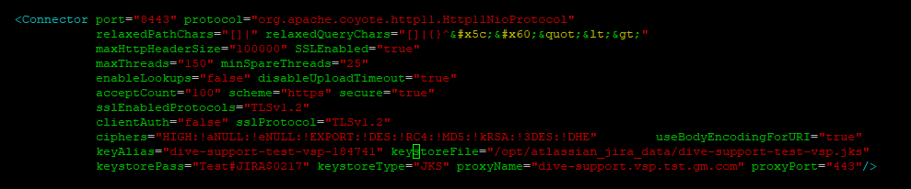
Once that is done, restart the server and your certificate should be renewed!!!!

Document History

Written and finished by Christian E. GMID gz1z2n 2/24/2023
Update by Christian E. GMID gz1z2n 10/18/2024
Update by Christian E. GMID gz1z2n 10/22/2024

