**document with screenshots of your implementation and results**

As we have run the test multiple times. reading is noted in excel sheet with calculations and graphs please check for excel document for all the results.

In these document, we just gave 1 screenshot of each test benchmark.

1. TestDfsio

Read

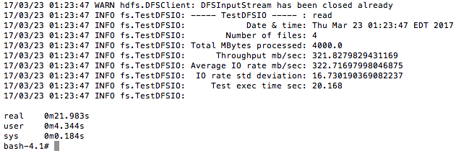

Write

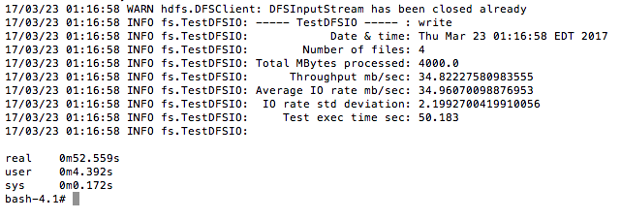

1. MR BenchMarck

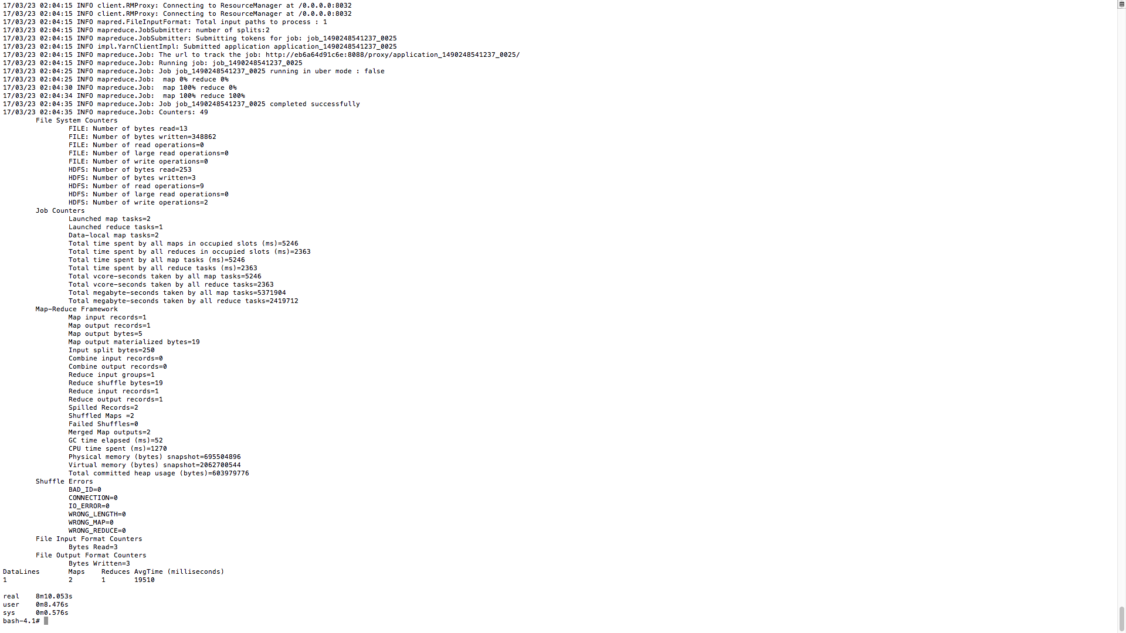

1. TeraGen

/Users/balajisai/Desktop/Images Of tests/TeraSort/TeraSort.JPG

1. NN BenchMarck

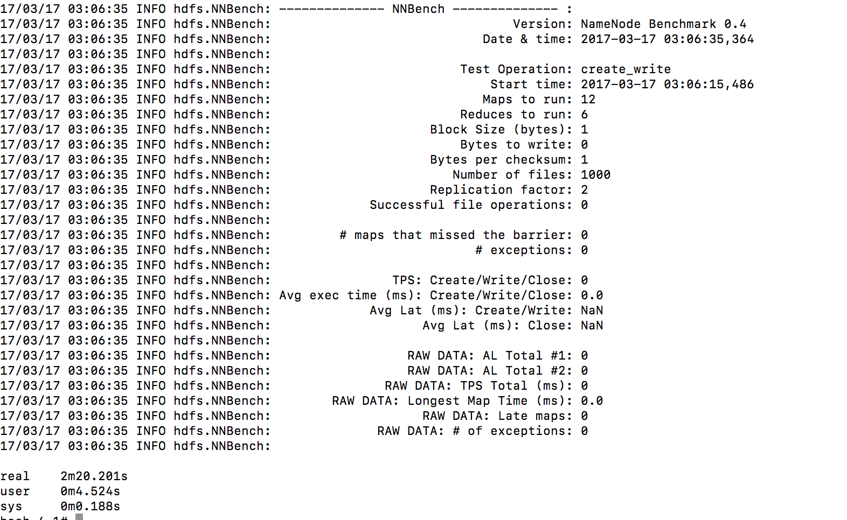

1. WordCount

