**JsonPowerDB**

**“Basic project about the JsonPowerDB and CRUD operations.”**

**What is JsonPowerDB?**

JsonPowerDB is a Real-time, High Performance, Lightweight and Simple to Use, Rest API based Multi-mode DBMS. JsonPowerDB has ready to use API for Json document DB, RDBMS, Key-value DB, GeoSpatial DB and Time Series DB functionality. JPDB supports and advocates for true server less and pluggable API development.

**Benefits of using JsonPowerDB**

* Simplest way to retrieve data in a JSON format.
* Schema-free, Simple to use, Nimble and In-Memory database.
* It is built on top of one of the fastest and real-time data indexing engine - PowerIndex.
* It is low level (raw) form of data and is also human readable.
* It helps developers in faster coding, in-turn reduces development cost.

**JsonPowerDB-Features**

* Nimble, simple to use, in memory, Real-time.
* **Schema free**- easy to maintain.
* **Serverless Support**- fast development – cuts time to market.
* **Multi-Mode database** – one solution to variety of data
* Multiple security layers.
* **Server Side** Native **NoSQL**- best performance.
* A single instance- **Million Indexes**.

Documentation to access all the functions of JsonPowerDB

<http://login2explore.com/jpdb/docs.html>

**Implementation** of **PUT**, **GET**, **UPDATE**, **REMOVE** in Talent API Tester

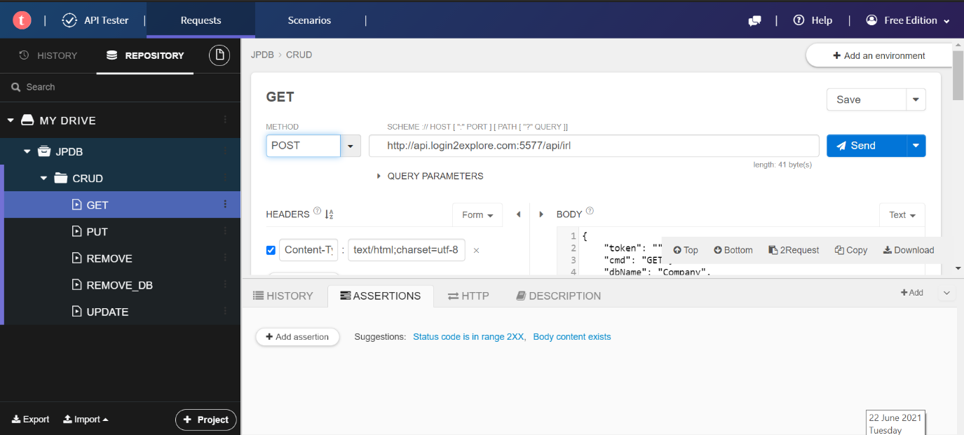

Creating a Small project to get the user input for Employee id, Employee name and email address and PUT data in JsonPowerDB.

