HW3：Project X

16340198 孙肖冉

A secret project by the government (let's call it Project X) will be executed by one person and consists of 6 tasks: A, B, C, D, E, and F. Figure 2.28 specifies the order in which the tasks need to be executed (precedence graph, cf. PERT/CPM). A possible execution trace is for example ABDCEF.

(a) Model the project in terms of a classical Petri net.

(b) How does one model so that E is optional?

(c) How does one model so that D and E should be executed consecutively, that is, B and C are not allowed between D and E?



（a）petri net：

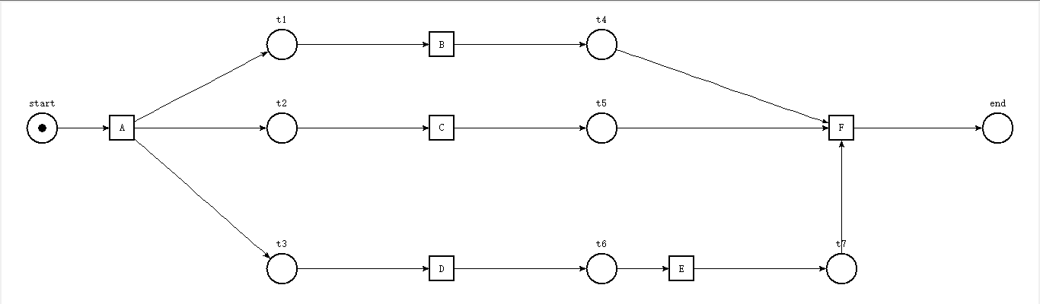

（b）增添了一个E’作为可供选择项（图中红框部分）

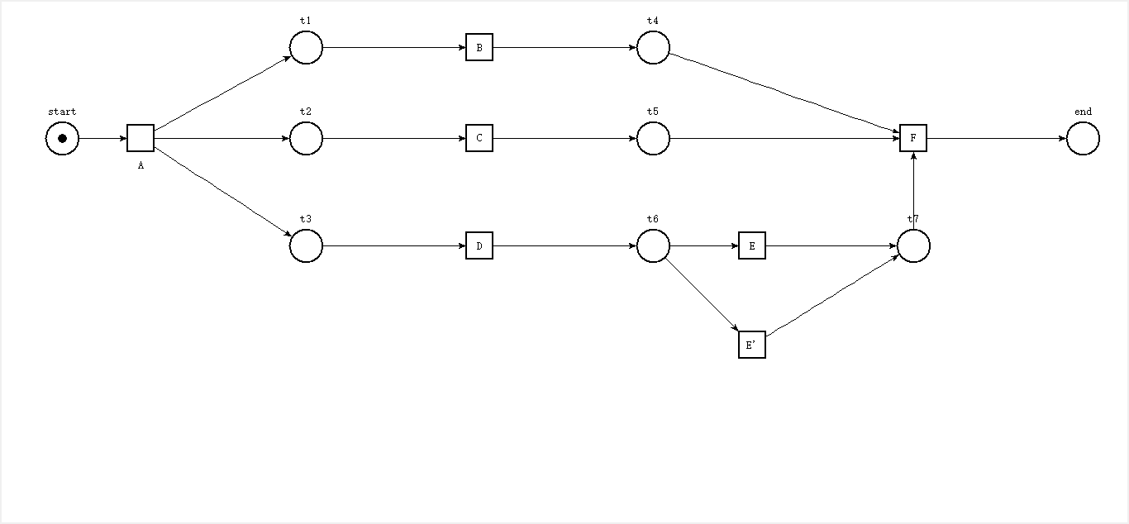

（c）由题意可得在更改后的项目中，DE需要连续执行，即在本项目中事件发生的顺序有以下几种可能：① ABCDEF ② ACBDEF ③ ABDECF ④ ACDEBF ⑤ ADEBCF ⑥ADECBF

在原项目中增添了t8（图中红框部分），修改之后的petri net 如下：

