White-box Testing

Control Flow Coverage
Statement coverage
Cover every executable statements, also called line coverage.
Basic block coverage
Cover every basic block.
Branch coverage
Cover all feasible edges coming out of the decision coverage.
Loop coverage
Concern the repetition count of the loop body execution. Must include the following 5 situations.
- bypass the loop
- Enter the loop once
- Enter the loop more than once
- Enter the loop max-1 times
- Enter the loop max times
All path coverage
Cover every feasible path in CFG.
Basis path coverage
Test the basis path set only instead of all possible paths, since the other paths can be constructed as their linear combination.

Logic Coverage
Decision coverage(Branch coverage)
Condition coverage
Concerns the coverage of each condition taking both true and false.(Question: what is condition?)
Short-circuiting condition coverage
Same with condition coverage, except it requires each condition being actually evaluated to true and false.
It subsumes to decision coverage.
Condition/decision coverage
Simply condition coverage + decision coverage
- For each condition, the test suite covers both true and false.
- For the whole decision, the test suite covers both and false.
Multiple-condition coverage
Cover all possible combinations of conditions.
Modified condition/decision coverage(MC/DC)
Requires that for each condition, both its evaluation true and false are shown to determine the outcome of the decision.
For each condition C, select two test cases such that the truth values of all the conditions, except for C, are the same, and the decision outcome evaluates to be true for one and false for the other.

Data Flow Coverage
Data flow
Occurs from where a variable is defined to where it is used, without any intervening re-definitions.
Definition
A value is written into a variable.
Use
The value of a variable is read.
- Computation use(c-use): the value of the variable directly affects a computation or is part of an output.
- Predicate use(p-use): the value of the variable directly affects a control flow (and may indirectly affect a computation).
Undefinition
A variable is not longer accessible.
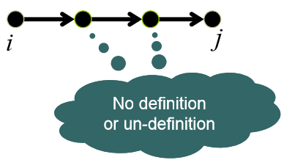
Def-clear path
A definition clear path with respect to x (def-clear path wrt x) is a path (i, n₁, n₂,...,n_{m}, j) where m≥0, containing no def(x) or un-def(x) in n₁, n₂,...,n_{m}.
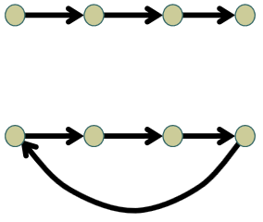
Simple path
A simple path is one in which all nodes, except possibly the first and the last, are distinct.
Loop free path
A simple path in which all nodes are distinct.
Du-path
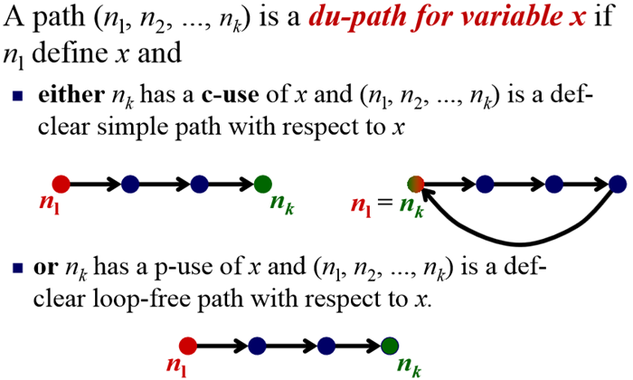
Data flow coverage
- All-defs coverage: requires the test suite covers at least one du-path that starts at i (all nodes with definition of x).
- All-uses coverage: for each node i in the CFG that contains a definition to variable x,all-uses coverage requires that for every use of x in the CFG, the test suite covers at least one feasible du-path of x that starts from i and ends at that use of x.
- All-du-paths coverage: for each node i in the CFG that contains a definition to variable x, the all-du-paths coverage requires that for every use of x in the CFG, the test suite covers all feasible du-path of x that starts from i and ends at that use of x.
- And a lot more methods in data flow coverage.

Interface Coverage
Function/Call coverage
Function coverage: cover every function at least once.
Call coverage: cover every call-site(edge in the call graph) at least once.
Inter-procedural data flow coverage
Object-oriented coverage

Mutant Coverage
Mutant
A program with seeded fault.
Mutation coverage
D/N
D=number of killed mutants
N=total number of mutants
Mutation testing
Use mutant coverage as the test adequacy criteria to design the test suite.

Black-box Testing

Level-1 Single input parameter
Equivalence class partitioning
Partition the input domain of the parameter into equivalence classes.
Adequacy criterion: cover each partition at least once.
Boundary value analysis
Analyze the boundary cases for each equivalence class in ECP.
Adequacy criterion: cover each boundary case at least once.
Cause-effect graph and decision table
Analyze the causal relation between input and output as edges.
Adequacy criterion: cover each edge at least once.

Level-2 Combination of input parameters
Combinatorial Coverage
Adequacy: cover each t-way interaction at least once.
Constrained Combinatorial Coverage
Adequacy criterion: combinatorial coverage subject to additional constraints between parameters.

Level-3 Sequence of combination of input parameters
Event-based Coverage
Step1: enumerate all windows of the program and build the window hierarchy.
Step2: for each window, identify the events that can occur and describe them with operators.
Step3: design test cases to cover representative events.
Step4: identify the ‘follow’ relationship between events and build the event flow graph.
Step5: design test cases to cover intra-window event interactions.
Step6: design test cases to cover inter-window event interactions.
State-based Coverage

