Test record: The required conditions, expected results, observed results, evidence, and revisions.

- Responsive: Test at 320, 768, and 1280 CSS-pixel viewport widths.
  - To test the responsiveness, I opened the site in Fire Fox Browser. When setting responsive view to 320, I expected the navigation and cards to stack, all elements scale down, and there to be no overflow. I observed that the viewport met all expectations. No revision was necessary. 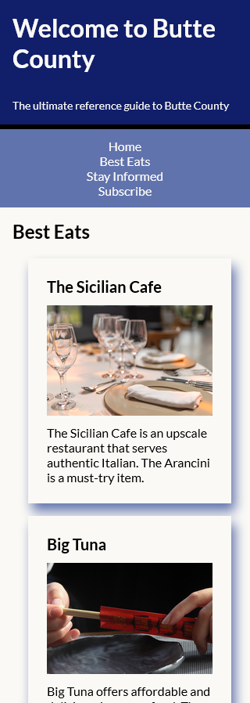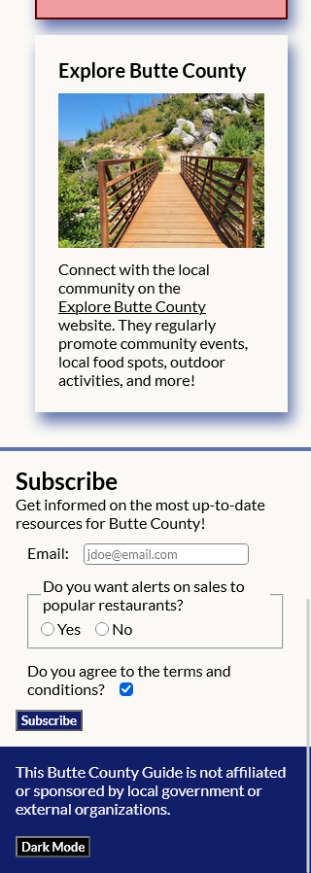
  - To test the responsiveness, I opened the site in Fire Fox Browser. When setting responsive view to 768, I expected the navigation to move horizontally in a row, cards to auto-fit when space was available to be moved on the same row, all elements scale up to fit the viewport, and there to be no overflow. I observed that the viewport met all expectations. No revision was necessary.
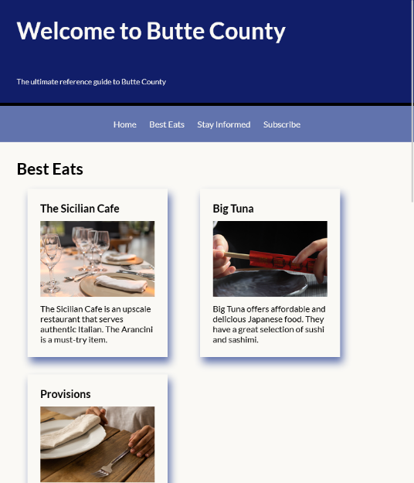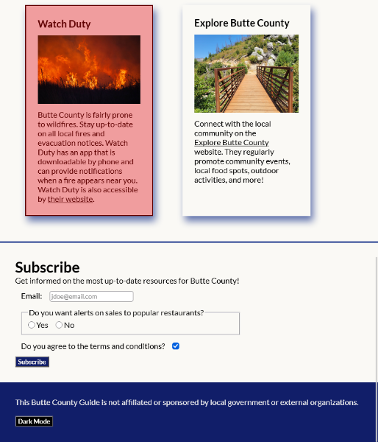
  - To test the responsiveness, I opened the site in Fire Fox Browser. When setting responsive view to 1280, I expected the navigation to remain centered in a row, cards to all be horizontal in the same row, all elements scale up to fit the viewport, and there to be no overflow. I observed that the viewport met all expectations. No revision was necessary.
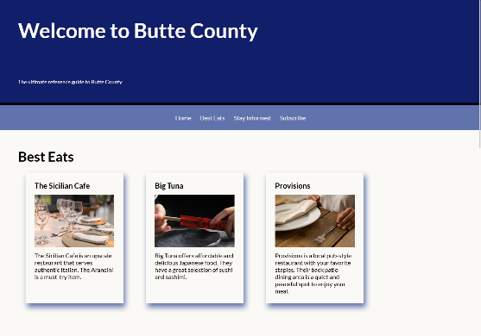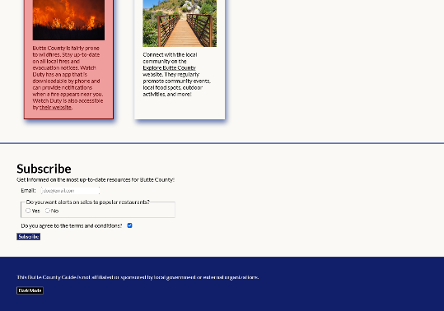
- Zoom: Test the page at 200% browser zoom.
  - To test how the website responds to users zooming on the website, I opened the site in the Fire Fox browser and zoomed on the website 200% (the proof of zoom can be seen circled in red in the top-right). I expect the text to be clear and legible. The text remains legible and precise. The viewport also put the cards in a stack so the user could view and scroll easier. The test succeeded and needed no revision.
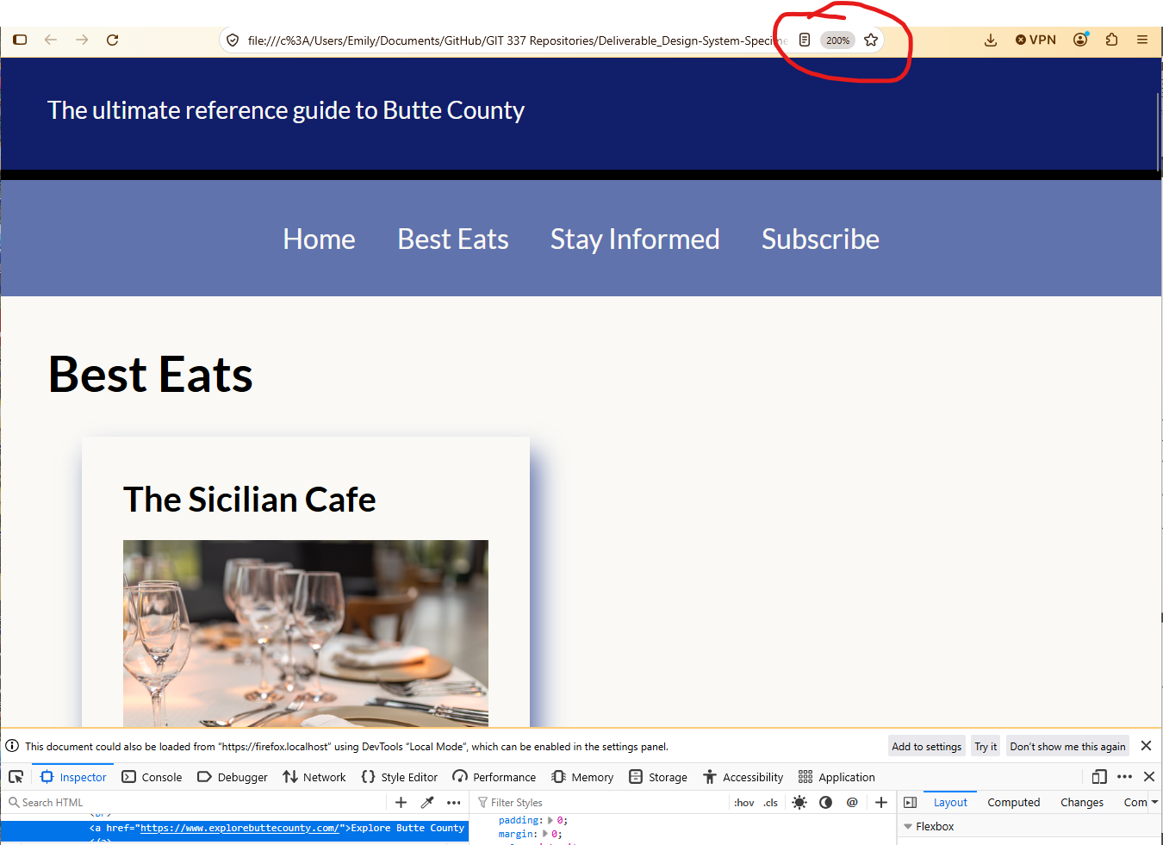
- Keyboard: Navigate through every link, button, and control without using a mouse.
  - To test keyboard navigation, I opened Fire Fox browser and hit tab. I expected the website have a light green visual focus indicator outline each actionable element, with the exception of bright red being used on the alternate themed card. I also expect when hitting enter, the action will occur (like hitting the subscribe button and being sent to the subscribe section). The test was successful and met all expectations no revisions were needed. The form is operating properly, accepting inputs, and links are all functional. Dark mode switches when entering on the button. ( I drew a red arrow on the screenshots to the indicator so its faster to find.)
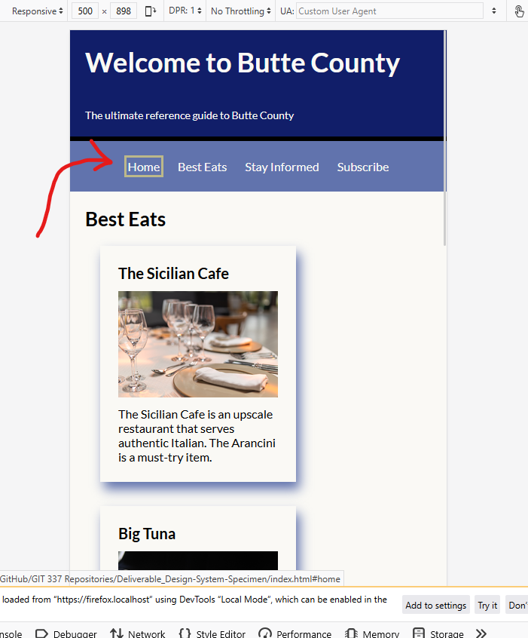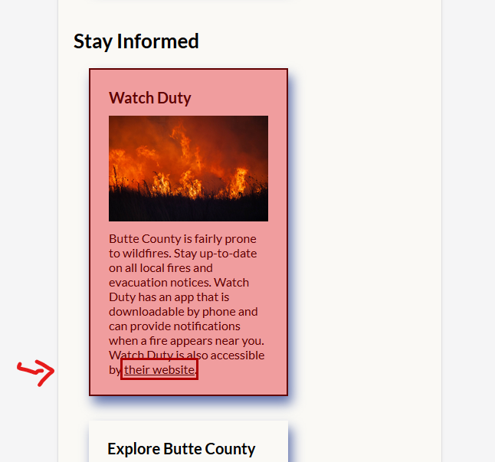
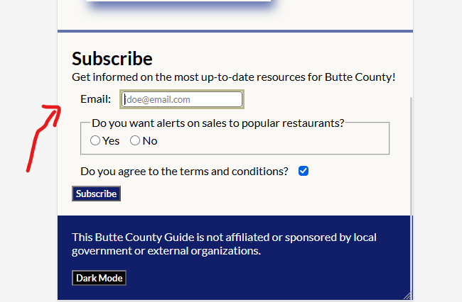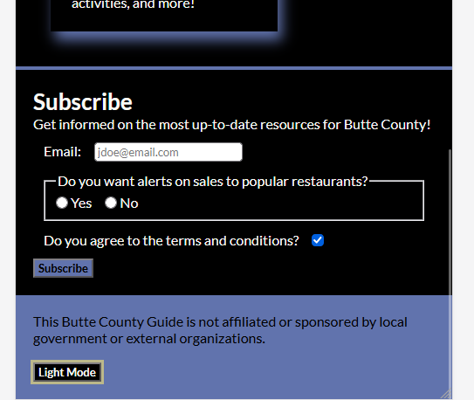
- Contrast: Check essential text, actions, focus indicators, and controls in both themes.
  - To test essential text, I removed the images folder from the asset file. I expected the alt-text to appear in its place. I observed the alt-text appear and maintain consistent formatting.
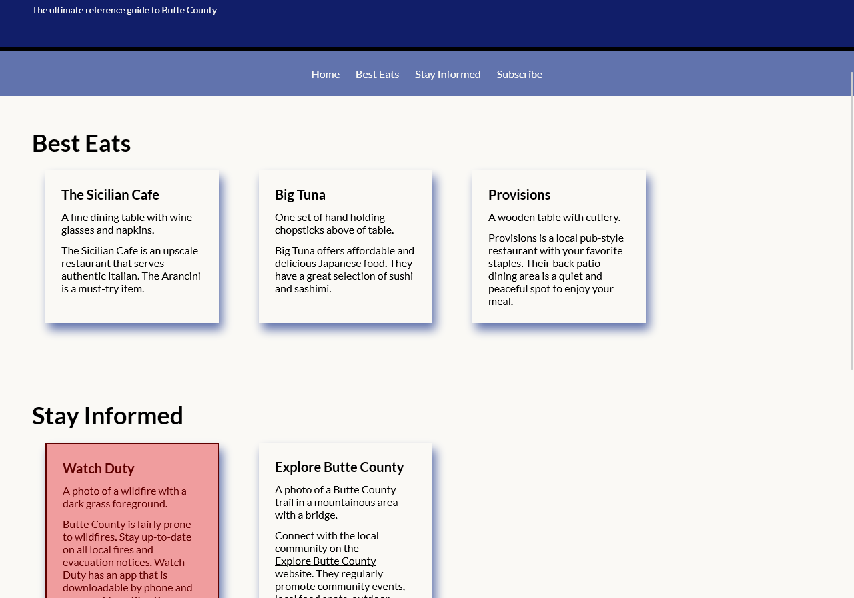
  - To test the actions, I opened the site in the Fire Fox browser and clicked through all of them to ensure proper functionality. Additionally, I entered information into the form to ensure it took required values and reset on hitting the subscribe button. I expected all links to function, the form to require a valid formatted email, radio buttons to be switchable, checkbox checkable, and the subscribe button to reset the form. I observed all links work properly, the subscribe form requires an email to be subscribed, buttons and checkbox work, and hitting subscribe resets the form. The focus indicator was tested with the keyboard test and screenshots and code defense can be found 1 bullet up.
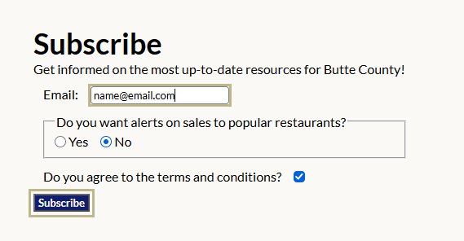
  - To test the controls in both themes, opened the site in the browser and clicked on dark mode and checked all links, hovering, form elements, and keyboard controls to ensure consistent functioning. I expected each function to work properly just as it did in the above tests. The tests turned out the same as the links were functional, form worked the same as it did in light mode, and keyboard controls were operational. No revisions necessary.
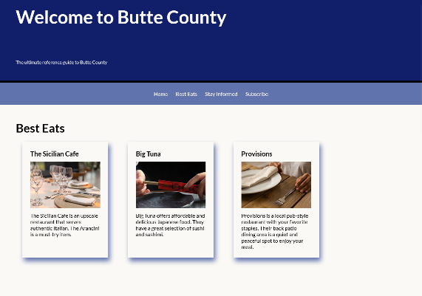 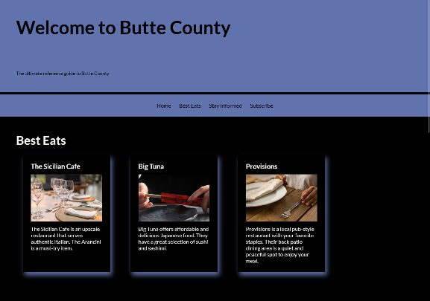
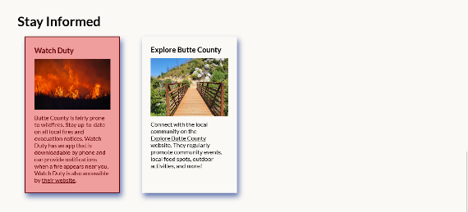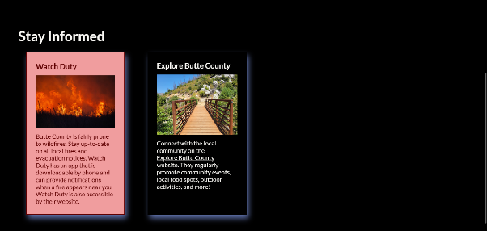

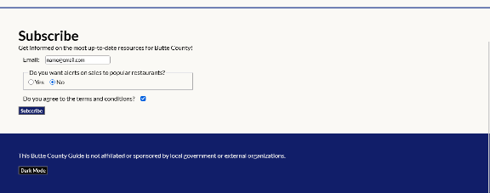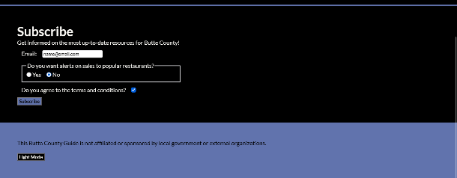

- Font fallback: Block, rename, or temporarily remove the preferred font and record what changes.
  - To test the fonts, I blocked the font face at-rule in the CSS file. I expected the lines to remain consistent and the Fallback font (arial) to activate. The first image below is the fallback and the second image is the preferred font. I observed all text sections and they all have the same number of lines per text element. There is no oddities and the site is legible. No revision is necessary.
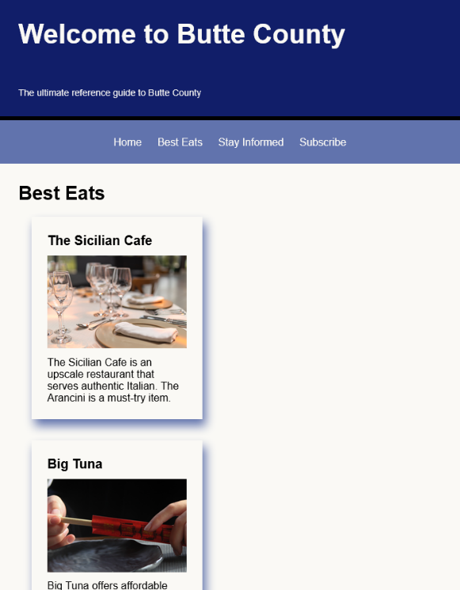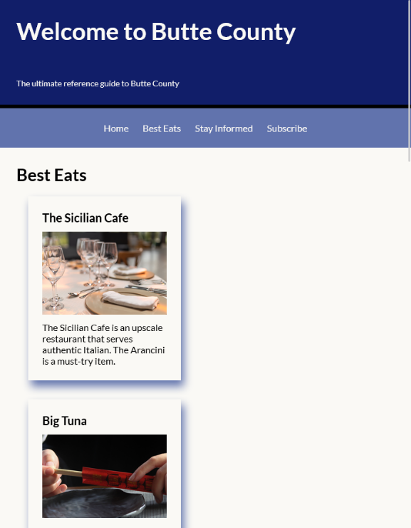
- Validation: Validate the final HTML and CSS and resolve errors caused by your code.
  - To test the code validity, I ran the HTML and CSS through the W3C validation service. I expect all of the code to return with no errors. The CSS came back with no error. However, there were 3 errors found in the HTML.
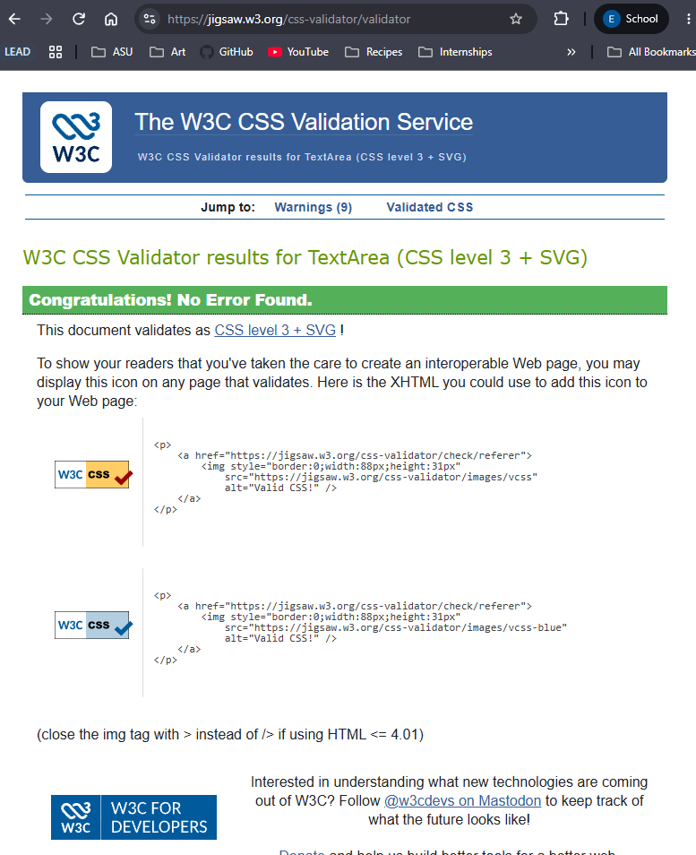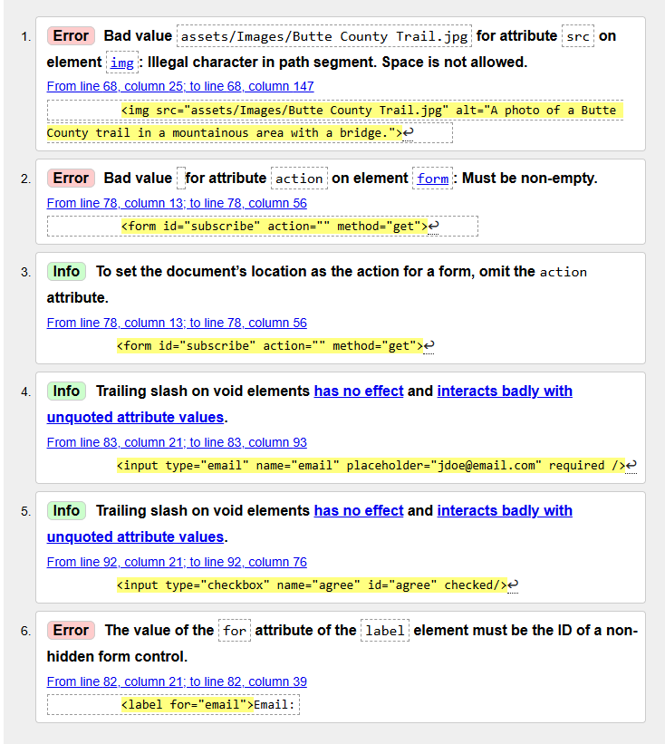
  - Revision 1: Bad value assets/Images/Butte County Trail.jpg for attribute src on element img (on line 68): Illegal character in path segment. Space is not allowed.
    - To fix this issue, I renamed the image with hyphens where the spaces were and updated the source URL in the image element. To test that the image was still functioning properly, I saved the HTML document and reloaded the browser. The image was still present, so the test passed.
  - Revision 2: Bad value for attribute action on element form (on line 78): Must be non-empty.
    - To fix this error, I removed the action attribute entirely.
  - Revision 3: The value of the for attribute of the label element must be the ID of a non-hidden form control (on line 82). After reviewing the code, I understood that the label has the for attribute to connect to the input via the inputs id. This is similar to how a primary key and foreign key work between separate tables in a database schema. I verified this by referring to MDN’s page <label> under the subsection “Associating a label with a form control”, that the “first element in the document with an ID attribute matching the value of the for attribute is the labeled control .” This confirmed my understanding as the label was the first one in the form. To solve this issue, I set its following input ID to email matching the label. To test this, I put the html code back in the HTML validator and got confirmation that the code is valid.
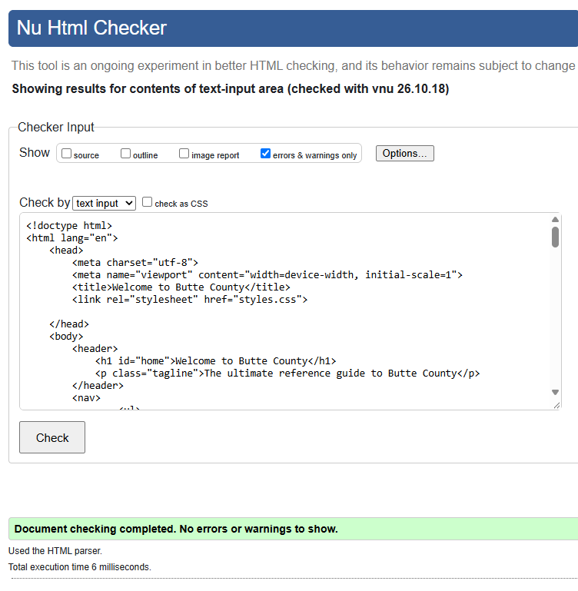
- Publication: Open the published URL in a private or signed-out browser window and verify that styles, fonts, media, links, and controls load correctly.
  - I created the page for the website on GitHub and this time opened it in Google Chrome to test both the published URL and a comparable browser. I expected the test results with the published URL to be consistent with testing in Fire Fox prior to publishing the page. The first test was to ensure fonts loaded and responsive layout worked efficiently. I tested the layout sizes 320, 720, and 1280. Results were consistent with previous tests. The fonts loaded and the layout was responsive. No revisions were needed.
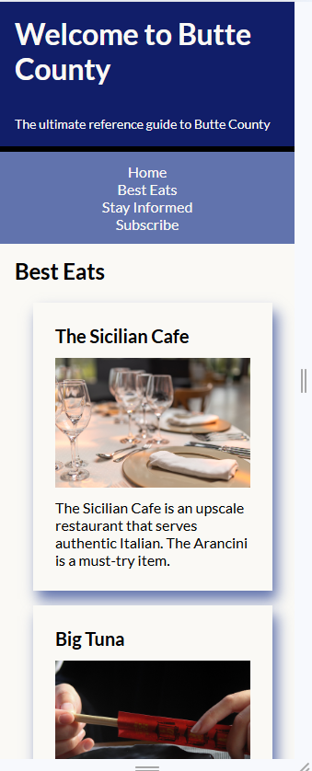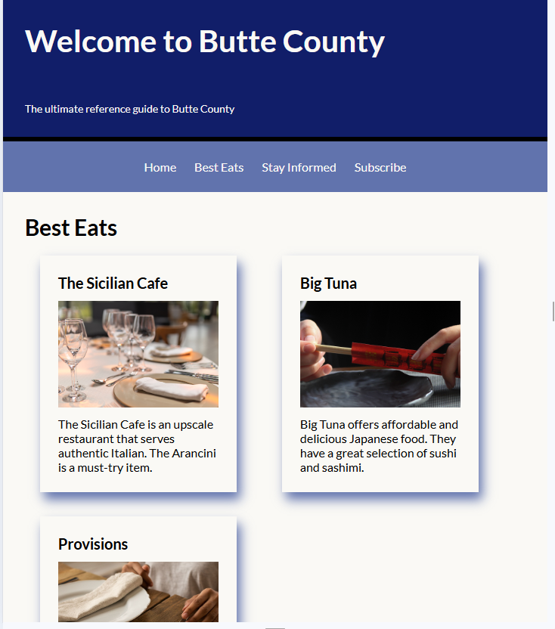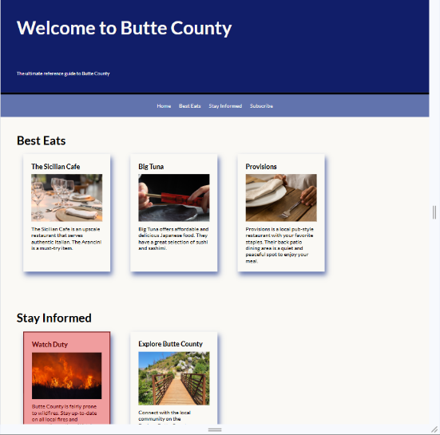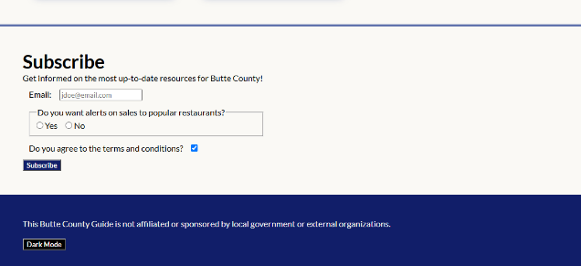
  - I then tested the keyboard functions and link functionality by pressing tab and using arrows to navigate through the site and pressed all of the link. I expected all tests to maintain consistency with previous ones. I confirmed that all links are functioning, the visual focus indicator is present, and highlighted links and inputs still have an outline when hovering.
Hover working and other theme is functioning properly.
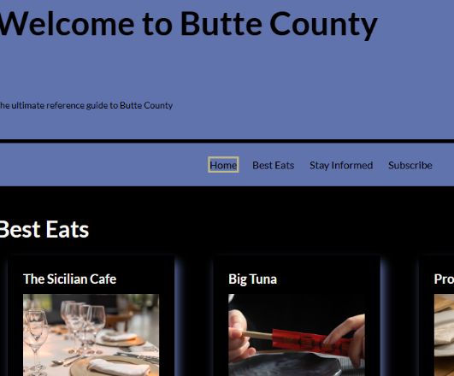
Visual focus indicator present (on the Yes radius button).
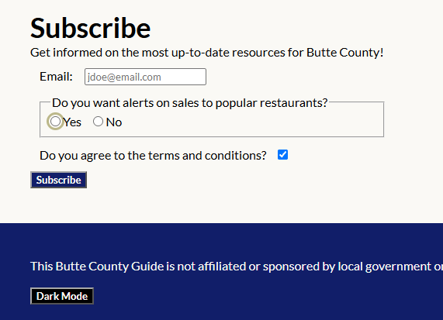
  - Lastly, I tested content clarity and resolution at 200% zoom. I expected the content to maintain its high resolution. After zooming in 200%, I confirmed that the image quality and test are clear and the site is still navigational. (Screenshot on next page.)
