

**EGE UNIVERSITY**

**ENGINEERING FACULTY**

**COMPUTER ENGINEERING**

**DATABASE MANAGEMENT**

**2021–2022 FALL SEMESTER**

**MIDTERM PROJECT REPORT**

**HAZIRLAYANLAR**

05190000072, Tuğcan Topaloğlu

05180000047, Elifnaz Acun

05180000113, Simge Merve Yaşbay

05180000081, Özlem Çelebi

İçindekiler

1. Analysis 2

1.1 Brief Explanation 2

2.1 Analysis Report for Each Web application 2

2.1.a What is the aim of each application? 2

2.1.b What are the main entities of them? 2

2.1.c What are the characteristics of each entity? 2

2.1.d What relationships exists among the entities? 3

2.1.e What are the constraints related to entities, their characteristics and the relationships ssssamong them? 4

2. Design - Conceptual Design 5

3. Design - Logical Model 6

3.1 Mapping 6

3.2 Relational Model 9

4. Implementation - Physical Model 10

4.1 Tables 10

4.2 Tuples 20

4.3 Triggers 21

4.4 Check Constraints 23

4.5 SQL Statements 26

4.5.a INSERT/DELETE/UPDATE Statements 26

4.5.b Select Statements 27

4.5.c Original Select Statements 31

# 1. Analysis

## 1.1 Brief Explanation

If we look at these two programs independently for the first time, LinkedIn is a business networking application that connects registered individuals, corporations, and schools all around the world. Job advertising, employment applications, job contacts, and talents, work experiences, interests, and other fields relevant to each user are all included in the application, as are profiles in the form of a CV.

Moodle, on the other hand, caters to a more specialized audience and allows teachers to require students to register for the course using the passwords they have created, and it incorporates quizzes, exams, homework, and other course-related activities.

## 2.1 Analysis Report for Each Web application

### 2.1.a What is the aim of each application?

LinkedIn's goal is to link professionals all over the world in order to create a more efficient and productive business network by allowing them to interact. Moodle's goal is to provide a unique educational environment for educators and students through its use and control, resulting in a more efficient teaching platform.

### 2.1.b What are the main entities of them?

Common main entities of both Db_User , User_Profile , College , Faculty , Department , Transcript.

In addition to these, the main entities of LinkedIn Company , Company_Profile , Collection , Job_Offer , Post , Achievement.

In addition to these, the main entities of Moodle Course , Grading_Req.

### 2.1.c What are the characteristics of each entity?

Db_User entity has unique user_id,username and password. The user can be of Student,Teacher and Worker. It has flag attributes that control each of them. If the user is a worker it has sector,career title and work time. If the user is a teacher it has teacher degree.

User_Profile entity has unique user_profile_id , full name , unique mail , address , unique phone , sex and birth date.

Company entity entity has unique company_id and mgr_id.

Company_Profile entity has unique company_profile_id,unique company name,company location, and unique company phone.

Transcript entity has unique transcript no , type , taken date and gpa.

College entity has unique college id , college name , location and phone.

Faculty entity has unique faculty id , name , location and phone.

Department entity has unique id,phone , name and location.

Course entity has unique id,name and description.

Grading_Req entity has unique id and type.One Grading_req can be only one of four types.These are Quiz,Project,Exam and Homework.Each of them has grade attribute.

Achievement entity has unique id,type and date. One Achievement can be only one of four types. These are Test Score , Willing Project , Language and Certificate. Each of them has name attribute and Test Score has score attribute.

Collection entity has unique id. Collection includes two type data.These are Job Offer and Post. Job Offer has unique id , title and location. Post has unique id.

### 2.1.d What relationships exists among the entities?

Each Db_User must has a User_Profile.Each User_Profile must belong a Db_User.

Each User_Profile can display more than one profile, and each User_Profile can be viewed by more than one User_Profile.Each User_Profile can connect with multiple User_Profile.

Each Db_User can save more than one Collection. Each Collection must necessarily be registered by a Db_User.

Each Db_User can apply to or view more than one Job_Offer. Each Job_Offer can be applied or viewed by more than one Db_User.

Each Db_User can share, like, comment on more than one Post. Each Post can be liked, shared, commented on by more than one Db_User.

Each Db_User can achieve more than one Achievement. An Achievement can belong to more than one Db_User.

Each Db_User can upload more than one Private_File. One Private_File must necessarily be uploaded by a Db_User.

Each Db_User can has more than one Transcript. One Transcript can only belong to one Db_User.

One Transcript can taken by only one College. Each College can take more than one Transcript.

Each Student can study only one College. Each College can has more than one Student.

Each Teacher can work only one College. Each College can has more than one Teacher.

Each College can have more than one Faculty. Each Faculty can belong to only one College.

Each Faculty can has more than one Department. Each Department must necessarily and only belong to one Faculty.

Each Department can give one or more Course. Each Course is provided by only one Department.

Each Student can enroll in more than one Course. Each Course can receive more than one Student registration.

Each Teacher can teach more than one Course. Each Course must be taught by one or more Teacher.

Each Course must has one or more Grading_Req. Each Grading_Req must belong to only one Course.

Every Worker can has a career in a Company. Each Company can has more than one Worker.

Each Company must has a Company_Profile. Each Company_Profile must belong to a Company.

Each Company can offers more than one Job_Offer. Each Job_Offer must be offered by only one Company.

### 2.1.e What are the constraints related to entities, their characteristics and the relationships among them?

Db_User’s user_id attiribute must be initialized between 100000 and 199999.

Transcript’s transcprit_no attribute must be initialized between 200000 and 299999.

College’s college_id attribute must be initialized between 300000 and 399999.

Faculty’s faculty_id attribute must be initialized between 400000 and 499999.

Department’s department_id attribute must be initialized between 500000 and 599999.

Course’s course_id attribute must be initialized between 600000 and 699999.

Grading_Req’s grading_req_id attribute must be initialized between 700000 and 799999.

Company’s company_id attribute must be initialized between 800000 and 899999.

User_Profile’s user_profile_id attribute must be initialized between 900000 and 999999.

Company_Profile’s company_profile_id attribute must be initialized between 700000 and 799999.

Achievement’s achievement_id attribute must be initialized between 110000 and 119999.

Collection’s cllection_id attribute must be initialized between 120000 and 129999.

Job_Offer’s job_offer_id attribute must be initialized between 130000 and 139999.

Post’s post_id attribute must be initialized between 140000 and 149999.

Private_File’s file_id attribute must be initialized between 150000 and 159999.

Grading types can be Exa, Project, Homework or Quiz.

Achievements types can be Willing Project, Language, Test Score or Certificate.

Collection can be both job offer or post.

# 2. Design - Conceptual Design

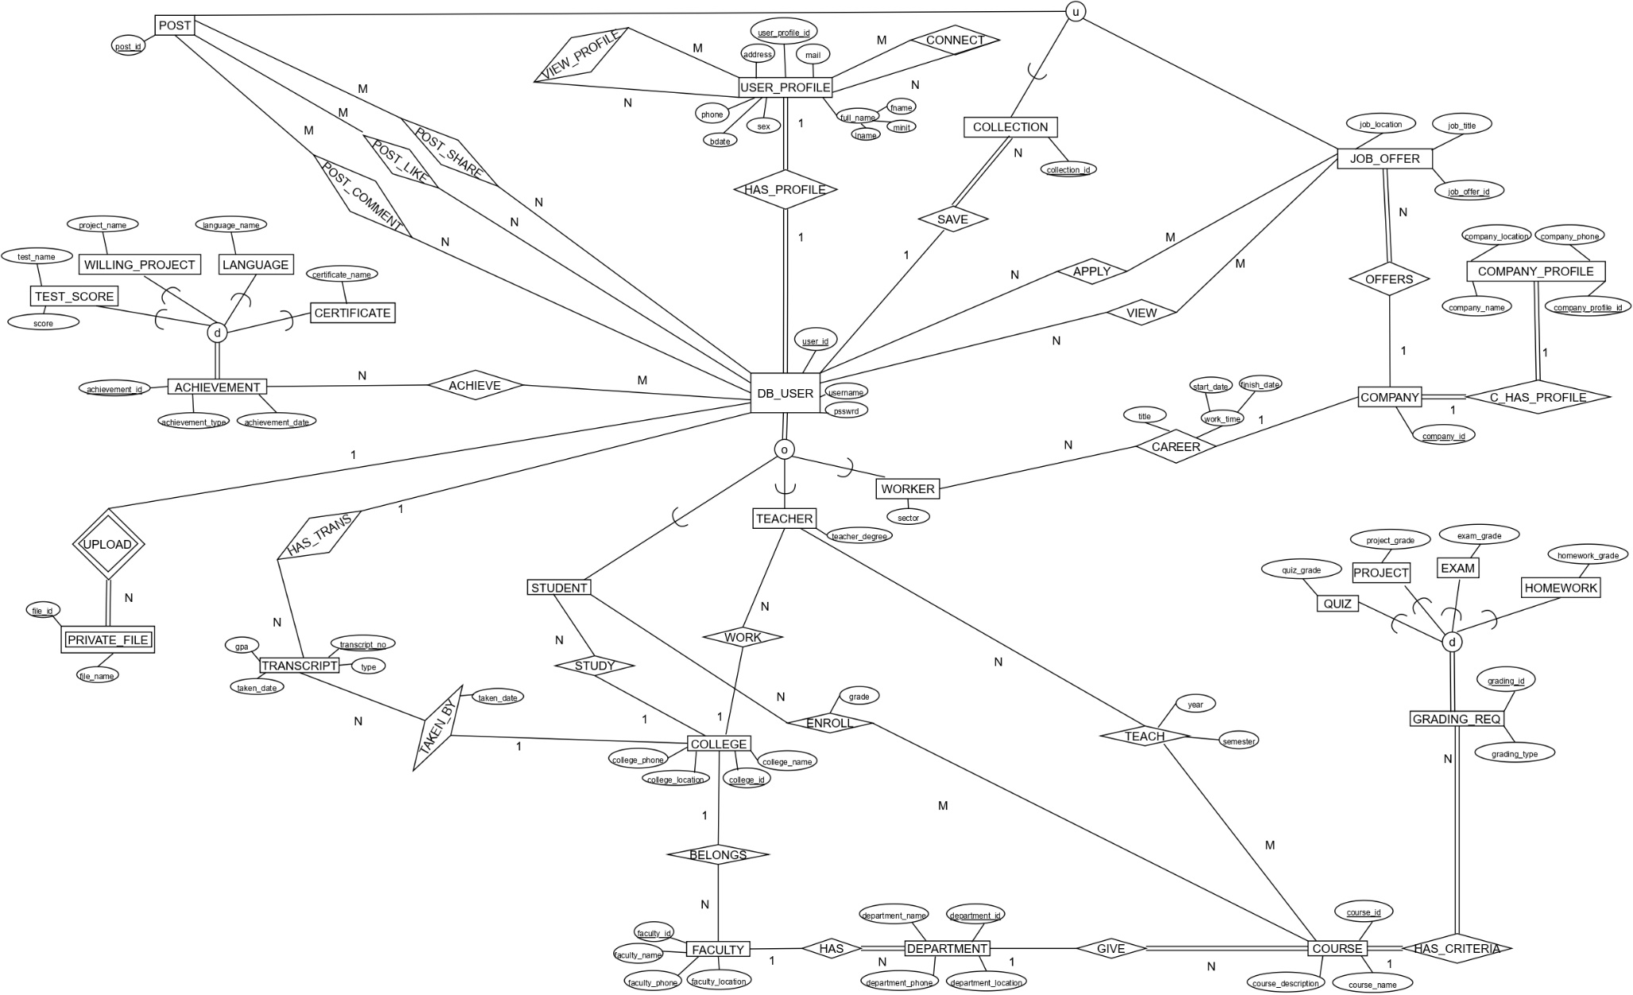

# 3. Design - Logical Model

## 3.1 Mapping

1.ITERATION

1-)

TRANSCRIPT(transcript_no,type,taken_date,gpa)

COLLEGE(college_id,college_name,college_location,college_phone)

FACULTY(faculty_id,faculty_name,faculty_location,faculty_phone)

DEPARTMENT(department_id,department_phone,department_name,department_location)

COURSE(course_id,course_name,course_description)

COMPANY(company_id,mgr_id)

COMPANY_PROFILE(c_profile_id,company_name,comapny_loc,company_phone)

USER_PROFILE(user_profile_id,fname,minit,lname,mail,address,phone,sex,bdate)

2-)

3-) 1 to 1

COMPANY(company_id,mgr_id,c_profile_id) C_HAS_PROFILE

4-) 1 TO N

FACULTY(faculty_id,faculty_name,faculty_location,faculty_phone,faculty_college_id) BELONGS

DEPARTMENT(department_id,department_phone,department_name,department_location,department_faculty_id) HAS

COURSE(course_id,course_name,course_description,course_department_id) GIVE

TRANSCRIPT(transcript_no,type,taken_date,gpa,t_college_id) TAKEN_BY

5-) M to N

VIEW_PROFILE(user_profile_id,user_viewer_id)

CONNECT(user_profile_id,user_connect_id)

6-)

7-)

8-)

8.D.)

DB_USER(user_id,username,psswrd,student_flag,teacher_flag,worker_flag,teacher_degree,sector)

8.A.)

ACHIEVEMENT(achievemet_id,date,achievement_type)

TEST_SCORE(achievemet_id,score,test_name)

WILLING_PROJECT(achievemet_id,project_name)

LANGUAGE(achievement_id,language_name)

CERTIFICATE(achievement_id,certificate_name)

8.A.)

GRADING_REQ(grading_req_id,grading_type)

QUIZ(grading_req_id,quiz_grade)

PROJECT(grading_req_id,project_grade)

EXAM(grading_req_id,exam_grade)

HOMEWORK(grading_req_id,homework_grade)

9-)

COLLECTION(collection_id)

POST(post_id,post_collection_id)

JOB_OFFER(job_offer_id,job_collection_id,job_title,job_location)

2.ITERATION

1-)

2-)

PRIVATE_FILE(file_id,private_user_id,file_name) UPLOAD

3-) 1 to 1

DB_USER(user_id,username,psswrd,student_flag,teacher_flag,worker_flag,teacher_degree,sector,user_profile_id) HAS_PROFILE

4-) 1 to N

TRANSCRIPT(transcript_no,type,taken_date,gpa,t_college_id,t_user_id) HAS_TRANS

DB_USER(user_id,username,psswrd,student_flag,teacher_flag,worker_flag,teacher_degree,sector,user_profile_id,student_college_id) STUDY

DB_USER(user_id,username,psswrd,student_flag,teacher_flag,worker_flag,teacher_degree,sector,user_profile_id,student_college_id,teacher_college_id) WORK

DB_USER(user_id,username,psswrd,student_flag,teacher_flag,worker_flag,teacher_degree,sector,user_profile_id,student_college_id,teacher_college_id,worker_company_id,career_title,start_date,finish_date) CAREER

JOB_OFFER(job_offer_id,job_collection_id,job_title,job_location,job_offer_company_id) OFFERS

COLLECTION(collection_id,collection_user_id) SAVE

GRADING_REQ(grading_req_id,grading_type,grading_req_course_id) HAS_CRITERIA

5-) N TO M

LIKE(post_id,user_id)

COMMENT(post_id,user_id)

SHARE(post_id,user_id)

ENROLL(user_id,course_id,grade)

TEACH(user_id,course_id,year,semester)

ACHIEVE(achievement_id,user_id)

APPLY(job_offer_id,user_id)

VIEW(job_offer_id,user_id)

6-)

7-)

8-)

9-)

## 3.2 Relational Model

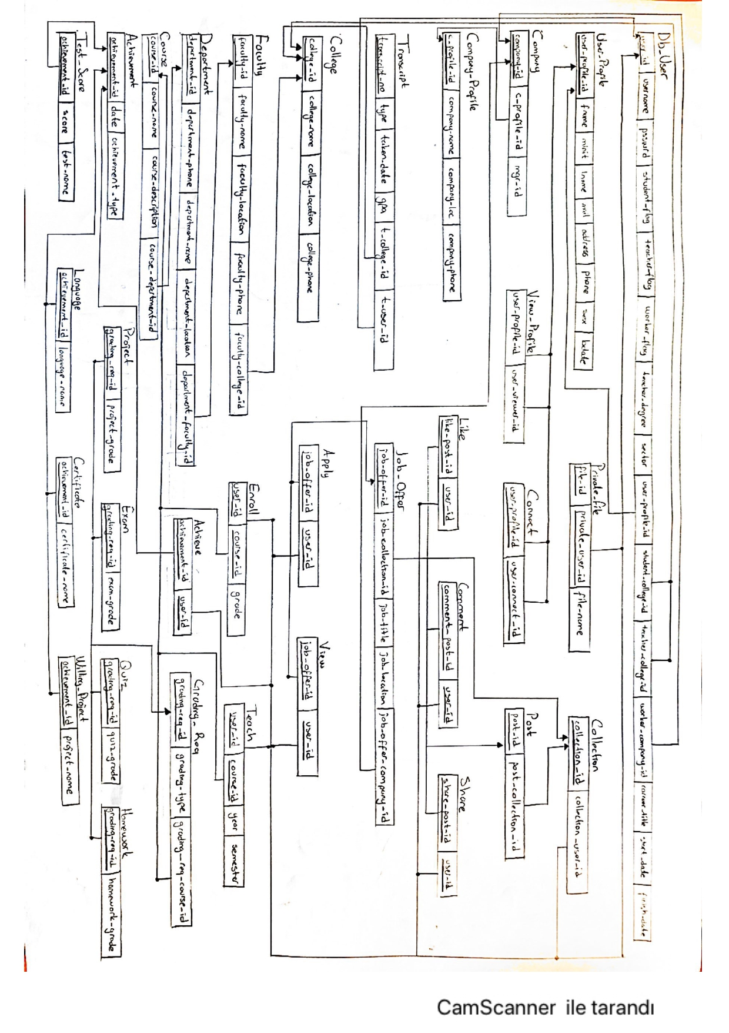

# 4. Implementation - Physical Model

Physical model implemented with POSTGRE SQL and pgAdmin 4.

All SQL codes can be found in Project folder. Tables can be found in “Tables.txt”. In order to maintain readibility all tuples are not included in tuples section and tuples can be found in “Tuples.txt”. Triggers can be found in “Triggers.txt”. Because of the disability of POSTGRE SQL instead of assertions we used check constraints and check constraints can be found in “CheckConstraints.txt”.Delete and Update insertions can be found in “DeleteUpdate.txt”. SQL statements can be found in “SelectStatements.txt”.

## 4.1 Tables

CREATE TYPE name AS(

Fname text,

Minit text,

Lname text

);

CREATE TYPE composite_time AS(

start_date Date,

finish_date Date

);

CREATE TABLE College(

college_id serial Primary Key NOT NULL,

college_name text unique NOT NULL,

college_location text,

college_phone integer unique

);

CREATE TABLE Company_Profile(

company_profile_id serial Primary Key NOT NULL,

company_name text UNIQUE NOT NULL,

company_location text,

company_phone integer UNIQUE

);

CREATE TABLE User_Profile(

user_profile_id serial Primary Key NOT NULL,

full_name name,

mail text unique NOT NULL,

address text,

phone integer unique,

sex character,

BDate Date

);

CREATE TABLE Company(

company_id serial Primary Key NOT NULL,

company_profile_id integer unique NOT NULL,

mgr_id integer unique NOT NULL,

Foreign Key(company_profile_id) references Company_Profile(company_profile_id) ON DELETE CASCADE ON UPDATE CASCADE

);

CREATE TABLE Db_User(

user_id serial Primary Key NOT NULL,

username text unique NOT NULL,

psswrd integer NOT NULL,

student_flag boolean,

teacher_flag boolean,

worker_flag boolean,

sector text,

teacher_degree text,

student_college_id integer,

teacher_college_id integer ,

worker_company_id integer ,

user_profile_id integer unique NOT NULL,

career_title text,

work_time composite_time,

Foreign Key(student_college_id) references College (college_id) ON DELETE CASCADE ON UPDATE CASCADE,

Foreign Key(teacher_college_id) references College (college_id) ON DELETE CASCADE ON UPDATE CASCADE,

Foreign Key(worker_company_id) references Company (company_id) ON DELETE CASCADE ON UPDATE CASCADE,

Foreign Key(user_profile_id) references User_Profile (user_profile_id) ON DELETE CASCADE ON UPDATE CASCADE

);

CREATE TABLE Transcript(

transcript_no serial Primary Key NOT NULL,

Type text NOT NULL,

taken_date Date,

gpa numeric NOT NULL,

t_user_id integer NOT NULL,

t_college_id integer NOT NULL,

Foreign Key(t_user_id) references Db_User(user_id) ON DELETE CASCADE ON UPDATE CASCADE,

Foreign Key(t_college_id) references College(college_id) ON DELETE CASCADE ON UPDATE CASCADE

);

CREATE TABLE Faculty (

faculty_id serial Primary Key NOT NULL,

faculty_name text NOT NULL,

faculty_location text,

faculty_phone integer unique,

faculty_college_id integer NOT NULL,

Foreign Key(faculty_college_id) references College(college_id) ON DELETE CASCADE ON UPDATE CASCADE

);

CREATE TABLE Department (

department_id serial Primary Key NOT NULL,

department_faculty_id integer NOT NULL,

department_phone integer unique,

department_name text NOT NULL,

department_location text,

Foreign Key(department_faculty_id) references Faculty(faculty_id) ON DELETE CASCADE ON UPDATE CASCADE

);

CREATE TABLE Course(

course_id serial Primary Key NOT NULL,

course_department_id integer NOT NULL,

course_name text NOT NULL,

course_description text,

Foreign Key(course_department_id) references Department(department_id) ON DELETE CASCADE ON UPDATE CASCADE

);

CREATE TABLE Grading_Req (

grading_req_id serial Primary Key NOT NULL,

grading_req_course_id integer NOT NULL,

grading_type text NOT NULL,

Foreign Key(grading_req_course_id) references Course(course_id) ON DELETE CASCADE ON UPDATE CASCADE

);

CREATE TABLE Quiz(

grading_req_id serial Primary Key NOT NULL,

quiz_grade integer NOT NULL,

Foreign Key(grading_req_id) references Grading_Req(grading_req_id) ON DELETE CASCADE ON UPDATE CASCADE

);

CREATE TABLE Project(

grading_req_id serial Primary Key NOT NULL,

project_grade integer NOT NULL,

Foreign Key(grading_req_id) references Grading_Req(grading_req_id) ON DELETE CASCADE ON UPDATE CASCADE

);

CREATE TABLE Exam(

grading_req_id serial Primary Key NOT NULL,

exam_grade integer NOT NULL,

Foreign Key(grading_req_id) references Grading_Req(grading_req_id) ON DELETE CASCADE ON UPDATE CASCADE

);

CREATE TABLE Homework(

grading_req_id serial Primary Key NOT NULL,

homework_grade integer NOT NULL,

Foreign Key(grading_req_id) references Grading_Req(grading_req_id) ON DELETE CASCADE ON UPDATE CASCADE

);

CREATE TABLE Private_File (

private_user_id integer NOT NULL,

file_id integer unique NOT NULL,

file_name text NOT NULL,

Primary Key(private_user_id, file_id),

Foreign Key(private_user_id) references Db_User(user_id) ON DELETE CASCADE ON UPDATE CASCADE

);

CREATE TABLE Achievement (

achievement_id serial Primary Key NOT NULL,

achievement_type text NOT NULL,

achievement_date Date

);

CREATE TABLE Willing_Project (

achievement_id serial Primary Key NOT NULL,

project_name text NOT NULL,

Foreign Key(achievement_id) references Achievement(achievement_id) ON DELETE CASCADE ON UPDATE CASCADE

);

CREATE TABLE Language (

achievement_id serial Primary Key NOT NULL,

language_name text NOT NULL,

Foreign Key(achievement_id) references Achievement(achievement_id) ON DELETE CASCADE ON UPDATE CASCADE

);

CREATE TABLE Certificate (

achievement_id serial Primary Key NOT NULL,

certificate_name text NOT NULL,

Foreign Key(achievement_id) references Achievement(achievement_id) ON DELETE CASCADE ON UPDATE CASCADE

);

CREATE TABLE Test_Score (

achievement_id serial Primary Key NOT NULL,

test_name text NOT NULL,

score integer NOT NULL,

Foreign Key(achievement_id) references Achievement(achievement_id) ON DELETE CASCADE ON UPDATE CASCADE

);

CREATE TABLE Collection (

collection_user_id integer NOT NULL,

collection_id serial Primary Key NOT NULL,

Foreign Key(collection_user_id) references Db_User(user_id) ON DELETE CASCADE ON UPDATE CASCADE

);

CREATE TABLE Job_Offer (

job_offer_id serial Primary Key NOT NULL,

job_offer_company_id integer NOT NULL,

job_collection_id integer NOT NULL,

job_title text NOT NULL,

job_location text,

Foreign Key(job_collection_id) references Collection(collection_id) ON DELETE CASCADE ON UPDATE CASCADE,

Foreign Key(job_offer_company_id) references Company(company_id) ON DELETE CASCADE ON UPDATE CASCADE

);

CREATE TABLE Post (

post_id serial Primary Key NOT NULL,

post_collection_id integer NOT NULL,

Foreign Key(post_collection_id) references Collection(collection_id) ON DELETE CASCADE ON UPDATE CASCADE

);

CREATE TABLE View_Profile(

user_profile_id integer NOT NULL,

viewer_id integer NOT NULL,

Primary key (user_profile_id, viewer_id),

FOREIGN KEY(user_profile_id) REFERENCES User_Profile (user_profile_id) ON DELETE CASCADE ON UPDATE CASCADE,

FOREIGN KEY(viewer_id) REFERENCES User_Profile (user_profile_id) ON DELETE CASCADE ON UPDATE CASCADE

);

CREATE TABLE Connect(

user_profile_id integer NOT NULL,

user_connect_id integer NOT NULL,

Primary key (user_profile_id, user_connect_id),

FOREIGN KEY(user_profile_id) REFERENCES User_Profile (user_profile_id) ON DELETE CASCADE ON UPDATE CASCADE,

FOREIGN KEY(user_connect_id) REFERENCES User_Profile (user_profile_id) ON DELETE CASCADE ON UPDATE CASCADE

);

CREATE TABLE Enroll(

user_id integer NOT NULL,

course_id integer NOT NULL,

grade integer NOT NULL,

Primary Key(user_id, course_id),

FOREIGN KEY(user_id) REFERENCES Db_User (user_id) ON DELETE CASCADE ON UPDATE CASCADE,

FOREIGN KEY(course_id) REFERENCES Course (course_id) ON DELETE CASCADE ON UPDATE CASCADE

);

CREATE TABLE Teach(

user_id integer NOT NULL,

course_id integer NOT NULL,

year integer,

semester text,

Primary Key(user_id, course_id),

FOREIGN KEY(user_id) REFERENCES Db_User (user_id) ON DELETE CASCADE ON UPDATE CASCADE,

FOREIGN KEY(course_id) REFERENCES Course (course_id) ON DELETE CASCADE ON UPDATE CASCADE

);

CREATE TABLE Achieve(

user_id integer NOT NULL,

achievement_id integer NOT NULL,

Primary Key(user_id, achievement_id),

FOREIGN KEY(user_id) REFERENCES Db_User (user_id) ON DELETE CASCADE ON UPDATE CASCADE,

FOREIGN KEY(achievement_id) REFERENCES Achievement (achievement_id) ON DELETE CASCADE ON UPDATE CASCADE

);

CREATE TABLE Apply(

user_id integer NOT NULL,

job_offer_id integer NOT NULL,

Primary Key (user_id, job_offer_id),

Foreign Key(user_id) references Db_User(user_id) ON DELETE CASCADE ON UPDATE CASCADE,

Foreign Key(job_offer_id) references Job_Offer(job_offer_id) ON DELETE CASCADE ON UPDATE CASCADE

);

CREATE TABLE View(

user_id integer NOT NULL,

job_offer_id integer NOT NULL,

Primary Key(user_id, job_offer_id),

Foreign Key(user_id) references Db_User(user_id) ON DELETE CASCADE ON UPDATE CASCADE,

Foreign Key(job_offer_id) references Job_Offer(job_offer_id) ON DELETE CASCADE ON UPDATE CASCADE

);

CREATE TABLE Post_Share(

post_id integer NOT NULL,

user_id integer NOT NULL,

Primary Key(post_id, user_id),

Foreign Key(post_id) references Post(post_id) ON DELETE CASCADE ON UPDATE CASCADE,

Foreign Key(user_id) references Db_User(user_id) ON DELETE CASCADE ON UPDATE CASCADE

);

CREATE TABLE Post_Like(

post_id integer NOT NULL,

user_id integer NOT NULL,

Primary Key (post_id, user_id),

Foreign Key(post_id) references Post(post_id) ON DELETE CASCADE ON UPDATE CASCADE,

Foreign Key(user_id) references Db_User(user_id) ON DELETE CASCADE ON UPDATE CASCADE

);

CREATE TABLE Post_Comment(

post_id integer NOT NULL,

user_id integer NOT NULL,

Primary Key (post_id, user_id),

Foreign Key(post_id) references Post(post_id) ON DELETE CASCADE ON UPDATE CASCADE,

Foreign Key(user_id) references Db_User(user_id) ON DELETE CASCADE ON UPDATE CASCADE

);

## 4.2 Tuples

INSERT INTO Db_User VALUES (100000,'worthbee',2154523,True,False,False,null,null,300000,null,null,900000,null,null);

INSERT INTO Db_User VALUES (100001,'decayvowel',52312,True,True,False,null,'Undergraduate',300000,300001,null,900001,null,null);

INSERT INTO Db_User VALUES (100002,'pradawreck',54413312,False,False,True,'Advertisement',null,null,null,800000,900002,'Computer Engineer',('01-06-2019',null));

INSERT INTO Db_User VALUES (100003,'cartierlinear',784515,True,True,True,'Banking','PHD',300000,300002,800001,900003,'Accounter',('16-09-2020','16-11-2020'));

INSERT INTO Db_User VALUES (100004,'surroundgrind',214566,True,False,True,'Software',300001,null,300002,null,900004,'Human Resources',('29-07-2021',null));

INSERT INTO Db_User VALUES (100005,'jestawful',88962,True,False,False,null,null,300003,null,null,900005,null,null);

INSERT INTO Db_User VALUES (100006,'frankfurtercovey',09066,False,True,False,null,'Graduate',null,300001,null,900006,null,null);

INSERT INTO Db_User VALUES (100007,'spindlereverse',514812,False,False,True,'Hardware',null,null,null,800003,900007,'Software Engineer',('03-01-2021','19-12-2021'));

INSERT INTO Db_User VALUES (100008,'increasedrash',798900,False,True,True,'Banking','Proffesor',null,300001,800001,900008,'Security',('24-04-2018',null));

INSERT INTO Db_User VALUES (100009,'sowseforgetful',889521,True,True,True,'Marketing','PHD',300004,300001,800000,900009,'Manager',('19-11-2017','02-09-2020'));

INSERT INTO Db_User VALUES (100010,'sweepevery',2832521,False,False,True,'Hardware',null,null,null,800001,900010,'Manager',('19-01-2018',null));

INSERT INTO Db_User VALUES (100011,'founderwonder',5687521,False,False,True,'Banking',null,null,null,800002,900011,'Manager',('12-05-2016',null));

INSERT INTO Db_User VALUES (100012,'phalangesexcited',5671521,False,False,True,'Marketing',null,null,null,800003,900012,'Manager',('16-06-2015',null));

## 4.3 Triggers

CREATE FUNCTION gpa_controller()

RETURNS TRIGGER AS $gpa_controller$

BEGIN

--check that new gpa is above 1,80

IF NEW.gpa < 1.80 THEN

RAISE EXCEPTION 'Transcript GPA can not be below 1,80.';

END IF;

END;

$gpa_controller$ LANGUAGE plpgsql;

CREATE TRIGGER trigger_gpa

BEFORE INSERT OR UPDATE OF gpa ON TRANSCRIPT

FOR EACH ROW

EXECUTE FUNCTION gpa_controller();

CREATE FUNCTION college_name()

RETURNS TRIGGER AS $college_name$

BEGIN

--check that college_name is given

IF NEW.college_name IS NULL THEN

RAISE EXCEPTION 'College Name cannot be null';

END IF;

END;

$college_name$ LANGUAGE plpgsql;

CREATE TRIGGER trigger_college_name

BEFORE INSERT OR UPDATE OF college_name ON COLLEGE

FOR EACH ROW

EXECUTE FUNCTION college_name();

CREATE FUNCTION psswrd_change()

RETURNS TRIGGER AS $psswrd_change$

BEGIN

--check that password has changed

IF NEW.psswrd <> OLD.psswrd THEN

RAISE EXCEPTION 'Password changed.';

END IF;

--check that new password is the same as the old one

IF NEW.psswrd = OLD.psswrd THEN

RAISE EXCEPTION 'New password can not be the same as the old one.';

END IF;

END;

$psswrd_change$ LANGUAGE plpgsql;

CREATE TRIGGER trigger_psswrd

BEFORE UPDATE OF psswrd ON DB_USER

FOR EACH ROW

EXECUTE FUNCTION psswrd_change();

## 4.4 Check Constraints

ALTER TABLE Db_User

ADD CONSTRAINT Db_User_CheckFinishDateGreaterThanStartDate

CHECK ((work_time).finish_date >= (work_time).start_date) ;

ALTER TABLE Quiz

ADD CONSTRAINT GRADE_CHECK

CHECK (quiz_grade>=40);

ALTER TABLE Project

ADD CONSTRAINT GRADE_CHECK

CHECK (project_grade>=40);

ALTER TABLE Exam

ADD CONSTRAINT GRADE_CHECK

CHECK (exam_grade>=40);

ALTER TABLE Homework

ADD CONSTRAINT GRADE_CHECK

CHECK (homework_grade>=40);

ALTER TABLE Achievement

ADD CONSTRAINT TYPE_CHECK_ACHIEVEMENT

CHECK (achievement_type IN ('Willing Project','Language','Test_Score','Certificate'));

ALTER TABLE Grading_Req

ADD CONSTRAINT TYPE_CHECK_REQ

CHECK (grading_type IN ('Quiz','Project','Exam','Homework'));

ALTER TABLE User_Profile

ADD CONSTRAINT CHECK_SEX

CHECK (Sex IN ('M','F'));

ALTER TABLE Db_User

ADD CONSTRAINT CHECK_LENGTH

CHECK (user_id Between 100000 and 199999);

ALTER TABLE Transcript

ADD CONSTRAINT CHECK_LENGTH

CHECK (transcript_no Between 200000 and 299999);

ALTER TABLE College

ADD CONSTRAINT CHECK_LENGTH

CHECK (college_id Between 300000 and 399999);

ALTER TABLE Faculty

ADD CONSTRAINT CHECK_LENGTH

CHECK (faculty_id Between 400000 and 499999);

ALTER TABLE Department

ADD CONSTRAINT CHECK_LENGTH

CHECK (department_id Between 500000 and 599999);

ALTER TABLE Course

ADD CONSTRAINT CHECK_LENGTH

CHECK (course_id Between 600000 and 699999);

ALTER TABLE Grading_Req

ADD CONSTRAINT CHECK_LENGTH

CHECK (grading_req_id Between 700000 and 799999);

ALTER TABLE Company

ADD CONSTRAINT CHECK_LENGTH

CHECK (company_id Between 800000 and 899999);

ALTER TABLE User_Profile

ADD CONSTRAINT CHECK_LENGTH

CHECK (user_profile_id Between 900000 and 999999);

## 4.5 SQL Statements

### 4.5.a INSERT/DELETE/UPDATE Statements

INSERT INTO Company_Profile VALUES(700000,'ARÇELİK','İZMİR',123665);

INSERT INTO Company_Profile VALUES(700001,'KOÇ','ANKARA',124785);

INSERT INTO Company_Profile VALUES(700002,'BEKO','İSTANBUL',96855);

INSERT INTO Company_Profile VALUES(700003,'ACUN MEDYA','İSTANBUL',127765);

DELETE FROM Db_User

WHERE username = 'worthbee';

DELETE FROM Faculty

WHERE faculty_college_id=2

DELETE FROM Company_Profile

WHERE company_location ='İZMİR'

UPDATE Db_User

SET sector='Marketing'

WHERE user_id = 100003

UPDATE Company_Profile

SET company_location ='ANKARA'

WHERE company_location='İSTANBUL'

UPDATE Achievement

SET achievement_date ='03-06-2022'

WHERE achievement_id=110016

### 4.5.b Select Statements

#### i) One Table

1)

Retrieve the full name, address, sex , birth date and phone of all users.

SELECT full_name,address,sex,BDate,phone

FROM User_Profile

tablo içeren bir resim

Açıklama otomatik olarak oluşturuldu

2)

Retrieve the user id and the user name of users who is either both student or teacher or both student or worker.

SELECT user_id,username

FROM Db_User

WHERE student_flag=true AND teacher_flag=true

UNION

SELECT user_id,username

FROM Db_User

WHERE student_flag=true AND worker_flag=true

tablo içeren bir resim

Açıklama otomatik olarak oluşturuldu

3)

Retrieve the year,semester of teacher with ID of 100008.

SELECT user_id,Teach.year,semester

FROM Teach

WHERE user_id=100008

tablo içeren bir resim

Açıklama otomatik olarak oluşturuldu

#### ii)Minimum Two Table

1)

Retrieve the users transcript information who has gpa more than 3.

SELECT user_id,transcript_no,type,gpa,taken_date,college_name

FROM Db_User,Transcript,College

WHERE gpa>3 AND t_user_id=user_id AND t_college_id=college_id

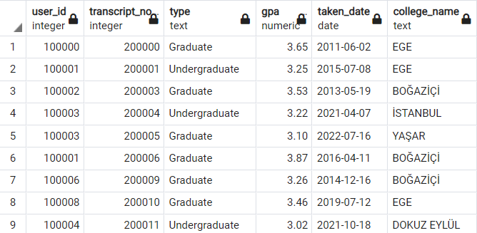

2)

Retrieve the career title and company names of user who is worker .

SELECT full_name,company_name,career_title

FROM Db_User, Company, Company_Profile, User_Profile

WHERE worker_flag=true AND Db_User.user_profile_id=User_Profile.user_profile_id AND worker_company_id=company_id

AND Company.company_profile_id=Company_Profile.company_profile_id

tablo içeren bir resim

Açıklama otomatik olarak oluşturuldu

3)

Retrieve the job offer information which offers by Arçelik.

SELECT job_title,job_offer_id,job_location,company_name

FROM Job_Offer, Company_Profile,Company

WHERE Company.company_id=800000 AND Company.company_profile_id=Company_Profile.company_profile_id

AND Company.company_id=Job_Offer.job_offer_company_id

tablo içeren bir resim

Açıklama otomatik olarak oluşturuldu

4)

Retrieve the grading requirements of the courses which in the department with ID of 500001

select course_name, grading_type

from Course, Grading_Req, Department

where department_id=500001 and course_department_id=department_id and course_id=grading_req_course_id

tablo içeren bir resim

Açıklama otomatik olarak oluşturuldu

#### iii)Minimum Three Table

1)

Retrieve the transcript information of user with ID of 100000.

select transcript_no, Transcript.Type, gpa, taken_date, college_name

from Db_User, College, Transcript

where Db_user.user_id =100000 and t_user_id=user_id and t_college_id=college_id

tablo içeren bir resim

Açıklama otomatik olarak oluşturuldu

2)

Retrieve the job offer information which offers by Arçelik.

SELECT job_title,job_offer_id,job_location,company_name

FROM Job_Offer, Company_Profile,Company

WHERE Company.company_id=800000 AND Company.company_profile_id=Company_Profile.company_profile_id

AND Company.company_id=Job_Offer.job_offer_company_id

tablo içeren bir resim

Açıklama otomatik olarak oluşturuldu

3)

Retrieve the worker's informations who works at the company with id of 800000.

SELECT full_name,company_name,mail,address,phone,sex,BDate, career_title,work_time

FROM Db_User,User_Profile,Company,Company_Profile

WHERE company_id=800000 AND Db_User.worker_company_id=company_id AND Db_User.user_profile_id= User_Profile.user_profile_id

AND Company.company_profile_id=Company_Profile.company_profile_id



### 4.5.c Original Select Statements

1)

Retrieve the name of company which located in İzmir or offers a job in İzmir.

select distinct company_name

from Company_Profile

where company_name in (

select company_name

from Company_Profile

where company_location='İZMİR')

or

company_name in (select company_name

from Company_Profile, Job_Offer, Company

where job_location='İzmir' and job_offer_company_id=company_id and Company.company_profile_id=Company_Profile.company_profile_id)

metin içeren bir resim

Açıklama otomatik olarak oluşturuldu

2)

If the user having 900000 user ids has a connection in the company which has offer a job that the user applied for, it returns that contact's user id.

select user_id

from Db_User

where (worker_company_id) in (select company_id

from Apply, Db_User, Job_Offer, User_Profile, Company_Profile,Company

where User_Profile.user_profile_id=900000 and Db_User.user_id=Apply.user_id

and Apply.job_offer_id=Job_Offer.job_offer_id and Job_Offer.job_offer_company_id=Company.company_id)

intersect

select user_id

from Db_User

where (user_profile_id) in (select user_connect_id

from Connect, Db_User, User_Profile

where User_Profile.user_profile_id=900000 and User_Profile.user_profile_id=Connect.user_profile_id)

metin içeren bir resim

Açıklama otomatik olarak oluşturuldu

3)

Returns the information of the teacher who teaches the courses in which the student with a user ID of 100000 is registered.

create view teacher(teacher_id, course_name, year, semester) as

(select distinct Teach.user_id, course_name, Teach.year, semester

from Enroll, Teach, Db_User, Course, User_Profile

where Db_User.user_id=100000 and Db_User.user_id=Enroll.user_id and Enroll.course_id=Course.course_id

and Course.course_id=Teach.course_id)

select full_name, teacher.course_name, teacher.year, teacher.semester

from teacher, Db_User, User_Profile

where teacher.teacher_id=Db_User.user_id and Db_User.user_profile_id=User_Profile.user_profile_id

metin içeren bir resim

Açıklama otomatik olarak oluşturuldu

4)

Retrieve the information of courses which has college_id of 300000

select college_name, faculty_name, department_name, course_name

from College, Faculty, Department, Course

where College.college_id=300000 AND College.college_id = Faculty.faculty_college_id AND Faculty.faculty_id=Department.department_faculty_id AND Department.department_id=Course.course_department_id

tablo içeren bir resim

Açıklama otomatik olarak oluşturuldu

tablo içeren bir resim

Açıklama otomatik olarak oluşturuldu

5)

Retrive the course names and faculty names which contains "Engineering" in all colleges.

SELECT course_name,college_name,faculty_name,department_name

FROM College, Faculty, Department, Course

WHERE department_name LIKE '%Engineering' AND Department.department_faculty_id=Faculty.faculty_id

AND Faculty.faculty_college_id= College.college_id AND Department.department_id=Course.course_department_id

tablo içeren bir resim

Açıklama otomatik olarak oluşturuldu

tablo içeren bir resim

Açıklama otomatik olarak oluşturuldu