Alorian Web Solutions

ISM4480 | Ref # 448388 | Professor Karen Walker

Group Project Part 3: Implementation and project Plan

Eric Barrier

2017

1 | Pre-development

**Domain Registration**

We will use the acronym AWS as our registered domain name.

**Hosting**

Because it will be a dynamically rendered single page application, we will use the domain hosting services of Surge.sh for our website. Surge is free, publishing is a simple one-line command from the terminal, and there are no file size limits.

2-1| Content Strategy

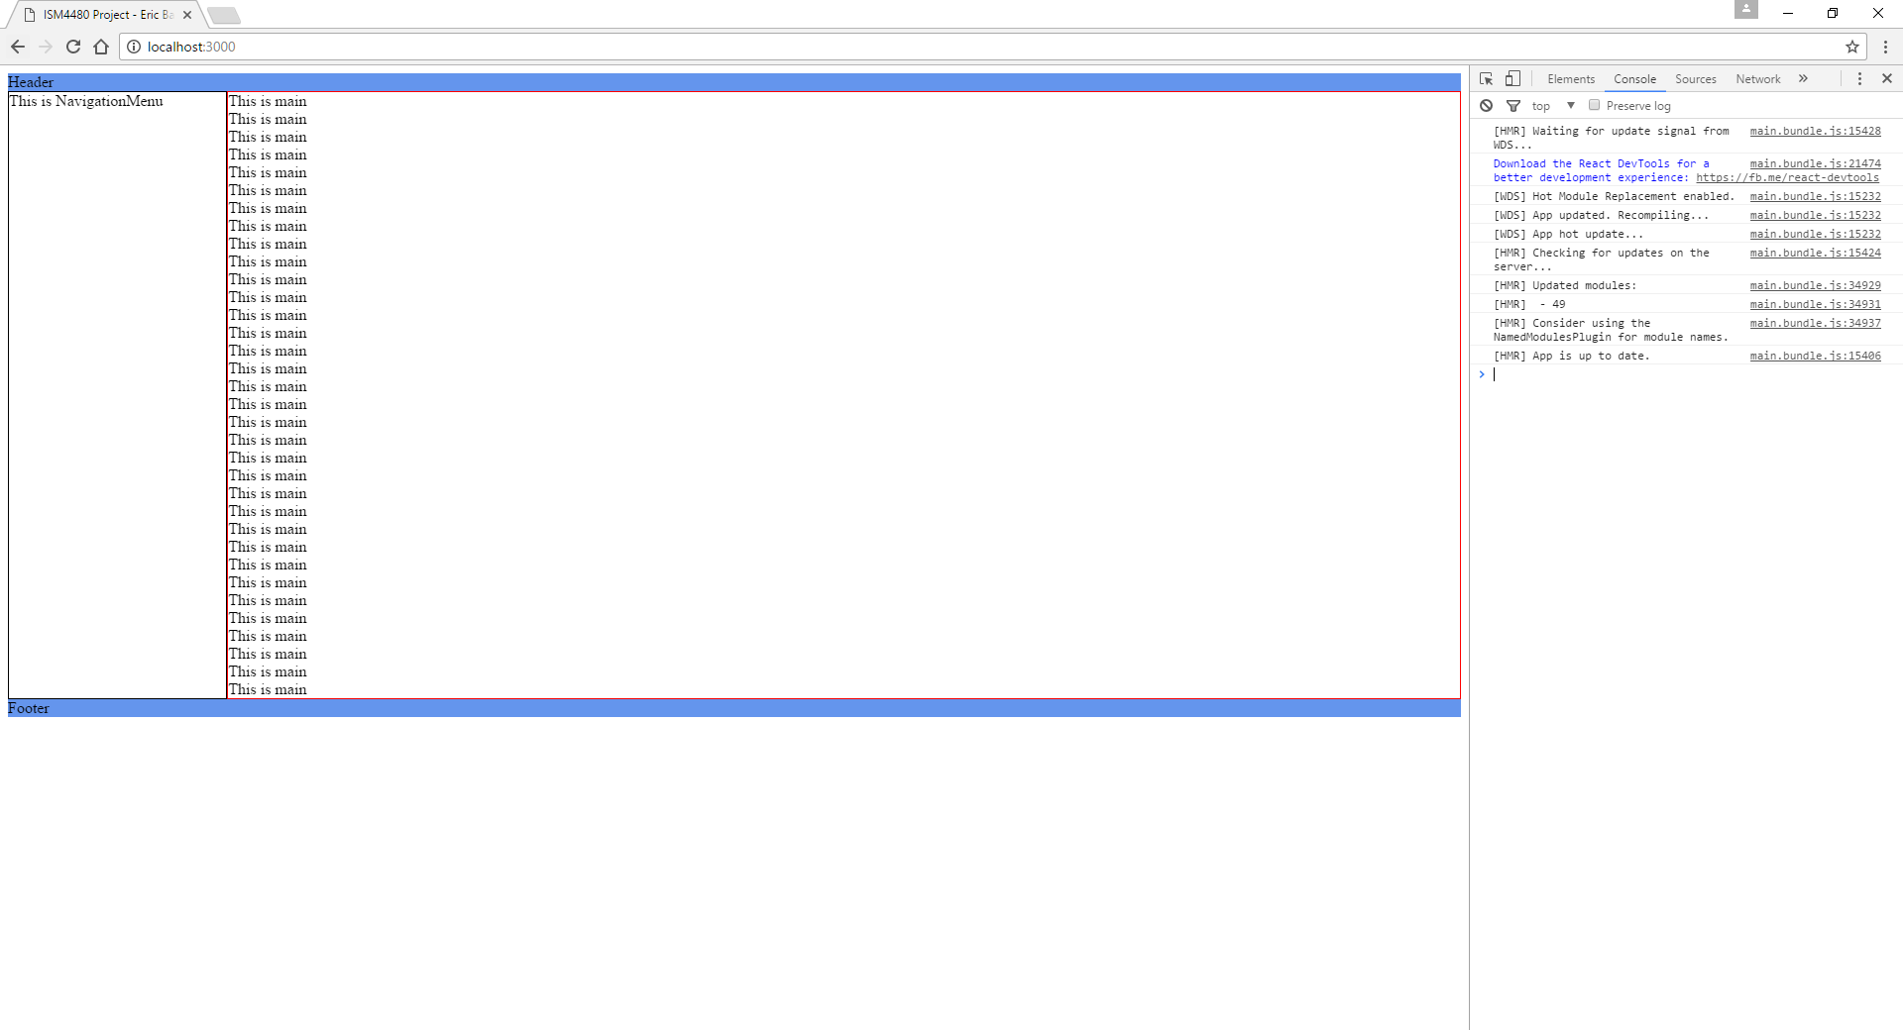

This was the first iteration of the desktop page layout. It made use of the HTML header and footer elements which were initially going to be used to contain logos and branding content. A side bar menu on the left would contain site navigation options, while a main content frame would comprise the majority of the page.

2-2 | Content Strategy Cont.

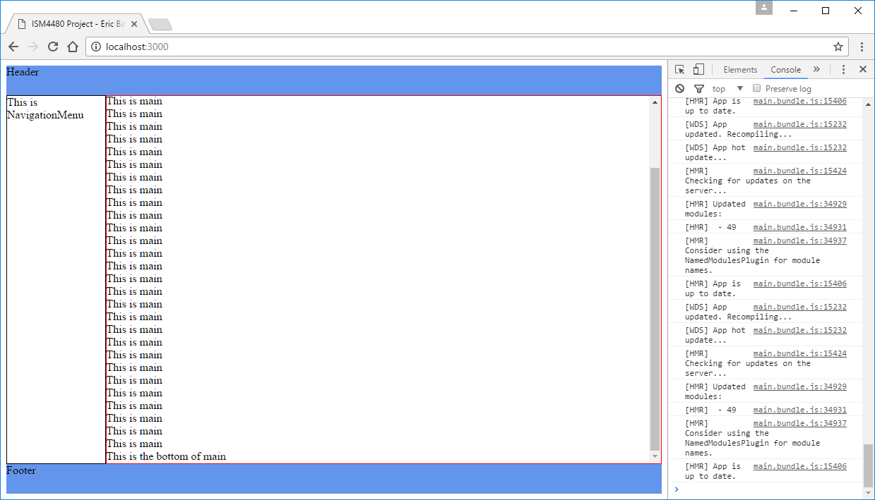

This demonstrates how the page’s main content frame was designed to work. Everything else is a static entity while scrolling occurs in the main body portion.

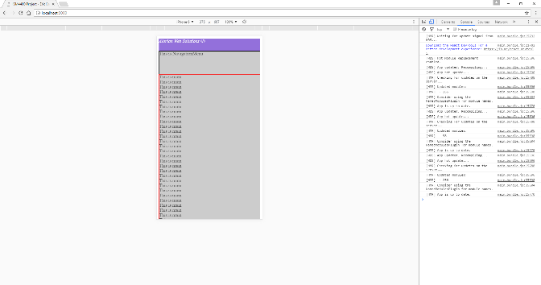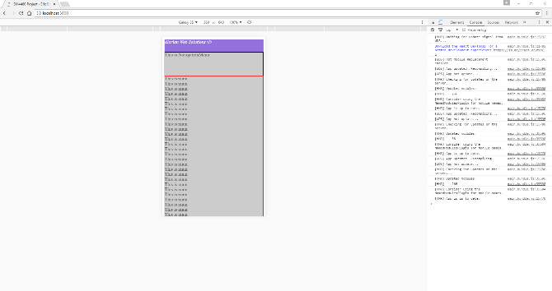

Here we see the first implementations of the design in a mobile responsive format. Using browser emulation tools to demonstrate how the page will display on both Samsung and iPhone devices, we are able to create CSS media queries to adjust the layout of the content accordingly.

2-3 | Content Strategy Cont.

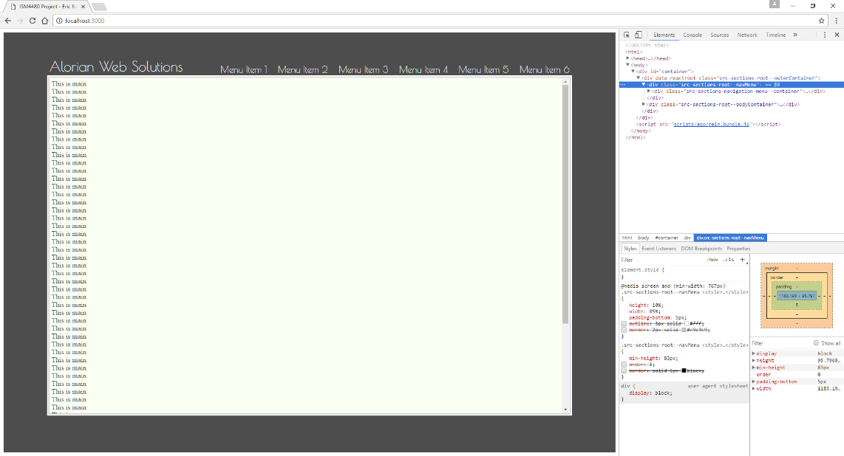

It was decided that the header and footer were actually unnecessary for what we wanted to achieve, and the layout was a little busier than we liked. Therefore, after going back to the drawing board for a bit, we arrived at the idea of a minimalistic design which resembles a picture frame. A simple text logo and navigation menu are positioned up top, with a scrollable main content frame in the center of the page.

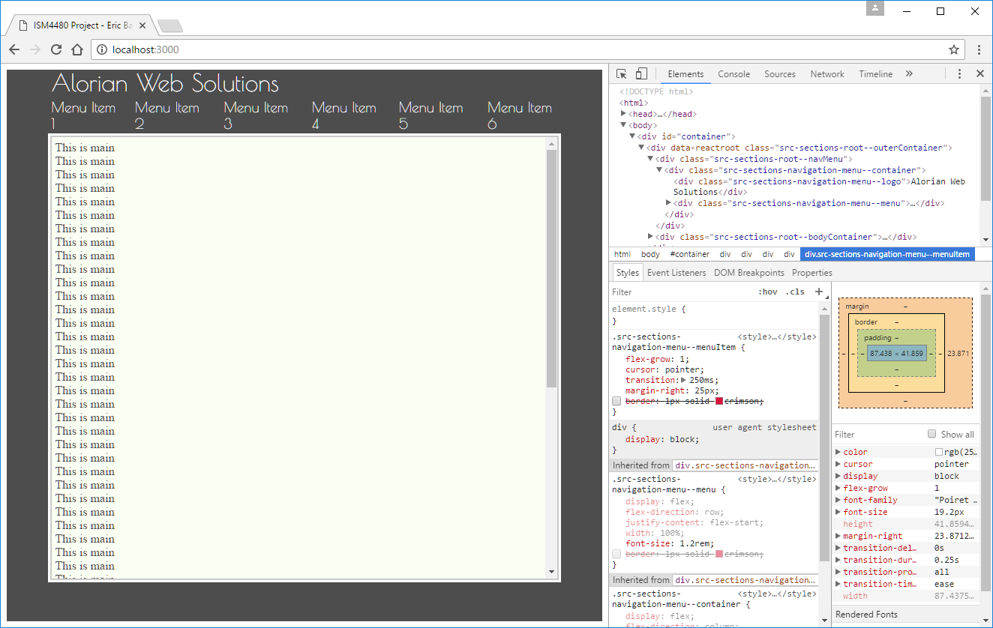

This screen demonstrates responsiveness, as the logo and menu shift positions on screen size shrink.

3 | Content Development

**Testing**

Using Webpack Development Server, combined with hot module reloading, development and testing will be done on the local machines of the developers.

**Initial Development Phase**

The first iteration of development will be simple, adhere to our minimalistic design, and have a navigation menu with 3 main content frames. We will roll this out first to introduce people to our brand before pushing out more complex content.

**The Decision for Mobile**

It is decided that our first priorities for development will be stationary desktop and mobile tablet device compatibility. Smartphone development is also very important, as is evident by the fact that we spent a little time developing a mobile responsive version of the first layout. Mobile development takes time, however, so in the interest of getting our company’s name out there, we are focusing on the other two major platforms first with full mobile phone support coming in a future release.