PAW FEEDS: An IoT-Based Automated Dog Food Dispenser with an Android Application For Scheduling and Real-Time Monitoring
Jhude Pathrick Madroñal, John Patrick E. Bucol, Antonio Miguel Apostol
Department of Information Technology College of Computing Studies,
Western Mindanao State University
Zamboanga City, Philippines

Email: eh202200846@wmsu.edu.ph ,eh202201374@wmsu.edu.ph, eh202201518@wmsu.edu.ph

Abstract— This study presents PAW FEEDS, an IoT-based automated dog feeding system includes a pet identification method using RFID technology, a portion monitoring management using load cells, and a remote scheduling method using a mobile application. In order to overcome the difficulties faced by busy dog owners in maintaining a regular schedule and portion control for dogs, the PAW FEEDS uses an ESP32 microcontroller for hardware management and an ESP32-CAM module for real-time video monitoring. The portion sizes are calculated using a dynamic formula based on the RER and MER formulas used in the field. The proposed PAW FEEDS has shown promising results in terms of hardware reliability, achieving a 95% rate in detecting pets using RFID. In addition, the usability test results showed a high level of satisfaction, achieving an average score of 4.42 average out of 5. This indicates that the proposed PAW FEEDS is a reliable and efficient method for automated pet feeding.
Keywords— Internet of Things (IoT), automated feeder, ESP32, ESP32-CAM, RFID, React Native, load cell.
I. INTRODUCTION
Feeding pets on time and getting the correct portion is a responsibility that many dog owners struggle to maintain, specifically those who are tend to go out and leave home for long hours. Consistent feeding time is important to our pet dogs, especially if we want them to be fed correctly. Missed or irregular feeding times may lead to problems such as overfeeding, underfeeding, or behavioral changes in dogs. The traditional methods such as manual scooping or even simple automatic feeders often fail to provide real-time confirmation that food has been dispensed, leaving owners uncertain about whether their pets have eaten or not. With the little help of Internet of Things (IoT) technology [1], everyday routines such as pet care can now be automated and monitored remotely. Smart-automatic feeders provide opportunities for owners to schedule feeding times, automate food dispensing, and reduce the chances of meals being missed. However, many commercial feeders [2] still lack accurate portion control and real-time monitoring features, which means owners cannot be certain if feeding has occurred or done precisely. The specific problem that this study seeks to address is the absence of a system that integrates automated scheduling, precise portion dispensing, and reliable monitoring into one device. While existing feeders provide convenience, they do not confirm whether food was released successfully or measured according to veterinary standards [3], [4]. This study introduces PAWFEEDS, an IoT-based smart dog feeder that integrates automation, monitoring, and portion control into a single system. The device consists of an ESP32-CAM (slave) for live video streaming [5] and a conventional ESP32 (master) [6] for scheduling, servo control, and REACT based mobile application. Dry food is dispensed precisely and reliably through an auger mechanism powered by a calibrated servo motor [7]. As a supplementary feature, integrated RFID technology [8] can recognize individual dogs using assigned tags. This allows the system to explore per-dog identification during feeding routines, while keeping its main focus on monitoring, automation, and usability. Owners can view feeding activity through live video, receive real-time alerts, and maintain confidence that feeding has occurred as scheduled. The research aims to assess the design and development process of an automated dog feeding system via Internet of Things (IoT) concept, which integrates the RFID technologies, load cells, and live video streaming. It also aims to evaluate the integration process of veterinary formulas, particularly the RER and MER, into a mobile application developed using React Native platform to determine individualized pet food portions. Moreover, this research aims to assess the hardware implementation process of the automated dog feeding system via dual controller architecture of ESP32 and ESP32-CAM technologies, as well as the empirical validation of the system based on hardware and user surveys.

RELATED WORKS

The integration of Internet of Things (IoT) in pet care has led to various automated feeding systems designed to assist busy owners. Several studies have successfully implemented remote dispensing and weight-based portioning. For instance, a GSM-controlled dog feeder utilizing a Raspberry Pi [9] integrates a load cell for precise food measurement. Despite this precision, the system relies heavily on manual SMS text triggers rather than a cohesive mobile application and lacks video monitoring. Other research has prioritized mobile connectivity; a mobile-controlled IoT smart pet feeder [10] introduced automated food dispensing managed through a dedicated mobile application. While this system provides remote scheduling convenience, it lacks real-time video monitoring and mechanisms for precise load-cell portion control.
Further studies have explored automation in different agricultural contexts, such as an IoT-enabled poultry feeder [11] and a fuzzy-logic fish feeding system [12] demonstrating the versatility of automated dispensing but remaining unadapted for specific canine nutritional standards. To address the need for observable feeding, recent developments have integrated camera modules. An intelligent pet feeder [13] successfully incorporated real-time video monitoring; however, the system lacked load cell sensors for weight feedback and RFID capabilities. Another system, an IoT pet feed system [14] utilized load cells for accurate food dispensing and app controls, but neither this nor the previously mentioned systems compute portions based on veterinary nutritional formulas.
As summarized in Table 1, while existing feeders provide various smart features independently, they do not offer a fully integrated solution. PAW FEEDS addresses this significant gap by combining automated dispensing, ESP32-CAM live video monitoring, precision load cell weight feedback, and multi-pet RFID identification into a single platform that automatically computes individualized portions based on standard RER and MER veterinary calculations.

Study | Automated Dispensing | Mobile App | Live Video | Load Cell | RFID | RER/MER
GSM Controlled Dog Feeder [9] | Yes | No | No | Yes | No | No
Mobile-Controlled IoT Pet Feeder [10] | Yes | Yes | No | No | No | No
IoT-Enabled Auto Poultry Feeder [11] | Yes | No | No | No | No | No
Fuzzy Logic Auto Fish Feeder [12] | Yes | No | No | No | No | No
Intelligent Feeder w/ Camera [13] | Yes | No | Yes | No | No | No
Auto Pet Feed System Applying IoT [14] | Yes | Yes | No | Yes | No | No
PAW FEEDS | Yes | Yes | Yes | Yes | Yes | Yes
Table 1. Comparison of Automated Feeding System

II. MATERIALS AND METHODS

The hardware architecture revolves around a dual-microcontroller setup. The primary controller, an ESP32 module [6], was programmed in C++ using the Arduino IDE. It is responsible for executing the feeding schedules, triggering the mechanical components, and processing pet identification. A secondary controller, the ESP32-CAM [5], was integrated specifically to manage the bandwidth-heavy task of live video streaming. The physical dispensing mechanism consists of a custom 3D-printed auger driven by an MG996R servo motor [7], which was calibrated to push dry kibble from a cone-shaped container. Additionally, an HX711 load cell amplifier and sensor were mounted underneath the container to continuously monitor the weight of the remaining food to ensure pets receive individual portions, an RFID/ISO15693 reader [8] was integrated to scan tags attached to the dogs' collars. On the software side, the system connects via Wi-Fi to Firebase Cloud services, which acts as the real-time database. This backend seamlessly synchronizes hardware status with a mobile application developed using React Native.
Software and Mobile Application Architecture
To ensure seamless remote management, the software architecture relies on a synchronized ecosystem between the React Native mobile application, the Firebase cloud backend, and the ESP32 hardware. User access and security are handled through Firebase Authentication, which manages session states and routes users based on their registered feeder ownership.
The communication protocol utilizes a combination of Firebase Firestore and Firebase Realtime Database (RTDB) to achieve message synchronization and real-time updates. The ESP32 acts as a dedicated Wi-Fi client, maintaining a continuous, open data stream with the RTDB. When an owner updates a feeding schedule or triggers a manual dispense via the React Native app, the command is written to Firebase and instantly pushed to the ESP32 stream callback. Conversely, the ESP32 continuously publishes live hardware data—such as remaining food weight from the load cell and RFID scan verifications—back to the cloud, allowing the mobile application's dashboard to reflect real-time physical states.

Component | Function
React Native App | Provides the user interface for inputting schedules, triggering manual feeds, and monitoring real-time food levels.
Firebase Authentication | Secures user login, manages active sessions, and links user profiles to their specific feeder IDs.
Firebase Realtime Database & Firestore | Synchronizes feeding commands, hardware status, and configurations with minimal latency between the app and the device.
ESP32 Wi-Fi Client | Maintains an active database stream to receive instant commands and publishes real-time sensor data (HX711, RFID) back to the cloud.
Table 2. Software Architecture Components and Functions

The RFID will scan and identify dogs using unique RFID tags assigned to them. When a valid tag is detected by the reader, the system will allow you to dispense manually or scheduled ensuring that the correct dog tag is recognized before dispensing. The RFID should accurately detect 95% and within its operating range by (3-5cm) at least.

The ESP32-CAM is to monitor or stream live video from the hardware to the mobile application dashboard. There are two cameras that will monitor both bowl at the same time. The auger mechanism is built by a 3D printer that is strong enough to be able to dispense small, medium, large dry kibble. The auger mechanism consists of a reverse for unclogging the stuck dry kibble from the auger and then it will not stop until it reaches the desired grams of the food bowl.
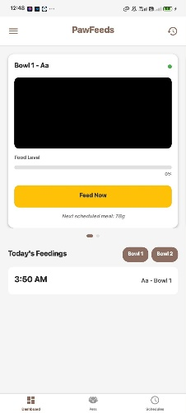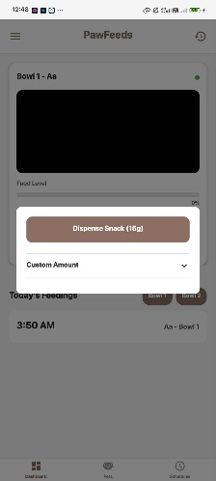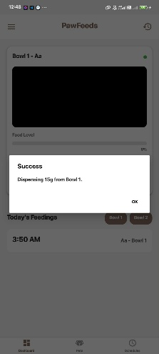
Fig. 5. Dashboard of the React Native mobile application
Through the mobile app interface, users can calculate precise caloric requirements by inputting their dog's weight, energy density, and activity level based on standard Resting Energy Requirement (RER) and Maintenance Energy Requirement (MER) formulas. To ensure accurate portion control, the mobile app calculates the exact amount of food the needs based on the standard veterinary formulas. First, the system calculates the Resting Energy Requirement (RER) based on the dog’s weight in kilograms [4]
RER = 70 x (weight) 0.75
Next, the system determines the Maintenance Energy Requirement (MER) [3] by multiplying the RER by a specific factor based on the dog’s activity level
MER = RER x activity multiplier
By using these calculations, the react native application tells the ESP32 how many grams of dry kibble dog food the auger mechanism needs to dispense for that specific dog.

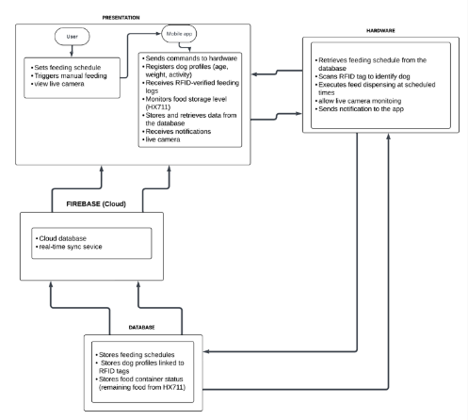
Fig. 6. Conceptual Framework of the PAW FEEDS system
The conceptual framework illustrates the interaction between the user, mobile application, firebase, database, and hardware components of PAW FEEDS system. The presentation layer the user interacts with the mobile application setting the scheduling, monitoring, registers dog profiles and trigger manual feeding. The mobile application developed in React Native, it communicates with both the database and the hardware, sending commands, retrieving data, receiving RFID scans, notifications, and functioning food storage levels that is connected through the Load cell weight sensors. The database serves as the central repository storing all saved feeding schedules, dog profiles, breeds, and food container status that is being measured by load cell. The firebase acts as the cloud backend database service for the PAWFEEDS, this serves as the messenger between the mobile application and local database. Using the firebase authentication, users will be secured while login in, update feeding configurations, and receives real-time notifications. The hardware that consists of layers like the ESP32 Devkit (Master), ESP32-CAM (Slave), RFID/ISO15693 module, and HX711 load cell. RFID scans are being verified in the mobile application if the dog is in the correct dispensing bowl. Notifications and feedback are sent back to the users for monitoring and control.
HARDWARE | FUNCTIONS
ESP32 | Main microcontroller for scheduling and hardware control
ESP32-CAM | Secondary microcontroller dedicated to monitor and lived feed video streaming
MG996R Servo Motor | High Torque-motor used to rotate the 3D- printed auger
HX711 Load Cell | Sensor module used to measure the weight of dry kibble
RFID Reader | Scans the dog’s collar to verify pet profile before automated feeding
RFID unique tags | these tags are unique identifiers worn by each dog; it triggers the device to dispense food after recognizing.
Breadboard | It consists of numerous holes that hold components.
Power Supply | Provides stable electrical power connections to all electronic components.
Feeding Container | Stores dry food and keeps it clean before dispensing.
Wi-Fi | This connects the ESP32 device to the network for the app communication and notifications.
Table 3. Hardware Components and Functions
III. RESULT AND DISCUSSION
The researchers conducted rigorous integration testing to validate both the hardware performance and user acceptance of the PAW FEEDS system.

Hardware and System Performance

The Firebase database securely processed user authentication and real-time data synchronization. The automated scheduling module reliably synchronized with the ESP32’s internal clock via an NTP server, guaranteeing that the servo-driven auger dispensed food at the exact times configured in the mobile app. During the hardware evaluation, the RFID reader was tested and evaluated by scanning the tag 100 times. To ensure the accuracy of the measurements, the tests involved varying distances, ranging from 1-5 cm. The test also involved the use of different RFID tags, each fixed to a different dog collar. The test was conducted in an environment with adequate lighting and ambient temperature. The RFID reader achieved a 95% success rate, identifying the tags for registered dogs prior to the release of the food. The 5% failure was attributed to tags being swiped at excessive speeds or outside the 5cm maximum range. The HX711 load cell was able to measure the weight in the container, and the dispensing mechanism accurately released the calculated kibble portions.

The 5% failure rate was primarily attributed to tags being swiped at excessive speeds. Furthermore, the HX711 load cell effectively monitored the container's weight, and the dispensing mechanism accurately released the calculated kibble portions. To further validate the technical reliability of the PAW FEEDS system, extensive hardware performance tests were conducted. Key metrics including dispensing accuracy, servo motor response time, cloud communication latency, and load cell precisions were evaluated. As illustrated in Table 2, the system was found to be highly efficient, with a 95% accuracy level for the food dispensing and a load cell error level of ±5 g. The average cloud latency between firebase database and the ESP32 microcontroller was recorded at 2 seconds, ensuring near real-time synchronization for remote monitoring and scheduling commands.

Test Parameters | Result | Notes
Total Scanning trials | 100 | Conducted during hardware evaluations
Successful Scans | 95 | Accurately Identified the registered dog’s collar tag
Failed Scans | 5 | Attributed to tags being swiped at fast speed or slow internet connections
Success Rate | 95%
Table 4. RFID reader detection rate

Metrics | Result
RFID Detection Accuracy | 95%
Food Dispensing accuracy | 95%
Load Cell Measurement Error | ±5-10 g
Servo Motor Response Time | 1.3 s
Average Cloud Latency | 10-15 s
ESP32-CAM stream | 15 fps
Table 5. Quantitative System Performance Metrics

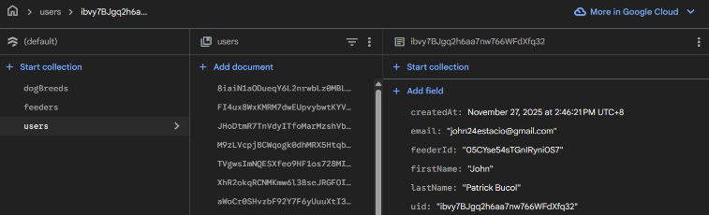Fig. 7. Firebase user account real time data

The middle column of the database interface displays the unique, auto-generated Document IDs assigned to each registered user. Selecting any of these IDs reveals the user's specific data fields in the right-hand panel, including details like their email address, name, and account creation timestamp. This database record is generated and populated immediately after the user completes the account creation and hardware provisioning processes, which is why the document successfully captures and stores the dedicated feederId required to link the user's account directly to their physical smart feeder.

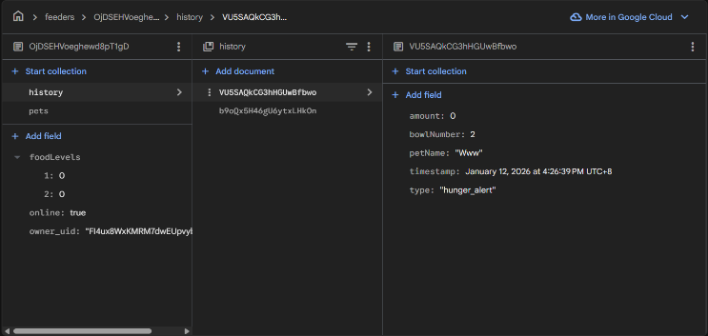Fig. 8. Data of the dog’s activity, kcal, status, portion size, weight, name, and size

The algorithm's baseline portion calculations are rooted in standard veterinary caloric equations. The daily food volume is derived from the subject's Resting Energy Requirement (RER), calculated exponentially as 70 × (body weight in kg) ^0.75. This baseline is then modified by the subject's Maintenance Energy Requirement (MER) multiplier such as adjusting for neutered status or activity level to establish the total daily portion. The system's Dynamic Load-Balancing Algorithm then autonomously divides this total MER across the user's specific daily feeding schedule to ensure accurate per-meal dispensing.

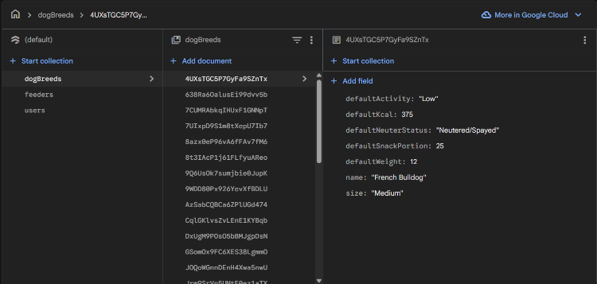Fig. 9. History of successful food dispenses

The system's baseline database categorizes canine subjects into standard veterinary weight classes: Small (< 10kg), Medium (10-25kg), and Large (> 25kg). These classifications align with the physiological and nutritional guidelines established by standard veterinary practice and the European Pet Food Industry Federation (FEDIAF)

User Acceptance
To evaluate the system's usability, reliability, and convenience, a survey was conducted using a 5-point Likert scale (from Strongly Disagree to Strongly Agree). The respondents consisted of 30 dog owners and 5 hands-on evaluators.

Fig. 10. Evaluation overall score of respondents

Based on the survey results, the respondents gave the PAW FEEDS system very positive ratings. Looking at the 5-point Likert scale data, the dog owners strongly agreed that the automated dispenser made it much easier to stick to a strict feeding schedule, which solved the main problem of the project. For the software side, the users found the React Native mobile app very easy to use. They mentioned that changing the feeding times and food portions directly from their phones was very convenient. As for the hardware, the survey showed that the machine accurately dispensed the correct amount of dry food based on the dog's calculated needs. Also, the respondents confirmed that the RFID scanner successfully read the collar tags, making sure that the right dog got the food and preventing other pets from stealing it.
Compared to normal feeding bowls, the evaluators strongly agreed that this IoT setup is a massive improvement over traditional manual feeding. However, one limitation pointed out by the users was the ESP32-CAM live stream. While they liked being able to check the food bowl remotely, the video quality and smoothness dropped if their Wi-Fi connection was slow. Overall, the participants concluded that PAW FEEDS is a reliable system and they would highly recommend it to other busy pet owners.

System Limitations
Although the PAW FEEDS system demonstrated highly reliable performance during experimental evaluation, several operational limitations were identified. Primarily, the system’s live video streaming via ESP32-CAM is highly dependent on the stability of the Wi-Fi connectivity. Consequently, the video quality and frames may be affected under poor network conditions. The RFID reader’s detection range is strictly limited to a maximum of 3-5 cm. the hardware limitation requires the unique tags to be positioned directly adjacent to the feeder’s scanning module to ensure successful authentication prior to the food being dispensed.

IV. CONCLUSION AND FUTURE WORKS
The PAW FEEDS system successfully addressed the challenges of inconsistent pet feeding by providing a reliable, IoT-based automated dispenser. By Integrating a dual -microcontroller setup (ESP32-CAM) an auger dispensing mechanism, and RFID technology, the system effectively automated feeding schedules while ensuring precise, individualized portions control based on the standard veterinary calculations (RER and MER). The React Native mobile application provided an efficient platform for using the remote scheduling and live monitoring. Rigorous testing was demonstrated strong hardware performance, highlighted by a 95% success rate in RFID tag detection and accurate weight monitoring via load cell. User acceptance evaluations confirmed that the system is a massive improvement over the traditional feeding manual, overall, this gives peace of mind to the busy dog owners.

For future enhancements, researchers suggest adding a dedicated battery backup to maintain the feeder’s operation during power fluctuates or power failures. Additionally, upgrading the camera module or optimizing video compression would minimize the systems inconsistent fps drops and reliant on strong Wi-Fi, ensuring smoother real-time monitoring.

ACKNOWLEDGMENT
The researchers would like to express their deepest gratitude to for the continuous prayers, strength, and guidance that sustained them throughout this study.
Sincere appreciation goes to our adviser, Mr. Jhon Paul I. Arip, MIT, for his technical mentorship and guidance, and to Mr. Jason A. Catadman, MIT, along with our beloved defense panelist, for their constructive feedback.
We also thank the dog owners and evaluators who tested the PAW FEEDS system. Finally, to our parents, families, and friends, thank you for your unwavering emotional and financial support during long nights of development and testing.

References

[1] | A. S. Gillis, "What is IoT (internet of things)?," 21 july 2025. [Online]. Available: https://www.techtarget.com/iotagenda/definition/Internet-of-Things-IoT.
[2] | M. A. Boateng and A. R. Akparibo, December 2022. [Online]. Available: https://ieeexplore.ieee.org/abstract/document/10031807.
[3] | P. N. Alliance, 2023. [Online]. Available: https://petnutritionalliance.org/wp-content/uploads/2023/03/MER.RER_.PNA_.pdf.
[4] | E. Carlson, "Today's Veterinary Nurse," 12 May 2023. [Online]. Available: https://todaysveterinarynurse.com/nutrition/veterinary-nutrition-math/.
[5] | D. A. P. E. N. S. W. D. E. W. M. M. Henry Dietz, "Electronic Imaging," January 2022. [Online]. Available: 10.2352/EI.2022.34.7.ISS-232.
[6] | E. f. I. A. C. Guide, "Nabto," 2025. [Online]. Available: https://www.nabto.com/guide-to-iot-esp-32/.
[7] | O. C. T. &. A. What is a Servo Motor: Definition, "Advanced Motion Controls," 30 May 2025. [Online]. Available: https://www.a-m-c.com/servomotor/.
[8] | A. Hayes, "Investopedia," 25 August 2025. [Online]. Available: https://www.investopedia.com/terms/r/radio-frequency-identification-rfid.asp.
[9] | M. C. G. Cabaltera, K. C. Cuaresma , A. B. Flores and N. P. Palba, "LPU–Laguna Journal of Engineering and Computer Studies," August 2018. [Online]. Available: https://lpulaguna.edu.ph/wp-content/uploads/2018/12/3-GSM-CONTROLLED-DOG-FEEDER-AND-AUTOMATIC-WATER-DISPENSER-USING-RASPBERRY-PI.pdf. [Accessed 23 March 2026].
[10] | A. A. Zainuddin, M. N. B. Mahazir, M. A. A. Adanan and M. H. A. Samsudin, "ResearchGate," December 2024. [Online]. Available: https://www.researchgate.net/publication/398822681_Design_and_Implementation_of_a_Mobile-Controlled_IoT_Smart_Pet_Feeder_for_Busy_Pet_Owners#fullTextFileContent.
[11] | T. Setiadi and T. I. Arifiandi, "ResearchGate," December 2024. [Online]. Available: https://www.researchgate.net/publication/388735706_Development_of_an_IoT-Enabled_Automatic_Poultry_Feeder_and_Cage_Temperature_Monitoring_System_Using_Microcontroller_Technology#fullTextFileContent.
[12] | E. M. Indrawati , B. Suprianto and U. T. Kartini, "Journal of Engineering Research and Reports," 28 February 2025. [Online]. Available: https://journaljerr.com/index.php/JERR/article/view/1417/3015.
[13] | P. N. Nitnaware, RiteshLaxmanItankar, L. G. Kurekar, A. S. Rangari, BhagwanGangadharDharmik and SanketSudhirMankar, "International Journal of Advances in Engineering and Management (IJAEM)," 5 May 2025. [Online]. Available: https://ijaem.net/issue_dcp/Intelligent%20Pet%20Feeder%20with%20Real%20Time%20Camera%20Monitoring.pdf.
[14] | A. V. C. Rangel, I. U. P. Monarrez and I. Soto, "ResearchGate," December 2024. [Online]. Available: https://www.researchgate.net/publication/390357734_Automatic_Pet_Feed_System_Applying_IoT#fullTextFileContent.

