**axis_data_gen**

Documentation

**Content**

**Table of Contents**

1 Introduction 3

1.1 Feature List 3

1.2 Modes of Operation 3

1.2.1 Continuous Trigger Generation 3

1.2.2 Sporadic Trigger Generation 5

2 Interfaces 6

2.1 GUI 6

2.1.1 General Configuration 6

2.1.2 Reset Values 7

2.2 Registers 8

2.2.1 Overview 8

2.2.2 Register Descriptions 8

# Introduction

The purpose of this IP is to generate AXI-stream traffic in a controlled way for testing purposes. The traffic generated contains counter values with configurable trigger/TLAST flags.

## Feature List

* Up to 32-bit data width
* Configurable data- and trigger-rate
* Different trigger generation schemes
  + Continuous: Generate a trigger every N samples
  + Sporadic: Generate X triggers, N samples apart and then stop generating triggers
* Generate single cycle triggers and/or TLAST (handshake)
* Static configuration possible
  + In this case no software to configure the core is required
  + Feature-set is slightly reduced
* Backpressure can be handled (data topped if TREADY low) or ignored

## Modes of Operation

### Continuous Trigger Generation

#### Back-to-Back data

The figure below shows an example waveform for the following settings:

DATA_SPAC 0  
DATA_WRP 4  
TRIG_OFFS 3  
TRIG_SPAC 1



#### Reduced Data-Rate

The figure below shows an example waveform for the following settings:

DATA_SPAC 1  
DATA_WRP 4  
TRIG_OFFS 3  
TRIG_SPAC 1



#### Reduced Back-Pressure

The figure below shows an example waveform for the following settings:

DATA_SPAC 1  
DATA_WRP 4  
TRIG_OFFS 3  
TRIG_SPAC 1  
CFG_USERDY 1



### Sporadic Trigger Generation

The figure below shows an example waveform for the following settings:

DATA_SPAC 0  
DATA_WRP 4  
TRIG_OFFS 3  
TRIG_SPAC 1

At the point marked with a dashed line, the trigger counter is set to two. The signal *Trig_Internal* shows the internal trigger signal (unsuppressed trigger) that is not visible to the ports. It is only shown to depict that the trigger alignment does not change if sporadic triggering is used.



# Interfaces

## GUI

### General Configuration

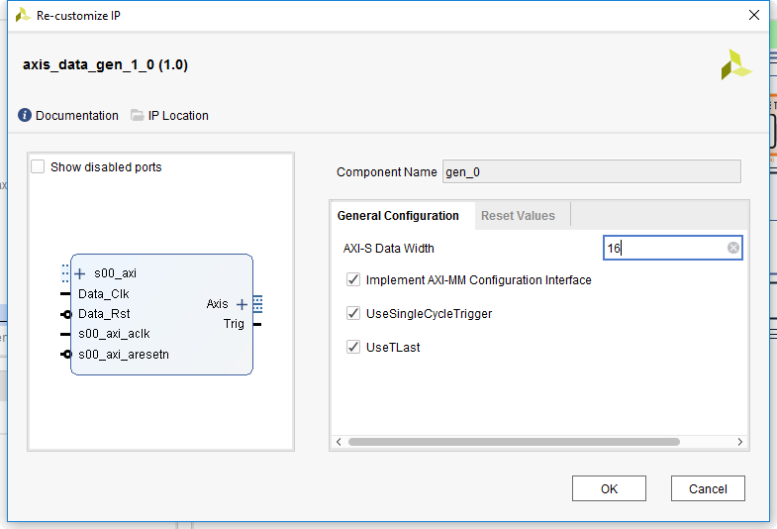

This page contains the following parameters

* AXI-S Data Width
  + Width of the AXI-S data port in bits
* Implement AXI-MM Configuration interface
  + If set, the core can be configured via an AXI-MM register bank
  + If not set, no runtime configuration is possible and the core starts generating data directly after the reset according to the settings on the page *Reset Values*
* UseSingleCycleTrigger
  + If set, a *Trig* output port is generated that contains trigger pulses that are exactly one clock cycle long.
  + If not set, the *Trig* output is omitted
* UseTlast
  + If set, the trigger signal is applied to TLAST (synchronous to the handshaking of course) according to the AXI-S specification
  + If not set, the TLAST port is omitted

### Reset Values

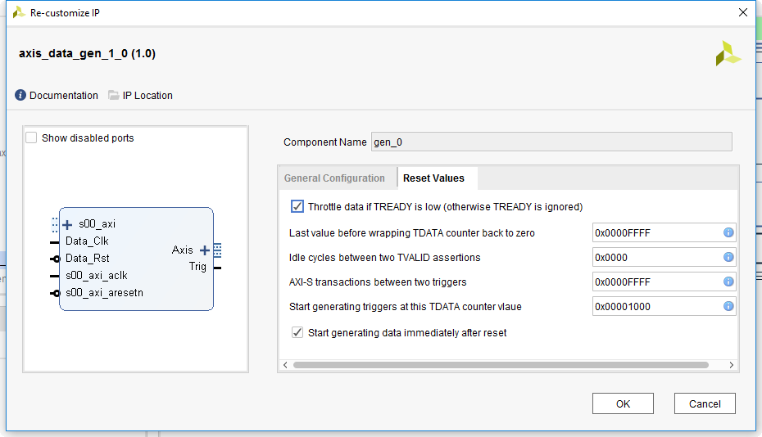

This page of the GUI contains the reset values for all registers required to generate data without an AXI-MM interface.

If an AXI-MM port is implemented, it is recommended to do all settings over this port instead of using the parameters in this GUI page.

Note that data can be entered in hex (*0x1234ABCD*), binary (*0b00100111*) or decimal (*0d1234*). Vivado detects the prefix automatically and does the conversion.

## Registers

### Overview

|  |  |  |
| --- | --- | --- |
| Byte Address Offset | Name | Description |
| 0x000 | CFG_ENA | Enable data generator |
| 0x004 | CFG_USERDY | Use TREADY signal for back-pressure handling |
| 0x010 | DATA_WRP | Last value before wrapping the data counter |
| 0x014 | DATA_SPAC | Number of clock cycles between two samples |
| 0x020 | TRIG_OFFS | Counter value to generate the first trigger at |
| 0x024 | TRIG_SPAC | Number of samples between two triggers |
| 0x028 | TRIG_SPOR_EN | Enable sporadic triggering |
| 0x02C | TRIG_SPOR_LD | Load sporadic trigger counter |
| 0x030 | TRIG_SPOR_CNT | Sporadic trigger counter |
| 0x040 | RDYLO | Ready-low detection |
| 0x050 | STAT_DATACNT | Current data counter |
| 0x054 | STAT_TRIGLEFT | Number of triggers left to generate in sporadic moe |

### Register Descriptions

#### CFG_ENA – Enable data generator (0x00)

|  |  |  |  |  |
| --- | --- | --- | --- | --- |
| Field | Bit(s) | Type | Reset | Description |
| ENA | 0 | RW | See GUI | 1 Data generator enabled 0 Data generator disabled |

If the data generator is disabled, all values are set to their initial value. So the data counter starts at zero ond the first trigger is generated at *TRIG_OFFS* after re-enabling.

#### CFG_USERDY – Use TREADY signal for back-pressure handling (0x04)

|  |  |  |  |  |
| --- | --- | --- | --- | --- |
| Field | Bit(s) | Type | Reset | Description |
| USERDY | 0 | RW | See GUI | 1 TREADY is used, when TREADY is ‘0’, the data   counter is stopped.  0 TREADY is ignored |

This register must not be changed while the data generator is running.

#### DATA_WRP – Last value before wrapping the data counter (0x10)

|  |  |  |  |  |
| --- | --- | --- | --- | --- |
| Field | Bit(s) | Type | Reset | Description |
| WRP | 31:0 | RW | See GUI | Last counter value before the data counter is wrapped back to zero.  Example: WRP = 13 leads to the counter sequence  …, 10, 11, 12, 13, 0, 1, 2 , … |

This register must not be changed while the data generator is running.

#### DATA_SPAC – Number of clock cycles between two samples (0x14)

|  |  |  |  |  |
| --- | --- | --- | --- | --- |
| Field | Bit(s) | Type | Reset | Description |
| SPAC | 15:0 | RW | See GUI | Number of clock cycle TVALID is held low between two samples. Apply 0 for back-to-back data generation. |

This register must not be changed while the data generator is running.

#### TRIG_OFFS – Counter value to generate the first trigger at (0x20)

|  |  |  |  |  |
| --- | --- | --- | --- | --- |
| Field | Bit(s) | Type | Reset | Description |
| OFFS | 31:0 | RW | See GUI | Counter value the trigger generation is started at. The first trigger is generated together with the sample number given in this register. |

This register must not be changed while the data generator is running.

#### TRIG_SPAC – Number of samples between two triggers (0x24)

|  |  |  |  |  |
| --- | --- | --- | --- | --- |
| Field | Bit(s) | Type | Reset | Description |
| SPAC | 31:0 | RW | See GUI | Number of samples between two triggers. Apply 0 for generating a trigger with each sample. |

This register must not be changed while the data generator is running.

#### TRIG_SPOR_EN – Enable sporadic triggering (0x28)

|  |  |  |  |  |
| --- | --- | --- | --- | --- |
| Field | Bit(s) | Type | Reset | Description |
| ENA | 0 | RW | 0 | 0 Triggers are generated continuously 1 Triggers are only generated when requested by   the sporadic trigger settings. |

This register is always reset to zero since sporadic triggering only makes sense if an AXI-MM interface is present. Otherwise the triggering would never be started (because it is started through the AXI-MM interface).

#### TRIG_SPOR_LD – Load sporadic trigger counter (0x2C)

|  |  |  |  |  |
| --- | --- | --- | --- | --- |
| Field | Bit(s) | Type | Reset | Description |
| LOAD | 0 | W | - | Write 1 to set the sporadic trigger counter. |

After the sporadic trigger counter is set, triggers are generated and the counter is decremented until it arrived at zero. After N triggers, the counter is zero and no more triggers are generated.

The *TRIG_SPAC* settings stay valid during sporadic triggering. Also do the trigger still occur at the positions given by *TRIG_OFFS* and *TRIG_SPAC*. If the sporadic trigger counter is zero, triggers are just suppressed but their alignment does not change.

#### TRIG_SPOR_CNT – Sporadic trigger counter (0x30)

|  |  |  |  |  |
| --- | --- | --- | --- | --- |
| Field | Bit(s) | Type | Reset | Description |
| CNT | 31:0 | RW | - | Number of triggers to generate after *TRIG_SPOR_LD* is asserted |

#### RDYLO – Ready-low detection (0x40)

|  |  |  |  |  |
| --- | --- | --- | --- | --- |
| Field | Bit(s) | Type | Reset | Description |
| WASLO | 0 | RCW1 | 0 | This bit is set when TREADY=’0’ delayed the data generation.  Write 1 to clear the bit. |

This functionality is very useful to see if the downstream logic (logic receiving the values generated) can handle the data-rate. If it cannot, pulls TREADY low which is detected here.

#### STAT_DATACNT – Current data counter (0x50)

|  |  |  |  |  |
| --- | --- | --- | --- | --- |
| Field | Bit(s) | Type | Reset | Description |
| CNT | 31:0 | R | 0 | Current value of the data counter |

#### STAT_TRIGLEFT – Current trigger counter (0x54)

|  |  |  |  |  |
| --- | --- | --- | --- | --- |
| Field | Bit(s) | Type | Reset | Description |
| CND | 31:0 | R | 0 | Current value of the trigger counter used for sporadic trigger generation. |