AmmiAbba Project



This SRS (Software Requirement Specification) is based on the telephonic conversation with the client. Project will be initiated after the signoff from client based on this SRS.

User Section

1. Homepage as per the design mockup provided by the client.
2. **Scenario I:**  
   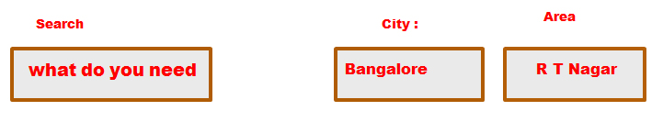

User does a search for a service from the main search panel on homepage.

Once a search is made he will see a form where he can put his requirement, partly prefilled by the data already provided by him. I.e. City and area. (See the image above)

On successful submission of the form following events will happen.

Data goes to a database.

Customer receives an Email confirmation

Admin receives an Email Alert

Admin receives an SMS Alert (* Needs subscription by the client.)

1. **Scenario II:**  
   
   1. User clicks on any of the boxes on the homepage.
   2. He is navigated to next page with the relevant form.
   3. On successful submission of the form following events will happen.

Data goes to a database.

Customer receives an Email confirmation

Admin receives an Email Alert

Admin receives an SMS Alert

**\*** Client will be required to purchase a subscription pack for sending SMS online.

Admin Section

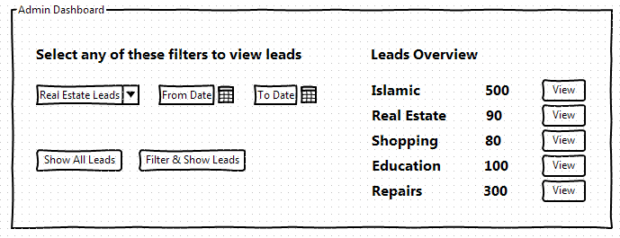

1. Login and Signup functionality
2. Dashboard (Home Screen):
   1. Admin would see a form with dropdowns to filter down results based on certain criteria
   2. Option to view all leads for a selected or all categories all at once (or with some limitation like 20 records at a time with page1, page2, page3 type pagination).
   3. Sort a given set of records by date, city, category etc.
3. Viewing Leads will happen in two steps.
   1. All Leads for a given category will get displayed on the first screen with “view” and “delete” action items (Fig 2.2). Pagination will appear only for leads more than 20 in a screen. Clicking on “delete” will delete this lead from the database.  
      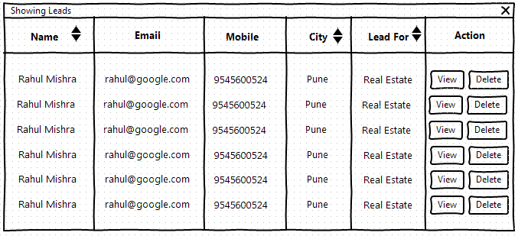

**Fig 2.2**

* 1. Clicking on “view” action will open this particular lead in another page with further, complete information (Fig 2.3).

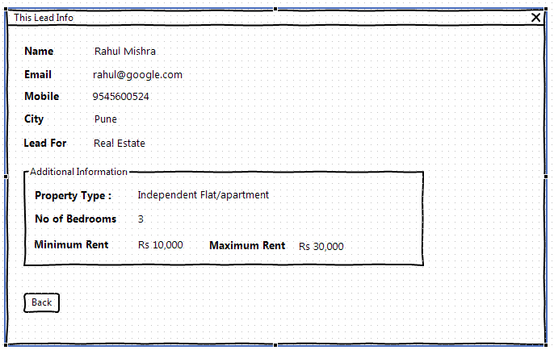

**Fig 2.3**

**------------------------------------------------------------------------------------------------------------------------------------------------------------------**

SRS Version: 1.0

Documented By: Micky Mishra

Date: 7th November 2013