Transportation Partner Requirements
Arrival and Handling Guidelines
- Packing/transportation crew should arrive at the designated time with all required materials to fulfill Device Packing Standards
  - Floor covering may be required to protect floors, to cover carpeted areas or to be used when floors have a rough surface – The CSG PM will coordinate this with the client, facilities team and transportation partner during planning
- Equipment will be handled with care and in a professional manner
  - Team lifting of all equipment or when moving racks at all times - This means a minimum of two resources packing each device
NOTE: Partner acknowledgment of electronic equipment being transported and confirmation that utmost care will be taken in handling
Device Packing Standards – See Appendix A for reference pictures
- Onsite packing is required for all services (except were agreed to with customer)
  - Servers/Devices
    - Large bubble anti-static bubble wrap is required
    - All servers/devices should be individually wrapped
    - Machine carts (or gondola’s) for in town transportation
    - D-containers (or properly sized equivalent) for long haul jobs
    - Wooden crates for International and/or Air Freight Shipments
  - Racks
    - Blanket wrap, corner boards and shrink-wrap racks initially
    - Blanket wrap prior to strapping in vehicle
    - Triple strap or logistic bars for securing within the vehicle
  - International and/or Air Freight shipments require custom crating - onsite wood crating is mandatory
  - LTL Freight shipments that require custom crating – wood crating is mandatory
    - Speed packs should NOT be used.
    - D-containers (or smaller C-E containers) are acceptable in most cases
    - Wooden crates for EMC/All Storage devices or as required by customer
NOTE: While off site crating may be easier and a preferred method for the transport partner, onsite crating under CSG supervision is required for chain of custody assurance
Transportation Vehicle Standards
- Minimum requirement - Air ride truck with a lift gate or a Sprinter van depending on load size.
- Dedicated/direct transportation,
  - GPS tracked,
  - Truck’s cargo door sealed with security seal with serial#.
  - Climate controlled with (2) team drivers for long hauls (greater than 4 hours)
    - For security reasons the truck must never be left unattended
- LTL transportation for less time sensitive equipment and gear that has a bigger downtime window
  - On site crating is preferred
  - Scheduled delivery required
    - We understand this is usually a delivery window, i.e. 10 AM – 12 PM
- Overnight air freight/commercial air/chartered air
  - On site crating is required
- International shipments
  - Client is responsible for all customs paperwork and associated VAT
  - Optional Service – CSG transportation partner may handle the import/export paperwork, taxes, duties, etc if client compliance allows. There is additional cost for this service
Communication Standards
- Dedicated Direct Method – Short Haul (less than 4 hours)
  - Incremental updates on truck status via email
  - Truck departure, duration midpoint and 1 hour out at an absolute minimum
- Dedicated Direct - Long Haul
  - Follow the minimum requirements plus updates every 4-6 hours based on PM/Customer requirements
- LTL or Air Freight
  - As agreed to by method standards and PM requirements
Truck rendered incapable to proceed
- If truck breaks down or is rendered incapable of proceeding due to accident, transport company will promptly send replacement truck and oversee transfer of Equipment to new truck.
  - Customer will cooperate as necessary to affect the transfer.
Appendix A - Sample Pictures:
- Proper wrapping of a server using large bubble anti-static bubble wrap
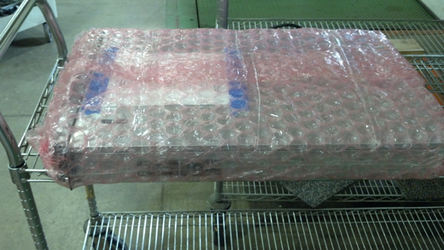
- Proper packing/wrapping of a D-Container
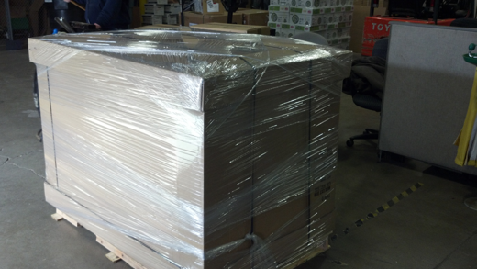
- Machine Cart (shrink wrapped to ensure nothing falls off the machine cart)
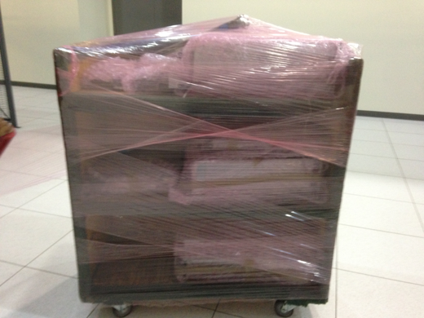
- Properly Packed rack (corner board and shrink wrap)
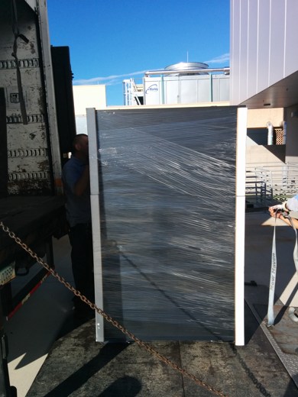
- Properly Secured Rack (blankets & triple strapping always required)
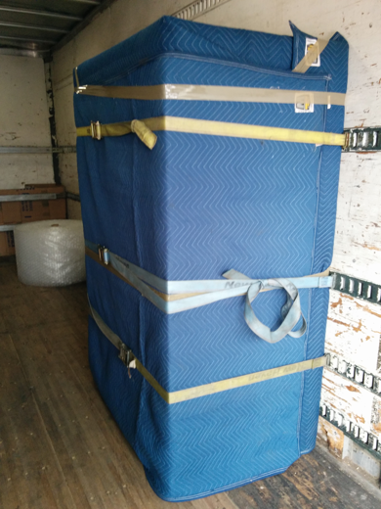
- Onsite Crating
