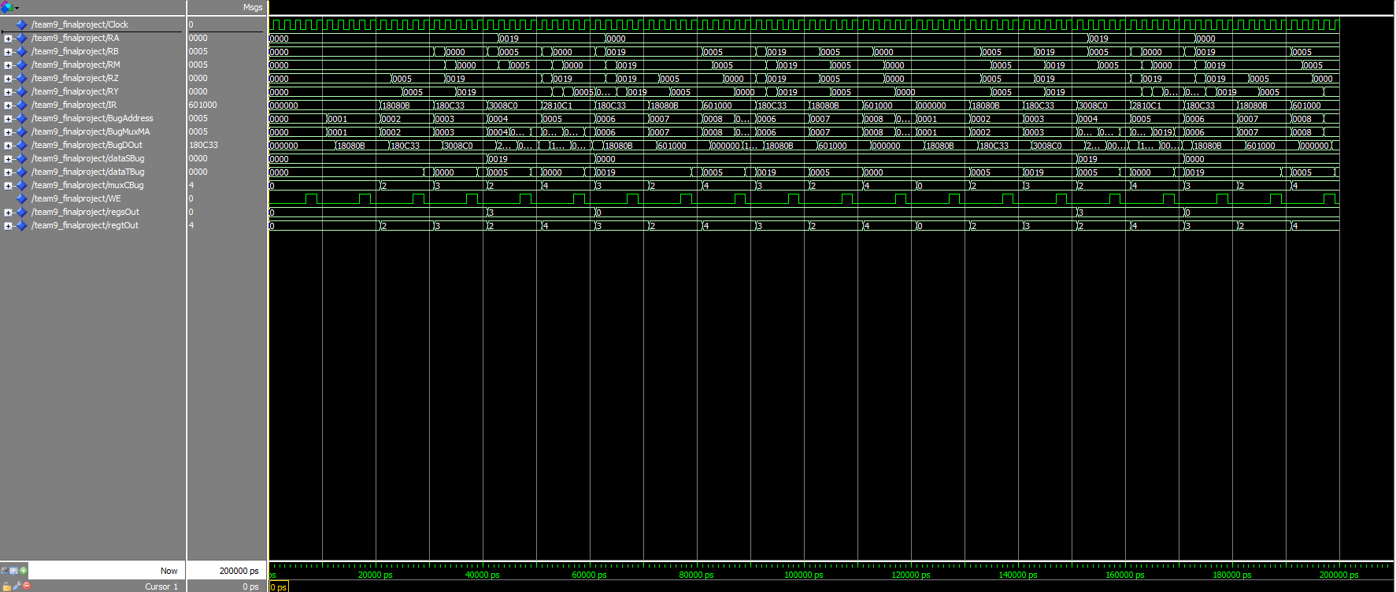
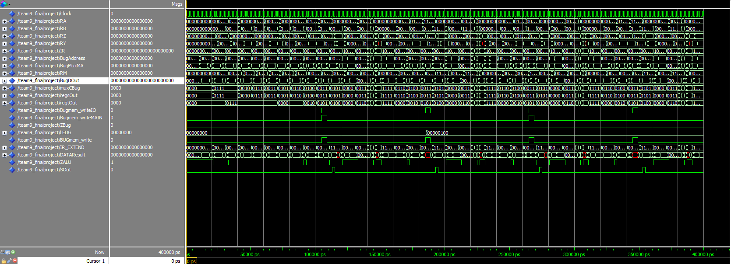

CSCE 230 Final Project
Version 2.0

Created By Valentino Hahn,
Ja’lon Clark, and Derek Vogel

- Implemented Instructions
The basic instructions in this processor are made up of three types: Double Operand (D), Single Operand (S), and Jump (J). All instructions consist of 24 bits and all vary according to the instruction type, as shown below. In addition, conditional execution can be implemented to every instruction by altering the condition bits to match each of the condition flags set within the control unit.

  - D-Types - Double Operand instructions are utilized when using two registers for basic arithmetic, load, and store.

    - ADD - Known as the addition instruction, this instruction adds the value in the register (according to its source value) plus to the destination register (according to its destination value) to the destination register. The ALU op code is set to be 00. It then computes the operation in the control unit then stores it into RZ, then to RY, then to the destination register specified in the instruction. This instruction is capable of taking in immediate values from -16 to +15 to replace the source register in computation.

0 | 0 | 0 | 1 | 1 | 0 | 0 | 0 | 0 | 0 | X | X | X | X | X | X | X | X | 0 | 0 | 0 | 0 | 0 | 0
OPCODE |  |  |  |  | COND |  |  |  | S | SOURCE |  |  |  | DESTINATION |  |  |  | IMMEDIATE |  |  |  |  | T

    - SUB - Known as the subtraction instruction, this instruction takes the value in the destination register (according to its destination value) and subtracts it by the source register (according to its source value). The difference will be set to the destination register. Within the control unit it sets the alu_op instruction to be 00 like add, but the difference is in the source register, the bits are inverted by setting the b_inv bit to 1 coming out of the control unit. It then computes the operation in the control unit then stores it into RZ, then to RY, then to the destination register specified in the instruction. This instruction is capable of taking in immediate values from -16 to +15 to replace the source register in computation.

0 | 0 | 1 | 0 | 0 | 0 | 0 | 0 | 0 | 0 | X | X | X | X | X | X | X | X | 0 | 0 | 0 | 0 | 0 | 0
OPCODE |  |  |  |  | COND |  |  |  | S | SOURCE |  |  |  | DESTINATION |  |  |  | IMMEDIATE |  |  |  |  | T

    - AND - This instruction will utilize logic “and” between the same bits between of the source and destination registers and sets the new value to the destination register. It sets the ALU_op within the control unit to be 10. It then sends the registers to the ALU and ands the two bitmaps. After computation, the value is stored into RZ, then to RY, then to the destination register. This instruction is capable of taking in immediate values from -16 to +15 to replace the source register in computation.

0 | 0 | 0 | 1 | 0 | 0 | 0 | 0 | 0 | 0 | X | X | X | X | X | X | X | X | 0 | 0 | 0 | 0 | 0 | 0
OPCODE |  |  |  |  | COND |  |  |  | S | SOURCE |  |  |  | DESTINATION |  |  |  | IMMEDIATE |  |  |  |  | T

    - OR - This instruction will utilize logic “or” between the same bits between of the source and destination registers and sets the new value to the destination register. It sets the ALU_op within the control unit to be 11. It then sends the registers to the ALU and ors the two bitmaps. After computation, the value is stored into RZ, then to RY, then to the destination register. This instruction is capable of taking in immediate values from -16 to +15 to replace the source register in computation.

0 | 0 | 0 | 0 | 1 | 0 | 0 | 0 | 0 | 0 | X | X | X | X | X | X | X | X | 0 | 0 | 0 | 0 | 0 | 0
OPCODE |  |  |  |  | COND |  |  |  | S | SOURCE |  |  |  | DESTINATION |  |  |  | IMMEDIATE |  |  |  |  | T

    - XOR - This instruction will utilize logic “exclusive or” between the same bits between of the source and destination registers and sets the new value to the destination register. It sets the ALU_op within the control unit to be 01. It then sends the registers to the ALU and ors the two bitmaps. After computation, the value is stored into RZ, then to RY, then to the destination register. This instruction is capable of taking in immediate values from -16 to +15 to replace the source register in computation

0 | 0 | 0 | 0 | 0 | 0 | 0 | 0 | 0 | 0 | X | X | X | X | X | X | X | X | 0 | 0 | 0 | 0 | 0 | 0
OPCODE |  |  |  |  | COND |  |  |  | S | SOURCE |  |  |  | DESTINATION |  |  |  | IMMEDIATE |  |  |  |  | T

    - LD - This instruction will load what is corresponding in the memory from the source register to the destination register. It sets the ALU_op within the control unit to be 00, so it computes an add for offsets. Then other selector bits to send it to one of the memory interfaces. Then in stage 4, It sets y_select to be 1 in which the value from one of the memory interfaces accessed will be stored into RY, then into the register. But before that, it sets MA_Select to be 0 to include the offset from the ALU, then sets mem_read to 1 to load from the specified address. This instruction is capable of taking in immediate values from -16 to +15 to replace the source register in computation

0 | 0 | 1 | 0 | 1 | 0 | 0 | 0 | 0 | 0 | X | X | X | X | X | X | X | X | 0 | 0 | 0 | 0 | 0 | 0
OPCODE |  |  |  |  | COND |  |  |  | S | SOURCE |  |  |  | DESTINATION |  |  |  | IMMEDIATE |  |  |  |  | T

    - ST - This instruction stores what is in the memory (according to the offset of the source register) and sets it to the destination register. It sets the ALU_op within the control unit to be 00, so it computes an add for offsets. Then other selector bits to send it to one of the memory interfaces. Then in stage 4, It sets y_select to be 1 in which the value from one of the memory interfaces accessed will be stored into RY, then into the register. But before that, it sets MA_Select to be 0 to include the offset from the ALU, then sets mem_write to 1 to load from the specified address. This instruction is capable of taking in immediate values from -16 to +15 to replace the source register in computation

0 | 0 | 1 | 1 | 0 | 0 | 0 | 0 | 0 | 0 | X | X | X | X | X | X | X | X | 0 | 0 | 0 | 0 | 0 | 0
OPCODE |  |  |  |  | COND |  |  |  | S | SOURCE |  |  |  | DESTINATION |  |  |  | IMMEDIATE |  |  |  |  | T

a.viii) CMP - this instruction will subtract the source and destination register from each other in stage 3, then will save any flags coming out of the ALU to the PS register, to be used for later instructions, such as JEQ. It sets the ALU_op within the control unit to be 00 and the b_inverse flag to 1. It then sends the registers to the ALU and subtracts the two bitmaps. After computation, the value is stored into RZ, then to RY, then to the destination register. Out of the ALU, if any of the alu_flags are set, such as zero or negative, it updates the PS register which feeds back into the control unit for future instructions. This instruction is capable of taking in immediate values from -16 to +15 to replace the source register in computation
0 | 0 | 1 | 1 | 1 | 0 | 0 | 0 | 0 | 1 | X | X | X | X | X | X | X | X | 0 | 0 | 0 | 0 | 0 | 0
OPCODE |  |  |  |  | COND |  |  |  | S | SOURCE |  |  |  | DESTINATION |  |  |  | IMMEDIATE |  |  |  |  | T

  - S-Types - Single Operand instructions are utilized when using one register for setting values of the register such as increment, decrement, etc.

    - INC - The increment instruction will add a single immediate value of 1 to the destination register and sets the sum to the destination register. It sets the ALU_op within the control unit to be 00, similar to an add, and sets the immediate value to be 1 and the immediate selector to be 1. Within the ALU, it will add 1 to the destination register, set that value into RZ, then to RY, then to the source register.

0 | 1 | 0 | 0 | 1 | 0 | 0 | 0 | 0 | 0 | X | X | X | X | X | X | X | X | 0 | 0 | 0 | 0 | 0 | 0
OPCODE |  |  |  |  | COND |  |  |  | S | SOURCE |  |  |  | UNUSED

    - DEC - The decrement instruction will subtract a single immediate value of 1 to the destination register and sets the difference to the destination register. It sets the ALU_op within the control unit to be 00, and b_inv to be 1, similar to a sub instruction, and sets the immediate value to be 1 and the immediate selector to be 1. Within the ALU, it will subtract 1 from the destination register, set that value into RZ, then to RY, then to the source register.

0 | 1 | 0 | 0 | 0 | 0 | 0 | 0 | 0 | 0 | X | X | X | X | X | X | X | X | 0 | 0 | 0 | 0 | 0 | 0
OPCODE |  |  |  |  | COND |  |  |  | S | SOURCE |  |  |  | UNUSED

    - CLR - The clear instruction will clear all of the bits of the destination register to 0. It sets the ALU_OP to be 10, and then sets the extend bits to 00, which will turn all of the bits in the register to 0. It then goes through the ALU, comes out as still 0, then it is stored into RZ, then to RY, then to the destination register.

0 | 0 | 1 | 0 | 0 | 0 | 0 | 0 | 0 | 0 | X | X | X | X | X | X | X | X | 0 | 0 | 0 | 0 | 0 | 0
OPCODE |  |  |  |  | COND |  |  |  | S | SOURCE |  |  |  | UNUSED

    - JR - This jump instruction sets the value program counter (pc) to the destination register. The next instruction will be at the destination register’s value. It sets the ALU_OP code to be 00, and the extend to be 00, to make the source register value extend to 16 bits. It then in stage 4 sets pc_enable to 1, and pc_select and inc_select to 0. This will replace the current PC value with that in the source register.

0 | 0 | 1 | 0 | 0 | 0 | 0 | 0 | 0 | 0 | X | X | X | X | X | X | X | X | 0 | 0 | 0 | 0 | 0 | 0
OPCODE |  |  |  |  | COND |  |  |  | S | SOURCE |  |  |  | UNUSED

  - J-Types - Jump instruction are utilized for transporting to a new location.

    - J - Jumps to the relative address. It adds the label value to the current PC value, and then jumps to the specified instruction. It does not set an ALU_OP code but instead sets pc_select, inc_select and b_select all to be 1. No ALU code needs to be set because within the PC there is an adder. Then it goes into the PC and adds the label value to the current PC value, and jumps to the specified address. The instruction does not return anything.

1 | 0 | 0 | 0 | 0 | 0 | 0 | 0 | 0 | 0 | X | X | X | X | X | X | X | X | X | X | X | X | X | X
OPCODE |  |  |  |  | COND |  |  |  | LABEL

    - JL - Jumps to the relative address and stores the return address in the RA. This will save the address in the link register, r15. It does not set an ALU_OP code but instead sets pc_select, inc_select and b_select all to be 1, along with y_select to be 01 to set the return value into the link register. No ALU code needs to be set because within the PC there is an adder. Then it goes into the PC and adds the label value to the current PC value, and jumps to the specified address. The instruction returns the old PC value into the link address, which is r15.

1 | 0 | 0 | 0 | 1 | 0 | 0 | 0 | 0 | 0 | X | X | X | X | X | X | X | X | X | X | X | X | X | X
OPCODE |  |  |  |  | COND |  |  |  | LABEL

- Components
  - ALU- handles the arithmetic of the selected operations. It can handle AND,OR,XOR, ADD, and SUB. The selector bit comes from bits 24 to 20 of the instruction. The ALU takes in two values and an ALU_OP code, which will tell the ALU what to do. Within the ALU, there are two multiplexers to determine if there are any inverted bits (for subtraction or other bits). They are then fed into a series of functions that determine the specified instruction, and then executes. A final multiplexer determines the output from the alu determined by the ALU_OP code, and then outputs it.
  - Control Unit- handles the instructions sends the op-code to the ALU, determines which memory addresses to access for loading and storing from the instruction. It takes in the clock, a reset bit, a mfc bit, an S bit, NCVZ ALU flags, 4 condition bits, and the 5 bit op-code. Within the control unit, from the inputs, it sets certain bits based on the instruction to be used for later phases. The condition flags within the control unit are a set of enable signals that are determined by the condition bits and the NCVZ flags. The control unit works in 5 stages, as indicated within it. The stages are: fetch, decode, calculate, memory, and writeback. Within the first and second stages, all the control unit does is reset the specified outputs, and input the source and destination registers. In stage 3, the multiplexer selector bits are set and the ALU_OP codes are set based on the instructions and then are sent to the ALU for processing, or to the PC register for branches. For stage 4, the control unit specifies storing the output into another register (RY), or accessing the two memory interfaces. In stage 5 the control unit says to store the values in a specified register (r1-r15).
  - Mux B- used to select either an immediate value operation or a register to register operation. 0 is for register operations, using RB, 1 is for immediate operations.
  - Mux Y-Used to select between the ALU output, the memory output, the IO output, and the address generator output to be put into RY.
  - PS- stores the flags from the ALU if the S bit in the instruction is set. Commonly used by CMP. It takes in the NCVZ flags from the ALU.
  - IR- Instruction Register, directly stores the instructions.
  - RA-stage buffer register for RA before going into the ALU.
  - RB-stage buffer register for RB before going into the ALU.
  - MuxC: This selects what the destination register will be, which in this case will either be the destination instruction or the link register
  - Instruction address generator: This is the PC and will help determine the instruction that will be executed next. If no jump instruction is used, the value of the PC automatically increments until the program stops being executed. Within it, there is an adder, which specifies offsets, and allows for jumps.
  - memory interface: Used to store and retrieve values in the main memory. This is determined by the address and the memory data. However it can only be accessed during load and store instructions, where mem_read and mem_write are set.
  - MuxMA: determines the address for the main memory access, or IO memory access.
  - src switch: generates access to the source and destination registers based off of the instructions
  - RegFlags: Stores the flags in the ALU into a register to be used for future instructions
  - MemWriteSelector: This will or the 4 most significant bits in the address, and if any of them are 1 then the mem_write bit from the control unit will go into the IO memory. If not, then the bit will go into the Main memory.
  - IO_MemoryInterface: This is where the values of IO devices are stored and loaded from. The address is determined by the 4 most significant bits from MuxMA. The end result is it takes in slider switches and key buttons from the board, then outputs a Hex display or green LED lights.

- Processor Speed
When utilizing the base clock speed of 2000ps per cycle, the processor worked as planned, incrementing and executing instructions like it’s supposed to. However when even trying to double that speed to 1000ps per cycle, the processor began breaking. By the time the next instruction was due up, it still hadn’t finished the last one and as a result around instruction 5, the processor stopped working entirely.

- Testing
(Zoom in to view results)
a.adding 10 to R1
b. AND R0 with immediate 3 gets a result of 0
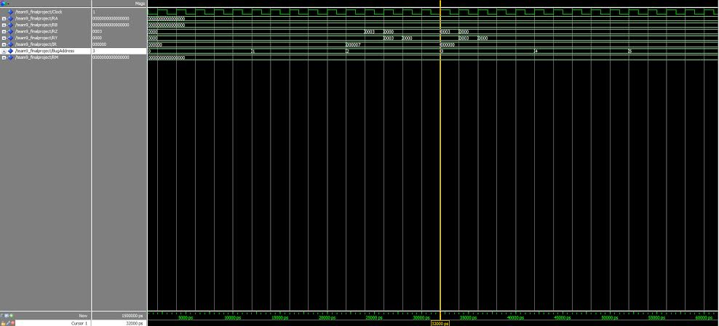

c. SUB 5 from R1 (R1 comes from the ADD instruction)

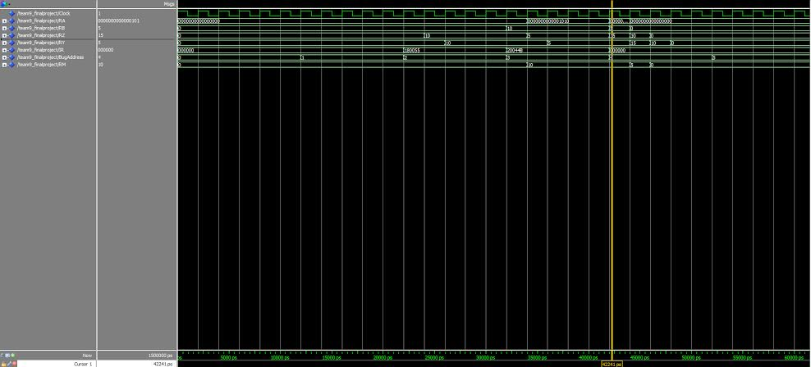

D. Oring R0 with immediate 3 gets 3

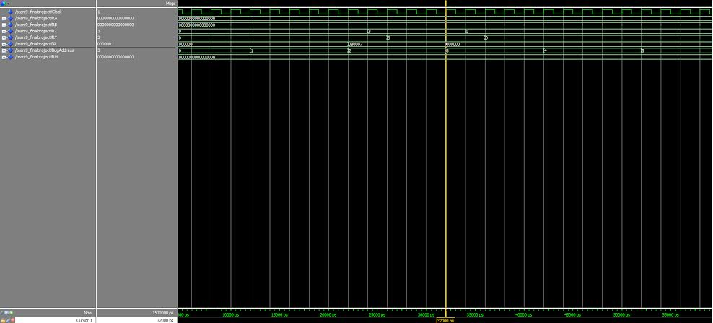

E. XORing R0 with 1 gets a value of 1

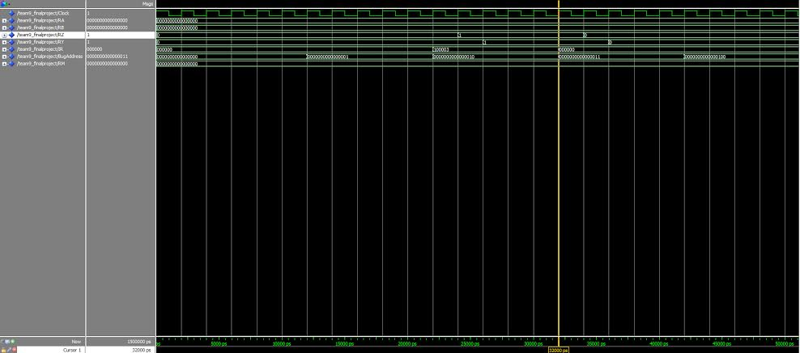

F. This utilizes all the instructions, specifically load, store, and branch. We have the file being simulated to pressing down KeyButtons 1,2,3 so therefore LEDG 1,2,3 light up in conjunction with that.
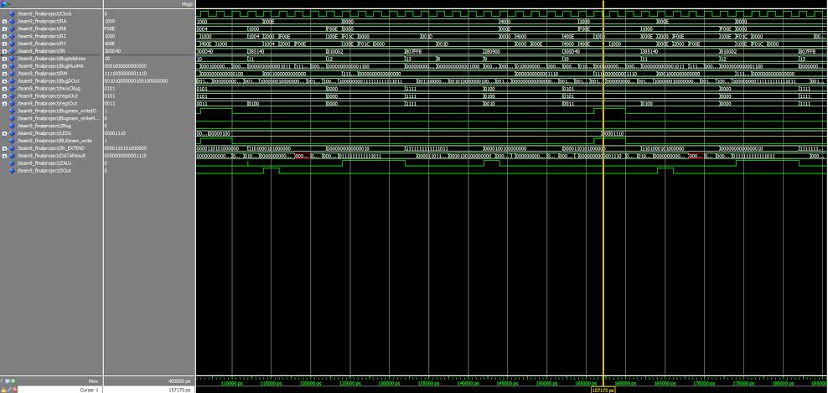
- condition flags
Each of these flags are set within the ALU and will allow conditional instructions based on the status of the PS register

Cond bits Char string Meaning Flags
0000 AL Always
0001 NV Never
0010 EQ Equal Z
0011 NE Not Equal NOT Z
0100 VS Overflow V
0101 VC No Overflow NOT V
0110 MI Negative N
0111 PL Postive or Zero NOT N
1000 CS Unsigned higher or same C
1001 CC Unsigned lower NOT C
1010 HI Unsigned Higher C AND (NOT Z)
1011 LS Unsigned Lower or same (NOT C) OR Z
1100 GT Greater than (NOT Z) AND ((N AND V) OR ((NOT N) AND (NOT V))) 1101 LT Less than (N AND (NOT V)) OR ((NOT Z) AND V)
1110 GE Greater than or equal (N AND V) OR ((NOT N) AND (NOT V)
1111 LE Less than or equal Z OR (((N AND (NOT V)) OR ((NOT Z) AND V)))

6) Assembler:
The assembler reduces assembly instructions to binary and then converts those instruction to hexadecimal values to write to a mif file for use in Quartus. It is a Java application made up of five classes, Assembler, AssemblerDriver, BadInstructionException, OverFlowException, and RegisterNotFoundException.
The Exception Classes:
The three exception classes extend the super class Exception to assist in error checking throughout the assembler.
The Assembler Class:
This class handles all conversions to hex and binary. It makes use of user inputs passed to it from the driver class. The assembly instructions and, or, xor, ld, st, add, sub, dec, inc, jr, j, and j.l are mapped to their op-codes using a hash table with the assembly instructions being the key. Any valid condition can be attached to these instruction and it will retrieve the same instruction's operation codes and each condition has been mapped similarly to set the condition bits. Any invalid instruction or condition entered at this stage will throw a Bad Instruction Exception and cause the user to be prompted for another input. Upon determining the the condition, the type of instruction is found using the first two bits from the operation code. This type identification is later used to determine how to set the register, or if registers are required.
Like the operations and conditions, the register location bits are also mapped to their corresponding binary representations using a hash table. In the instruction setting phase, offset is considered and removed before the register is located. The assembler looks for the '(' character before the register and sets the immediate to the values that come before the parenthesis. It is capable of handling positive, negative, and zero offset with the requirement that 0 and all other numbers be specified before the parenthesis. Entry of invalid registers will result in a Register Not Found Exception. An exception is also thrown anytime the user attempts to use register 0 as a destination.
If the immediate value is not set by the offset, then the user is prompted to enter one. Any value larger than 15 or less than -16 throws an Over Flow Exception.
All of the bits are concatenated into one 24-bit binary instruction. If an error occurs and an instruction longer than 24 bits is produced, a Bad Instruction Exception is thrown to prevent invalid hex values being written to the mif file. During the hex conversion phase, this 24 bit instruction is broken down into six, four bit sections, converted to hex and then returned from the assembler to be used by the driver class for file writing.
The Assembler Driver Class:
The driver class handles all user input and file writing. Upon application start up, a new mif file titled "MemoryIntialization" is created and the first instruction is set to "000000". The driver class prompts the user through each phase of the instruction input process. This class also handles any exception that is thrown by the assembler class. The Driver class makes use of the PrintWriter Class to write and append the mif files.
In phase 1, the operation is input, if an error is generated meaning an invalid operation was input the user is re prompted until a valid instruction is entered.
In phase 2, the register are input and the immediate value is set if necessary, for jump instructions the desired pc value change is entered in this phase in place of a register. user input prompts the user for the source register first then the destination register. After both inputs have been taken for double operations, the input registers are then passed to the assembler where error checking and or retrieval occurs. For single operands only the source register is prompted and the single input is sent to an alternative register setting method in the assembler class designed specifically for single operation instructions.
In phase 3, the conversion to hex occurs. error detections occurs exclusively in the assembly class. Any invalid hex exceptions produced cause a fatal error and the application is shut down to prevent bad hex values being written to the mif file.
In phase 4, the hex value produced by the assembler is appended to the mif file. Each new instruction is added to the list and the place holders for new instructions are updated so they act as non-operations within the processor. The file writing phase makes use of a counter variable, line to ensure that the proper boxes are set to non-operations.
Phase 5 is the repeat phase, the user is prompted to enter 'y' to convert another instruction and informed that pressing any other button will finalize the mif file and terminate the application. Upon reset the immediate value is set to 0, all instruction validation variables are set to true, the counter variable is incremented, and the hex value is reset to a blank value to prevent possible multiple writings.
Limitations:
One limitation of this set up is the inability to keep old instruction. By writing a new file at the start of the application, it forces the user to input all instructions they want to use in the mif file every time instead of appending what might already exist. This does, however, reduce the possibility of an invalid mif file being produced and unusable by Quartus.

7) Group Experiences
- Ja’lon Clark- Assisted primarily in the testing and reporting. Directly handled a number of our issues that weren’t caught in our initial testing of our ALU in lab 8. In addition he worked almost exclusively on the assembler towards the end of the project.

- Val Hahn - Assisted on the design on the processor. Val dealt with testing and editing the processor. He worked most exclusively with the initial design of the processor and on the reports. In addition, he got the final song to work on the drumstick.

- Derek Vogel - Assisted on the design on the processor. Derek dealt with testing and editing the processor, and making sure everything connected in the correct way, and especially worked with debugging. He made sure that the test results matched our desired intentions.

- Conclusion
Developing the processor from the beginning to the end was an emotional roller coaster because of the huge time commitment. Testing and debugging took up most of our time to get it to work. Despite not getting the check offs for the second through fourth phases, we were able accomplish the checks offs only days after the time cutoff. Our processor was able to implement all of the basic instructions until the IO phase. The group was in tears when the implementation of the drum kit worked. Like any other project, this required a lot collaborating and communication similarly to real life careers like a software development team. Even though this experience has its good and bad days, the project has finally achieved its goal of understanding the processor.

