SUPPLEMENT TO PROVISIONAL PATENT APPLICATION
Additions and Clarifications for Attorney Review
December 30, 2025 - DRAFT
HOW TO USE THIS SUPPLEMENT
This document provides additions to Kassim's December 19, 2025 draft. Content is organized to integrate directly into the existing draft:
• Blue boxes indicate NEW CONTENT to be inserted at specified locations
• Yellow boxes provide RESPONSES to Kassim's questions/comments
• Figures 5-11 are provided with reference numerals matching the specification
• Proposed streaming claims (41-46) extend the existing claim set

SECTION 1: RESPONSES TO ATTORNEY QUESTIONS
1.1 Merkle Proof Purpose (Comments 213-214)
KASSIM'S QUESTION: I'm still not quite understanding the point of generating Merkle proofs as evidence.
RESPONSE: Merkle proofs enable TRUSTLESS verification. The proof allows third parties to verify content origin WITHOUT trusting Encypher's database. This is critical for: (1) court-admissible evidence where opposing counsel cannot challenge database integrity; (2) verification if Encypher ceases operations; (3) independent auditing by third parties. The key insight: trustlessness requires the Merkle root to be embedded in the manifest OR anchored to a public blockchain. Database-only storage is NOT trustless.
The patent should cover multiple trust architectures:
Fully Embedded (Trustless): "...wherein the manifest embedded in the text includes sufficient Merkle tree nodes to generate a Merkle proof for any segment without accessing an external database."
Database-Dependent: "...wherein the Merkle tree is stored in an external database system, and generating the Merkle proof requires querying the database system."
Blockchain-Anchored (Partial Trustless): "...wherein the Merkle root is anchored to a distributed ledger, and the Merkle tree is stored in a database system that is mirrored or replicated for redundancy."
Decentralized Storage: "...wherein the Merkle tree is stored on a decentralized content-addressable storage network, and a content identifier for the stored Merkle tree is anchored to a distributed ledger."
1.2 Evidence Generation Without Database (Comments 199-200)
KASSIM'S QUESTION: BIG ISSUE: Evidence generation can be accomplished without database at all.
RESPONSE: Correct. The patent should cover BOTH scenarios as independent claim variants. Recommend splitting Claim 21 into: (A) Database-required claims for corpus-wide attribution (identifying unknown text sources from a large collection); (B) Database-free claims for single-document verification (all data travels with the document in embedded manifest). Both are valuable and non-obvious for different use cases.
1.3 Dual-Binding Manifest Necessity (Comment 339)
KASSIM'S QUESTION: Why not just digitally sign the text + assertion with a certificate?
RESPONSE: Dual-binding solves a chicken-and-egg problem: the manifest must hash the text, but the text must contain the manifest. Standard signing only verifies that the manifest hasn't been modified. Dual-binding ALSO verifies that the text content hasn't been modified after manifest embedding. See FIG. 10 for the construction sequence: (1) hash text → (2) create preliminary manifest with placeholder → (3) hash preliminary manifest → (4) replace placeholder with that hash → (5) sign final manifest → (6) embed. The self-referential hash in step 3-4 creates a cryptographic binding that detects post-embedding tampering.
1.4 Streaming Handler Claims (Comment 361)
KASSIM'S QUESTION: Did we decide not to include independent claims directed to the streaming handler?
RESPONSE: We SHOULD include these. The streaming handler with O(log n) buffer management is the core innovation of IDF-004 and represents a critical competitive moat for the AI/LLM market. Proposed Claims 41-46 are provided in Section 4 of this supplement. This is novel, non-obvious, and directly addresses the technical problem of authenticating content that doesn't exist in complete form until stream termination.
1.5 UUID Structure (Comments 24-26)
KASSIM'S QUESTION: How does a 256-bit hash fit within a 128-bit UUID?
RESPONSE: It doesn't. The UUID is a POINTER to an external repository, not a container for the hash. The 128-bit UUID serves as a primary key in the external database where the full manifest (including 256-bit hashes) is stored. See FIG. 9 for clarification: the lightweight manifest (920) contains only UUID (924), while the full manifest data including hashes resides in the external repository (928).
1.6 Unbalanced Merkle Tree Completion
KASSIM'S QUESTION: Do we need to say anything about how an unbalanced Merkle tree is completed, or is this well known?
RESPONSE: While padding techniques are known in the art, our specific approach should be described for completeness. See FIG. 5 (Step 8) which shows: when segment count is not a power of two, pad with zero-value hashes (H_H = 0) to complete the tree. The padding approach is deterministic and enables verification without requiring the verifier to know the original segment count.
1.7 Stream Ciphers
KASSIM'S QUESTION: Note: should we include any stream ciphers here or elsewhere in the specification?
RESPONSE: Stream ciphers (like ChaCha20, Salsa20) are not directly relevant to our hashing and authentication methods. Stream ciphers are for encryption, not hashing. However, we could mention that authenticated encryption modes (like AES-GCM or ChaCha20-Poly1305) could optionally be used to encrypt manifests before embedding, providing confidentiality in addition to authentication. This would be a dependent claim enhancement, not core to the invention.

SECTION 2: ADDITIONAL FIGURE DESCRIPTIONS
[NEW CONTENT: Insert after existing FIG. 4 description in 'Brief Description of the Drawings' section]
FIG. 5 illustrates a streaming Merkle tree construction sequence with O(log n) buffer management, showing incremental hash tree generation during content streaming.
FIG. 6 illustrates a system architecture 600 for granular content authentication including content sources layer 610, processing layer 620, storage layer 630, and output layer 640.
FIG. 7 illustrates document segmentation 700 showing hierarchical structure with paragraphs 710, 720, 730 containing text segments.
FIG. 8 illustrates hash table structures 810, 820 with linked lists for mapping leaf hashes to multiple Merkle roots and roots to document metadata.
FIG. 9 illustrates a comparison of full C2PA manifest structure 910 versus lightweight UUID manifest structure 920 with external repository 928.
FIG. 10 illustrates a dual-binding manifest construction sequence 1010-1060 showing placeholder replacement for self-referential hashing.
FIG. 11 illustrates an evidence generation flow 1110-1170 showing target text processing, database lookup, and evidence package generation.

SECTION 3: DETAILED DESCRIPTION ADDITIONS
3.1 Streaming Merkle Tree Construction
[NEW CONTENT: Insert at placeholder: '[Add more detail here regarding buffering and Merkle tree formation in context of streaming method...]']
Referring now to FIG. 5, a method of streaming Merkle tree construction with bounded memory usage is illustrated. This method enables real-time authentication of content streams, such as text generated by large language models (LLMs), while the content is being generated and before its final length is known.
In step 1, the streaming handler 622 receives and buffers characters from a content source until a segment boundary is detected according to a segmentation criteria (e.g., end of sentence punctuation). Upon detecting the boundary, the buffered segment is normalized and hashed to generate a segment hash value (e.g., H_A). The segment hash value is stored in a hash buffer, and the segment itself is immediately output to a destination such as a display or data store. The hash buffer is separate from and smaller than the content segment buffer.
In step 2, when a second segment completes, a second segment hash value (H_B) is generated. The system detects an adjacent unpaired hash value at the same tree level (H_A) and combines them by concatenating H_A and H_B and hashing the concatenation to generate an interior hash value H_AB. The original leaf hashes H_A and H_B may be discarded from the buffer or retained depending on implementation, but the buffer now contains at minimum only the interior hash H_AB.
Steps 3 through 7 continue this process. When a new segment hash is generated and no adjacent unpaired hash exists at the same level, the new hash is stored in the buffer. When an adjacent unpaired hash does exist, they are combined to form an interior hash, and this combining cascades upward through the tree levels until no more adjacent unpaired hashes exist. The key property of this method is that the hash buffer size never exceeds O(log n) entries, where n is the total number of segments, regardless of content length.
In step 8, when end-of-stream is detected (e.g., connection termination, explicit end marker, or timeout), the system completes the Merkle tree. If the number of segments is not a power of two, padding hash values (e.g., H_H = 0) are added to balance the tree. The remaining buffer entries are combined through successive hashing operations to generate the final Merkle root (e.g., H_ABCDEFGH). A manifest including the Merkle root, segment count, and digital signature is then generated and may be embedded in the final segment of the output stream or stored in an external repository identified by a UUID.
3.2 System Architecture
[NEW CONTENT: Insert at placeholder: '[ADD SECTIONS REGARDING REPOSITORY ARCHITECTURE (IDF#1)...]']
Referring to FIG. 6, a system architecture 600 for granular content authentication comprises four functional layers. A content sources layer 610 includes various sources of text content requiring authentication: publisher systems 612, AI generation systems 614 (such as large language models), and enterprise systems 616.
A processing layer 620 receives content from the sources layer and performs authentication operations. The processing layer includes a streaming handler 622 that buffers incoming content and detects segment boundaries, a Merkle tree generator 624 that constructs hierarchical hash structures from segments as described with reference to FIG. 5, and a manifest generator 626 that creates signed manifests containing Merkle roots and assertions.
A storage layer 630 provides persistent storage for authentication data. The storage layer includes a hash table database 632 maintaining mappings from leaf hashes to Merkle roots and from Merkle roots to document metadata (as illustrated in FIG. 8), a Merkle tree store 634 for complete tree structures, and optionally a blockchain anchor 636 for immutable timestamping of Merkle roots. The blockchain anchor 636 publishes Merkle roots to a distributed ledger, enabling trustless verification even if the hash table database 632 becomes unavailable.
An output layer 640 provides interfaces for content delivery and verification. The output layer includes authenticated content output 642 (content with embedded manifests or UUIDs), an evidence generator 644 for creating verification packages, and an attribution reporter 646 for identifying content sources.
3.3 Hash Table Data Structure
[NEW CONTENT: Replace FIG. XX____ placeholders with FIG. 8 references]
Referring to FIG. 8, hash table data structures 810 and 820 enable efficient lookup for evidence generation and attribution. Table 810 maps leaf hashes (segment hash values) to Merkle roots. Because a single text segment may appear in multiple source documents, each bucket in table 810 may map to multiple Merkle roots stored as a linked list. For example, hash value H_X might appear in documents Doc2, Doc5, and Doc8, represented as: Root_Doc2 → Root_Doc5 → Root_Doc8 → NULL.
Table 820 maps Merkle roots to document metadata including document identifier, author information, creation timestamp, and optionally positional information for each leaf in the tree. Together, tables 810 and 820 enable both forward lookup (given a segment, find source documents) and reverse lookup (given a document, enumerate its segments).
3.4 Full vs. Lightweight Manifest Structures
Referring to FIG. 9, two manifest structures are compared to address different deployment scenarios. A full C2PA manifest 910 includes a header 912 with magic number and version information, a JUMBF payload 914 containing content hash, Merkle root, and assertion data, and a signature block 916 with algorithm identifier, certificate chain, and digital signature. This structure provides self-contained verification but requires 2-10 KB of embedded data, which may be impractical for sentence-level embedding or platforms that strip metadata.
A lightweight UUID manifest 920 includes a BOM prefix 922 (U+FEFF), a UUID 924 (128-bit identifier encoded via Unicode variation selectors), and optional compact assertion data 926. Full manifest data is stored in an external repository 928 and retrieved using the UUID as a lookup key. This structure requires only 50-200 bytes of embedded data, maximizing survival across platform modifications that typically strip metadata. The UUID serves as a pointer to the external repository, not as a container for hash values.
3.5 Dual-Binding Manifest Construction
[NEW CONTENT: Insert at placeholder: '[ADD FURTHER DISCUSSION OF BENEFITS AND USES CASES FOR DUAL-BINDING METHOD...]']
Referring to FIG. 10, a dual-binding manifest construction sequence 1010-1060 creates a cryptographic binding between text content and the manifest itself, solving the challenge that the manifest must hash the text but the text must contain the manifest.
At step 1010, the text content is normalized and hashed to generate H_text. At step 1020, a preliminary manifest is created containing H_text, assertions, and a placeholder value (e.g., zeros or a sentinel) in a designated self-hash field. At step 1030, the preliminary manifest is serialized to a canonical byte format and hashed to generate H_preliminary.
At step 1040, the placeholder is replaced with H_preliminary to create the final manifest. This replacement creates a self-referential structure: the manifest contains a hash of itself (in its preliminary form). At step 1050, the final manifest is digitally signed using a private key. At step 1060, the signed manifest is embedded in the text content.
To verify a dual-bound manifest, a verifier: (1) extracts the manifest from the text; (2) verifies the digital signature; (3) extracts H_preliminary from the manifest and replaces it with the placeholder; (4) hashes the manifest-with-placeholder and compares to H_preliminary; (5) removes the manifest from the text and hashes the remaining content; (6) compares to H_text in the manifest. This process detects both manifest tampering and post-embedding text modification.
3.6 Evidence Generation Flow
[NEW CONTENT: Insert at placeholder: '[ADD SECTIONS REGARDING... EVIDENCE GENERATION (IDF#2) HERE]']
Referring to FIG. 11, an evidence generation flow 1110-1170 processes target text of unknown origin to identify source documents and generate verifiable evidence. At step 1110, target text is received. At step 1120, the target text is segmented according to the same segmentation criteria used during encoding. At step 1130, each segment is normalized and hashed to generate target hash values.
At step 1140, the hash table database 632 is queried using each target hash value to find matching leaf hashes and their associated Merkle roots. The linked list structure (FIG. 8) enables identification of all documents containing each segment.
At step 1150, Merkle proofs are generated for each matching segment. A Merkle proof consists of the sibling hashes required to recompute the path from a leaf to the Merkle root. The proof also encodes positional information: whether each sibling is a left or right child determines the segment's position in the original document.
At step 1160, an evidence package is assembled containing: source document identifier, matching segment text, Merkle proof for each match, position in source document, and timestamp evidence (optionally including blockchain anchor data). At step 1170, candidate source documents are identified, ranked by match confidence based on the number and contiguity of matching segments.
Importantly, Merkle proofs enable trustless verification: a third party can independently verify that a segment belongs to a claimed source document by recomputing the Merkle root from the segment hash and proof, without trusting the database operator. This property is essential for court-admissible evidence.

SECTION 4: PROPOSED STREAMING HANDLER CLAIMS
[NEW CONTENT: Add as Claims 41-46 after existing Claim 40]
41. A computer-implemented method of authenticating streaming text content, the method comprising:
receiving a stream of characters from a content source;
buffering the received characters in a segment buffer until a segment boundary is detected according to a segmentation criteria;
upon detecting the segment boundary, hashing the buffered segment to generate a segment hash value;
storing the segment hash value in a hash buffer;
outputting the buffered segment to a destination;
if the hash buffer contains an adjacent unpaired hash value at a same tree level, combining the segment hash value with the adjacent hash value to generate an interior hash value, and repeating the combining step for each tree level until no adjacent unpaired hash value exists;
repeating the receiving, buffering, hashing, storing, outputting, and combining steps for subsequent segments;
upon detecting end-of-stream, completing a Merkle tree from the hash buffer to generate a Merkle root; and
generating a manifest including the Merkle root.
42. The method of claim 41, wherein completing the Merkle tree includes adding padding hash values when a number of segments is not a power of two.
43. The method of claim 41, wherein a maximum size of the hash buffer during streaming is O(log n) where n is a total number of segments.
44. The method of claim 41, wherein the content source is a large language model (LLM) or other artificial intelligence system.
45. The method of claim 41, further comprising embedding an interim authentication marker in one or more segments during streaming, prior to detecting end-of-stream.
46. The method of claim 41, wherein the manifest is stored in a repository external to the streamed content, and a UUID identifying a location in the repository is embedded in the streamed content using Unicode variation selectors.

SECTION 5: DRAWING FIGURES
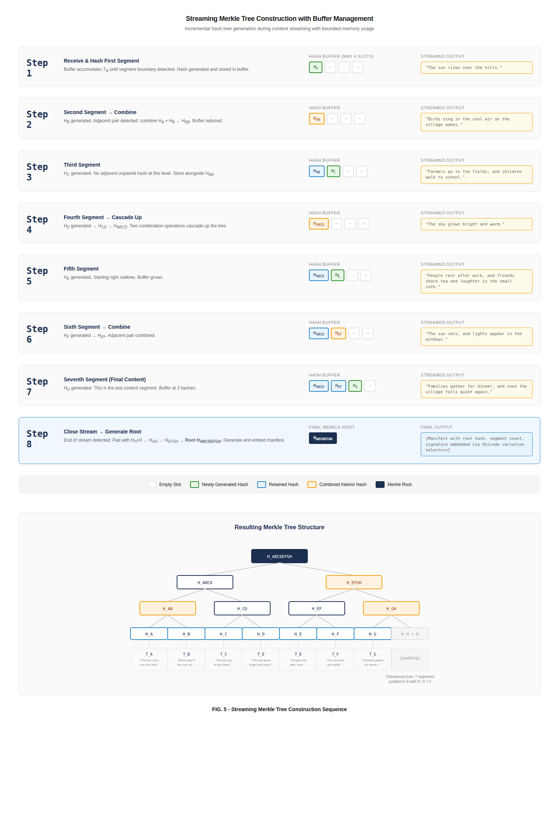
FIG. 5 - Streaming Merkle Tree Construction Sequence

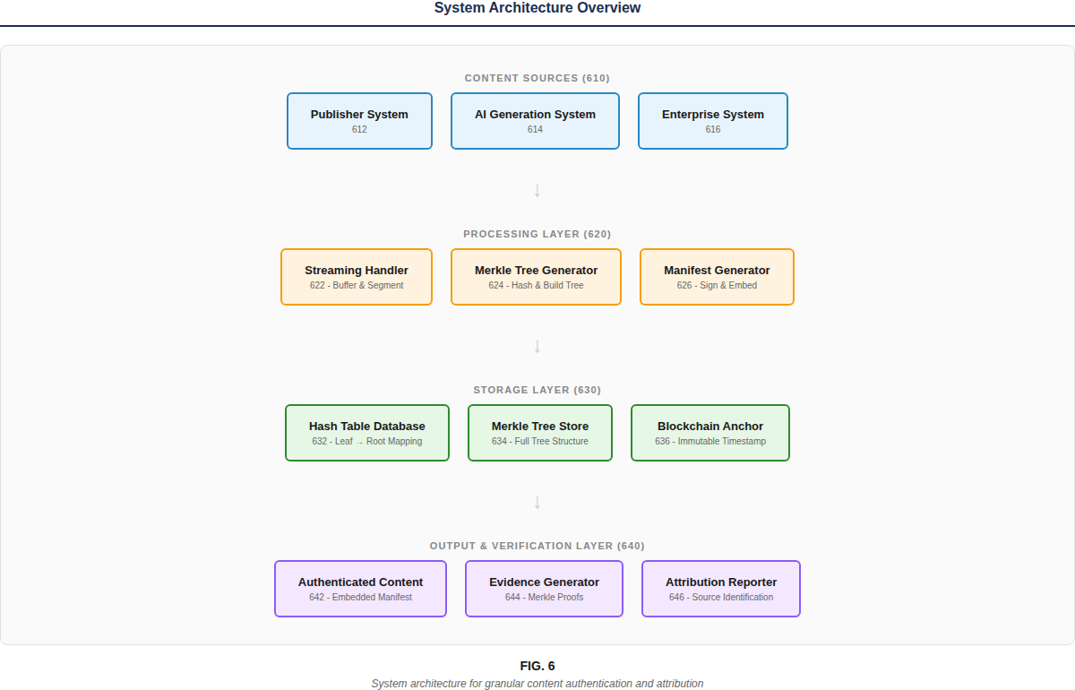
FIG. 6 - System Architecture (600)

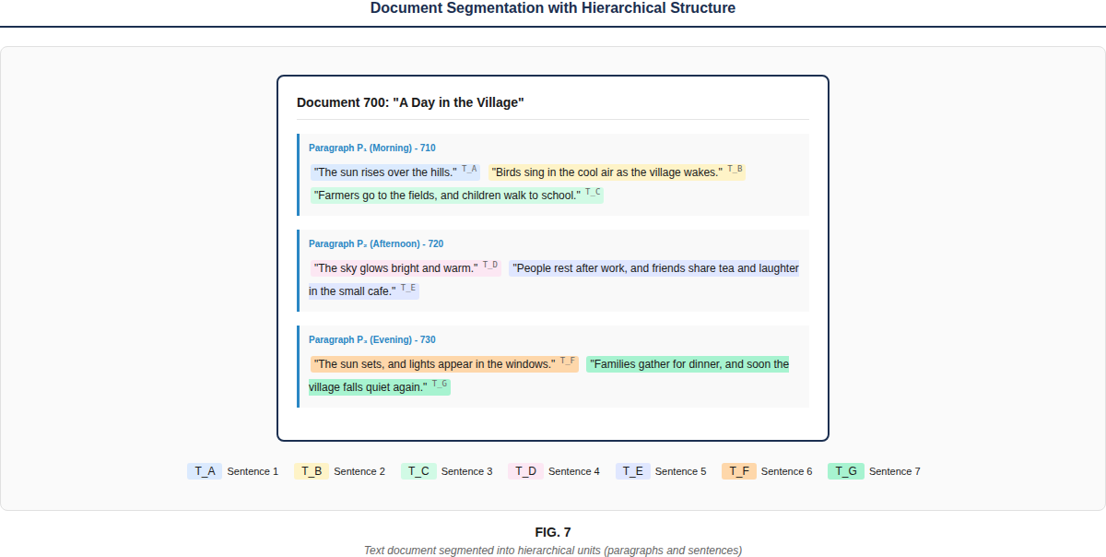
FIG. 7 - Document Segmentation (700)

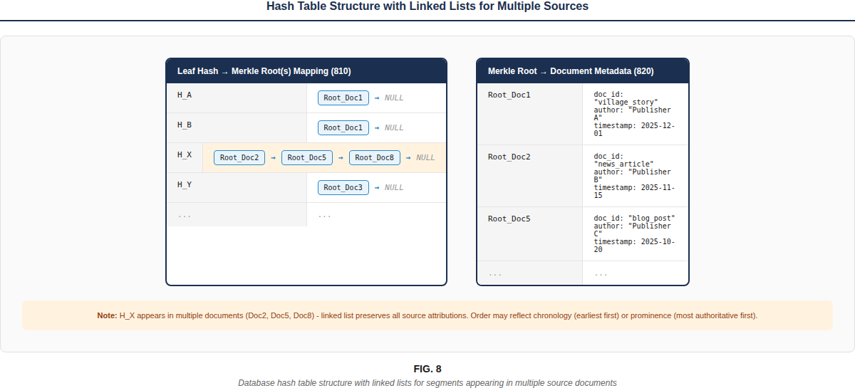
FIG. 8 - Hash Table Structure (810, 820)

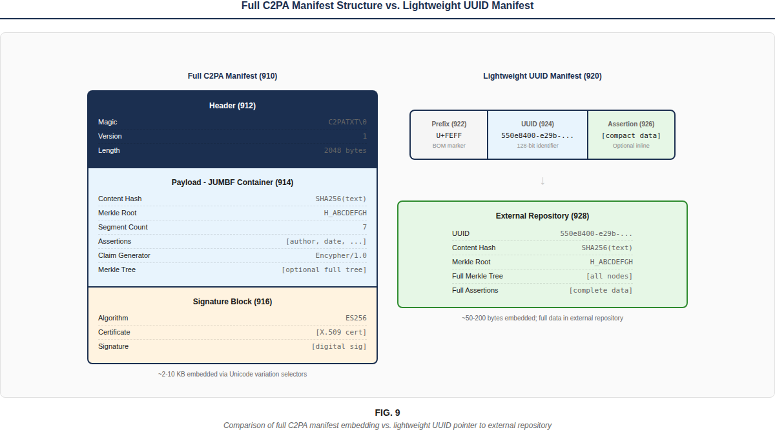
FIG. 9 - Full C2PA Manifest (910) vs. Lightweight UUID Manifest (920)

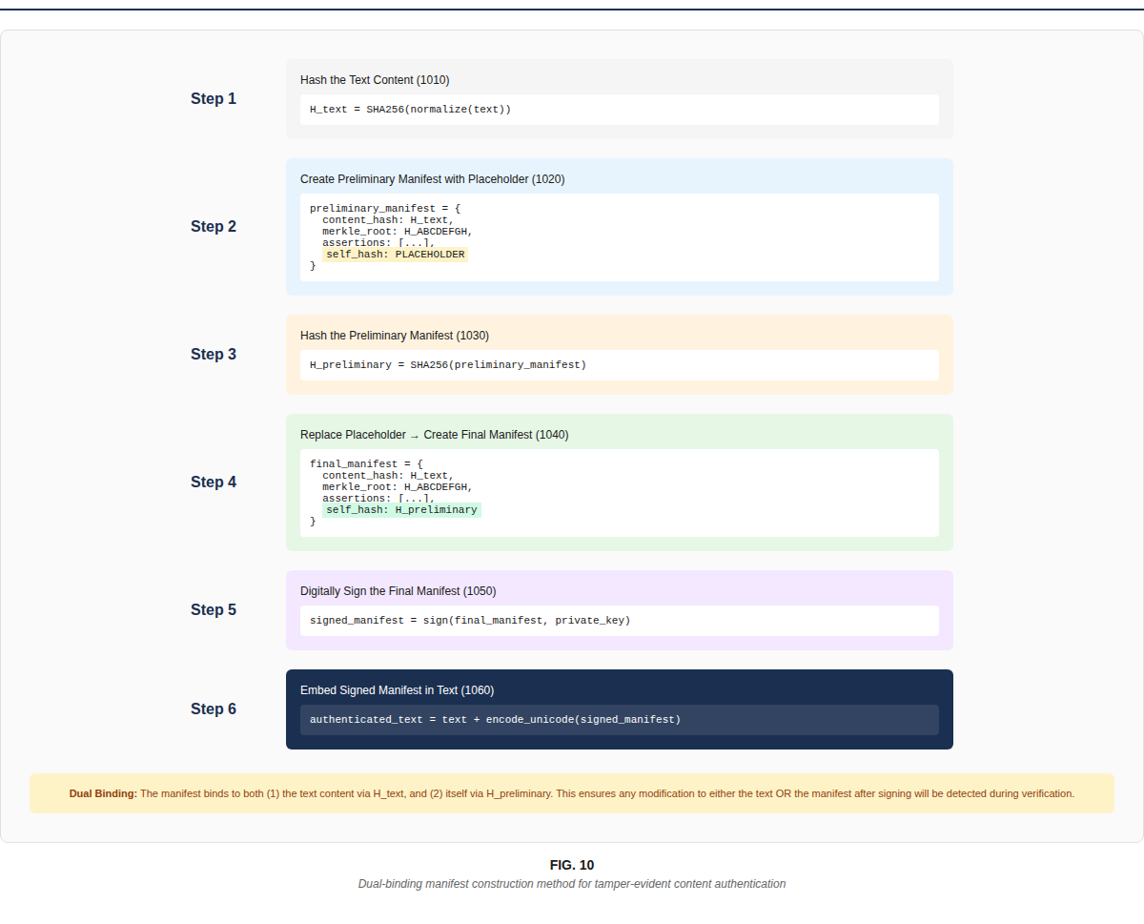
FIG. 10 - Dual-Binding Manifest Construction (1010-1060)

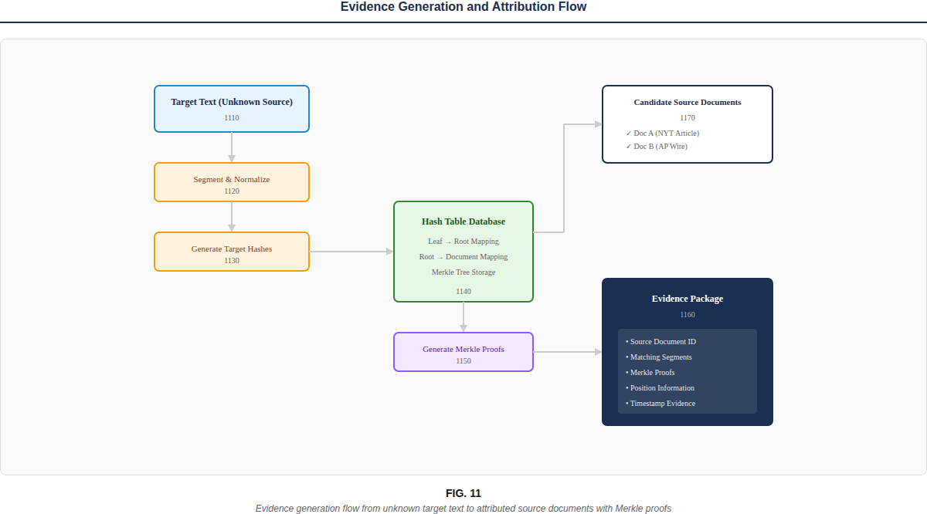
FIG. 11 - Evidence Generation Flow (1110-1170)

SECTION 6: REFERENCE NUMERAL TABLE
The following reference numerals are used in FIGS. 5-11 and should be added to the specification:
Reference | Description
600 | System architecture for granular content authentication
610 | Content sources layer
612, 614, 616 | Publisher system, AI generation system, Enterprise system
620 | Processing layer
622, 624, 626 | Streaming handler, Merkle tree generator, Manifest generator
630 | Storage layer
632, 634, 636 | Hash table database, Merkle tree store, Blockchain anchor
640 | Output and verification layer
642, 644, 646 | Authenticated content, Evidence generator, Attribution reporter
700 | Document (segmentation example)
710, 720, 730 | Paragraphs P1, P2, P3
810, 820 | Hash tables (leaf→root mapping, root→document mapping)
910, 920 | Full C2PA manifest, Lightweight UUID manifest
912, 914, 916 | Header, JUMBF payload, Signature block
922, 924, 926, 928 | BOM prefix, UUID, Optional assertion, External repository
1010-1060 | Dual-binding construction steps
1110-1170 | Evidence generation flow steps

