EasyExcel

Locke

How To Use 1
1. Editor a xlsx 1
2. Set paths for generating 2
3. Import xlsx files 2
4. Set resource mode 2
5.Open the example scene and play. 3
Config.cs 3
Tools Menu 4
1.Import: 4
2.Clean 4
3.Build Assetbundle 4
API Examples 4

How To Use

1. Editor a xlsx
Editor a xlsx with the format below:
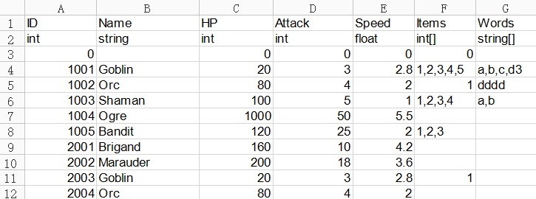
The first row is the name of variables.
The second row is the type of variables.
The third row is default values.
For more details, you can refer to the xlsx files in EasyExcel/Example/ExcelFiles.
The table below show the formats of types and default values.
Type | Default Value
int | 0 or any other int value
int[] | 0 or any other int value
float | 0 or any other float value
float[] | 0 or any other float value
string | empty of any string without outside quotes
string[] | empty of any string without outside quotes

2. Set paths for generating
Set your following two paths in EasyExcel/Config.cs
CSharpPath | It is where generated code will be.  It is relative to your Unity project root,  for example “Assets/EasyExcel/Example/AutoGenCode/”.
AssetPath | It is where generated assets will be.  It is relative to your Unity project root,  for example “Assets/EasyExcel/Example/AutoGenAsset/”.

3. Import xlsx files
Click menu Tools->EasyExcel->Import
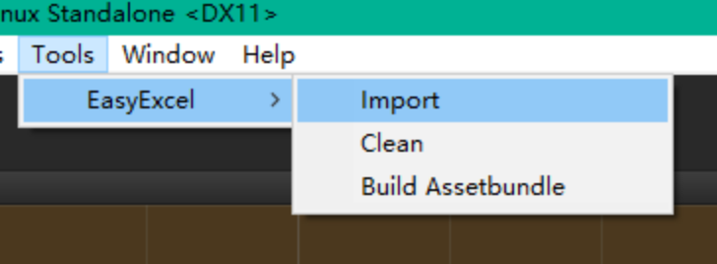
You will see a dialog for selecting the folder where your xlsx files are. Browser to your folder and click ok, then the xlsx files will be imported to your project.
When the process is done, you will see .cs files in CSharpPath and .asset files in AssetPath.

4. Set resource mode
(1) LoadFromAssetbundle
Before running, you need to Set LoadFromAssetbundle. Set true if you want to load the generated assets from assetbundle. Set false if you want to load them from Resources folder.
If true, AssetPath must be in one of your project's Resources folders,
and the option AssetbudleName below will be applied as the name of the assetbundle,
the option AssetbundlePath will be the output folder.
If false, AssetPath should be outside of all the Resources folders, and the two option AssetbudleName and AssetbundlePath will not be used.

(2) AssetBundleName
The name of the assetbundle. You can change it to your own, or leave it by default.

(3) AssetbundlePath
The output folder of the assetbundle. You can change it to your own, or leave it by default.

- Build Assetbundle
If LoadFromAssetbundle is false, ignore this step.
If LoadFromAssetbundle is true, you need to build assetbundle first:
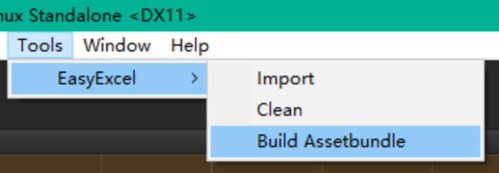

5.Open the example scene and play.
If false, AssetPath should not be in any of the Resources folders, the two option AssetbudleName and AssetbundlePath will not be used.

Config.cs
The table below shows the details of Config.cs
Name | Description
CSharpPath | This is where the generated csharp files will be.
AssetPath | This is where the generated ScriptableObject files will be.
LoadFromAssetbundle | If true, the ScriptableObjects should be built into assetbundle before running. The AssetbudleName below will be applied as the name of the assetbundle. The AssetbundlePath below will be the output folder.  If false, make sure AssetPath is somewhere in Resources folder, for example "Assets/Resources/aaa/bbb", and the two options AssetbudleName and AssetbundlePath will not be used.
AssetbudleName | Assetbudle name of generated ScriptableObject files.
AssetbundlePath | Assetbundle path
RowDataClassNamePostfix | Postfix of generated RowData classes. For example Item.xlsx corresponds to Item + RowDataClassNamePostfix.
DataTableClassNamePostfix | Postfix of generated RowData classes. For example Item.xlsx corresponds to Item + DataTableClassNamePostfix.
AssetFileExtension | Extension of generated ScriptableObject files. For example Item.xlsx corresponds to Item + AssetFileExtension.

Tools Menu
Tools menu of EasyExcel are under Tools->EasyExcel.

1.Import:
Select a folder of xlsx files and import them as ScriptableObjects.

2.Clean
Delete all the files and folders of Config.CSharpPath and Config.AssetPath.

3.Build Assetbundle
Build the assetbundle of all the generated ScriptableObjects, to folder Config.AssetbudlePath with assetbundle name Config.AssetbudleName.

API Examples
- Initialize and load all data
This should be put where your game initialize.
- Find a ItemRowData by id
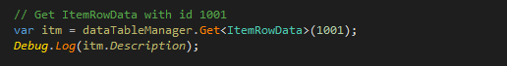
- Find ItemRowData list
