# Enda Kilgarriff – Assignment 3 – Testing

Overdraft 0 – User correctly inputs yes/no.



Overdraft.txt before code is run.

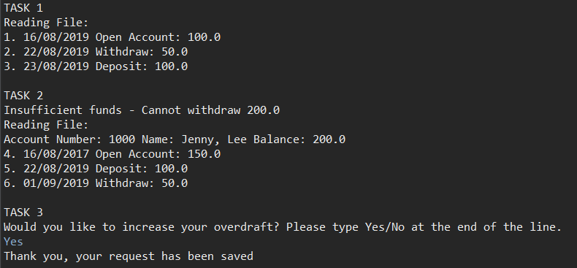

Console output once run. User submitted Yes.



Overdraft.txt after user input.

Overdraft 50 – User input incorrect.

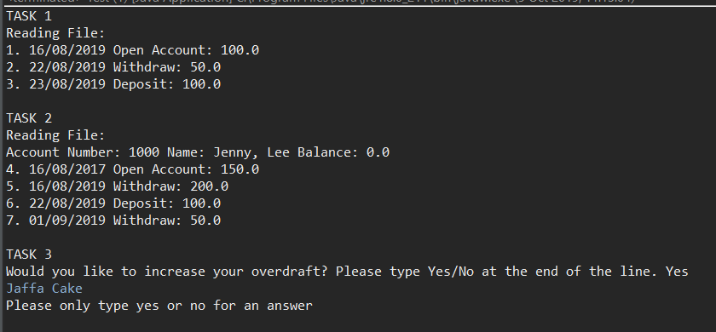

Console output. Withdrawal of 200 euro successful as overdraft changed.



Overdraft.txt not changed.