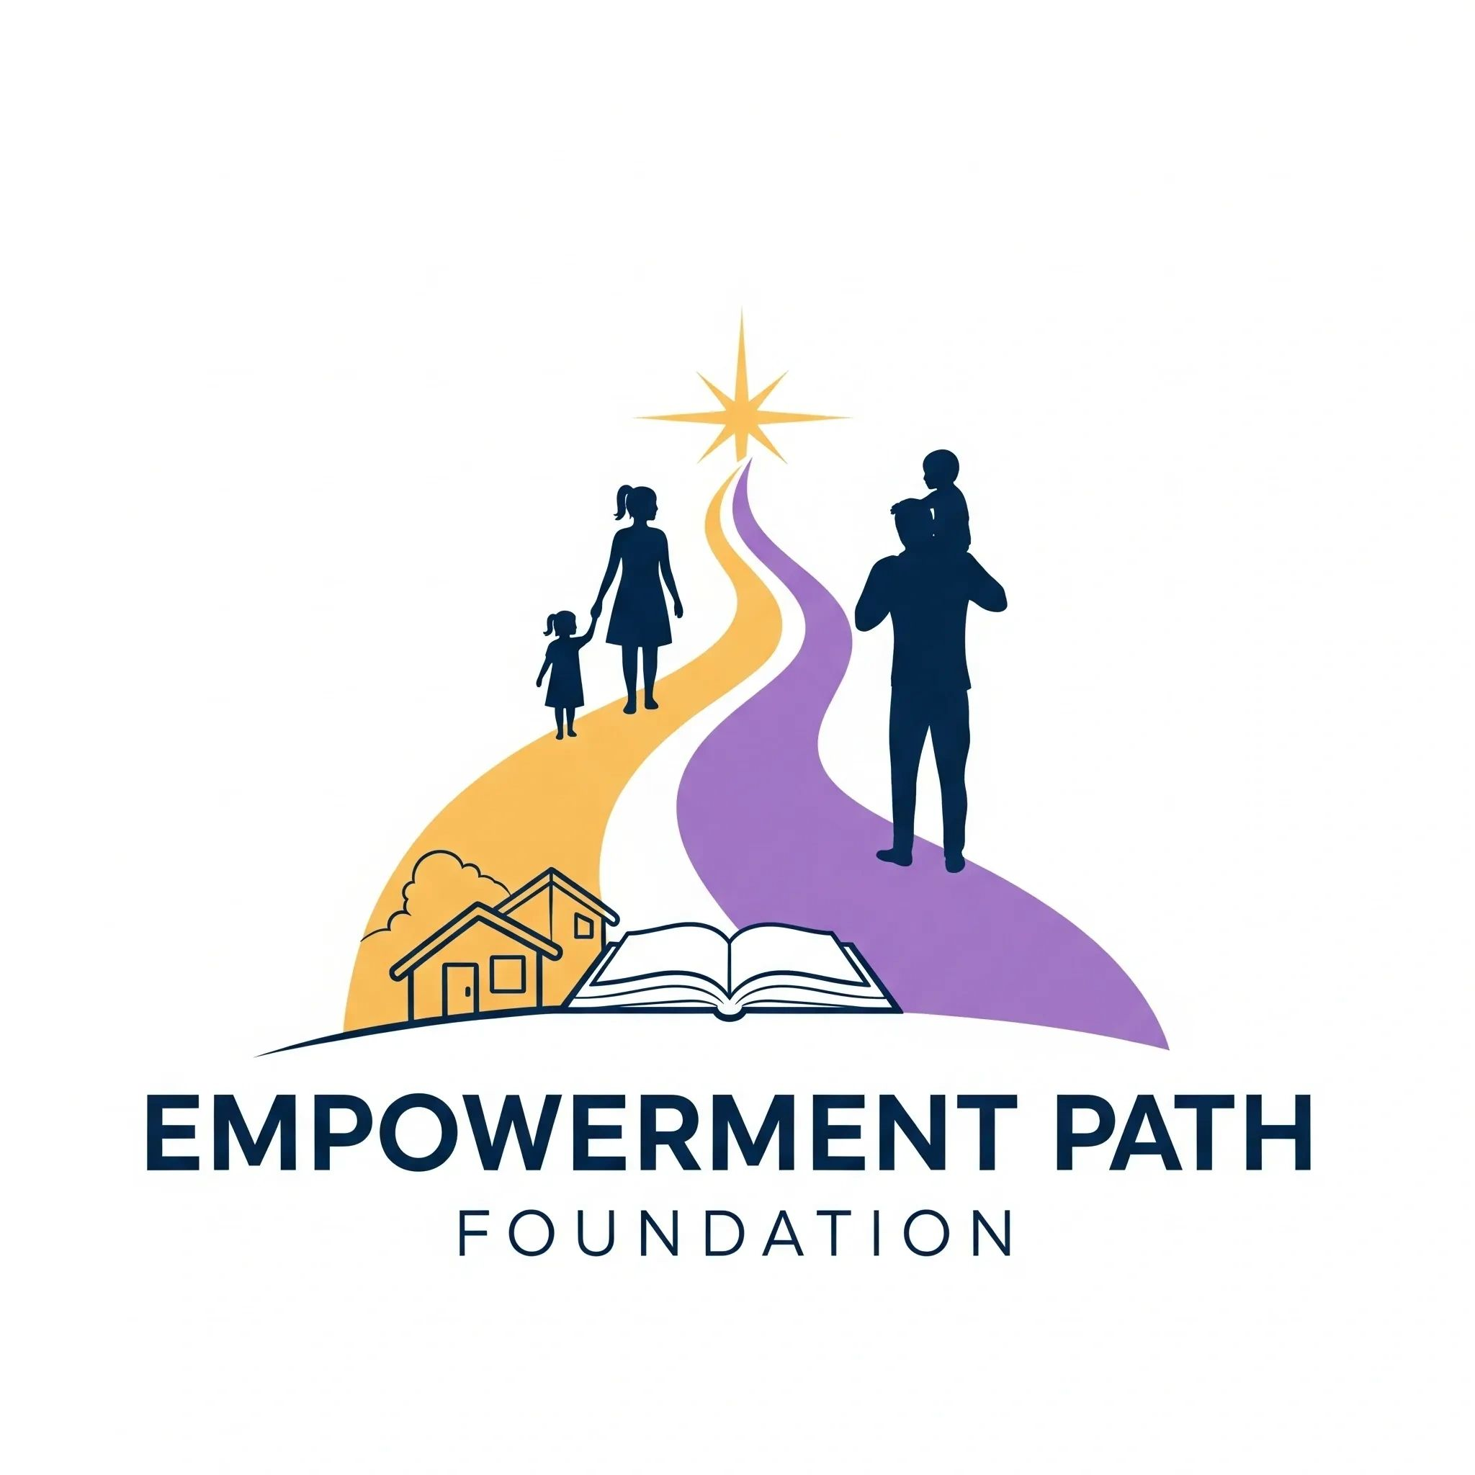

FOR IMMEDIATE RELEASE
Empowerment Path Foundation Launches Mother's Day Blessing Basket Initiative to Support Single Mothers Across Detroit and Metro Detroit
Detroit, MI — April 2, 2026
This Mother's Day, Empowerment Path Foundation is calling on the community to come together in support of single mothers through its Mother's Day Blessing Basket Initiative, a heartfelt effort designed to uplift, honor, and provide essential care items to mothers in need.
The initiative will provide 100 baskets for 100 moms — thoughtfully curated baskets filled with self-care items, essentials, and uplifting gifts for mothers participating in local programs across Detroit and Metro Detroit. Confirmed partner organizations include Peggy's Place, CASS Community Social Services/Fox Family Shelter, and Alternatives for Girls, all of which serve women and families navigating housing instability and life transitions.
Community members are invited to "Sponsor a Mom" for $100, which fully funds one blessing basket. Donations are being accepted now through April 25, 2026, with additional contributions welcomed in person during the basket assembly event. All donations are tax-deductible as allowed by law through our fiscal sponsor, Bringing Back the Block.
"We believe every mother deserves to feel seen, appreciated, and supported, especially those navigating life's challenges on their own," said Tina N. Bowden, Founder of Empowerment Path Foundation. "This initiative is about more than gifts. It is about restoring dignity, spreading love, and reminding these women that their community stands with them."
Event Details:
- Date: May 2, 2026
- Time: 2:00 p.m. – 8:00 p.m.
- Location: Lockeroom Lounge, 18290 Livernois Avenue, Detroit, Michigan 48221
- Purpose: Drop-offs, donations, and basket assembly
Volunteers, donors, and community supporters are encouraged to attend.
To ensure privacy and respect, participating mothers will not be publicly identified. When needed, identifiers such as nicknames or numbers will be used internally to personalize baskets while maintaining confidentiality.
Empowerment Path Foundation is actively seeking:
- Individual sponsors
- Corporate sponsors
- Donation partners
- Volunteers
This initiative is part of the organization's broader mission to support and empower single mothers and their children through resources, community programming, and advocacy.
To sponsor a mother, donate, or get involved, please contact:
Tina N. Bowden, Founder
Empowerment Path Foundation
empowermentpathfoundation@gmail.com
Phone: 313-937-6077
EmpowermentPathFoundation.org

About Empowerment Path Foundation
Empowerment Path Foundation is a community-driven nonprofit organization dedicated to supporting single mothers/fathers and their children through empowerment programs, resources, and strategic partnerships that promote stability, self-sufficiency, and long-term success.
Empowerment Path Foundation operates under fiscal sponsorship with Bringing Back the Block, a nonprofit organization supporting community-based initiatives. Donations made to Empowerment Path Foundation are tax-deductible to the extent allowed by law through Bringing Back the Block.

