An EndeavourOS ARM based Simple Home Server.
August 26, 2020

SAMBA
We will be setting up a Windows 10 computer as a client to share files on our LAN server.
Make sure that your Windows 10 computer has “Network Discovery” turned on.
Settings - Network and Internet - Network and Sharing Center - Advanced Sharing Settings

Since this Windows computer will be a Client, an entry must be made in the “hosts” file.
Click on the Windows button in the panel then Windows Accessories, Right click on Notepad, --> more --> Run as Administrator.
In Notepad, Click on file --> open.
This PC --> Local Disk (C:) --> Windows --> System32 --> drivers --> etc
In the lower right, change “Text Documents (*.txt)” to “All Files”
open hosts, At the end of the file, add the following
192.168.0.155 enosServer
adjust the IP address and host name as necessary.
File --> Save

In Windows 10, Right click on "This PC" then click on "Properties" and find the workgroup.

If I remember correctly, WORKGROUP is the default work group. On anything that involves security, I hate using any defaults. I am going to call my work group TRESAMIGOS. If you have an existing work group that is not WORKGROUP you can use that. Otherwise choose a work group name of your choice. All Windows computers wanting to access the enosServer must have the same work group name. To change a work group name in Windows 10:
Right click "This PC" then "properties" to the right of the work group section click on "Change settings" See this document for the work group naming rules and help changing it.
https://www.tenforums.com/tutorials/36133-change-workgroup-windows-10-a.html
We are done with the Windows computer for a while.

On a Linux Client computer, in a Terminal window, SSH into enosServer.
$ ssh pshare@enosServer
$ su (then change to root using su)
# pacman -Syu (When installing packages, start with a updated system. reboot if necessary)
# pacman -S samba (install samba packages)

A smb.conf file is not supplied as part of the samba package. EndeavourOS
includes a /etc/samba/smb.conf file during the script installation.
# ll /etc/samba (/etc/samba/smb.conf should exist from the script installation)
total 16
-rw-r - - r- - 1 root root 8105 Mar 27 03:55 smb.conf

look for a smb.conf file. Check the permissions and ownership compared to above.
If so, all our necessary config files are in place.
An important quote from the smb.conf file

# Any line which starts with a ; (semi-colon) or a # (hash)
# is a comment and is ignored. In this example we will use a #
# for commentary and a ; for parts of the config file that you
# may wish to enable
#
# NOTE: Whenever you modify this file you should run the command "testparm"
# to check that you have not made any basic syntactic errors.

Still in The Client computer which is ssh’ed into enosServer computer
# vi /etc/samba/smb.conf

read all the comment lines at the beginning of the file then find the following lines
#================== = Global Settings======================
[global]

# workgroup = NT-Domain-Name or Workgroup-Name, eg: MIDEARTH
workgroup = WORKGROUP
Change workgroup = WORKGROUP to workgroup = YOURWORKGROUPNAME

Still in "Global Settings" Find the following line
hosts allow = 127. 192.168.0.

If necessary, adjust 192.168.0. to your appropriate address.

The 192.168.0. is the static IP address we assigned to this enosServer computer, minus the the last triad. This means any computer with an IP address that starts with 192.168.0. is allowed to connect. Any computer not on our LAN block is not allowed. The 127. allows any local loop backs for testing and/or troubleshooting.

Find following lines at the very end of this smb.conf file
[ENOSshare]
comment = Samba Share
path = /server
valid users = pshare
public = no
writeable = yes
printable = no
create mask = 0765

If desired, change the share name [ENOSshare] to something else.
Change “valid users = pshare” to your username if you chose to change it.
Don’t change anything else except the lines mentioned above.

Close the editor. After editing, test the changes that were made.
# testparm

Should not be any errors.

Above we set up a Samba share named ENOSshare, told it which directory we are sharing, and allowed ONLY user pshare to be a valid user. The share name [ENOSshare] is case sensitive when we configure the Windows computers. Next we need to set up a Samba account for user pshare.

Still ssh-ed into the enosServer computer as root
# smbpasswd -a pshare
New SMB password: EnterAPassword
Retype new SMB password: Re-enter the same password
password can be whatever you want and does not need to be an existing password.

Next we set up the Server's firewall for samba. Adjust IP the address as necessary.
# ufw allow from 192.168.0.0/24 to any port 445
# ufw allow from 192.168.0.0/24 to any port 137
# ufw allow from 192.168.0.0/24 to any port 138
# ufw allow from 192.168.0.0/24 to any port 139
# ufw status
Status: active

To Action From
-- ------ ----
9XXX ALLOW 192.168.0.0/24
445 ALLOW 192.168.0.0/24
137 ALLOW 192.168.0.0/24
138 ALLOW 192.168.0.0/24
139 ALLOW 192.168.0.0/24

Now we need systemd to start up the services at boot up.
# systemctl enable smb.service
# systemctl enable nmb.service
# systemctl start smb.service
# systemctl start nmb.service

Restart the enosServer computer
# systemctl reboot
connection to enosserver closed.
SETTING UP A WINDOWS CLIENT COMPUTER
IN A WINDOWS COMPUTER
Click on the “This PC” icon --> Computer Tab --> “Map Network Drive” to get the following:

In the “Drive” pull down, select S: for the drive letter to mount Samba Share to, or any other drive letter of your choice.

In the “Folder” pull down enter \\enosServer\ENOSshare (ENOSshare is case sensitive)
Make sure “Reconnect at sign-in” is checked
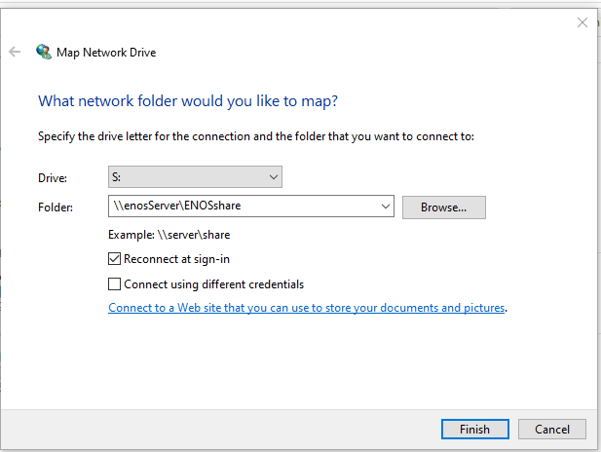
Click Finish
You will get a dialog box saying Trying to connect

Then a box asking for username and password. Enter pshare for user and pshare's Samba password that we entered with # smbpasswd -a pshare
Make sure “Remember my credentials” is checked.

Go back to “This PC” and in addition to Local Disk (C:) you should see the ENOSshare
mounted as Drive S: under the Network Locations header.
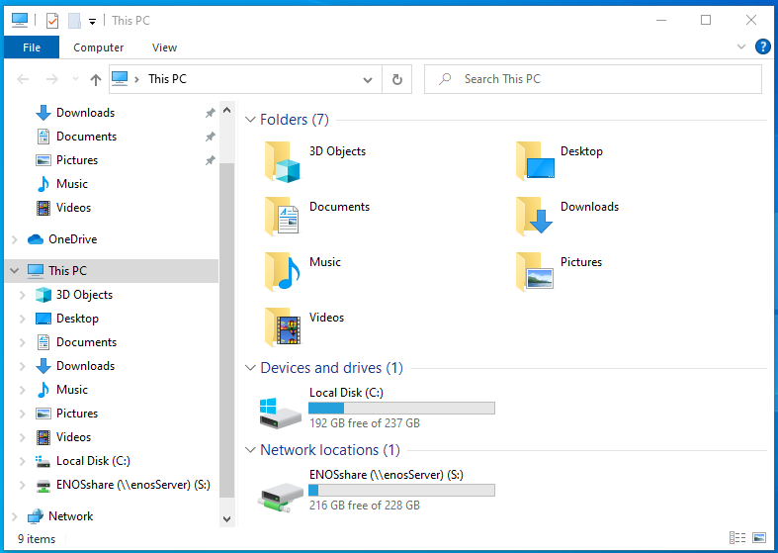
If you have the SMBshare mounted and listed as above. Power off and restart Windows and see if the SMBshare is automatically mounted after logging in. If it automatically mounts at boot up, we are done with Samba. Sometimes after login, the Icon for enosServer will look like the following.
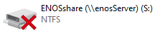

Just double click on it, and it will usually go find the enosServer and mount it.

Now that this is set up and working, I think in a lot of cases the “Network Discovery” can be turned off. See the top of the first page for configuring “Network Discovery” and see if everything still works with it off. If so, and nothing else requires Network Discovery, then leaving it off should be more secure.

Now Setup any other Windows machines in the exact same manner.

