An EndeavourOS based Simple Home Server.
July 22, 2020

MINIDLNA

If you want to play your MP3s, display Pictures, and view videos, on your Smart TV or any other DLNA device, a minidlna server will need to be installed.

IN A LINUX CLIENT computer, from a Terminal window, SSH into the enosServer and become root.
# pacman -Syu (When installing packages, start with a updated system. reboot if necessary)
# pacman -S minidlna (when asked about repositories, I hit enter and accept the defaults)
# vi /etc/minidlna.conf
port=8200 (in the second line, make sure port is set to 8200)

You can tell minidlna what directories on enosServer it will share.
Scroll to the section that begins with “# set this to the directory you want scanned.”
There are directions and examples given. Here is how I set up my directories

media_dir=A,/server/MP3
media_dir=A,/server/Ogg
media_dir=P,/server/Pictures
media_dir=V,/server/Movies

The A, indicates the following directory will contain Audio. P, = Pictures V, = Videos
which are the three media formats that minidlna supports.
In my case the directory /server/MP3 and all sub-directories contains my MP3 Audio.
The directory /server/Ogg and all sub-directories contains my Ogg Audio.
The directory /server/Pictures and all sub-directories contains my Pictures (images).
The directory /server/Movies and all sub-directories contains my MP4 videos.
All directories specified must exist on the enosServer Data drive. Adjust the paths to whatever you set up for your media.

(Right under this section is the Friendly Name section. I changed it to: remove the #)
friendly_name=EndeavourOS DLNA server
Save and close minidlna.conf

# gpasswd -a minidlna pshare (add pshare to the minidlna group)
# gpasswd -a minidlna users
# groups minidlna
minidlna users pshare
# systemctl enable minidlna.service (enable systemd to start minidlna at boot up)

Setup the server firewall and client firewall if one exists.
Port 8200
Minidlna
Server
Port 1900
Port 8200
Minidlna
Client
Port 1900
TCP

UDP

When the Client computer issues a request, it does so on port 8200 with TCP protocol.
The Server computer responds on port 1900 with UDP protocol.
We need to open port 8200 on the enosServer firewall

# ufw allow from 192.168.0.0/24 to any port 8200
Reboot the enosServer computer.

In a Linux client computer, if there is a firewall installed, we need to open port 1900.
Using gufw:
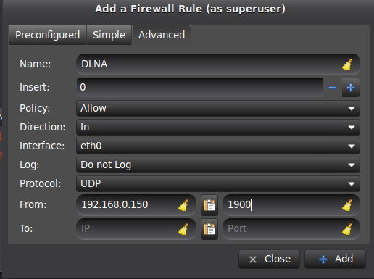
Interface: can be “any” or use pull down to select your specific Interface
From: IP address of enosServer, adjust as necessary.

If you have another firewall app, such as firewalld open port 1900 to let in your IP address.

In a Windows 10 computer make sure “Network Discovery” is turned on.
Settings - Network and Internet - Network and Sharing Center - Advanced Sharing Settings

Using a Smart TV, Windows MediaPlayer, VLC, or other DLNA enabled device on your LAN, see if it will recognize the EndeavourOS DLNA Server. Minidlna works on my Samsung Smart TV, and my YAMAHA AV Receiver.

To use DLNA with VLC, if the Playlist column is not visible on the left side, click on the "View" tab and click "Playlist". Scroll down to "Universal Plug'n'Play" and click. EndeavourOS DLNA Server should be listed.

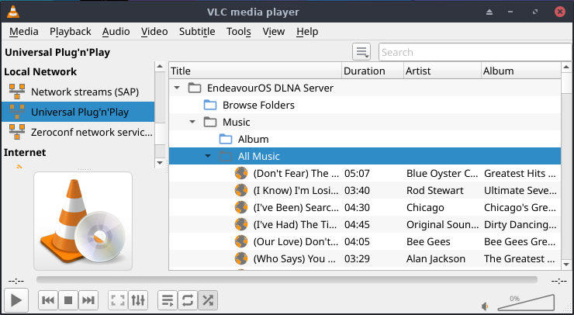
More info setting up the configuration file can be found at:
https://www.mankier.com/5/minidlna.conf

For audio, I know mp3, ogg, flac, and wma are supported, as long as the DLNA client supports those formats. VLC on a PC supports all four. My SMART TV, not so much.

For Pictures (images), jpeg and png are supported, not sure about any others

For Video, mp4 is supported, not sure about any others.

These are the major formats. Experiment around and see what else is supported.

You can also select and view your MP4 movies on VLC.
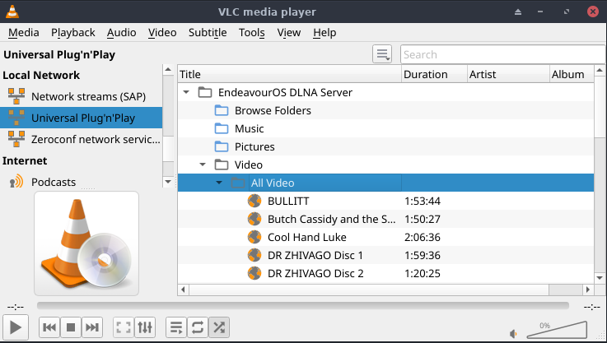
Lastly, you can set up your vacation pictures in a folder on the server, then have a slide show on your Smart TV in the family room and bore your friends to death.

