UART Transmitter Design Ideas
This section is to understand how to formulate the design intuitively.
Take note that this project works for clock speed other than 50MHz and bit rate other than 115200 bits/s too (simply change the appropriate parameters in verilog files). In this section, we will see how the parameters are calculated.
Let’s say we are using a CPLD with clock speed 50MHz, and we are interested in designing an UART receiver with bit rate 115200 bits/s. Then, CLOCKS_PER_BIT = clock speed / bit rate = (50 M clocks/s) / (115200 bits/s) ≈ 434 clocks per bit. Besides, we set the data width (number of data bits in a packet) to 8 bits (1 byte).
Now, let’s discuss the timing diagram below. Do not worry about the initial underscore like “i_”, “w_”, “o_”, “r_”. They are only used in Verilog coding later on (to represent input, wire, output, register respectively). They are not important for the design formulation.
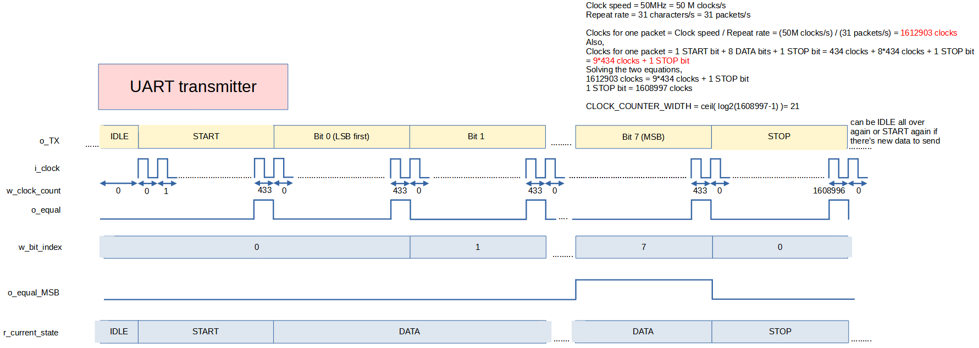

Initially, when there is nothing to transmitt, r_current_state of FSM is IDLE and o_TX is high. When there is something to send (e.g. it might be some event that triggers sending, like in this project, the trigger is when FSM sees that we are pressing push buttons), r_current_state transitions into START state and the value to be sent can be instructed to be loaded into transmitter shift register by the START state.

In START state, the clock counter will start counting, and take note that the clock count is w_clock_count. Since CLOCKS_PER_BIT is 434, the clock count will be reset after w_clock_count=434-1=433. To tell the FSM to transitions from START state into DATA state, we can make use of the o_equal pulse generated when w_clock_count=433. The counting continues until w_clock_count=433 again, then transmitter shift register shift by one bit (so that o_TX changes), and w_bit_index is incremented by one from 0 to 1. This process of clock counting, shifting, and incrementing w_bit_index is continued for all data bits. When sending MSB bit, o_equal_MSB=1, and this can be used to tell FSM to transition into STOP state. After sending the MSB bit, w_bit_index is reset back to zero and FSM transitions into STOP state.

For the STOP bit, the w_clock_count reaches 1608996 instaed of 433 before reseting. Basically the STOP bit is to limit how fast can data be sent out. For example, in this project, when we press and hold a push button, the key value of the push button is sent at repeat rate of 31 times per second. To know the length of STOP bit (CLOCKS_FOR_STOP) to limit repeat rate to 31 times per second, the calculation is as follows.

Clock speed = 50MHz = 50 M clocks/s
Repeat rate = 31 characters/s = 31 packets/s

Clocks for one packet = Clock speed / Repeat rate = (50M clocks/s) / (31 packets/s) = 1612903 clocks
Also,
Clocks for one packet = 1 START bit + 8 DATA bits + 1 STOP bit = 434 clocks + 8*434 clocks + 1 STOP bit = 9*434 clocks + 1 STOP bit
Solving the two equations,
1612903 clocks = 9*434 clocks + 1 STOP bit
CLOCKS_FOR_STOP = 1 STOP bit = 1608997 clocks

CLOCK_COUNTER_WIDTH = ceil( log2(1608997-1) )= 21

After the STOP bit is complete, the transmitter can send START bit again if there is still data to send, or back to IDLE state, sit back and relax.

With the thinking process so far, we can see that our UART receiver design should consist of four things
1) transmitter_shifter.v: To shift out serially the parallel load to o_TX.
2) transmitter_bit_counter.v: To keep track of w_bit_index and output o_equal_MSB. o_equal_MSB is used to tell r_current_state when to transition from DATA to STOP state.
3) transmitter_clock_counter.v: To keep track of w_clock_count and output o_equal. o_equal is useful to reset clock counter itself, tell FSM when to transition, tell when transmitter_shifter should shift, tell when bit counter should increment etc.
4) transmitter_control.v: The FSM that will tell r_current_state. r_current state can be used to disable shifting of transmitter_shifter, tell when bit_counter and clock_counter should not be counting etc.

UART Transmitter Datapath Design
When discussing datapath and control unit design, this timing diagram will be referred extensively.
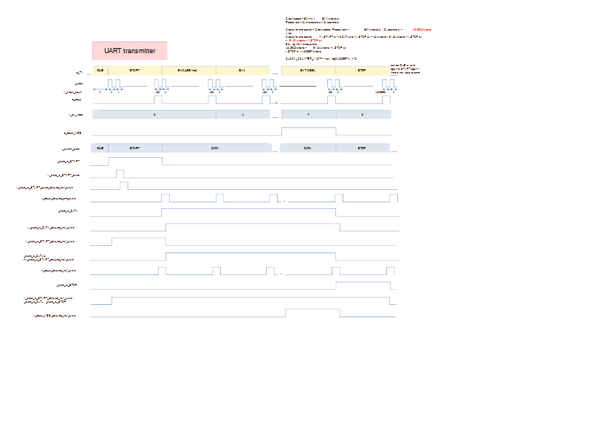

transmitter_shifter.v
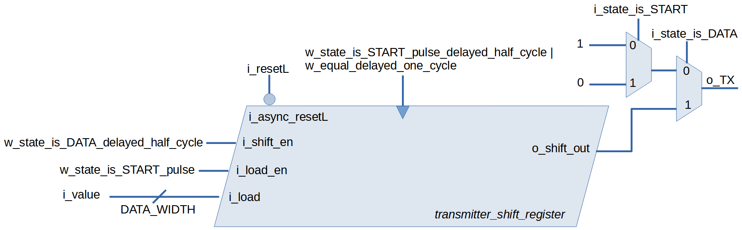

Transmitter shifter consists of transmitter_shift_register and two multiplexers. The transmitter_shift_register is a parallel-in-serial-out (PISO) shift register. Internally the implementation is based on rotation register, but, whether we use rotation register or right shift register internally, it doesn’t matter since on the outside we are using it as shift register. During IDLE state, the multiplexer selects logic 0 for the o_TX. During START state, a pulse (w_state_is_START_pulse) is generated from i_state_is_START, and this pulse is used to load data to be sent into the shift register at posedge of the pulse delayed half cycle (w_state_is_START_pulse_delayed_half_cycle). Also, during START state, the multiplexer selects logic 0 for the o_TX.

During DATA state, the multiplexer selects o_shift_out of the shift register. Also, the shift register is allowed to shift, with the posedge trigger being w_equal_delayed_one_cycle. At first thought, it seems like i_shift_en should be i_state_is_DATA, but to prevent unwanted shifting due to posedge of w_equal_delayed_one_cycle right after the START bit, we delay i_state_is_DATA by half cycle to get w_state_is_DATA_delayed_half_cycle. It turns out delaying by half cycle has an additional benefit of providing an extra shift right after sending MSB bit, such that the internal rotation register in transmitter_shift_register completes one cycle of rotation and is back to the data it loaded during START state. This is not an important point, just an extra for debugging if wanted.

transmitter_bit_counter.v
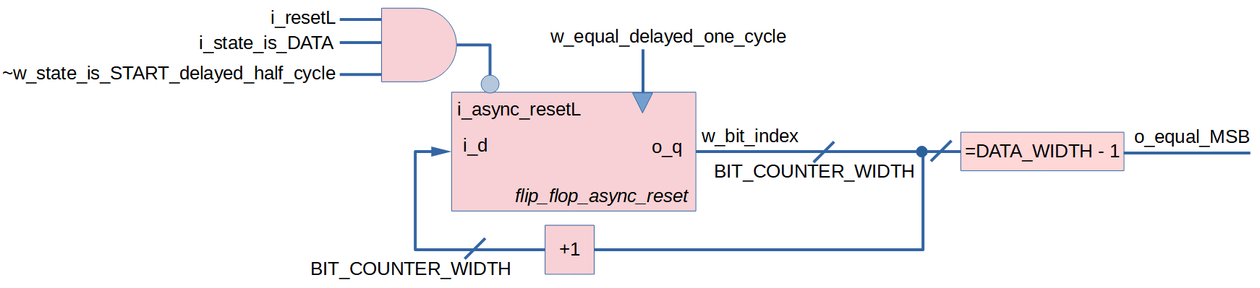

This transmitter_bit_counter.v is actually the same as receiver_bit_counter.v, anyway, let’s discuss the same thing again here.

The bit counter consists of a flip flop with asynchronous reset, a comparator to tell o_equal_MSB and an adder to increment w_bit_index by one. Since we are sending 8 data bits per packet, BIT_COUNTER_WIDTH = ceil( log2(DATA_WIDTH-1) ) = ceil( log2(8-1)) = 3. The clock for bit counter is w_equal_delayed_one_cycle (i.e. o_equal delayed by one cycle as discussed before in timing diagram).

There are three conditions when we should not reset the bit counter. Firstly, the most obvious condition is when i_resetL (the global active low reset) is high. Secondly, we don’t want reset when i_state_is_DATA. However, on a closer inspection on the timing diagram, we notice that having the second condition is still not enough, because the w_equal_delayed_one_cycle right after the START bit may cause unwanted increment of w_bit_index. So, the third condition is to make sure resetL is zero during the first half cycle of the first clock during i_state_is_DATA, and this is done by & with ~w_state_is_START_delayed_half_cycle. All together, we feed the i_async_resetL with the expression i_resetL & i_state_is_DATA & ~w_state_is_START_delayed_half_cycle.

transmitter_clock_counter.v
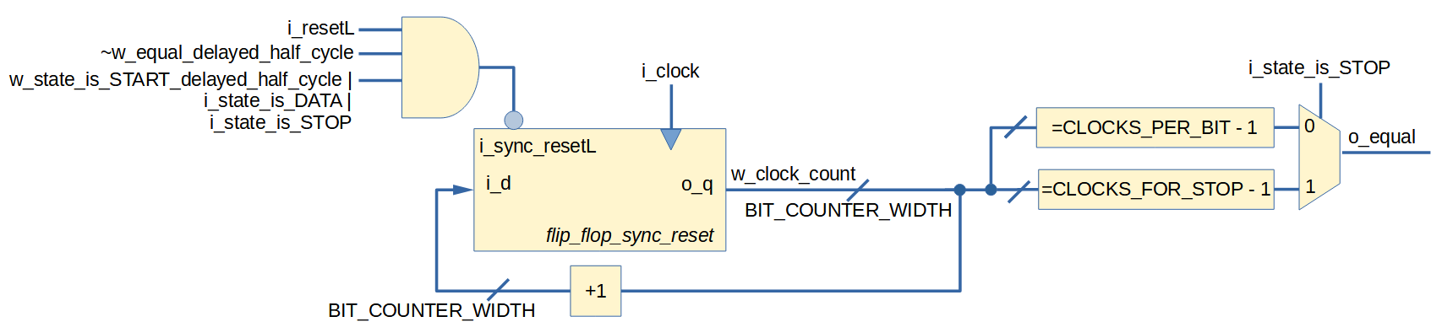

The clock counter consists of a flip flop with active low synchronous reset, adder to increment w_clock_count by 1, two comparators and one multiplexers. The maximum value that w_clock_count can be is CLOCKS_FOR_STOP – 1 = 1608997-1 = 1608996, so CLOCK_COUNTER_WIDTH = ceil( log2(CLOCKS_FOR_STOP-1) ) = ceil( log2(1608996)) = 21.

The clock for the flip flop is i_clock Using states from FSM as selector for the multiplexers, we can select at what value should the clock counter reset. When state is STOP, the number of clocks to elapse is CLOCKS_FOR_STOP. Else (during START bit and each DATA bit), we only need CLOCKS_PER_BIT.

Now let’s consider when we should not reset the clock counter. First condition is obviously when the global active-low reset is high (i_resetL = 1). Secondly, we need reset when w_equal_delayed_half_cycle (i.e. o_equal delayed by half cycle), and because reset is active low, we negate it to ~ w_equal_delayed_half_cycle. Third condition where we don’t want reset is when current state is START or DATA or STOP. However, taking a closer look at timing diagram, to prevent unwanted w_clock_count increment right after the middle of the START bit, we use w_state_is_START_delayed_half_cycle (i.e. i_state_is_START delayed half cycle). All together, we feed i_sync_resetL with i_resetL & ~w_equal_delayed_half_cycle & (w_state_is_START_delayed_half_cycle | i_state_is_DATA | i_state_is_STOP).

UART Transmitter Control Unit Design
The control unit is nothing but an FSM.

transmitter_control.v
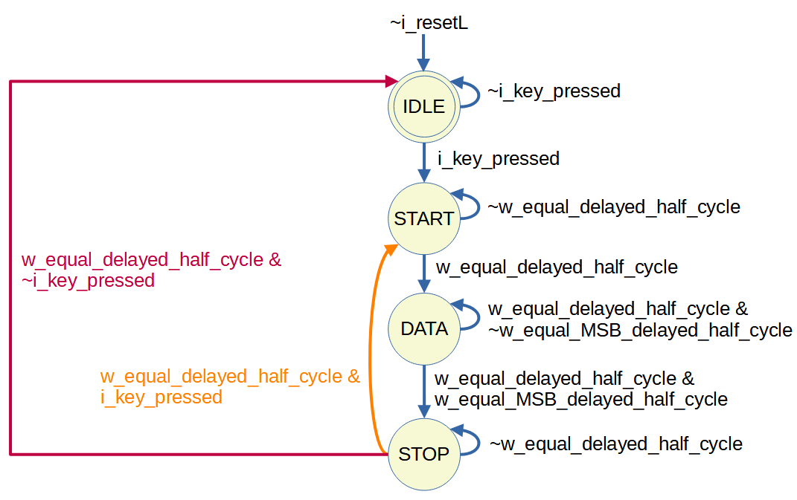

The logic w_equal_delayed_half_cycle is o_equal delayed half cycle, while w_equal_MSB_delayed_half_cycle is o_equal delayed half cycle. Delaying by half cycle is done intentionally to prevent hold time violation. Although synthesizer may insert delay to ensure zero hold time requirement, we would rather be safe and do the delay ourselves.
Starting from IDLE state, as long as there is no trigger (i.e. i_key_pressed in this project), the state stays. Else, it’s time to start sending the data, so the state transitions to START state. As long as clock counter hasn’t issued pulse (w_equal_delayed_half_cycle) to transition to DATA state, the state stays. Else when there is pulse issued (due to CLOCKS_PER_BIT has elapsed), state transitions to DATA.
During the DATA state, there will be a few pulses of w_equal_delayed_half_cycle, but eventually what will cause the state to transition to STOP state is if it is accompanied with w_equal_MSB_delayed_half_cycle (which tells FSM that MSB bit has already completed transmitting).
At STOP state, if the clock counter hasn’t issued pulse (w_equal_delayed_half_cycle), the state stays. Else, when there is pulse, the FSM check if key is still being pressed. If it is, then the state transitions to START to initiate transmission. Else, the state simply goes back to IDLE.

UART Transmitter Code
Here are all the code for this UART transmitter project. The Verilog HDL files are organized in the repository like this:
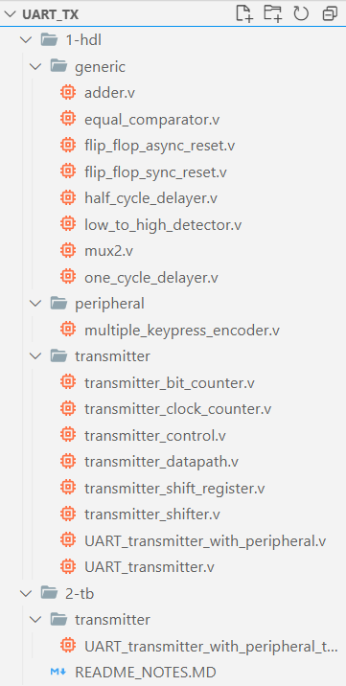

Generic
This folder contains commonly-used blocks.
generic/adder.v | generic/equal_comparator.v
module adder #(  parameter WIDTH=8  )(  input [WIDTH-1:0] i_a, i_b,  output [WIDTH-1:0] o_y  );  assign o_y = i_a + i_b;  endmodule | module equal_comparator#(  parameter WIDTH=8  )(  input [WIDTH-1:0] i_a, i_b,  output o_c  );  assign o_c = (i_a == i_b);  endmodule

generic/flip_flop_async_reset.v | generic/flip_flop_sync_reset.v
module flip_flop_async_reset #(  parameter WIDTH=8  )(  input i_clock,  input i_async_resetL,  input [WIDTH-1:0] i_d,  output reg [WIDTH-1:0] o_q  );  always @(posedge i_clock or negedge i_async_resetL) begin  if (~i_async_resetL) o_q <= 0;  else o_q <= i_d;  end  endmodule | module flip_flop_sync_reset #(  parameter WIDTH=8  )(  input i_clock,  input i_sync_resetL,  input [WIDTH-1:0] i_d,  output reg [WIDTH-1:0] o_q  );  always @(posedge i_clock) begin  if (~i_sync_resetL) o_q <= 0;  else o_q <= i_d;  end  endmodule

generic/half_delayer.v | generic/one_cycle_delayer.v
module half_cycle_delayer(  input i_clock,  input i_async_resetL,  input i_to_be_delayed_half_cycle,  output reg o_delayed_half_cycle  );  always @(negedge i_clock or negedge i_async_resetL) begin  if (~i_async_resetL) o_delayed_half_cycle <= 0;  else o_delayed_half_cycle <= i_to_be_delayed_half_cycle;  end  endmodule | module one_cycle_delayer(  input i_clock,  input i_resetL,  input i_to_be_delayed_one_cycle,  output o_delayed_one_cycle  );  wire w_delayed_half_cycle;  half_cycle_delayer inst_half_cycle_delayer(  .i_clock(i_clock),  .i_async_resetL(i_resetL),  .i_to_be_delayed_half_cycle(i_to_be_delayed_one_cycle),  .o_delayed_half_cycle(w_delayed_half_cycle)  );  flip_flop_async_reset #(  .WIDTH(1)  ) inst_flip_flop_async_reset(  .i_clock(i_clock),  .i_async_resetL(i_resetL),  .i_d(w_delayed_half_cycle),  .o_q(o_delayed_one_cycle)  );  endmodule

generic/mux2.v | generic/low_to_high_detector.v
module mux2 #(  parameter WIDTH=1  )(  input [WIDTH-1:0] i_d0, i_d1,  input i_s,  output [WIDTH-1:0] o_y  );  assign o_y = i_s ? i_d1 : i_d0;  endmodule | module low_to_high_detector(  input i_clock,  input i_resetL,  input i_level,  output o_pulse  );  localparam [1:0]  STATEZERO= 2'b00,  STATEONE = 2'b01,  STATETHREE=2'b10;  reg[1:0] r_current_state, r_next_state;  initial begin  r_current_state <= STATEZERO;  r_next_state <= STATEZERO;  end  always @(r_current_state, i_level) begin  r_next_state = r_current_state;  case(r_current_state)  STATEZERO:  if (i_level) r_next_state <= STATEONE;  STATEONE:  r_next_state <= STATETHREE;  STATETHREE:  if (~i_level) r_next_state <= STATEZERO;  endcase  end  always @(posedge i_clock, negedge i_resetL)  if (~i_resetL) r_current_state <= STATEZERO;  else r_current_state <= r_next_state;  assign o_pulse = (r_current_state == STATEONE);  endmodule

Peripheral
Under this folder is code for peripheral attached to UART transmitter. In this project, four push buttons are used for key a, s, d, w respectively. In the code below, notice the workaround used to send value in case two buttons are pressed simultaneously. For example, when both w and a are pressed, we send “#”. Later on we will write Python driver that will unpack this “#” symbol back into “w” and “a”.
peripheral/multiple_keypress_decoder.v
module multiple_keypress_encoder #(
parameter DATA_WIDTH=8
)(
input i_key_a,
input i_key_s,
input i_key_d,
input i_key_w,
output reg [DATA_WIDTH-1:0] o_value,
output o_key_pressed
);
localparam [DATA_WIDTH-1:0] lp_a_value = 'h61;
localparam [DATA_WIDTH-1:0] lp_s_value = 'h73;
localparam [DATA_WIDTH-1:0] lp_d_value = 'h64;
localparam [DATA_WIDTH-1:0] lp_w_value = 'h77;

localparam [DATA_WIDTH-1:0] lp_wa_value = 'h23; //#
localparam [DATA_WIDTH-1:0] lp_wd_value = 'h24; //$
localparam [DATA_WIDTH-1:0] lp_sa_value = 'h25; //%
localparam [DATA_WIDTH-1:0] lp_sd_value = 'h26; //&

always @(i_key_a, i_key_s, i_key_d, i_key_w)
case({i_key_a, i_key_s, i_key_d, i_key_w})
4'b0000: o_value <= 0; //null
4'b1000: o_value <= lp_a_value;
4'b0100: o_value <= lp_s_value;
4'b0010: o_value <= lp_d_value;
4'b0001: o_value <= lp_w_value;
4'b1001: o_value <= lp_wa_value;
4'b0011: o_value <= lp_wd_value;
4'b1100: o_value <= lp_sa_value;
4'b0110: o_value <= lp_sd_value;
default: o_value <= 0; //null
endcase

assign o_key_pressed = i_key_a | i_key_s | i_key_d | i_key_w;
endmodule

Transmitter
Under this folder is code for datapath and control unit of the UART transmitter.
transmitter/transmitter_shift_register.v
module transmitter_shift_register #(
parameter DATA_WIDTH = 8
)(
input i_clock,
input i_async_resetL,
input i_shift_en,
input i_ld_en,
input [DATA_WIDTH-1:0] i_load,
output o_shift_out
);
reg [DATA_WIDTH-1:0] r_internal_load = 0;

always @(posedge i_clock or negedge i_async_resetL) begin
r_internal_load = r_internal_load;
if (~i_async_resetL) r_internal_load <= 0;
else if (i_ld_en) r_internal_load <= i_load;
else if (i_shift_en) r_internal_load <= {r_internal_load[0], r_internal_load[DATA_WIDTH-1:1]};
end

assign o_shift_out = r_internal_load[0];
endmodule

transmitter/transmitter_shifter.v
module transmitter_shifter #(
parameter DATA_WIDTH = 8
)(
input i_clock,
input i_resetL,
input [DATA_WIDTH-1:0] i_value,
input i_state_is_START,
input i_state_is_DATA,
input i_equal,
output o_TX
);
wire w_state_is_START_delayed_half_cycle;
half_cycle_delayer inst_half_cycle_delayer_for_START(
.i_clock(i_clock),
.i_async_resetL(i_resetL),
.i_to_be_delayed_half_cycle(i_state_is_START),
.o_delayed_half_cycle(w_state_is_START_delayed_half_cycle)
);

wire w_state_is_DATA_delayed_half_cycle;
half_cycle_delayer inst_half_cycle_delayer_for_DATA(
.i_clock(i_clock),
.i_async_resetL(i_resetL),
.i_to_be_delayed_half_cycle(i_state_is_DATA),
.o_delayed_half_cycle(w_state_is_DATA_delayed_half_cycle)
);

wire w_equal_delayed_half_cycle;
half_cycle_delayer inst_half_cycle_delayer_for_equal(
.i_clock(i_clock),
.i_async_resetL(i_resetL),
.i_to_be_delayed_half_cycle(i_equal),
.o_delayed_half_cycle(w_equal_delayed_half_cycle)
);

wire w_state_is_START_pulse;
low_to_high_detector inst_low_to_high_detector(
.i_clock(i_clock),
.i_resetL(i_resetL),
.i_level(i_state_is_START),
.o_pulse(w_state_is_START_pulse)
);

wire w_equal_delayed_one_cycle;
one_cycle_delayer inst_one_cycle_delayer_for_equal(
.i_clock(i_clock),
.i_resetL(i_resetL),
.i_to_be_delayed_one_cycle(i_equal),
.o_delayed_one_cycle(w_equal_delayed_one_cycle)
);

wire w_state_is_START_pulse_delayed_half_cycle;
half_cycle_delayer inst_half_cycle_delayer_for_START_pulse(
.i_clock(i_clock),
.i_async_resetL(i_resetL),
.i_to_be_delayed_half_cycle(w_state_is_START_pulse),
.o_delayed_half_cycle(w_state_is_START_pulse_delayed_half_cycle)
);

wire w_clock = w_state_is_START_pulse_delayed_half_cycle | w_equal_delayed_one_cycle;
wire w_shift_en = w_state_is_DATA_delayed_half_cycle;
wire w_shift_out;
transmitter_shift_register #(
.DATA_WIDTH(DATA_WIDTH)
) inst_transmitter_shift_register(
.i_clock(w_clock),
.i_async_resetL(i_resetL),
.i_shift_en(w_shift_en),
.i_ld_en(w_state_is_START_pulse),
.i_load(i_value),
.o_shift_out(w_shift_out)
);

localparam [0:0] lp_one = 1;
localparam [0:0] lp_zero = 0;
wire w_mux_stage1;
mux2 #(
.WIDTH(1)
) inst_mux2_stage1(
.i_d0(lp_one),
.i_d1(lp_zero),
.i_s(i_state_is_START),
.o_y(w_mux_stage1)
);

mux2 #(
.WIDTH(1)
) inst_mux2_stage2(
.i_d0(w_mux_stage1),
.i_d1(w_shift_out),
.i_s(i_state_is_DATA),
.o_y(o_TX)
);
endmodule

transmitter/transmitter_bit_counter.v
module transmitter_bit_counter #(
parameter BIT_COUNTER_WIDTH=3,
parameter DATA_WIDTH=8
)(
input i_clock,
input i_resetL,
input i_state_is_START,
input i_state_is_DATA,
input i_equal,
output o_equal_MSB
);
wire w_equal_delayed_one_cycle;
one_cycle_delayer inst_one_cycle_delayer_for_equal(
.i_clock(i_clock),
.i_resetL(i_resetL),
.i_to_be_delayed_one_cycle(i_equal),
.o_delayed_one_cycle(w_equal_delayed_one_cycle)
);

wire [BIT_COUNTER_WIDTH-1:0] w_adder;
wire [BIT_COUNTER_WIDTH-1:0] w_bit_index;
wire w_resetL;
flip_flop_async_reset #(
.WIDTH(BIT_COUNTER_WIDTH)
) inst_flip_flop_async_reset(
.i_clock(w_equal_delayed_one_cycle),
.i_async_resetL(w_resetL),
.i_d(w_adder),
.o_q(w_bit_index)
);

localparam [BIT_COUNTER_WIDTH-1:0] lp_DATA_WIDTH_minus_one = DATA_WIDTH-1;
equal_comparator #(
.WIDTH(BIT_COUNTER_WIDTH)
) inst_equal_comparator(
.i_a(w_bit_index),
.i_b(lp_DATA_WIDTH_minus_one),
.o_c(o_equal_MSB)
);

localparam [BIT_COUNTER_WIDTH-1:0] lp_one = 1;
adder #(
.WIDTH(BIT_COUNTER_WIDTH)
) inst_adder(
.i_a(w_bit_index),
.i_b(lp_one),
.o_y(w_adder)
);

wire w_state_is_START_delayed_half_cycle;
half_cycle_delayer inst_half_cycle_delayer_for_START(
.i_clock(i_clock),
.i_async_resetL(i_resetL),
.i_to_be_delayed_half_cycle(i_state_is_START),
.o_delayed_half_cycle(w_state_is_START_delayed_half_cycle)
);
assign w_resetL = i_resetL & (~w_state_is_START_delayed_half_cycle & i_state_is_DATA);
endmodule

transmitter/transmitter_clock_counter.v
module transmitter_clock_counter #(
parameter CLOCK_COUNTER_WIDTH=21,
parameter CLOCKS_PER_BIT=434,
parameter CLOCKS_FOR_STOP=1612903
)(
input i_clock,
input i_resetL,
input i_state_is_START,
input i_state_is_DATA,
input i_state_is_STOP,
output o_equal
);
wire [CLOCK_COUNTER_WIDTH-1:0] w_adder;
wire [CLOCK_COUNTER_WIDTH-1:0] w_clock_count;
wire w_resetL;
flip_flop_sync_reset #(
.WIDTH(CLOCK_COUNTER_WIDTH)
) inst_flip_flop_sync_reset(
.i_clock(i_clock),
.i_sync_resetL(w_resetL),
.i_d(w_adder),
.o_q(w_clock_count)
);

localparam [CLOCK_COUNTER_WIDTH-1:0] lp_one = 1;
adder #(
.WIDTH(CLOCK_COUNTER_WIDTH)
) inst_adder(
.i_a(w_clock_count),
.i_b(lp_one),
.o_y(w_adder)
);

wire w_equal_CLOCKS_PER_BIT_minus_one;
localparam [CLOCK_COUNTER_WIDTH-1:0] lp_CLOCKS_PER_BIT_minus_one = CLOCKS_PER_BIT-1;
equal_comparator #(
.WIDTH(CLOCK_COUNTER_WIDTH)
) inst_equal_comparator_for_CLOCKS_PER_BIT_minus_one(
.i_a(w_clock_count),
.i_b(lp_CLOCKS_PER_BIT_minus_one),
.o_c(w_equal_CLOCKS_PER_BIT_minus_one)
);

wire w_equal_CLOCKS_FOR_STOP_minus_one;
localparam [CLOCK_COUNTER_WIDTH-1:0] lp_CLOCKS_FOR_STOP_minus_one = CLOCKS_FOR_STOP-1;
equal_comparator #(
.WIDTH(CLOCK_COUNTER_WIDTH)
) inst_equal_comparator_for_CLOCKS_FOR_STOP_minus_one(
.i_a(w_clock_count),
.i_b(lp_CLOCKS_FOR_STOP_minus_one),
.o_c(w_equal_CLOCKS_FOR_STOP_minus_one)
);

mux2 #(
.WIDTH(1)
) inst_mux2_for_equal(
.i_d0(w_equal_CLOCKS_PER_BIT_minus_one),
.i_d1(w_equal_CLOCKS_FOR_STOP_minus_one),
.i_s(i_state_is_STOP),
.o_y(o_equal)
);

wire w_equal_delayed_half_cycle;
half_cycle_delayer inst_half_cycle_delayer_for_equal(
.i_clock(i_clock),
.i_async_resetL(i_resetL),
.i_to_be_delayed_half_cycle(o_equal),
.o_delayed_half_cycle(w_equal_delayed_half_cycle)
);

wire w_state_is_START_delayed_half_cycle;
half_cycle_delayer inst_half_cycle_delayer_for_START(
.i_clock(i_clock),
.i_async_resetL(i_resetL),
.i_to_be_delayed_half_cycle(i_state_is_START),
.o_delayed_half_cycle(w_state_is_START_delayed_half_cycle)
);

assign w_resetL = i_resetL &
~w_equal_delayed_half_cycle &
(w_state_is_START_delayed_half_cycle | i_state_is_DATA | i_state_is_STOP);
endmodule

transmitter/transmitter_datapath.v
module transmitter_datapath #(
parameter DATA_WIDTH = 8,
parameter BIT_COUNTER_WIDTH=3,
parameter CLOCK_COUNTER_WIDTH=21,
parameter CLOCKS_PER_BIT=434,
parameter CLOCKS_FOR_STOP=1608997
)(
input i_clock,
input i_resetL,
input [DATA_WIDTH-1:0] i_value,
//input i_state_is_IDLE,
input i_state_is_START,
input i_state_is_DATA,
input i_state_is_STOP,
output o_equal,
output o_equal_MSB,
output o_TX
);
transmitter_shifter #(
.DATA_WIDTH(DATA_WIDTH)
) inst_transmitter_shifter(
.i_clock(i_clock),
.i_resetL(i_resetL),
.i_value(i_value),
.i_state_is_START(i_state_is_START),
.i_state_is_DATA(i_state_is_DATA),
.i_equal(o_equal),
.o_TX(o_TX)
);

transmitter_bit_counter #(
.BIT_COUNTER_WIDTH(BIT_COUNTER_WIDTH),
.DATA_WIDTH(DATA_WIDTH)
) inst_transmitter_bit_counter(
.i_clock(i_clock),
.i_resetL(i_resetL),
.i_state_is_START(i_state_is_START),
.i_state_is_DATA(i_state_is_DATA),
.i_equal(o_equal),
.o_equal_MSB(o_equal_MSB)
);

transmitter_clock_counter #(
.CLOCK_COUNTER_WIDTH(CLOCK_COUNTER_WIDTH),
.CLOCKS_PER_BIT(CLOCKS_PER_BIT),
.CLOCKS_FOR_STOP(CLOCKS_FOR_STOP)
) inst_transmitter_clock_counter(
.i_clock(i_clock),
.i_resetL(i_resetL),
.i_state_is_START(i_state_is_START),
.i_state_is_DATA(i_state_is_DATA),
.i_state_is_STOP(i_state_is_STOP),
.o_equal(o_equal)
);
endmodule

transmitter/transmitter_control.v
module transmitter_control(
input i_clock,
input i_resetL,
input i_key_pressed,
input i_equal,
input i_equal_MSB,
output o_state_is_START,
output o_state_is_DATA,
output o_state_is_STOP
);
localparam [1:0]
IDLE = 2'b00,
START = 2'b01,
DATA = 2'b10,
STOP = 2'b11;

reg[1:0] r_current_state, r_next_state;

wire w_equal_delayed_half_cycle;
half_cycle_delayer inst_half_cycle_delayer_for_equal(
.i_clock(i_clock),
.i_async_resetL(i_resetL),
.i_to_be_delayed_half_cycle(i_equal),
.o_delayed_half_cycle(w_equal_delayed_half_cycle)
);
wire w_equal_MSB_delayed_half_cycle;
half_cycle_delayer inst_half_cycle_delayer_for_equal_MSB(
.i_clock(i_clock),
.i_async_resetL(i_resetL),
.i_to_be_delayed_half_cycle(i_equal_MSB),
.o_delayed_half_cycle(w_equal_MSB_delayed_half_cycle)
);

always @(r_current_state, i_key_pressed,
w_equal_delayed_half_cycle,
w_equal_MSB_delayed_half_cycle) begin
r_next_state = r_current_state;
case(r_current_state)
IDLE:
if (~i_key_pressed) r_next_state <= IDLE;
else if (i_key_pressed) r_next_state <= START;
START:
if (~w_equal_delayed_half_cycle) r_next_state <= START;
else if (w_equal_delayed_half_cycle) r_next_state <= DATA;
DATA:
if (w_equal_delayed_half_cycle & ~w_equal_MSB_delayed_half_cycle) r_next_state <= DATA;
else if (w_equal_delayed_half_cycle & w_equal_MSB_delayed_half_cycle) r_next_state <= STOP;
STOP:
if (~w_equal_delayed_half_cycle) r_next_state <= STOP;
else if (w_equal_delayed_half_cycle & i_key_pressed) r_next_state <= START;
else if (w_equal_delayed_half_cycle & ~i_key_pressed) r_next_state <= IDLE;
endcase
end

always @(posedge i_clock, negedge i_resetL)
if (~i_resetL) r_current_state <= IDLE;
else r_current_state <= r_next_state;

assign o_state_is_START = (r_current_state == START);
assign o_state_is_DATA = (r_current_state == DATA);
assign o_state_is_STOP = (r_current_state == STOP);
endmodule

transmitter/UART_transmitter.v
module UART_transmitter #(
parameter DATA_WIDTH = 8,
parameter BIT_COUNTER_WIDTH=3,
parameter CLOCK_COUNTER_WIDTH=21,
parameter CLOCKS_PER_BIT=434,
parameter CLOCKS_FOR_STOP=1608997
)(
input i_clock,
input i_resetL,
input i_key_pressed,
input [DATA_WIDTH-1:0] i_value,
output o_TX
);
wire w_state_is_START;
wire w_state_is_DATA;
wire w_state_is_STOP;
wire w_equal;
wire w_equal_MSB;

transmitter_control inst_transmitter_control(
.i_clock(i_clock),
.i_resetL(i_resetL),
.i_key_pressed(i_key_pressed),
.i_equal(w_equal),
.i_equal_MSB(w_equal_MSB),
.o_state_is_START(w_state_is_START),
.o_state_is_DATA(w_state_is_DATA),
.o_state_is_STOP(w_state_is_STOP)
);

transmitter_datapath #(
.DATA_WIDTH(DATA_WIDTH),
.BIT_COUNTER_WIDTH(BIT_COUNTER_WIDTH),
.CLOCK_COUNTER_WIDTH(CLOCK_COUNTER_WIDTH),
.CLOCKS_PER_BIT(CLOCKS_PER_BIT),
.CLOCKS_FOR_STOP(CLOCKS_FOR_STOP)
)
inst_transmitter_datapath(
.i_clock(i_clock),
.i_resetL(i_resetL),
.i_value(i_value),
.i_state_is_START(w_state_is_START),
.i_state_is_DATA(w_state_is_DATA),
.i_state_is_STOP(w_state_is_STOP),
.o_equal(w_equal),
.o_equal_MSB(w_equal_MSB),
.o_TX(o_TX)
);
endmodule

transmitter/UART_transmitter_with_peripheral.v
module UART_transmitter_with_peripheral #(
parameter DATA_WIDTH = 8,
parameter BIT_COUNTER_WIDTH=3,
parameter CLOCK_COUNTER_WIDTH=21,
parameter CLOCKS_PER_BIT=434,
parameter CLOCKS_FOR_STOP=1608997
)(
input i_clock,
input i_resetL,
input i_key_a,
input i_key_s,
input i_key_d,
input i_key_w,
output o_TX
);
wire [DATA_WIDTH-1:0] w_value;
wire w_key_pressed;
multiple_keypress_encoder #(
.DATA_WIDTH(DATA_WIDTH)
) inst_keypress_encoder(
.i_key_a(i_key_a),
.i_key_s(i_key_s),
.i_key_d(i_key_d),
.i_key_w(i_key_w),
.o_value(w_value),
.o_key_pressed(w_key_pressed)
);

UART_transmitter #(
.CLOCK_COUNTER_WIDTH(CLOCK_COUNTER_WIDTH),
.BIT_COUNTER_WIDTH(BIT_COUNTER_WIDTH),
.DATA_WIDTH(DATA_WIDTH),
.CLOCKS_PER_BIT(CLOCKS_PER_BIT),
.CLOCKS_FOR_STOP(CLOCKS_FOR_STOP)
) inst_UART_transmitter(
.i_clock(i_clock),
.i_resetL(i_resetL),
.i_key_pressed(w_key_pressed),
.i_value(w_value),
.o_TX(o_TX)
);
endmodule

UART Transmitter Game Controller Driver
Before we can use the project to play racing game in computer, we need to write a driver that understands the meaning of the data sent from our UART transmitter and perform actions like keydown and keyup accordingly.
UART_game_controller_driver.py
import pyautogui
import serial
ser = serial.Serial(port='COM3',baudrate=115200,timeout=0.2)
last_key = b''
last_key_combination = []
current_key = b''
current_key_combination = []
def unpack(current_key):
if current_key == b'#':
current_key_combination = [b'w', b'a']
elif current_key == b'$':
current_key_combination = [b'w', b'd']
elif current_key == b'%':
current_key_combination = [b's', b'a']
elif current_key == b'&':
current_key_combination = [b's', b'd']
else:
current_key_combination = [current_key]
return current_key_combination
while True:
try:
current_key = ser.read()
print(current_key)
if current_key != last_key:
current_key_combination = unpack(current_key)
# First comparison:
# compare last key combination with current key combination
# if last key is null then nothing to keyUp
if last_key != b'':
for key in last_key_combination:
if key not in current_key_combination:
print('key not in current_key_combination', key)
pyautogui.keyUp(key.decode("utf-8"))
last_key_combination.remove(key)
else:
# remove equal because redundant in second comparison
current_key_combination.remove(key)
# second comparison:
# compare current key combination with last key combination
# if current key is null then nothing to keyDown
if current_key != b'':
for key in current_key_combination:
if key not in last_key_combination:
pyautogui.keyDown(key.decode("utf-8"))
last_key_combination.append(key)
# finally save current key as last key for future comparison
last_key = current_key
except:
ser.close()
break

UART Transmitter Testbench and Simulation
UART_transmitter_with_peripheral_tb.v
`timescale 1ns/100ps

module UART_transmitter_with_peripheral_tb();
parameter DATA_WIDTH=8;
parameter BIT_COUNTER_WIDTH=3;
parameter CLOCK_COUNTER_WIDTH=21;
parameter CLOCKS_PER_BIT=434;
parameter CLOCKS_FOR_STOP=1608997;

reg r_clock;
initial begin
r_clock = 1;
forever begin
#0.5 r_clock = ~r_clock;
end
end

reg r_resetL;
reg r_key_a;
reg r_key_s;
reg r_key_d;
reg r_key_w;

wire w_TX;
UART_transmitter_with_peripheral #(
.DATA_WIDTH(DATA_WIDTH),
.BIT_COUNTER_WIDTH(BIT_COUNTER_WIDTH),
.CLOCK_COUNTER_WIDTH(CLOCK_COUNTER_WIDTH),
.CLOCKS_PER_BIT(CLOCKS_PER_BIT),
.CLOCKS_FOR_STOP(CLOCKS_FOR_STOP)
) inst_UART_transmitter_with_peripheral(
.i_clock(r_clock),
.i_resetL(r_resetL),
.i_key_a(r_key_a),
.i_key_s(r_key_s),
.i_key_d(r_key_d),
.i_key_w(r_key_w),
.o_TX(w_TX)
);

initial begin
r_resetL=0; r_key_a=0; r_key_s=0; r_key_d=0; r_key_w=0; #(CLOCKS_PER_BIT * 2);
r_resetL=1; #(CLOCKS_PER_BIT * 2);
r_key_a=1; #(CLOCKS_PER_BIT * (DATA_WIDTH + 1) + CLOCKS_FOR_STOP);
r_key_a=0; #(CLOCKS_PER_BIT * 2);
r_key_w=0; #(CLOCKS_PER_BIT); $stop;
end
endmodule

The simulation waveform is the same as the timing diagram we discussed earlier on except with added peripheral (4 push buttons named i_key_a, i_key_s, i_key_d, and i_key_w in the simulation waveform). When i_key_a is pressed, r_current_state becomes 01 (START) and o_TX changes from the initial logic 1 to logic 0. After sending this START bit, r_current_state transition to DATA state (r_current_state=10). Looking when r_current_state=10, and looking at o_TX, we can see the data is being sent correctly (the data to be sent is o_value = 01100001). The o_TX starts sending serially by sending out the LSB first and ends with MSB. After DATA state, we have quite a long STOP bit, and this is intentional as discussed before to limit repeat rate. Finally since i_key_a is released, at the end the r_current_state simply go back to IDLE state and wait for further key press.
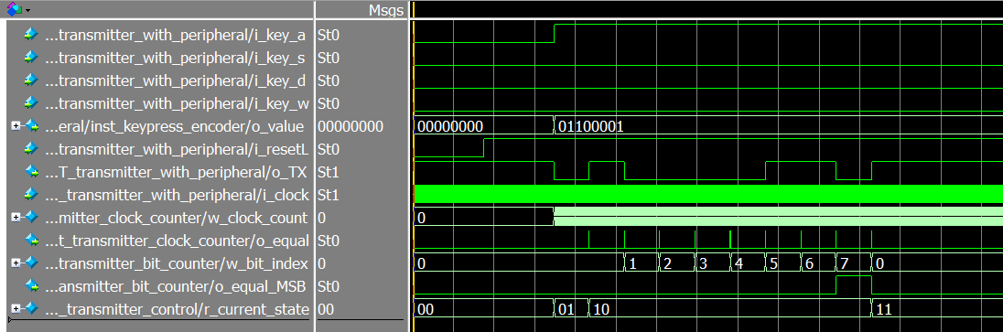 continued...
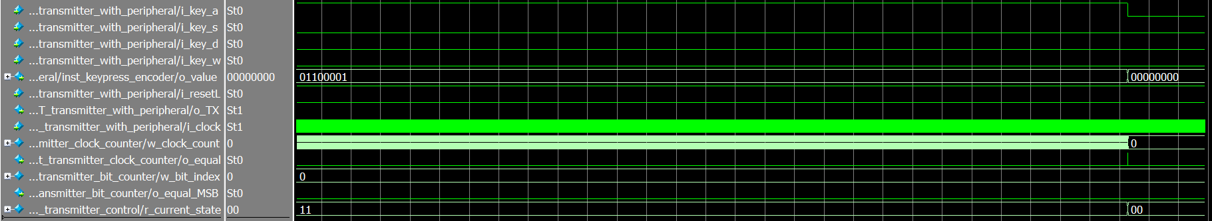

UART Transmitter Hardware
For the demo, please watch the YouTube video:
https://youtu.be/VMD-bAN7MmI?t=3686
Code for download:
https://github.com/endeneer/CPLD_UART_Datapath_and_Control_Unit
