**Development of Automated Enrollment System for Senior High**

**ZYRUS VAN EYECK S. GOZAR**

**DEAN JOSHUA M. QUILATAN**

**JULIE ANN D. TENORIO**

**A Thesis Presented to the**

**Faculty of the College of Science**

**Technological University of the Philippines**

**Ayala Blvd., Ermita, Manila**

**In Partial Fulfillment of the**

**Requirements for the Degree**

**Bachelor of Science in Information Technology**

**­­**

**February 2017**

**Approval Sheet**

**Acknowledgement**

**Double spaced. 5 character indentation. Ragged edge on the right**

**Abstract**

**Single spaced. No indentation. Ragged edge on the right. 1 paragraph**

**Table of Contents**

**Page**

Title Page

Approval Sheet

Acknowledgement

Abstract

Table of Contents

List of Tables

List of Figures

List of Appendixes

**Chapter 1 THE PROBLEM AND ITS SETTING**

Introduction

Background of the Study

Objectives of the Study

Scope and Limitation of the Study

Significance of the Study

**Chapter 2 CONCEPTUAL FRAMEWORK**

Review of Related Literature

Related Studies

Conceptual Model of the Study

Operational Definition of Terms

**Chapter 3 METHODOLOGY**

Project Design

Project Development

Operation and Testing Procedure

Evaluation Procedure

**Chapter 4 RESULTS AND DISCUSSION**

Project Description

Project Structure

Project Capabilities and Limitations

Project Evaluation

**Chapter 5 SUMMARY, CONCLUSIONS, AND RECOMMENDATIONS**

Summary of Findings

Conclusions

Recommendations

**REFERENCES**

**CURRICULUM VITAE**

**List of Tables**

**Table Page**

1. Device Table

**List of Figures**

Figure Page

1

**List of Appendixes**

Appendix Page

A

**Chapter 1**

**THE PROBLEM AND ITS SETTING**

**Introduction**

K-12 is a short form for the publicly-supported school grades prior to college. Students acquire in-depth knowledge, skills, values, and attitudes through continuity and consistency across all levels and subjects. After going through Kindergarten, the enhanced Elementary and Junior High curriculum, and a specialized Senior High program, every K-12 graduate will be ready to go into different paths like further education (College), employment or entrepreneurship. ​

A grading system plays a key role in the management system of any school. But, such systems do not often relate expectations, outcomes, and performance. From the faculty perspective, these are necessary to avoid disagreement from students and parents. Grading system is the most commonly used means of analyzing student performance, talents, and skills. Students’ grades are vital information needed in advancing to the next grade/year level and its accuracy is very important.

Automated grading system used to help parents and kids inform about what students are doing in class and how well they are doing it, and makes students more accountable for their work and eliminates unwelcome surprises. Keeping track of grades provides students with more timely feedback, a key to keeping students engaged in the learning experience. This application helps to improve the fairness, consistency, and efficiency of grading. It provides a brief overview of the breakdown of the final grade.

**Background of the Study**

Nazareth Institute of Alfonso is a small private school in Alfonso, Cavite. They are still utilizing the manual system in almost all phases of their school work. The school maintains a small staff of teachers and personnel as compared to its growing population. There are teachers handling as much as four different subjects, aside from being a class adviser and area coordinator. Majority of the teachers handle three different grade levels.

Nazareth Institute of Alfonso uses the manual way of computing grades, scheduling, plotting of sections and adding information or records of both students and teachers. This process takes a lot of effort and by storing and computing data manually, the process is prone to errors.

Developing an automated grading system for Nazareth Institute of Alfonso would make the task of recording data and computing grades easier. This will not only benefit the teachers of the school but also the students and their parents because of the improvement in the accuracy of calculations and in the proficiency and productivity of the teachers.

**Objectives of the Study**

The general objective of the study is to develop an Automated Grading System for Nazareth Institute of Alfonso.

Specially aims to:

1. Design a website within the following features:

For Teachers:

1. View and print Teacher’s subject loads and schedules
2. View and print Teacher’s students master lists and,
3. Compute the student’s quarterly grade based on inputted data

For Admin:

1. Add, edit and update student’s information
2. Allocation of student’s section and schedules and,
3. Allocation of teacher’s subject loads

For Students/Guardian:

1. View and print student’s grade
2. Create an Application using:
3. Visual Basic 2015
4. MySQL
5. Adobe Photoshop
6. Test and improve in terms of exploring through the Application
7. Determine the acceptability level of the Application using ISO 9126

**Scopes and Limitations**

**Significance of the Study**

**Chapter2**

**CONCEPTUAL FRAMEWORK**

This chapter contains the Review of Related Literature and Study which will be applied in the study, Conceptual Framework and Operational Definition of Terms.

**Review of Related Literature**

The following are the things that helped the researchers to deepen and conceptualize this study:

**HyperText Markup Language (HTML)**

HTML is a form of markup that is oriented toward the presentation of single-page text documents with specialized rendering software called an HTML user agent, the most common example of which is a web browser.

It provides a mean to describe the structure of text-based information in a document by denoting certain text like headings, paragraphs etc. and to that text with interactive forms, embedded images and other brackets. Such a file is typically created with the intent that it will be accessed over the World Wide Web, which uses the HTTP network protocol to transfer the files to requesting computers. A request for an HTML document is usually made by a web browser.

**Cascading Style Sheet (CSS)**

A data format used to separate style from structure on Web pages. With CSS, designers are able to use tags to reference a style rather than describe it at each instance. Then, when a style needs to be changed, only the referenced declarations need to be changed, not all of the instances where it is used.

CSS information may be contained on each Web page, called from an external file, or both. For sites with many style declarations, the centralized method (external file) offers the most potential efficiency gains in terms of site management.

This programming language will be used by the researchers in developing the proposed system because it is generally used to style web pages written in HTML. It is the only language that manages to design document presentation including elements such as layouts, colors and fonts.

**Active Server Pages (ASP)**

ASP is a development framework for building web pages. It is Microsoft's first server-side script engine for dynamically generated web pages. As for ASP.NET, it refers to an open-source server-side web application framework designed for web development to produce dynamic web pages. It was developed by Microsoft to allow programmers to build dynamic web sites, web applications and web services.

ASP.NET is a web development platform, which provides a programming model, a comprehensive software infrastructure and various services required to build up robust web applications for PC, as well as mobile devices.

ASP.NET is used to produce interactive, data-driven web applications over the internet. It consists of a large number of controls such as text boxes, buttons, and labels for assembling, configuring, and manipulating code to create HTML pages..

**Database Management System (DBMS)**

A **database management system** is a [computer software](https://en.wikipedia.org/wiki/Computer_software) application that interacts with the user, other applications, and the database itself to capture and analyze data. Consist of an integrated set of computer software that allows [users](https://en.wikipedia.org/wiki/User_(computing)) to interact with one or more databases and provides access to all of the data contained in the database.

**MS SQL**

MS SQL is a relational database management system (RDBMS) based on SQL (Structured Query Language) which is created by Microsoft.  It is a full-featured database primarily designed to compete against competitors Oracle Database (DB) and MySQL. Like all major RBDMS, SQL Server supports ANSI SQL, the standard SQL language. The said database management system’s function is to store and retrieve data which are requested by other software applications. The data requested may run either on the same computer or on another across a network which also includes the Internet.

The researchers will use this database management system because it is commonly used by web applications that need a database system. There are many GUI (Graphical User Interface) applications that could handle MySQL easier and faster.

**Microsoft Visual Studio**

Microsoft Visual Studio is used to develop computer programs for Microsoft Windows, as well as web sites, web applications and web services. Visual Studio uses Microsoft software development platforms such as Windows API, Windows Forms, Windows Presentation Foundation, Windows Store and Microsoft Silverlight. It can produce both native code and managed code.

Visual Studio includes a code editor supporting IntelliSense as well as code refactoring. Other built-in tools includes a forms designer for building GUI applications, web designer, class designer, and database schema designer.

Visual Studio supports different programming languages and allows the code editor and debugger to support nearly any programming languages. Built-in languages include C++, C#, and VB.NET. IT also supports HTML, JavaScript, and CSS.

**Evaluation System**

**ISO 9126**

The ISO 9126 is an international standard for the evaluation of software quality. The standard is divided into four parts which respectively addresses the following subjects: quality model; external metrics; internal metrics; and quality in use metrics. ISO 9126 Part one, referred to an ISO 9126-1 is an extension of previous work done by McCall(1977), Boehm(1978), FURPS and others in defining a set of software quality characteristics. ISO 9126-1 represents the latest (and ongoing) research into characterizing software for the purposes of software quality control, software quality assurance and software process improvement (SPI). This article defines the characteristics identified by ISO 9126-1. The other parts of ISO 9126, concerning metrics or measurements of these characteristics, are essential for SQC, SQA and SPI but the main concern of it is the definition of the basic ISO 9126 Quality Model which are the following:

**Functionality**

* The functions included in the system are fully functional (Accuracy)
* The functions required in the system are implemented (Compliance)

**Reliability**

* The system encounters no error or bug. (Maturity)
* The system does not terminate despite errors or bugs encountered ( Fault Tolerance)

**Usability**

* The system is easy to operate. (Operability)
* The system displays instructions that are easy to understand. (Understandability)

**Efficiency**

* The system can easily execute the request (Time Behavior)
* The system uses minimal resources (Resource Behavior)

**Maintainability**

* The system can identify the resource of failure when an error is encountered (Analyzability)
* The system can easily be modified for expansion and correction (Changeability)

**Portability**

* The system can be easily installed (Installability)
* The system can run on different operating environments (Adaptability)

**Related Studies**

**Conceptual Model of the Study**

Shown below is the conceptual model of the study. It illustrates the flow and how the system was developed. It contains the input, process and the output.

**OUTPUT**

Senior High Enrollment System

(Nazareth Institute of Alfonso)

**PROCESS**

System Analysis

-Identify the problem and objectives

-Analyzing System needs

Project Design

-Planning, design and development of the system

System Implementation

-testing and debugging of the system

**INPUT**

Knowledge Requirements:

-Enrollment System

-Database

-Web Designing

-C#

-HTML&CSS

-JavaScript

-MySQL

Software Requirements:

-MySQL

-Visual Studio 2015

- Adobe Photoshop

Hardware Requirements:

-Computer Unit (Pentium 4 or higher processor, 400 gb ram)

EVALUATION

***Figure 1***. Conceptual Model of the Study

**Input**

In this phase, there are three requirements which are knowledge requirement, software requirement and hardware requirement. To develop the proposed system they must know the process of the school’s grading system. They must also have knowledge in database management and web designing.

Next is the software requirement, it is needed to create and develop the system. The proposed system will use Visual Studio 2015 as a programming language and MySQL for the database and will use Adobe Photoshop for the designs needed.

Lastly, to use this application the hardware requirement is needed to make this system running. The proposed system will use Pentium 4 or higher processor with 4 GB ram.

**Process**

The process components consists of System analysis, project design and system implementation. System analysis is the process of analyzing and gathering information needed to develop the system, project design is the process where the appearance of the system is being created. System implementation is the delivery of the system into production.

**Output**

The final output of this study is the Senior High Enrollment System for Nazareth Institute of Alfonso. The system will make the manual process into automated process.

**Operational Definition of Terms**

**Subject Grade** – numeric equivalent of a student’s performance in subject or grade component.

**Official List of Students** – List of student names who are officially enrolled in the school for the current school year.

**Student Report Card** – a report given to the parents containing the grades of the student for a given quarter.

**Final Grade** – The grade of the student for the subject as computed by the teacher and that appears on the Student Report Card. It is determined by the sum of all ratings for the different grade components divided by the total number of grade components.

**Visual Studio** is an integrated development environment used to create applications for Windows, Android, iOS and modern web applications, which was developed by Microsoft.

**C#** is a programming language that is designed for building a variety of applications that run on the .NET Framework. C# is simple, powerful, type-safe, and object-oriented.

**Database** is a collection of information that is organized so that it can easily be accessed, managed, and updated.

**Chapter 3**

**METHODOLOGY**

This chapter contains the project design, program development, operation and testing procedure, and evaluation procedure.

**Project Design**

The system design is composed of Context Level Diagram, and Data Flow Diagram for the K-12 Online Grading System for Nazareth Institute of Alfonso.

In the Student side, the person will be able to view his/her subject/quarterly grade, and final grade. Students will also be given a chance to evaluate his/her teacher’s performance.

In the Teacher side, the teacher will be able to view his/her students, and add/update students’ grade. Teacher will also view his/her performance rating.

In the Admin side, the admin will be able to distribute faculty loading and class schedules view the performance rating of the teachers and distribute it to the teachers.

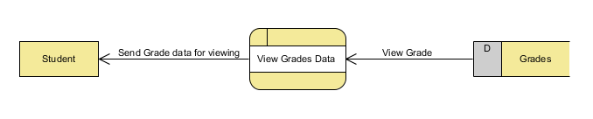

***Figure 2***. Data Flow Diagram for Students

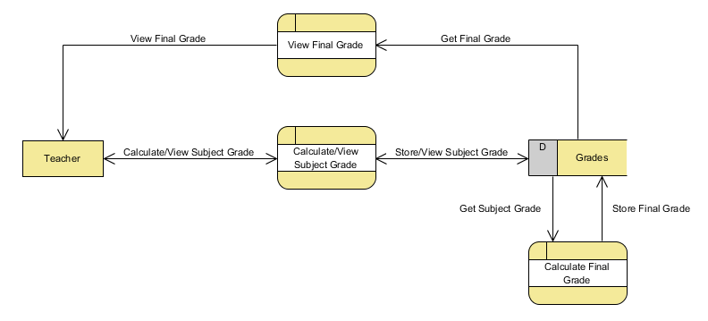

***Figure 3***. Data Flow Diagram for Teachers

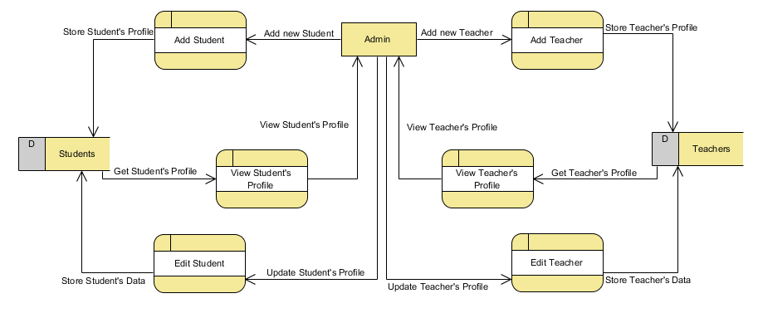

***Figure 4***. Data Flow Diagram for Admin

Teacher

Student

View Class Record

Add/Update Class Grades

***Figure 5***. Context Level Diagram for K-12 Online Grading System

View Performance Rate

Send Teacher’s Performance Rate

View Teacher’s Performance Rate

Administrator

Evaluate Teacher’s Performance

View Subjects/Final Grade

K-12 Online Grading System

**Project Development**

The project development consists of a set of related activities that leads to the production of the system. The researchers chose the Waterfall Model Approach in developing the K-12 Online Grading System for Nazareth Institute of Alfonso, as it simple and easy to understand and use, and easy to manage due to the rigidity of the model; each phase has specific deliverables and a review process.. In the Waterfall model approach, the whole process of project development is divided into separate phases, typically, the outcome of one phase acts as the input for the next phase sequentially. All the phases are cascaded to each other in which progress is seen as flowing steadily downwards (like a waterfall) through the phases. The next phase is started only after the defined set of goals are achieved for previous phase and it is signed off, so the name "Waterfall Model". Also, phases do not overlap.

The sequential phases in Waterfall model are:

*Requirement Gathering and Analysis:* All possible requirements of the system to be developed are captured in this phase and documented in a requirement specification doc.

*System Design:* The requirement specifications from first phase are studied in this phase and system design is prepared. System Design helps in specifying hardware and system requirements and also helps in defining overall system architecture.

*Implementation:* With inputs from system design, the system is first developed in small programs called units, which are integrated in the next phase. Each unit is developed and tested for its functionality which is referred to as Unit Testing.

*Integration and Testing:* All the units developed in the implementation phase are integrated into a system after testing of each unit. Post integration the entire system is tested for any faults and failures.

*Deployment of the System:* Once the functional and non-functional testing is done, the product is deployed in the customer environment or released into the market.

*Maintenance:* There are some issues which come up in the client environment. To fix those issues patches are released. Also to enhance the product some better versions are released. Maintenance is done to deliver these changes in the customer environment.

**Operation and Testing Procedures**

This section is used to check if the system meets the criteria according to the systems functionality, accuracy, responsiveness and reliability. The researcher will conduct a test on the system as a part of the Operation and Testing Procedures.

**For Functionality Testing:**

1. The researcher will perform the Log-in Function by entering the username and password.
2. If the entered credentials matches the information of any of the users: Student, Teacher, and Admin, the system will automatically directed to his/her personal account.
3. In the Student account, there will be Grade Viewer and Teacher’s Performance Rating.
4. The researcher will click Grade Viewer and it will be directed to the page, he/she will be able to view his/her quarterly grades and final grade.
5. The researcher will click Teacher’s Performance Rating and it will be directed to the page, he/she will be able to rate his/her teachers in every subject he/she has.
6. In the Teacher account, the researcher will be Enlistment and Performance Rating.
7. The researcher will click Enlistment and it will be directed to the page, he/she will be able to add/update his/her students’ quarterly grades or final grade.
8. The researcher will click Performance Rating and it will be directed to the page, he/she will be able to view his/her performances.

**For Accuracy Testing:**

1. The researcher will access the Enlistment module.
2. The grades for each students will display the grade, must be same value in Grade Viewer Module.

**For Reliability Testing:**

1. The researcher will access the Enlistment module.
2. The grades for each students will display the grade, must be same value in Grade Viewer Module.

**For Responsiveness Testing:**

1. The researcher will access the site through a mobile device.
2. The researcher will logon to his/her account the same way he/she does it through a computer.
3. The researcher will check if the site is properly displayed through a mobile device.
4. For the student, researcher will check his/her grades to check if those modules are working properly just like on the web-based system. For the teachers, researcher will check his/her performance rating.
5. The researcher will perform the Logout function.

**Evaluation Procedure**

To measure the system’s performance, an evaluation instrument using ISO 9126 was used. The survey form can be found in the Appendix. The criteria are Functionality, Reliability, Usability, Maintainability, and Portability. The following are the steps done during the evaluation:

1. Evaluation forms was distributed to forty-five (47) CS/IT/IS students and three (3) IT Professionals;
2. Prior to the completion of evaluation forms, the researchers demonstrated how to use the system to the group of evaluators composing of IT Professionals and CS/IT/IS students;
3. After the demonstration, the researcher asked the evaluators to use the intranet based system.
4. Finally, the evaluators rated the system based on 4 Point Likert Scale. The response was chosen from a scale of 1 to 5, 5 being the highest which means Very Acceptable, and 1 being the lowest which means Not Acceptable.

**Table 1** – 4 Point Likert Scale

|  |  |
| --- | --- |
| Item |  |
| 4 | Very Acceptable |
| 3 | Acceptable |
| 2 | Moderately Acceptable |
| 1 | Not Acceptable |

1. Data was tabulated to compute for the mean of each criterion and the overall mean computation for the given criteria.
2. In interpreting the results of the evaluation. The study used the Rating Scale for Interpreting the Evaluation Result.

**Table 2** – Rating Scale for Interpreting the Evaluation Result

|  |  |
| --- | --- |
| Item |  |
| 3.76 – 4.00 | Very Acceptable |
| 2.76 – 3.75 | Acceptable |
| 1.76 – 2.75 | Moderately Acceptable |
| 1.00 – 1.75 | Not Acceptable |