**ParseHub Manual**

The following file demonstrates how to download ParseHub, import the created scraper template, and begin the scrape process that will give back a usable CSV file. A video demonstration is available [here.](https://youtu.be/v0Cb5dJdIoo)

Download ParseHub

* To begin, you must download ParseHub from <https://www.parsehub.com/> and click the download for free button.
* You then click the appropriate button that aligns with your operating system. For example, I am on a windows device so I clicked the windows installer.
* Open the installer and perform a standard installation. The default settings should be fine, meaning you should be able to click next or continue without modifying any of the options unless you prefer a location to install it.
* For best practice, it is recommended to create an account before making a project. Once complete, you should navigate to the home screen of the app similar to what is shown below (It does not need to be identical)

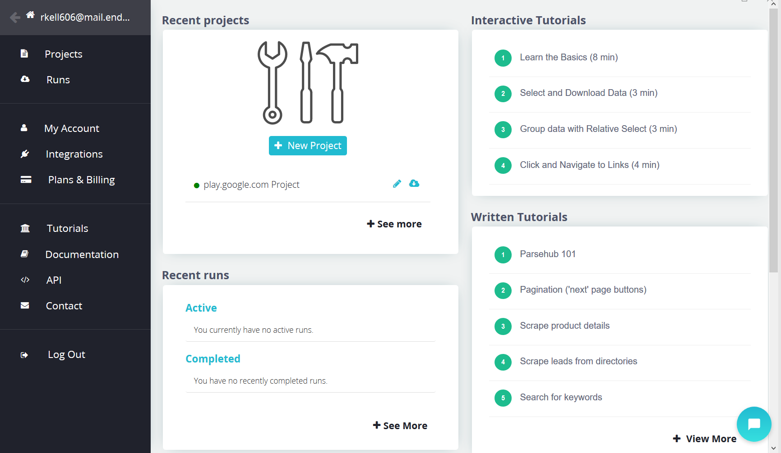

Importing Scraper Template

The following section shows you how to import the template used to generate readable CSV files that can be utilized by the project.

* Begin by clicking on the projects tab on the left side of the screen as shown above. You should be taken to a screen similar to the one shown below.

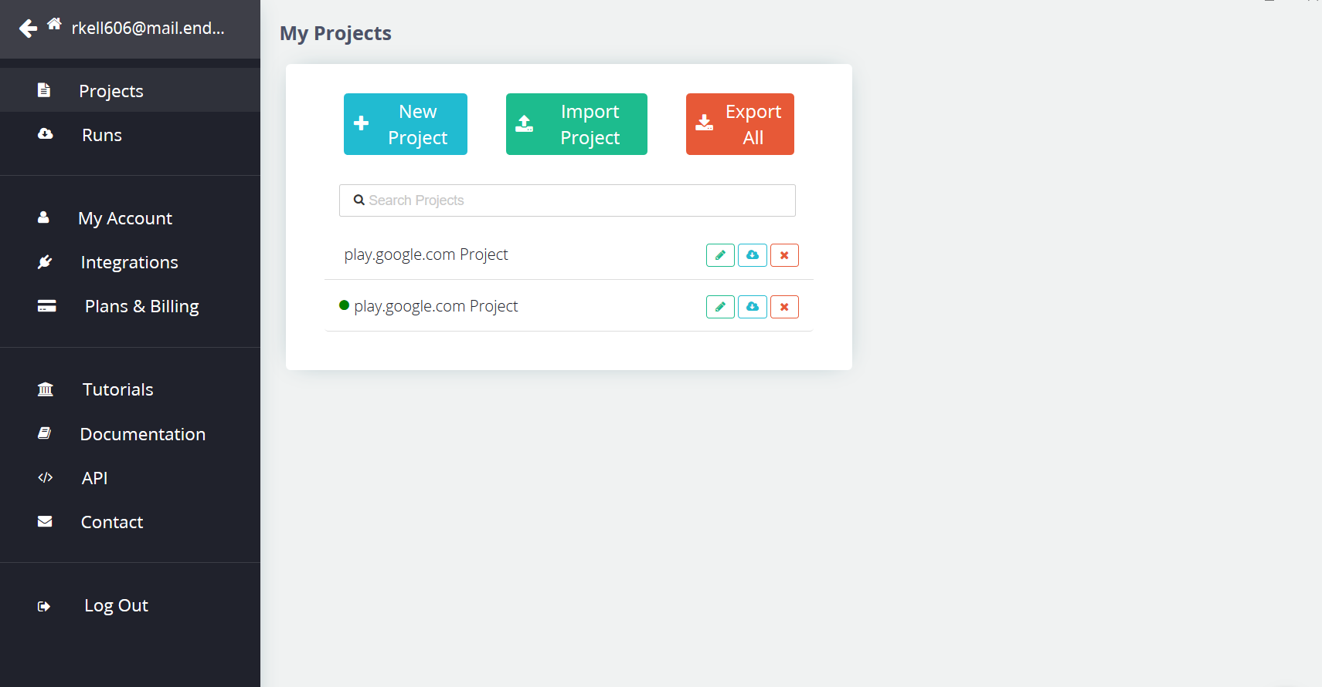

* Next, you will select the import button and look for the google_play_scraper file that you might have already downloaded from the google folder provided. This template is pre-built to be able to scrape any generic page in google play as long as it's filtered properly. If you have not, download the file and then upload it to ParseHub. After doing this, you should see a screen similar to the one below

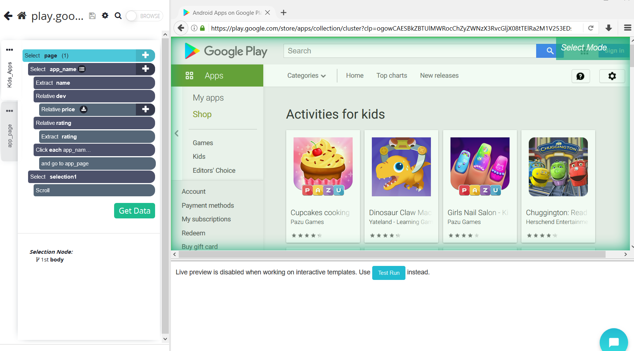

* This template provides all the instructions for the scraper to work (the left side of the screen), the only work required on your part is to click on the gear icon roughly at the top left of the screen (as shown in the picture above), and click on settings. There will be a setting to called “starting site” in which you can paste a URL of your choosing. Once pasted, the preview on the right should look like the page of the URL you pasted. Starting pages should be filtered down to one specific category and include a list of apps in a similar structure to the images below.

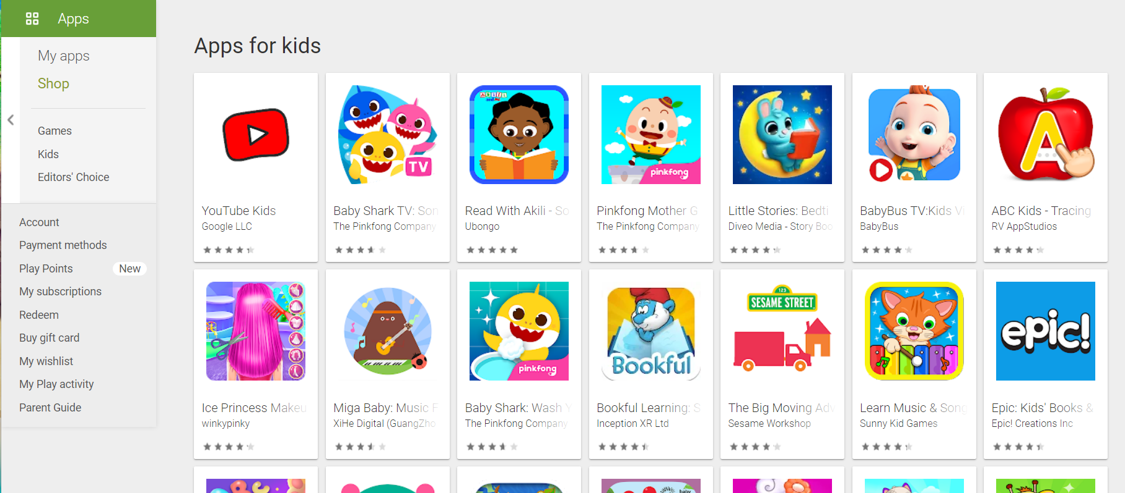

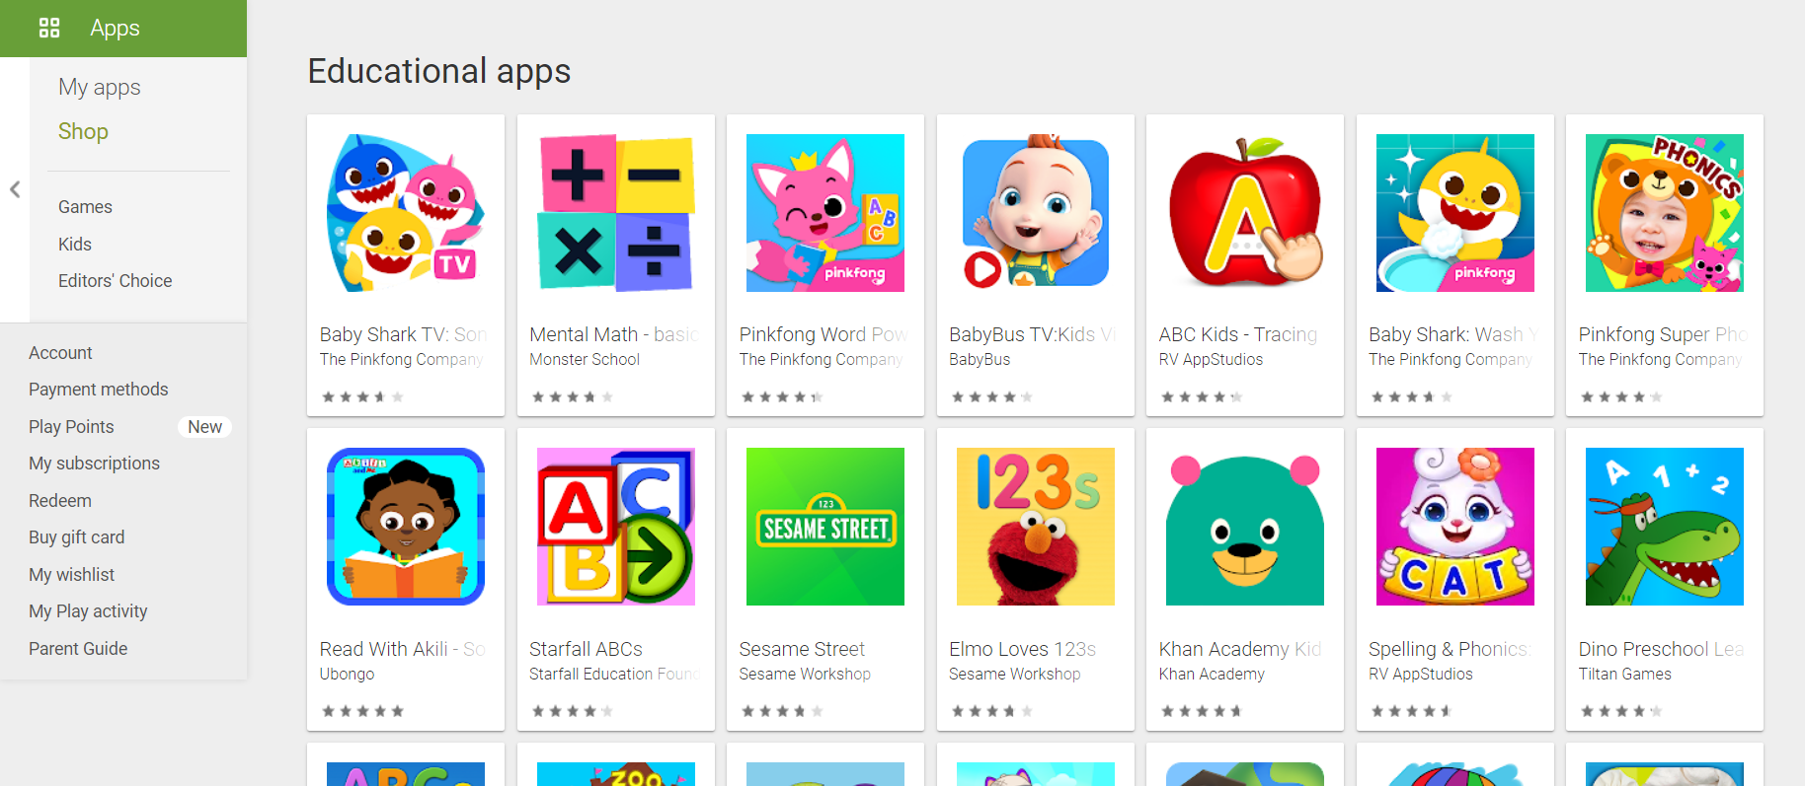

* Once you have picked the page you would like to scrape the data from. You will need to initiate the scrape process.

Starting a Scrape and Getting an Excel File

* Once you are happy with the scrape settings, you may click on the “Get Data” button as shown in the picture below.

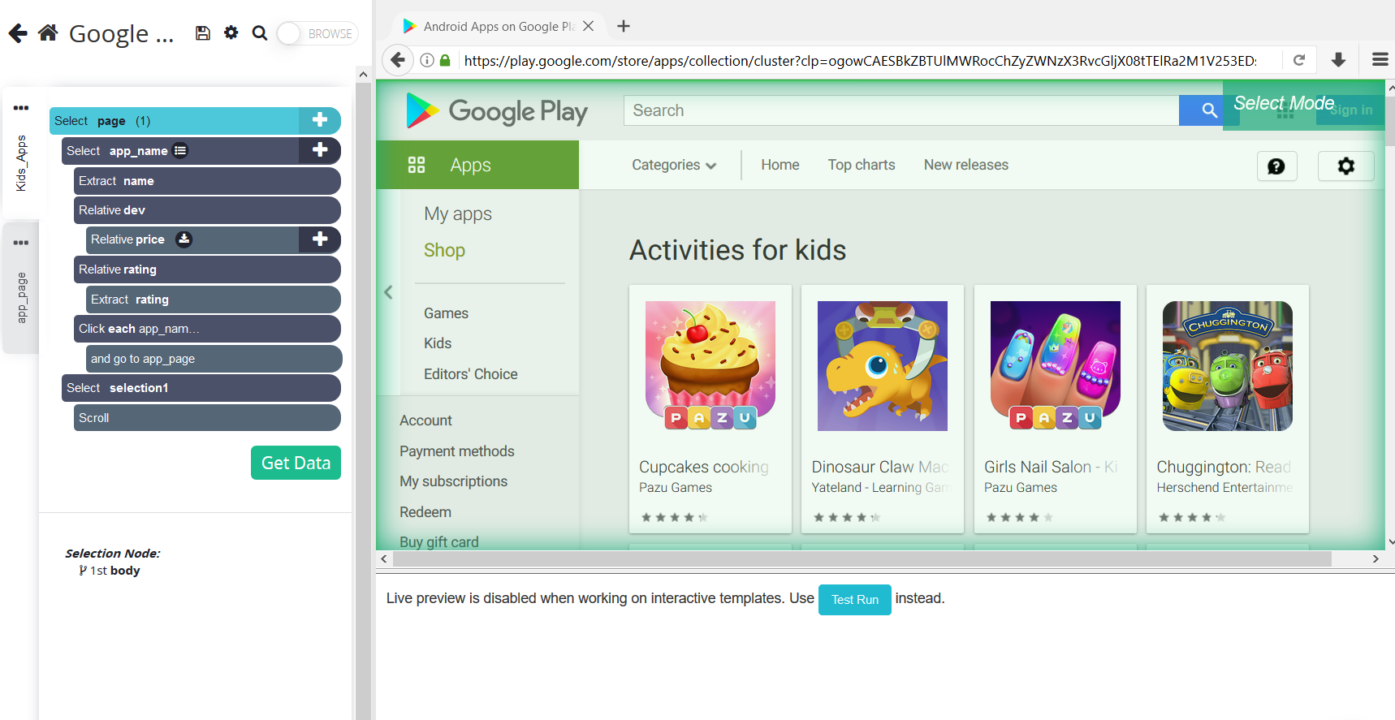

* You will then see a page like the one below. You should click on the run button. No setting changes should be necessary.

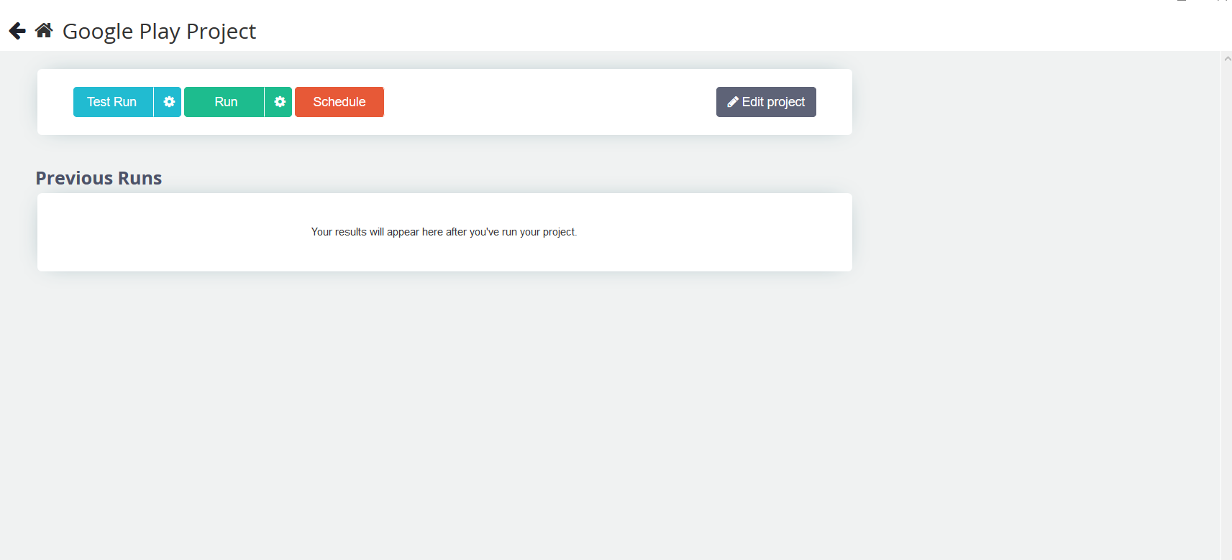

* The process will begin. For scrapes that require a hundred or so apps, this can take a little bit. You will be given an email once your project has finished scraping. Once complete, you will click on the “CSV/Excel” button to download the scrape. There is no need to modify anything inside of it, this can be simply uploaded to the Google Play Filter Project and it will take care of it from there.

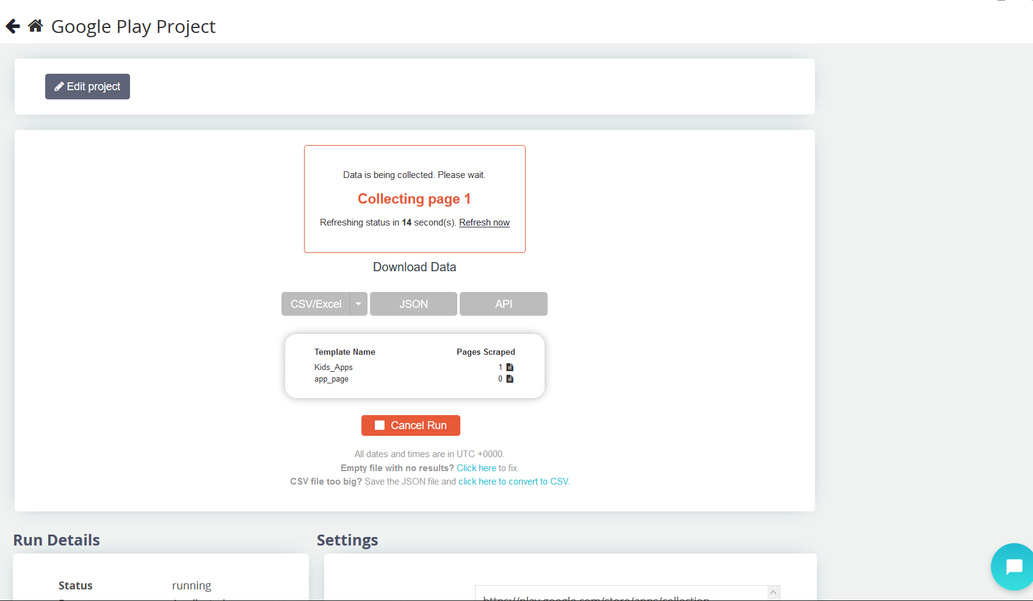

* You now have a usable excel file. You can now upload the excel file into the built program and follow the instructions listed on it to learn how you can modify the data and obtain a cleaner and more detailed version of the CSV.