B2B AI ORDER
PROCESSING AGENT
Week 2 — Design and Planning Document
FlowForge Mentorship Project
Team Members
Lea Murturi
Endi Hyseni
Imane
Design period: June 22–28, 2026
Prepared for mentor review

Document Control
Document | B2B AI Order Processing Agent — Week 2 Design Document
Version | 1.0
Team | Lea Murturi, Endi Hyseni, Imane
Status | Ready for mentor review
Scope | MVP design: email intake, AI extraction, validation, human review, XML generation and reporting

Table of Contents
1. Executive Summary
2. Problem Definition
3. High-Level Solution and Scope
4. Core Features
5. End-to-End Workflow
6. System Architecture
7. Low-Level System Design
8. Data Design
9. Dashboard and Visual Prototype
10. Technology Stack
11. Alternatives Considered
12. Security and Non-Functional Requirements
13. Risks and Mitigations
14. MVP Acceptance Criteria
15. Out of Scope and Future Enhancements

1. Executive Summary
The B2B AI Order Processing Agent is a supplier-facing application that monitors a dedicated Outlook inbox, recognizes customer orders, identifies the client, extracts structured order data from email text and multiple attachment formats, validates the result against business rules, and prepares two XML files for ERP import. The solution combines automation with controlled human oversight so that uncertain, scanned or incomplete orders are never transmitted without employee review.
The MVP is designed for suppliers and distributors that receive high volumes of customer orders in inconsistent layouts. Each client can use a different AI prompt, required-field configuration, validation rules and clarification email templates. Employees manage all exceptions through a dashboard and remain responsible for sending clarification emails and transmitting the final XML files to the ERP.

2. Problem Definition
B2B suppliers frequently receive orders from hundreds of customers by email. The order information may appear in the email body, PDFs, scanned documents, images, spreadsheets, CSV files or Word documents. Layouts and terminology vary by customer, and a single email may contain several attachments that together form one order.
- Manual order entry is slow, repetitive and expensive.
- Employees must search across multiple files to find required fields.
- Inconsistent layouts make fixed parsers difficult to maintain.
- Missing, duplicate or conflicting values can cause incorrect ERP entries.
- The source of a value is often difficult to trace after manual processing.
- Scanned or image-based documents increase extraction uncertainty.
Design objective: Reduce manual entry while preserving reliability, traceability and explicit employee control over exception handling and ERP transmission.

3. High-Level Solution and Scope
The system operates as an AI-assisted order-processing workflow. It automatically performs routine intake, document preparation, extraction and validation, then routes the order to an appropriate state. The dashboard provides the employee with the original evidence, extracted values, field sources, validation results and controlled actions.

3.1 MVP Input Scope
- Email body text
- Native PDF attachments
- Scanned PDF attachments
- JPG and PNG images
- Microsoft Excel files (.xlsx)
- Microsoft Word files (.docx)
- CSV files
- Multiple attachments in one email

3.2 Extracted Data
Order Header | Order Items
Ticket number  Customer number and name  Commission number and name  Store address  Delivery address  Delivery week  Order date and requested delivery date  Contact person, sender, phone and Mail To  Price and currency (when supplied) | Article number  Model number  Quantity  Unit or line price (when supplied)  Currency (when supplied)
For every extracted value, the system stores the source type, source file and confidence score. Sources may include the email body, native PDF, scanned PDF, image, Excel, Word or CSV attachment.

3.3 Explicit Scope Boundaries
- Scanned PDFs and image-based orders are always routed to Human in the Loop, even when extraction succeeds.
- Clarification emails are prepared automatically but sent only after an employee reviews and clicks Send.
- The system generates one Header XML and one Items XML only after approval.
- XML files are not automatically inserted into the ERP. The employee separately reviews the XML status and clicks Send XMLs.
- The MVP uses local file storage and local Docker deployment.

4. Core Features
Email Intake and Classification: Monitor Outlook, retrieve the email body and all attachments, classify the message as order or non-order, and preserve the original evidence.
Client-Aware Routing: Identify the client and load its active AI prompt, required fields, validation rules and clarification templates from PostgreSQL.
Multi-Format Document Processing: Extract text and structured content from PDF, Word, Excel and CSV files; use OCR for scanned PDFs and images.
AI-Based Field Extraction: Produce structured header and item records and retain the source and confidence for each extracted field.
Validation and Decisioning: Check required fields, customers, articles, dates, quantities, prices, currency, duplicates, conflicts and client-specific rules.
Human Review and Clarification: Allow employees to inspect, edit, approve, reject, comment, report issues and send a prepared clarification email.
XML and Reporting: Generate two ERP XML files after approval, transmit them only after a manual action, and export operational reports to Excel.

5. End-to-End Workflow
- A new email arrives in the supplier’s Outlook inbox.
- The Email Monitoring Service retrieves the body, metadata and all attachments and stores the original input.
- The email is classified. Non-orders are archived and do not enter the extraction workflow.
- For an order, the Client Detection Service identifies the customer and loads its prompt, validation rules and templates.
- The Document Processing module inspects every content source. OCR is invoked for scanned PDFs and images.
- The AI Extraction module returns structured header and item data, field sources and confidence values.
- The Validation Engine applies common and client-specific rules.
- The Decision Engine assigns the processing state: OK, Human in the Loop, Waiting for Reply or Failed.
- The employee opens the order, reviews the original evidence and edits fields where necessary.
- Incomplete orders use a scenario-specific clarification template. The employee reviews and sends the email manually. A customer reply is matched to the same order and the new content is extracted and validated.
- After approval, the system generates Header XML and Items XML and marks the order ERP Ready.
- The employee reviews the XML status and separately clicks Send XMLs. The result is recorded in the audit trail.

5.1 Status Model
Processing State | Meaning
OK | Required data is present and validation passed.
Human in the Loop | Manual review is required because of scanned/image input, uncertainty, conflicts or a configured rule.
Waiting for Reply | The customer must supply missing or unclear information.
Failed | A technical problem prevented processing.
Lifecycle states: Approved or Rejected → ERP Ready after both XML files are generated → XMLs Sent after the operator manually transmits them.

6. System Architecture
The architecture is split into separate automated and operator-controlled workflows so each figure remains readable on a single page.
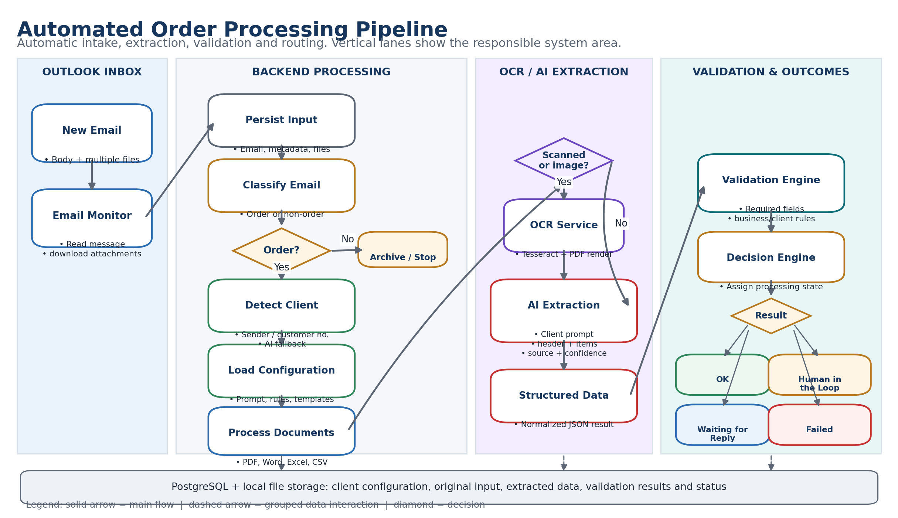
Figure 1. Automated order processing pipeline with responsibility lanes.

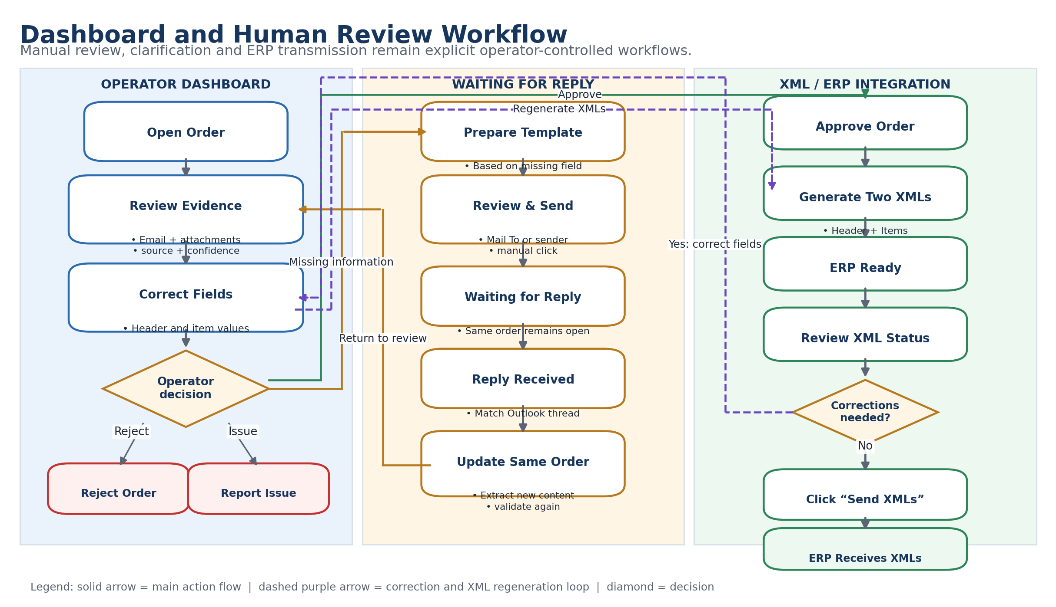
Figure 2. Dashboard and human-review workflow, including the waiting-for-reply loop and manual XML transmission.

6.1 Architectural Style
The MVP uses a modular monolith in one FastAPI application. Logical modules have clear interfaces but are deployed together, which keeps delivery manageable for a three-person team while preserving a path to future service extraction.
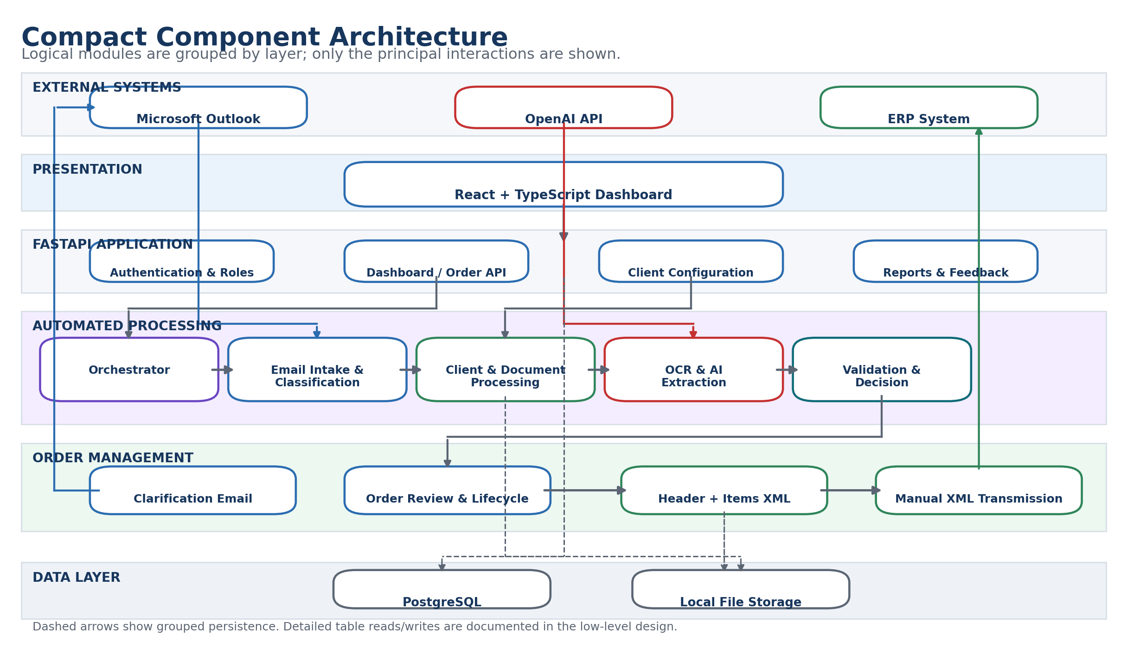
Figure 3. Compact component architecture for the MVP.

7. Low-Level System Design

Email Module
Connect to Outlook through Microsoft Graph, detect new messages, retrieve message metadata and all attachments, preserve the conversation/thread identifier, and trigger the orchestrator.

Processing Orchestrator
Execute the processing steps in the correct order, update progress, capture errors and ensure retries do not create duplicate orders.

Classification Module
Classify the email as order, non-order, spam or unknown. Only orders continue through the pipeline.

Client Configuration Module
Identify the client and load the active prompt version, required fields, validation rules and clarification templates from the database.

Document Processing Module
Detect file type, extract text and tabular content, preserve attachment metadata and prepare normalized content for the AI model.

OCR Module
Use Tesseract OCR for images and scanned PDFs, with Poppler/pdf2image for PDF rendering. Set the mandatory Human-in-the-Loop flag.

AI Extraction Module
Submit client-specific instructions and prepared content to the OpenAI API and return structured JSON for header fields, items, sources and confidence.

Validation Module
Apply deterministic business rules for completeness, customers, products, dates, quantities, prices, currency, duplicates, conflicts and customer-specific requirements.

Decision Module
Combine extraction metadata and validation outcomes to assign the processing state.

Order Management Module
Serve dashboard operations, save corrections, approvals, rejections, comments and state transitions.

Clarification Email Module
Select the appropriate template, resolve the recipient from Mail To or sender, prepare a message and send it only after the employee confirms.

XML Module
Generate and version Header XML and Items XML, expose their status to the dashboard and transmit them only after a separate manual authorization.

Reporting Module
Aggregate operational metrics and generate Excel reports for daily, weekly, monthly, yearly and custom date ranges.

Feedback and Audit Modules
Capture employee-reported problems and maintain traceable logs of automated and manual actions.

7.1 Main API Groups
API Area | Representative Operations
Authentication | POST /auth/login; GET /auth/me
Orders | GET /orders; GET /orders/{id}; PUT /orders/{id}; POST /orders/{id}/approve; POST /orders/{id}/reject
Clarification | POST /orders/{id}/prepare-email; POST /orders/{id}/send-email
XML | POST /orders/{id}/generate-xml; POST /orders/{id}/send-xmls
Clients | GET /clients; GET/PUT /clients/{id}; GET/POST /clients/{id}/prompts; manage rules and templates
Reports | GET /reports/overview; POST /reports/export-excel
Feedback | POST /feedback; GET /feedback
Users / Settings | Role-controlled administration endpoints

8. Data Design
PostgreSQL stores structured application data. Original attachments and generated XML files are stored on the local file system, while the database keeps paths, metadata, status and audit references.
Entity | Purpose
Users | Dashboard users, roles and active status.
Clients | Customer identification data and operational status.
ClientPrompts | Versioned, client-specific AI extraction prompts.
EmailTemplates | Scenario-specific clarification subjects and bodies.
Emails | Inbound and outbound message metadata, conversation identifiers, sender and Mail To data.
Attachments | File metadata, local path, type and scanned-document flag.
Orders | Header data, processing state, lifecycle state and approval information.
OrderItems | Article, model, quantity and optional price/currency values.
ExtractedFields | Value, source type, source file and confidence for each field.
ValidationIssues | Issue type, severity, message and resolution information.
GeneratedXMLs | Header/Items type, path, version, generation and transmission status.
FeedbackIssues | Employee-reported extraction, prompt, validation, attachment, XML or system problems.
ProcessingLogs | Chronological technical and user-action audit trail.

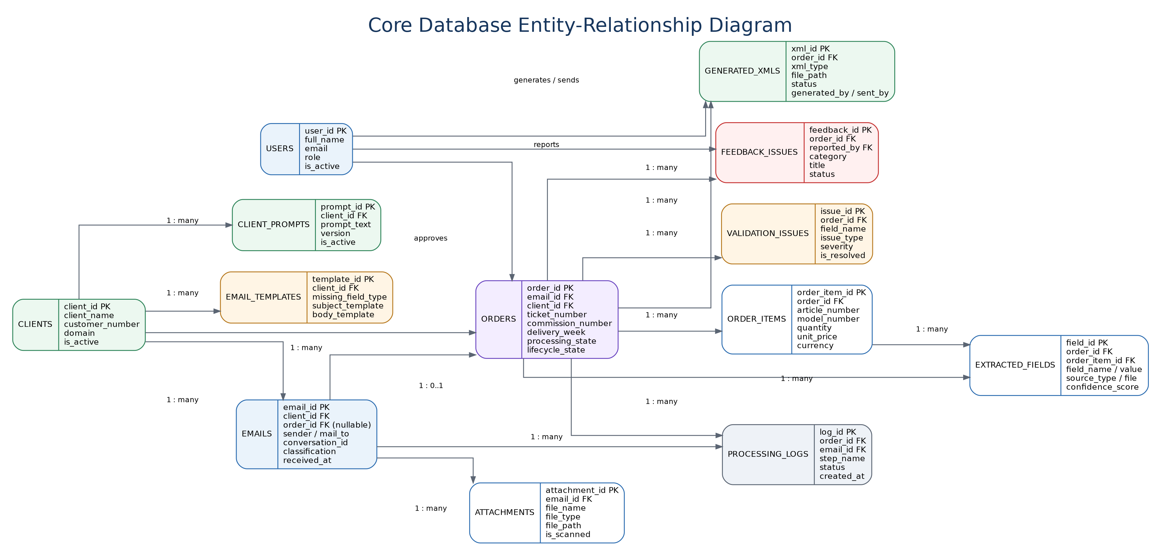
Figure 4. Core relational data model and principal relationships.

8.1 Waiting-for-Reply Data Continuity
A clarification reply must not create a new order. The email record retains the Outlook conversation identifier and a link to the existing order. When a reply arrives, the system associates the new email and attachments with that order, updates extracted fields and performs validation again. Previous values, messages and changes remain available in the audit history.

8.2 Interaction Sequence
The sequence emphasizes that customer replies update the same order and that XML transmission occurs only after a separate manual authorization.
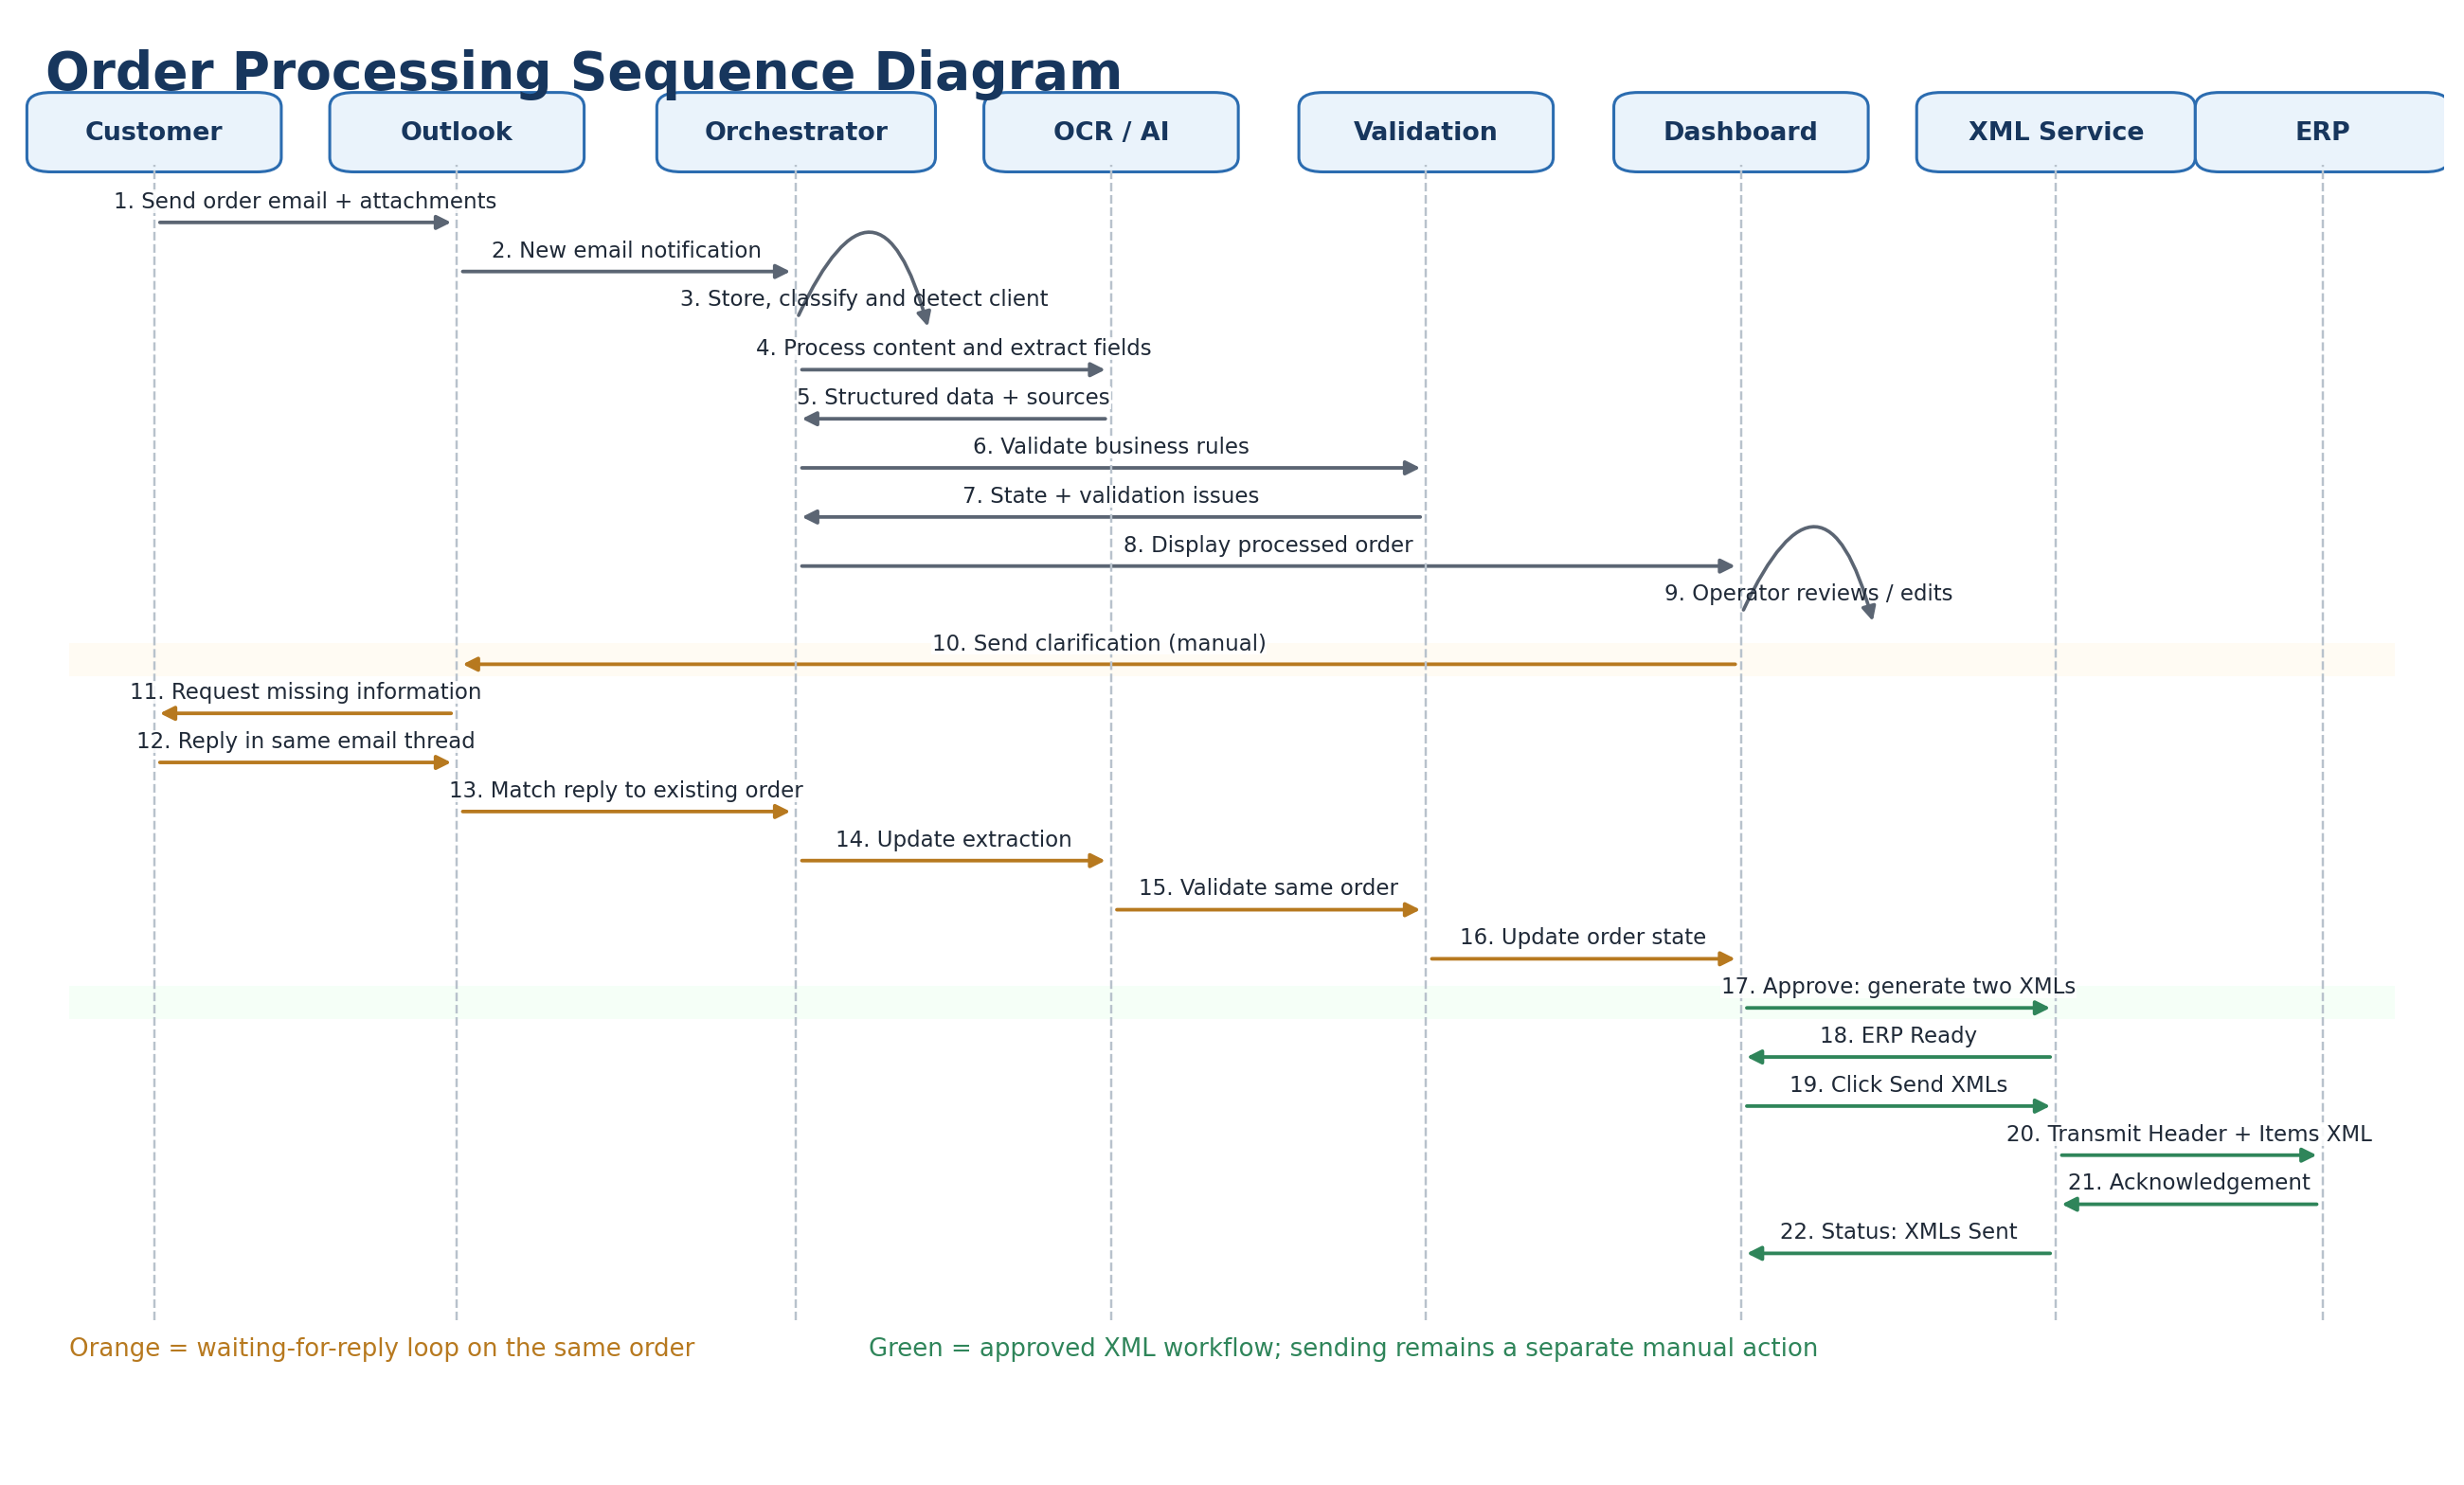
Figure 5. Chronological interaction among the customer, Outlook, backend modules, operator, XML service and ERP.

9. Dashboard and Visual Prototype
The dashboard is the operational control center. A complete order history is retained while filters and status tabs prioritize records that need attention.
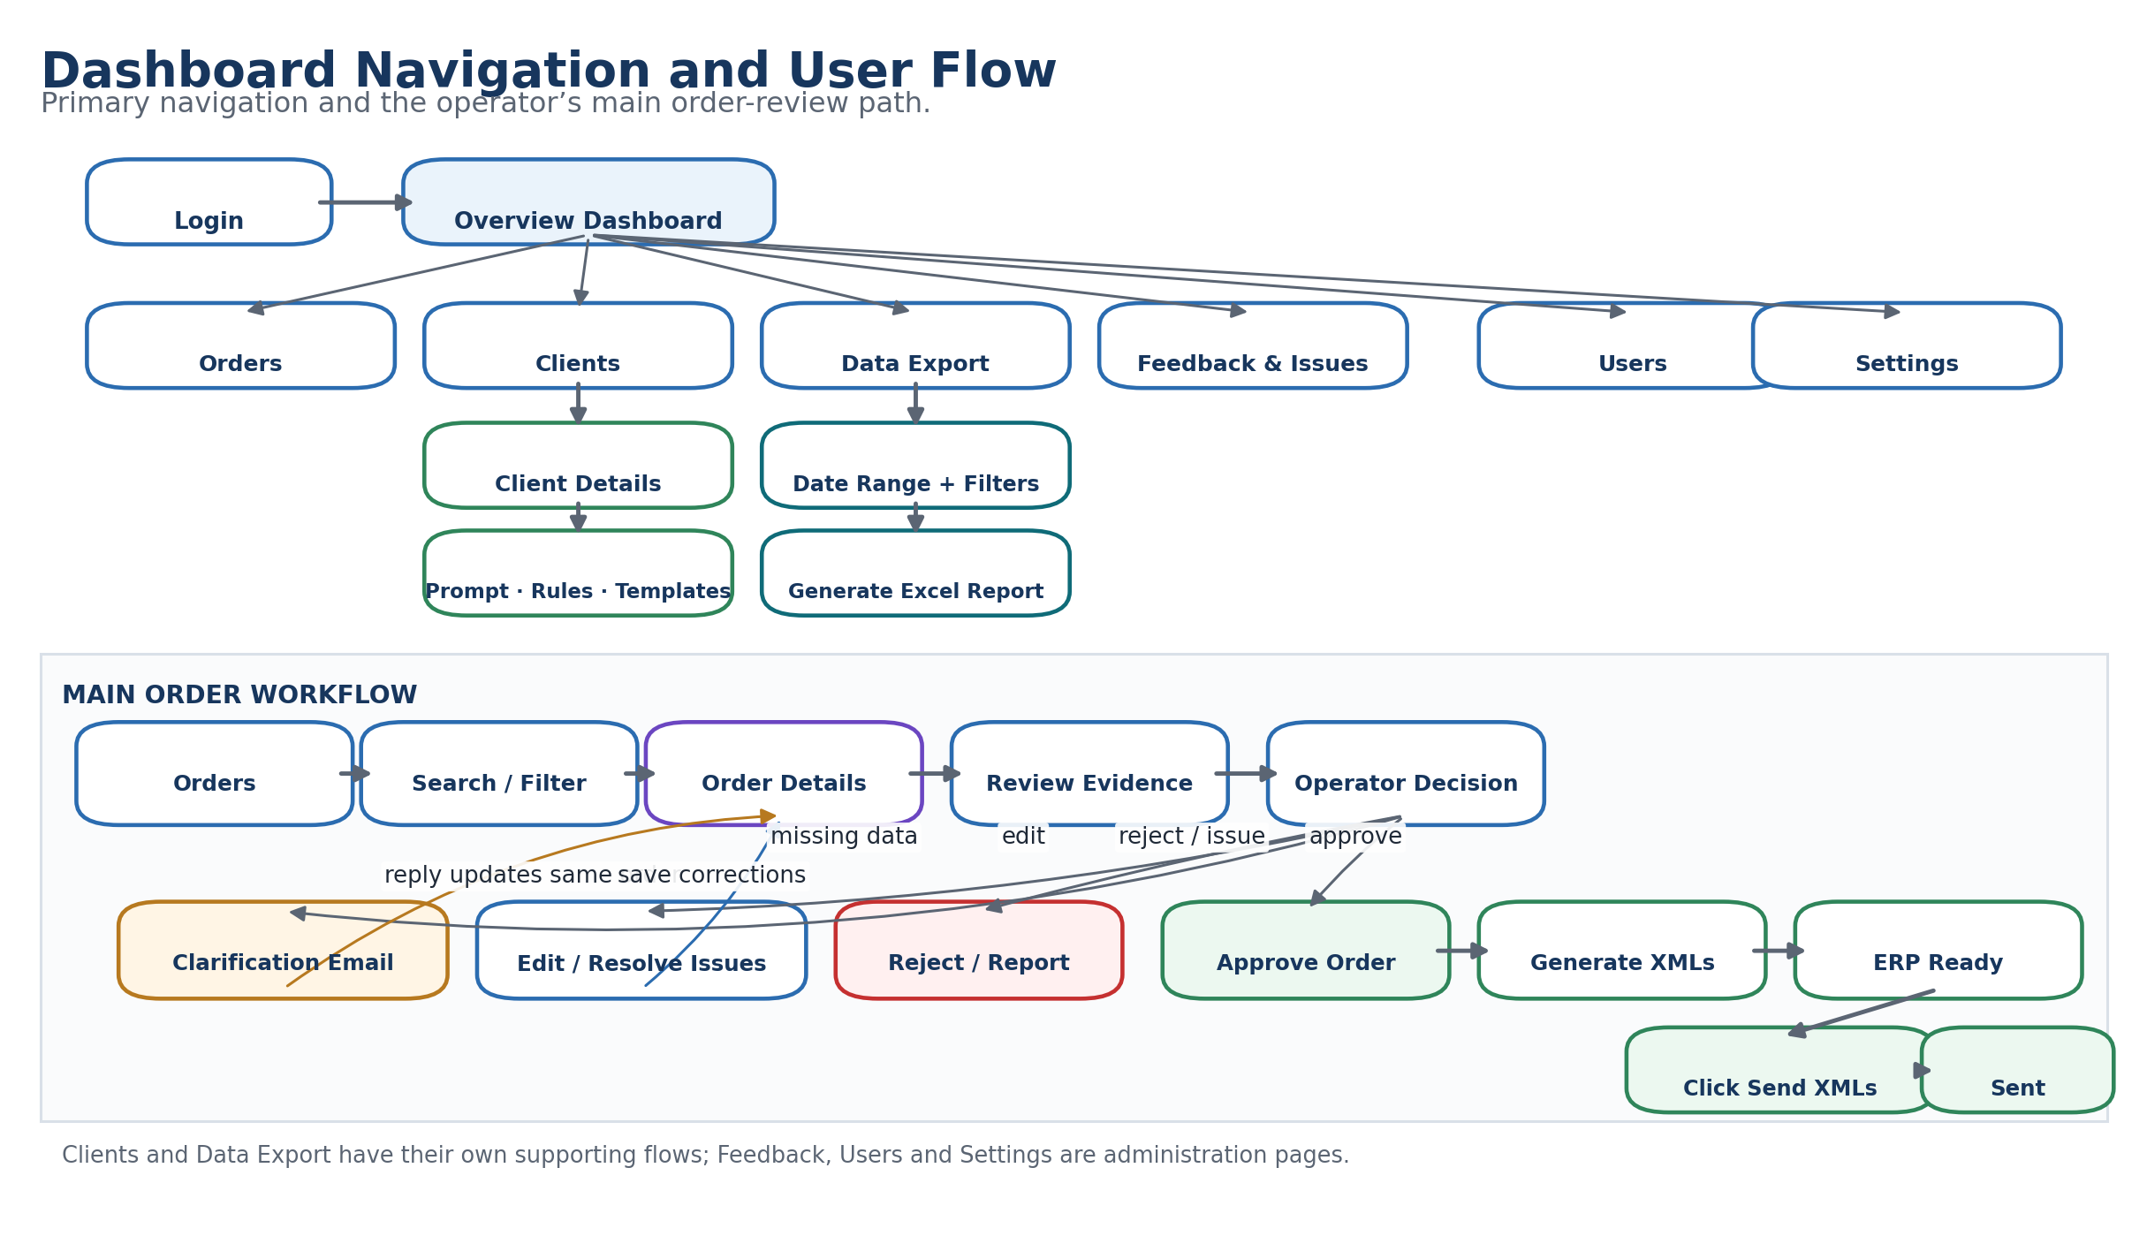
Figure 6. Dashboard navigation and principal user flows.

9.1 Main Pages
Overview: KPIs, date filters, order-volume trends, status distribution, top clients and recent orders.
Orders: Searchable and filterable table containing all orders and processing/lifecycle states.
Order Details: Header and item fields, original email, attachments, sources, confidence, validation issues, comments, history and XML actions.
Clients: Client records, identification values, prompt versions, required fields, validation rules, templates and client-filtered orders.
Data Export: Excel reporting for daily, weekly, monthly, yearly and custom date ranges.
Feedback & Issues: Operational issue reporting and progress tracking for developers.
Users: User creation, role assignment, activation and deactivation.
Settings: Inbox, AI, XML, ERP endpoint, reporting and system configuration.

9.2 Overview Wireframe
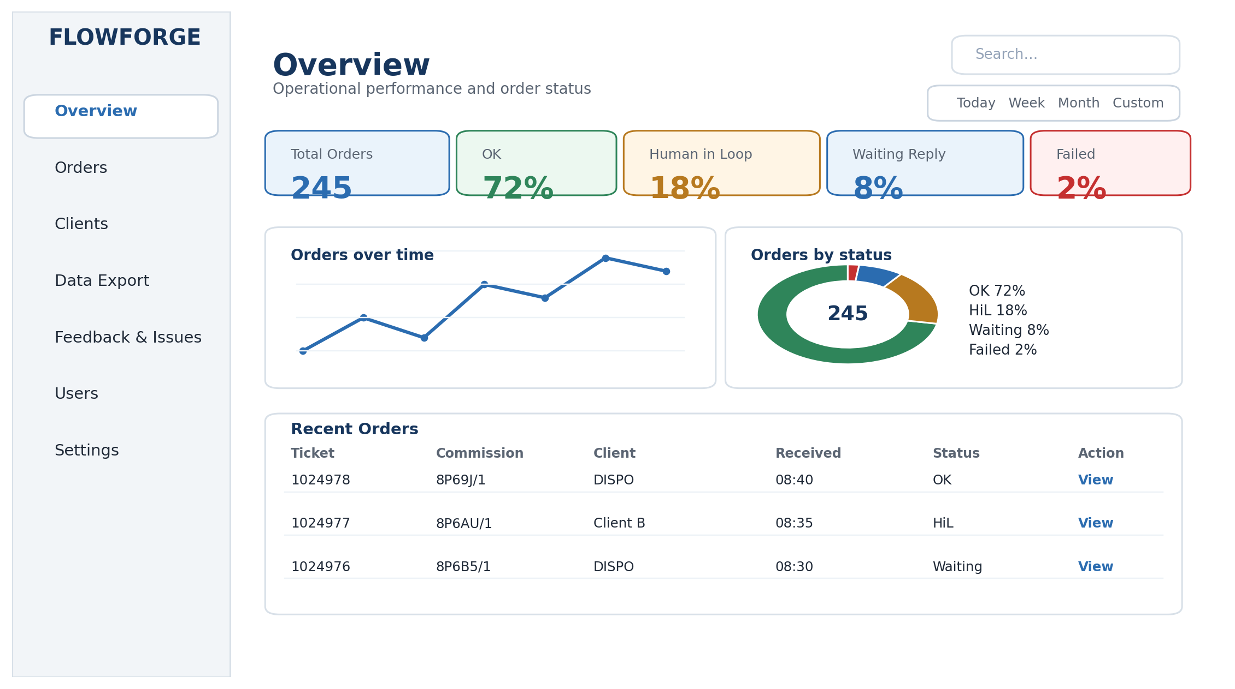
Figure 7. Low-fidelity Overview dashboard wireframe.

9.3 Orders Wireframe
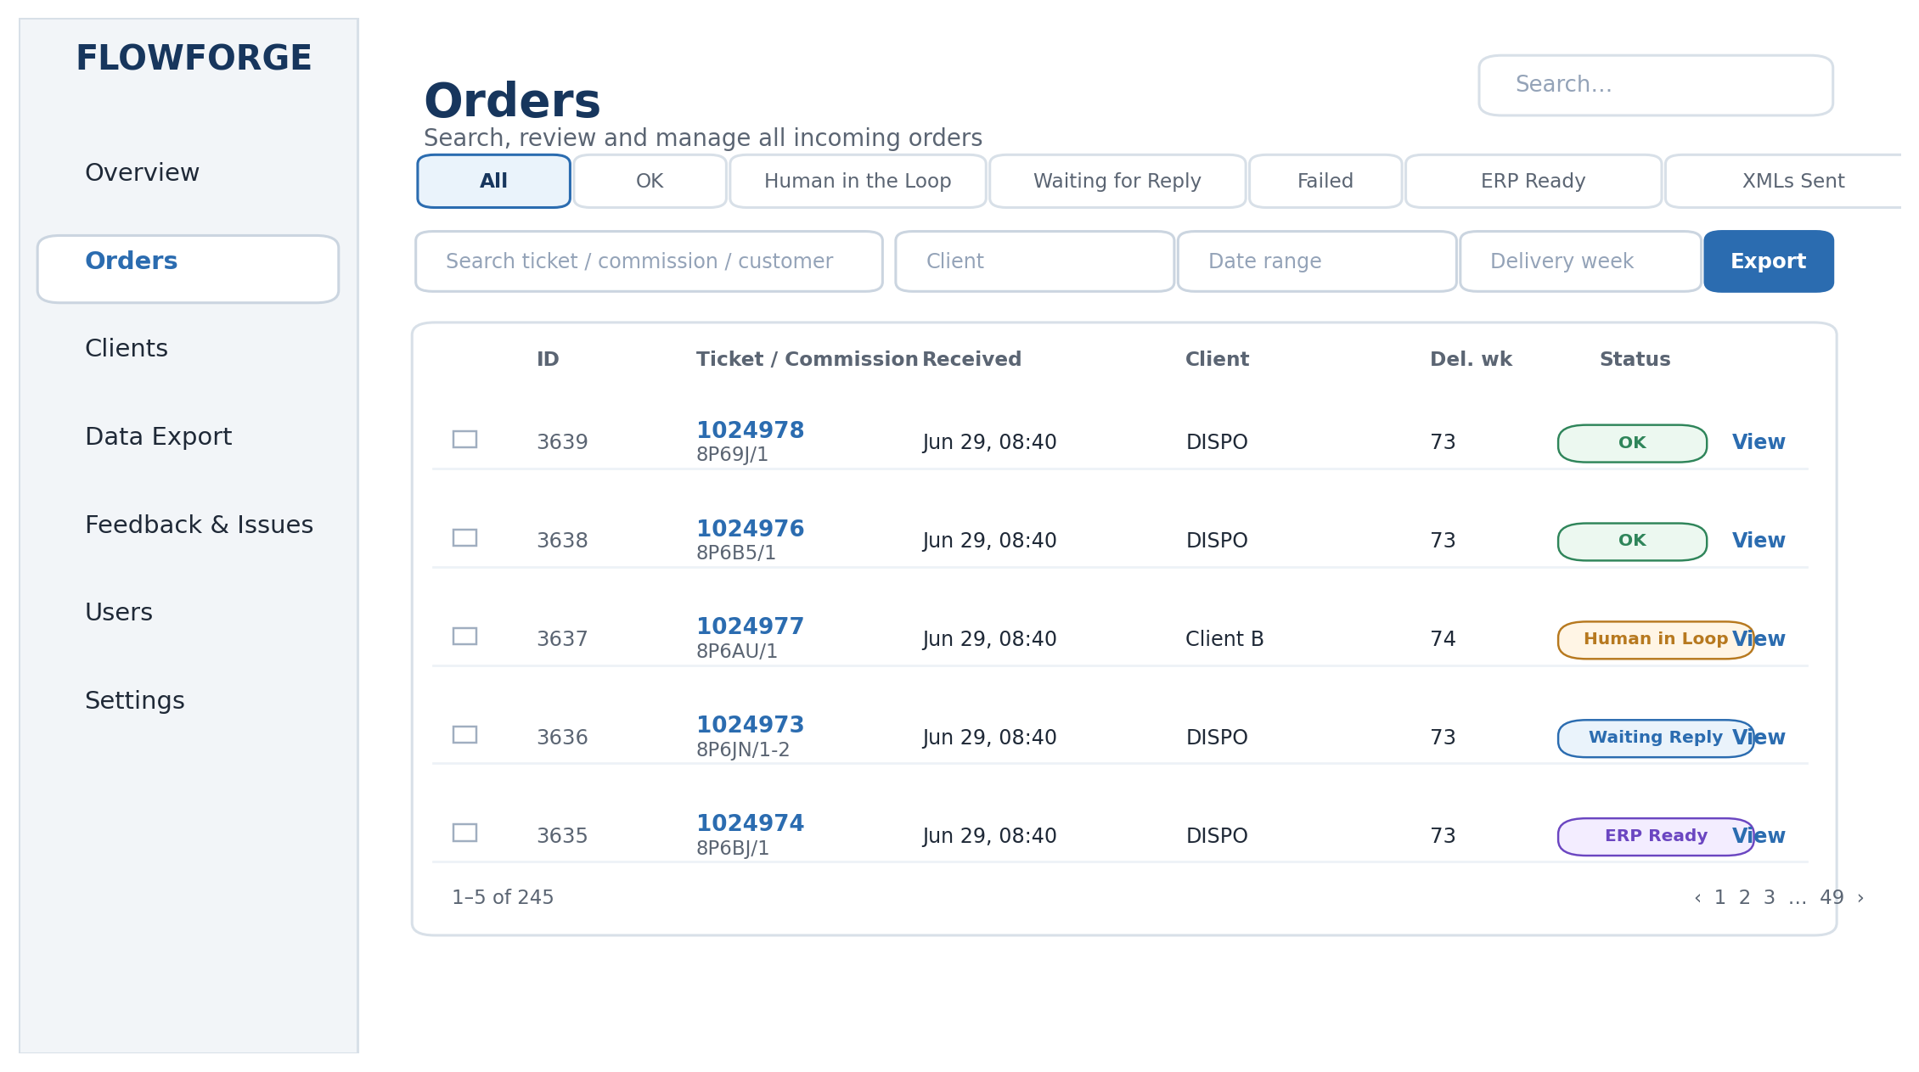
Figure 8. Low-fidelity Orders list wireframe.

9.4 Order Details Wireframe
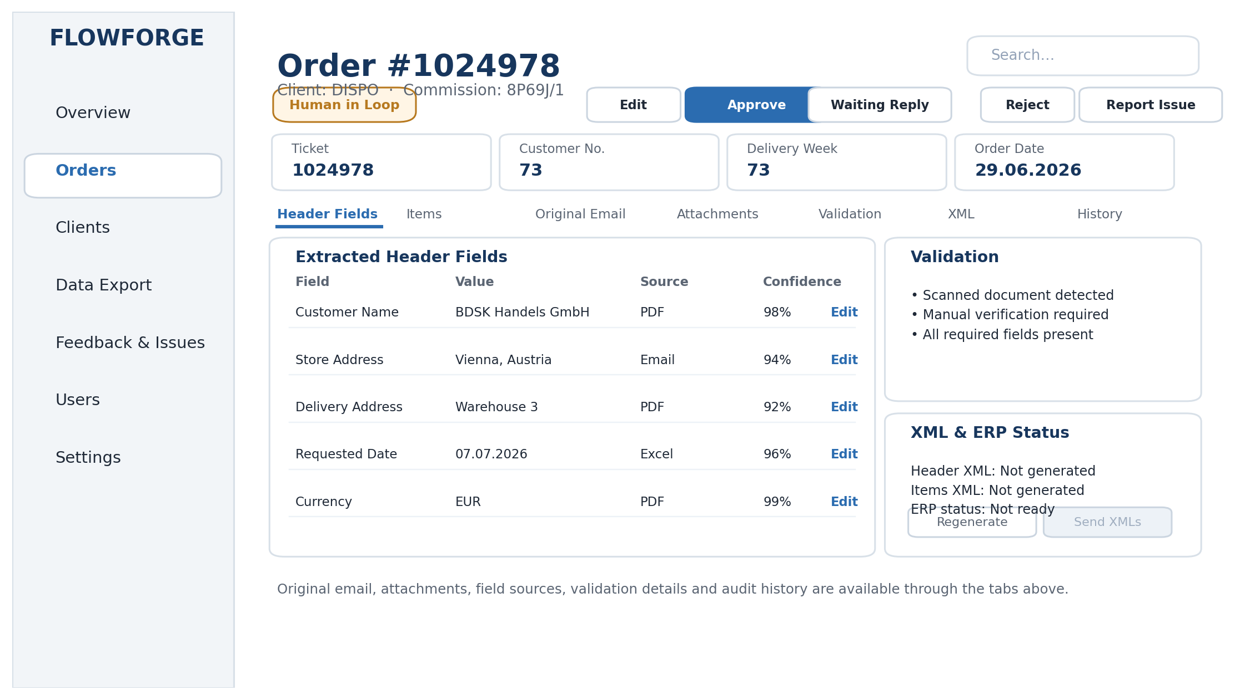
Figure 9. Low-fidelity Order Details wireframe.

9.5 Clients Wireframe
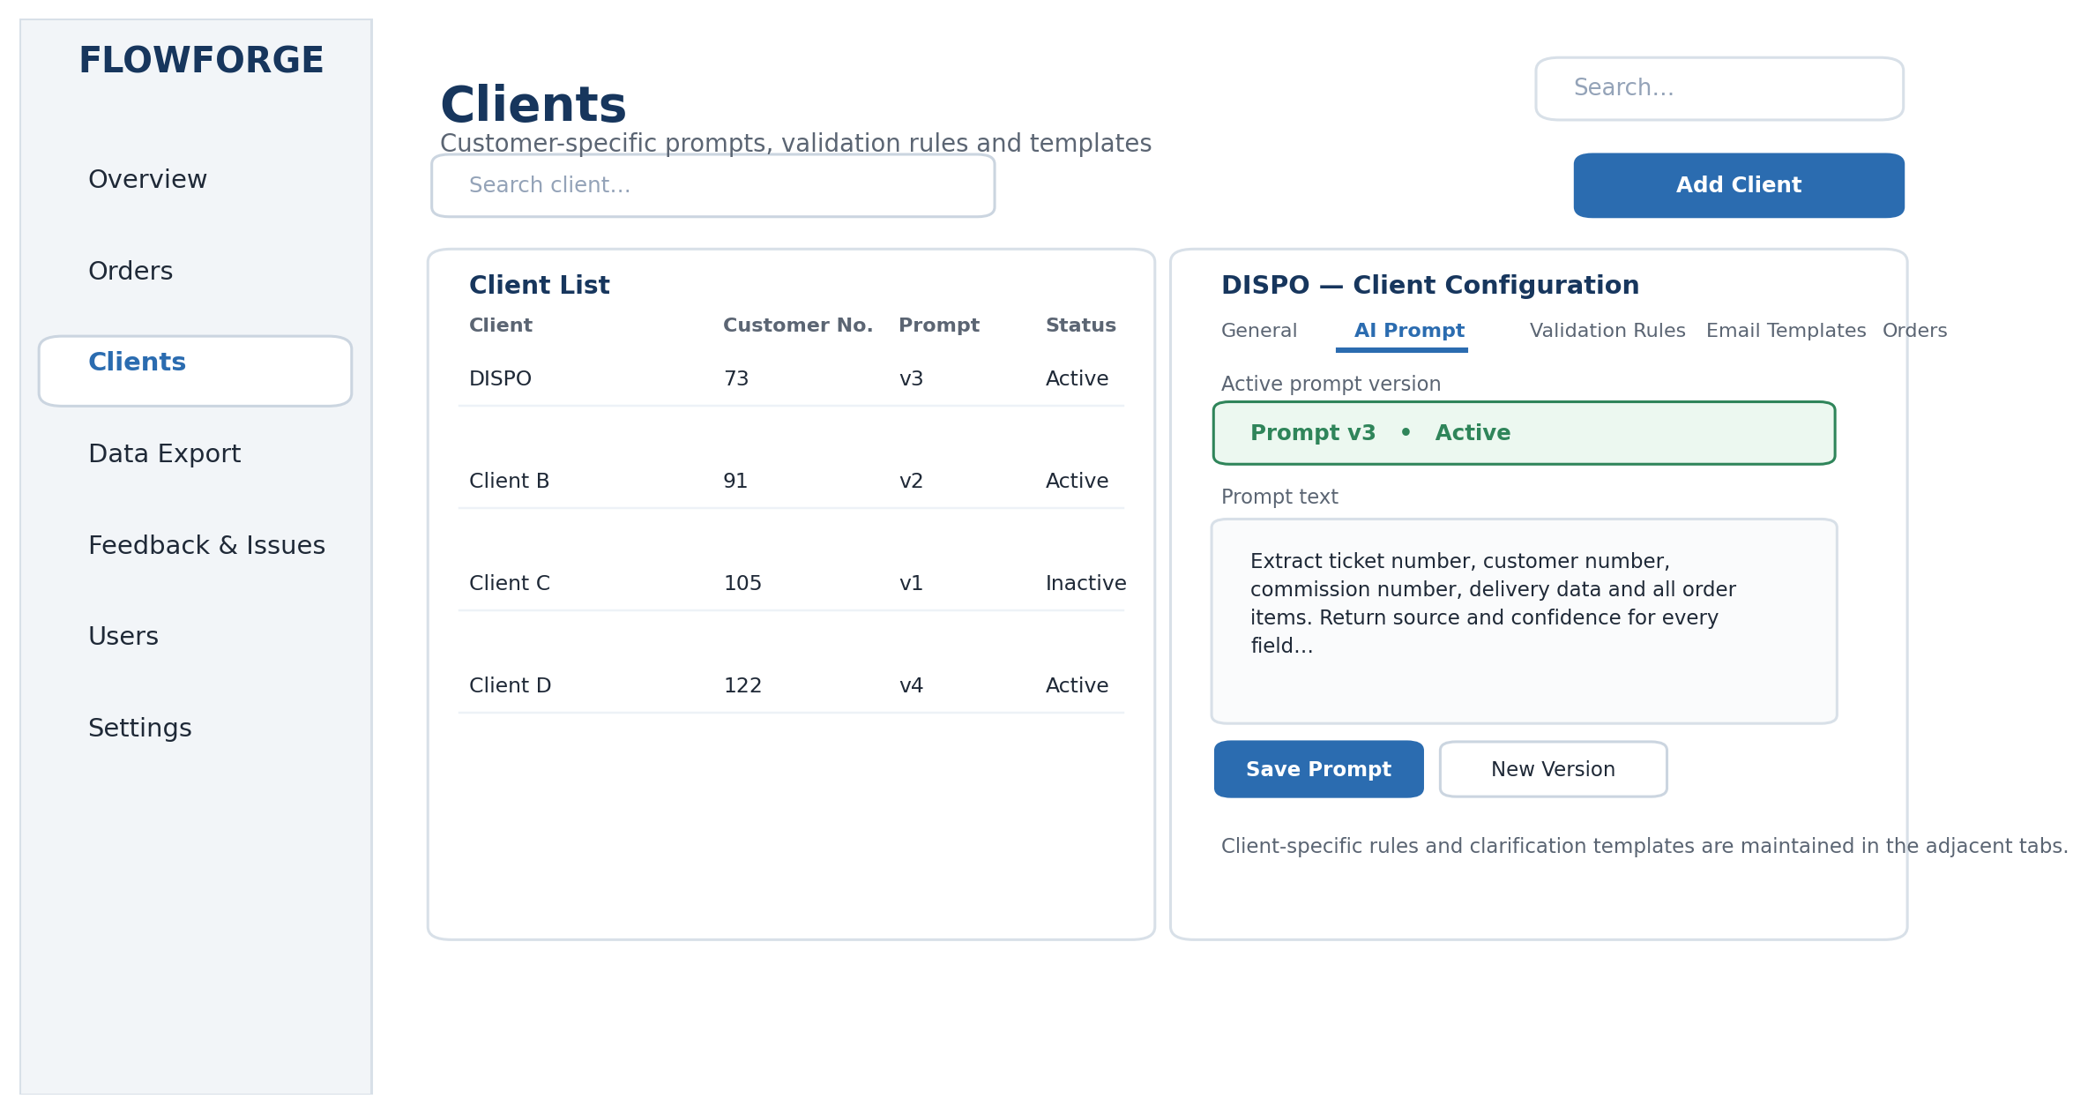
Figure 10. Low-fidelity Clients and prompt-configuration wireframe.

10. Technology Stack
Layer | Selection | Rationale
Frontend | React + TypeScript | Modern component-based dashboard with type safety.
Backend | Python FastAPI | Strong fit for AI, OCR, document processing, asynchronous APIs and automatic API documentation.
Database | PostgreSQL | Relational integrity for clients, emails, orders, items, validations, XMLs and audit records.
AI Extraction | OpenAI API | Flexible extraction across different customer layouts using database-managed client prompts.
OCR / Documents | Tesseract OCR, Poppler/pdf2image, pdfplumber, python-docx, openpyxl/pandas | No-cost local tools for scanned images, PDFs, Word, Excel and CSV processing.
Email | Microsoft Outlook through Microsoft Graph API | Secure enterprise email and attachment access, including conversation/thread identifiers.
Authentication | JWT with password hashing and role checks | Lightweight MVP authentication with controlled user access.
File Storage | Local file system | Simple MVP storage for original attachments and generated XML files.
Deployment | Local Docker / Docker Compose | Consistent environment for the three-person development team.

11. Alternatives Considered
Area | Alternatives | Selected | Reason
Frontend | Angular and Vue | React + TypeScript | React offers rapid component development, a mature ecosystem and strong TypeScript support without Angular’s additional framework complexity.
Backend | ASP.NET Core and Node.js | Python FastAPI | Python has the strongest local ecosystem for OCR, AI, document parsing and XML/Excel automation.
Architecture | Independent microservices | Modular FastAPI monolith | A modular monolith reduces deployment and coordination overhead for a three-person MVP while retaining clear module boundaries.
Database | MongoDB and SQL Server | PostgreSQL | The data model is strongly relational and benefits from foreign keys, transactions and open-source operation.
Extraction | Customer-specific regular expressions and custom ML models | OpenAI API with client prompts | Layouts vary significantly, so an LLM offers faster adaptability than maintaining a separate parser or training set for every client.
OCR | Azure Document Intelligence and Google Document AI | Tesseract + Poppler | Open-source tools meet the zero-cost MVP constraint; commercial OCR remains an upgrade path.
Email | Generic IMAP and Gmail API | Microsoft Graph / Outlook | Graph provides realistic enterprise mailbox, attachment and conversation-thread support.
Storage | Azure Blob Storage and Amazon S3 | Local file storage | Local storage minimizes cost and setup for the prototype; cloud object storage can replace it later.
Authentication | Microsoft Entra ID / OAuth SSO | JWT login | JWT is adequate for the MVP and avoids tenant-level identity configuration.
Deployment | Azure, AWS and managed PaaS | Local Docker | Docker gives every team member a consistent, low-cost environment and keeps deployment reproducible.

12. Security and Non-Functional Requirements

12.1 Security and Privacy
- Store secrets such as Graph and OpenAI credentials in environment variables, never in source control.
- Hash user passwords and enforce role-based authorization for administration, prompt changes, approvals and XML sending.
- Validate attachment extension, MIME type and size before processing.
- Restrict file paths and prevent executable uploads or path traversal.
- Retain an audit record of extraction, edits, approval, clarification emails, XML generation and XML transmission.
- Do not send clarification emails or XML files without an explicit employee action.
- Avoid including unnecessary email or attachment content in logs.

12.2 Non-Functional Priorities
Traceability: Every extracted field must be traceable to an email or attachment source.
Reliability: Duplicate handling, transactional updates and clear failure states must prevent accidental duplicate ERP orders.
Usability: Operators must see exceptions, evidence and actions on one order-details screen.
Maintainability: Client prompts, required fields, rules and templates must be data-driven rather than hardcoded.
Performance: Email ingestion should be asynchronous so one large attachment does not block other orders.
Cost: The MVP should use free local OCR, local storage and local Docker except for the chosen AI API.
Observability: Processing logs and issue reporting must make failed stages easy to diagnose.

13. Risks and Mitigations
Risk | Mitigation
Variable AI accuracy | Use client-specific prompts, strict structured output, deterministic validation, confidence values and Human-in-the-Loop review.
Poor OCR quality | Always route scanned/image input to manual review; preserve the original file and OCR text for comparison.
Incorrect client detection | Use sender/domain and customer data first, AI only as fallback, and allow manual correction.
Duplicate processing | Use Outlook message/conversation identifiers and business keys such as client + ticket/commission to detect duplicates.
Missing customer information | Generate scenario-specific email templates and keep the order in Waiting for Reply until the same thread is updated.
Unsafe automatic ERP posting | Separate approval, XML generation and the manual Send XMLs action; log all transitions.
Prompt changes affecting existing orders | Version prompts and apply the active version only to newly processed or newly received content.
Large scope for three developers | Use a modular monolith, prioritize the end-to-end happy path and defer cloud deployment and direct ERP automation.

14. MVP Acceptance Criteria
- ☐ The application reads new emails and multiple attachments from a configured Outlook inbox.
- ☐ The classifier separates orders from non-orders.
- ☐ At least a limited set of configured clients is identified and routed to database-stored prompts.
- ☐ The system accepts email text, PDF, scanned PDF, image, Word, Excel and CSV input.
- ☐ Scanned/image input is processed by OCR and always receives a Human-in-the-Loop flag.
- ☐ Header and item fields are returned in structured form, with a source for every populated field.
- ☐ Business rules identify missing, invalid, duplicate, unknown or conflicting data.
- ☐ The dashboard displays all orders and allows filtering by state, date and client.
- ☐ An employee can view evidence, edit values, approve, reject, comment and report an issue.
- ☐ Waiting-for-Reply orders provide a template and recipient; sending requires an employee click.
- ☐ A reply is matched to and updates the same order.
- ☐ Approval generates one Header XML and one Items XML.
- ☐ Sending XMLs is a separate manual action and its result is recorded.
- ☐ The Overview and Data Export pages provide daily, weekly, monthly, yearly and custom-range Excel reporting.

15. Out of Scope and Future Enhancements

15.1 Out of Scope for the MVP
- Automatic ERP insertion without employee confirmation
- Cloud hosting and cloud object storage
- Enterprise single sign-on
- Automatic learning from operator corrections
- A manual Reprocess Order button
- Support for every possible customer layout from the first release

15.2 Future Enhancements
- Direct integrations with ERP platforms such as SAP, Microsoft Dynamics or Odoo
- Cloud deployment, scalable workers and message queues
- Advanced commercial OCR for difficult scans
- Multi-language extraction and clarification templates
- Role-based approval thresholds and supervisor workflows
- Analytics for extraction accuracy, common missing fields and customer-specific failure patterns
- Automated prompt evaluation and controlled prompt rollout
- External API for partners and customer self-service order status

Conclusion
The design meets the Week 2 requirements by defining the business problem, high-level solution, core functionality, detailed system structure, alternatives, technology choices and visual prototype. It also establishes clear safety boundaries: uncertain input requires human review, customer clarification is manually sent, and XML transmission remains a separate operator-controlled action. The document is therefore ready for mentor review and can be converted directly into Week 3 implementation tasks.
Editable Mermaid source definitions for the architecture, workflow, sequence, ER and navigation diagrams are provided in the accompanying FlowForge_Week2_Mermaid_Diagrams.md file.

