CIRT: HLD

|  |  |
| --- | --- |
| 1. Document Information | |
| Document Name | High-Level Design for CIRT |
| Service | Provide High-Level Design |
| Author | Endi Troqe |
| Contributors | Ryan Soroka, Owen O’Neil, Andres Ponce, Jared Kendrick, Rodrigo Asturias |
| Issue Date | 2/18/2025 |

|  |  |  |  |
| --- | --- | --- | --- |
| 1. Document History | | |  |
| **Version** | **Date** | **Summary of change** | **Reference ID** |
| 1.0 | 02/18/2025 | Initial draft | N/A |
|  |  |  |  |
|  |  |  |  |
|  |  |  |  |

|  |
| --- |
| This document includes data that is **CONFIDENTIAL** and shall not be disclosed outside UCL and shall not be duplicated, used, or disclosed in whole or in part for any purpose other than to evaluate and implement procedures defined within this document. |

# Roles

## Roles Matrix

|  |  |  |
| --- | --- | --- |
| **Role** | **Summary of content provided or responsibility** | **Named individual** |
| Backend database and user authentication  (Backend and Frotend) |  | Endi Troqe |
| Article page and front page  (Backend and Frotend) |  | Ryan Soroka |
| Search function  (Backend and Frotend) | Monitors service change or service introduction. | Owen O’Oneil |
| Frontpage | Monitors operational change or operational introduction. | Rodrigo Asturias |
| Frontpage | Member of Design Advisory Group assigned to this design | Andres Ponce |
| Article page  (Backend and Frotend) | Ensure business architecture/requirements are monitored, maintained and matched to the solution. | Jared Kendrick |

# Context

## Summary

The Academic Research Database allows users with a **UTampa email** to **publish, view, and review research articles**. While anyone can access public research, **only privileged users** (faculty, designated reviewers) can **approve and publish submissions**. The platform ensures transparency and security in academic publishing, leveraging modern web technologies.

## Service categorisation

* **Criticality Level:** High
* **Business Impact:** Facilitates academic collaboration and research dissemination

# Functional Overview

## System Components

* **User Authentication:** Only UTampa email users can submit research.
* **Submission Module:** Users upload research papers for approval.
* **Review System:** Privileged users evaluate and approve submissions.
* **Public Access Interface:** Allows anyone to browse and search published research.High-Level Process Flow

## High-Level Process Flow

1. **User Registration & Authentication**: Users sign up with their UTampa email.
2. **Research Submission**: Users submit papers, which enter a pending state.
3. **Review & Approval**: Privileged users assess and approve research for publication.
4. **Public Access & Search**: Approved research is displayed for public viewing.

# System Architecture

## Logical Architecture

* **Frontend**: React.js for a dynamic, responsive interface.
* **Backend**: Node.js with Express.js for API services.
* **Database**: MongoDB for structured research storage.
* **Authentication**: Firebase authentication for secure login/signup.

## Tech Stack

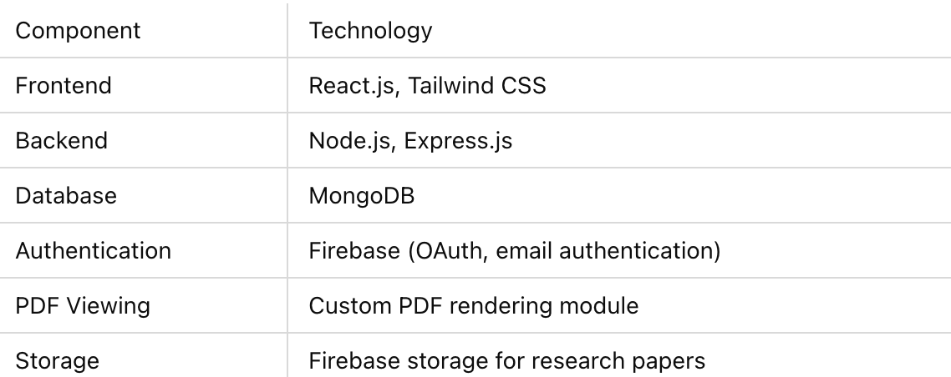

# Security

* **Role-based access control (RBAC)** for managing user permissions.
* **Encryption of research articles and user data** to protect confidentiality.
* **Audit logs** to track submission and review actions.

# UML Diagram

# Conclusion

This High-Level Design (HLD) outlines the architecture, functionality, and security of the **Academic Research Database** at **UTampa**. The system provides a structured and transparent platform for research publication while maintaining high security and compliance standards. Future enhancements will further improve its functionality and user experience.