SmartHive Backend Platform
Design, implementation and validation of the server side of a hive monitoring system
James Tack
SmartHive project, backend epic SCRUM-81
18 October 2026

Abstract
SmartHive monitors beehives with a camera and environmental sensors on a Raspberry Pi 3B at each hive. This report describes the server side: a broker that accepts messages from the nodes over mutually authenticated TLS, an ingestor that validates and stores them without duplicates, a REST and WebSocket interface for the dashboard, an alert engine, delivery of notifications by email and ntfy, image storage with thumbnails, exports, a weather overlay, and retention and backup jobs. The system is one Python package deployed as three processes on top of PostgreSQL with TimescaleDB and Mosquitto. The design favours a small number of well-understood parts because the team has six students and one semester. The implementation covers nine of the ten planned stories and is checked by 181 automated tests that run against a real database and a real broker. The remaining story, a 48 hour soak test, needs a demonstration machine and has not been run.
Keywords: beekeeping, MQTT, time series, alerting, FastAPI, PostgreSQL, TimescaleDB, Internet of Things.

Contents
Right-click and choose Update field to build the table of contents.

1. Introduction
A beekeeper who manages many hives cannot inspect each of them every day, and some of the problems that matter most (hornet attacks, small hive beetle, a rising varroa load, a colony that stops regulating its temperature) develop over days. SmartHive puts a node at the hive that measures temperature and humidity, photographs the entrance and runs the image analysis locally. The node sends small results rather than video, because the Pi has 1 GB of memory and the link may be slow.
The backend is the part that receives those results, keeps them, decides when something needs attention and shows the state to the beekeeper. It is also the integration point of the project: the node, the hive simulator, the machine learning jobs and the dashboard are built in parallel by different people and meet at the backend contracts.
This report records what was built, why it was built that way, and how it was checked. Section 2 lists the constraints, Section 3 describes the architecture, Sections 4 to 8 describe each subsystem, Section 9 describes security, Section 10 describes validation, and Section 11 lists what is missing.

2. Requirements and constraints
The constraints came from the project scope, the hardware and the team, and they shaped most decisions.
Table 1. Constraints and their effect on the backend.
Constraint | Consequence for the design
One node to a handful of nodes | No horizontal scaling, no message queue cluster. One machine runs everything.
Raspberry Pi 3B, 1 GB RAM | Images are analysed on the node. The server receives detections and small summaries.
No real-time clock on the node, about one day of battery | Gaps of hours are normal. Data arrives late, in bursts, sometimes twice and sometimes with a wrong clock.
No budget | Self-hosted, free and open-source software only.
Six students, one semester, three of them not backend developers | Few parts, one language, boring technology.
No data from real customers | The hive simulator is a first-class client and speaks the same contract as the node.

Five quality goals were ranked. No silent data loss came first: anything the node measured eventually reaches the database exactly once, or the gap is visible. Contract stability was second, because the components are built independently. The others were simplicity, timeliness (a detection should reach the dashboard within about ten seconds on a working link) and security appropriate to a demonstrator.

3. Architecture

3.1 Overview
The server is a modular monolith: one Python package with three entry points, ingest, api and worker, built into one container image (ADR-0006). A microservice split would add deployment and debugging cost that a six-person team cannot afford, and nothing in the load requires it. Modules talk through the database and through PostgreSQL LISTEN/NOTIFY, so the processes stay decoupled and can be separated later without changing the contracts.
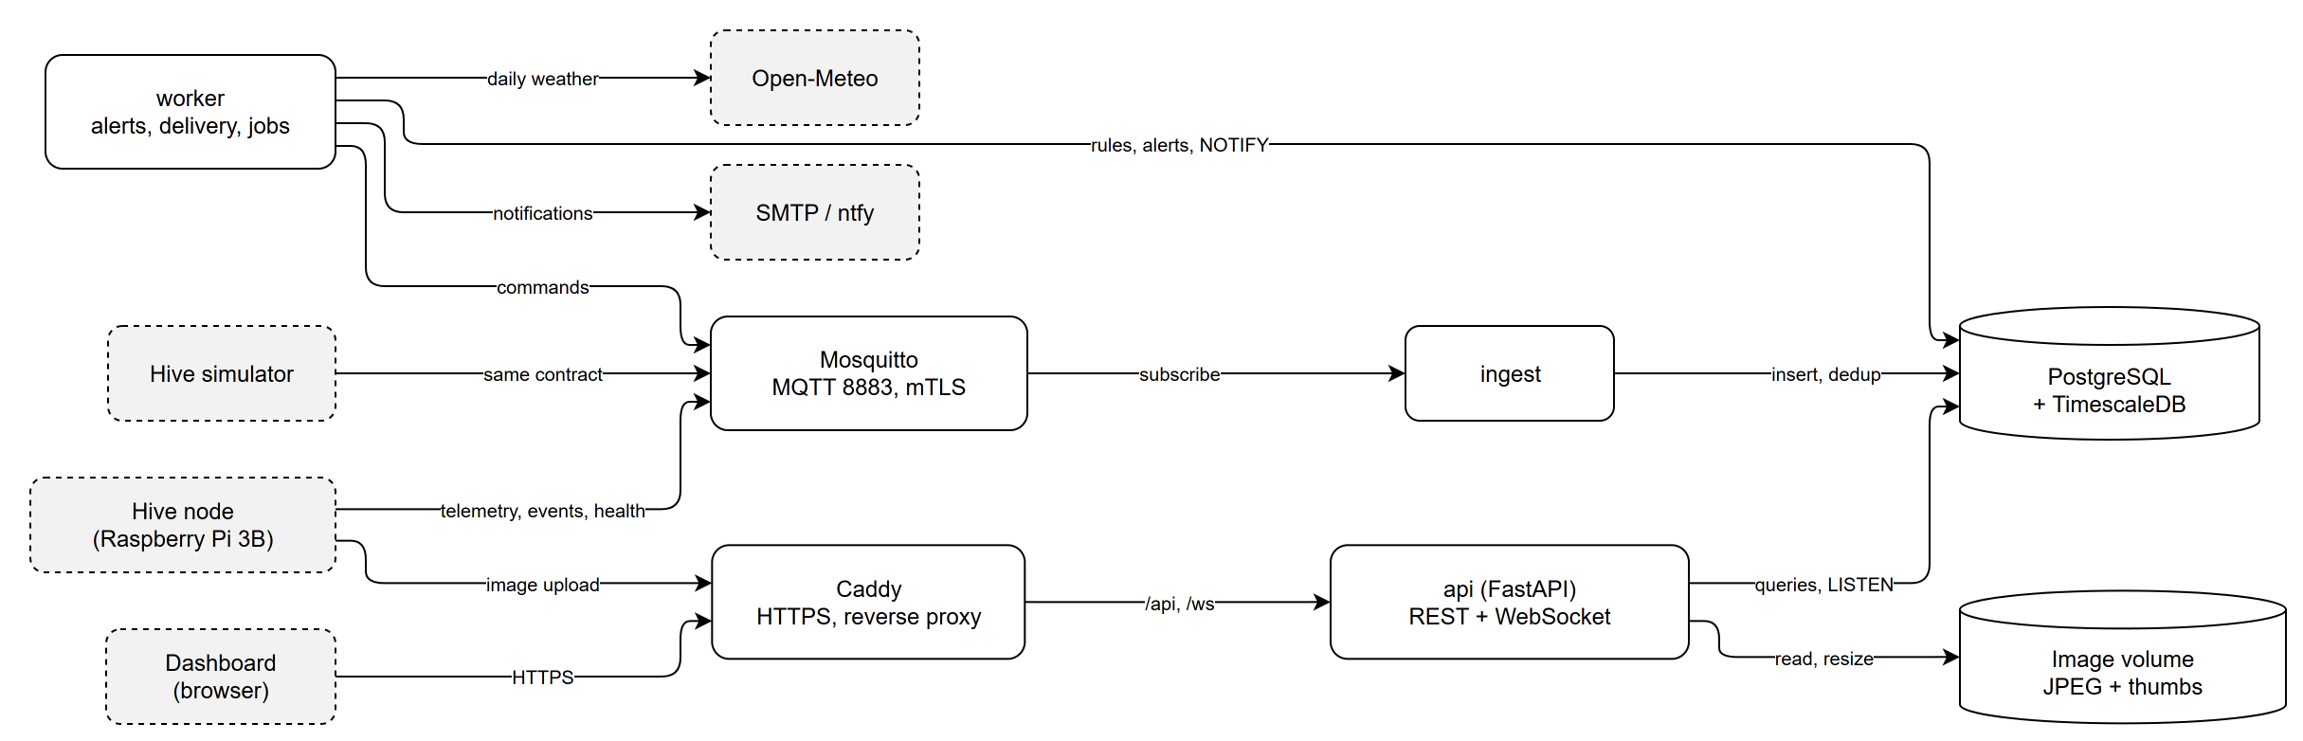
Figure 1. Containers of the SmartHive server and their connections. Dashed boxes are outside the server.
Figure 1 shows the containers. Mosquitto receives MQTT traffic on port 8883. The ingestor subscribes, validates and writes. The API serves the dashboard through Caddy, which terminates HTTPS. The worker evaluates alert rules, sends notifications, fetches weather and runs maintenance. PostgreSQL with the TimescaleDB extension holds all structured data. Image files live on a volume, with their metadata in the database (ADR-0007).

3.2 Technology
Table 2. Technology choices.
Layer | Choice | Reason
Language | Python 3.11 | One language for ingestion, API and jobs; the machine learning work is also in Python.
Web framework | FastAPI, Uvicorn | Typed request models, generated OpenAPI for the dashboard client.
Database | PostgreSQL 16 with TimescaleDB (Apache-2.0 features only) | Relational data and time series in one store; hypertables for readings.
Database access | SQLAlchemy 2 (Core), asyncpg, Alembic | Plain SQL with typed parameters; forward-only migrations.
Broker | Eclipse Mosquitto | Small, supports mutual TLS and per-topic ACLs.
Authentication | Argon2id, JWT (HS256), rotating refresh tokens | See Section 9.
Images | Pillow | Decoding and resizing JPEG for thumbnails.
Email | Jinja2 templates, SMTP; ntfy over HTTP | Plain-text and HTML parts; Mailpit in development.
Testing | pytest, httpx, Testcontainers | Real PostgreSQL, Mosquitto and Mailpit in Docker.

3.3 From a measurement to an alert
Figure 2 follows one message through the system. The node publishes with QoS 1. The ingestor validates the payload against its JSON Schema and inserts with ON CONFLICT DO NOTHING on the message identifier, so a redelivery changes nothing. After the commit it issues NOTIFY smarthive_ingest. The worker wakes on the notification, and also on a 60 second timer so that a lost notification costs at most a minute. It evaluates the rules, opens or updates an alert, writes one pending notification row per channel and announces the change on smarthive_alerts. The API forwards that to subscribed WebSocket clients, and the worker delivers email and ntfy messages from the pending rows.
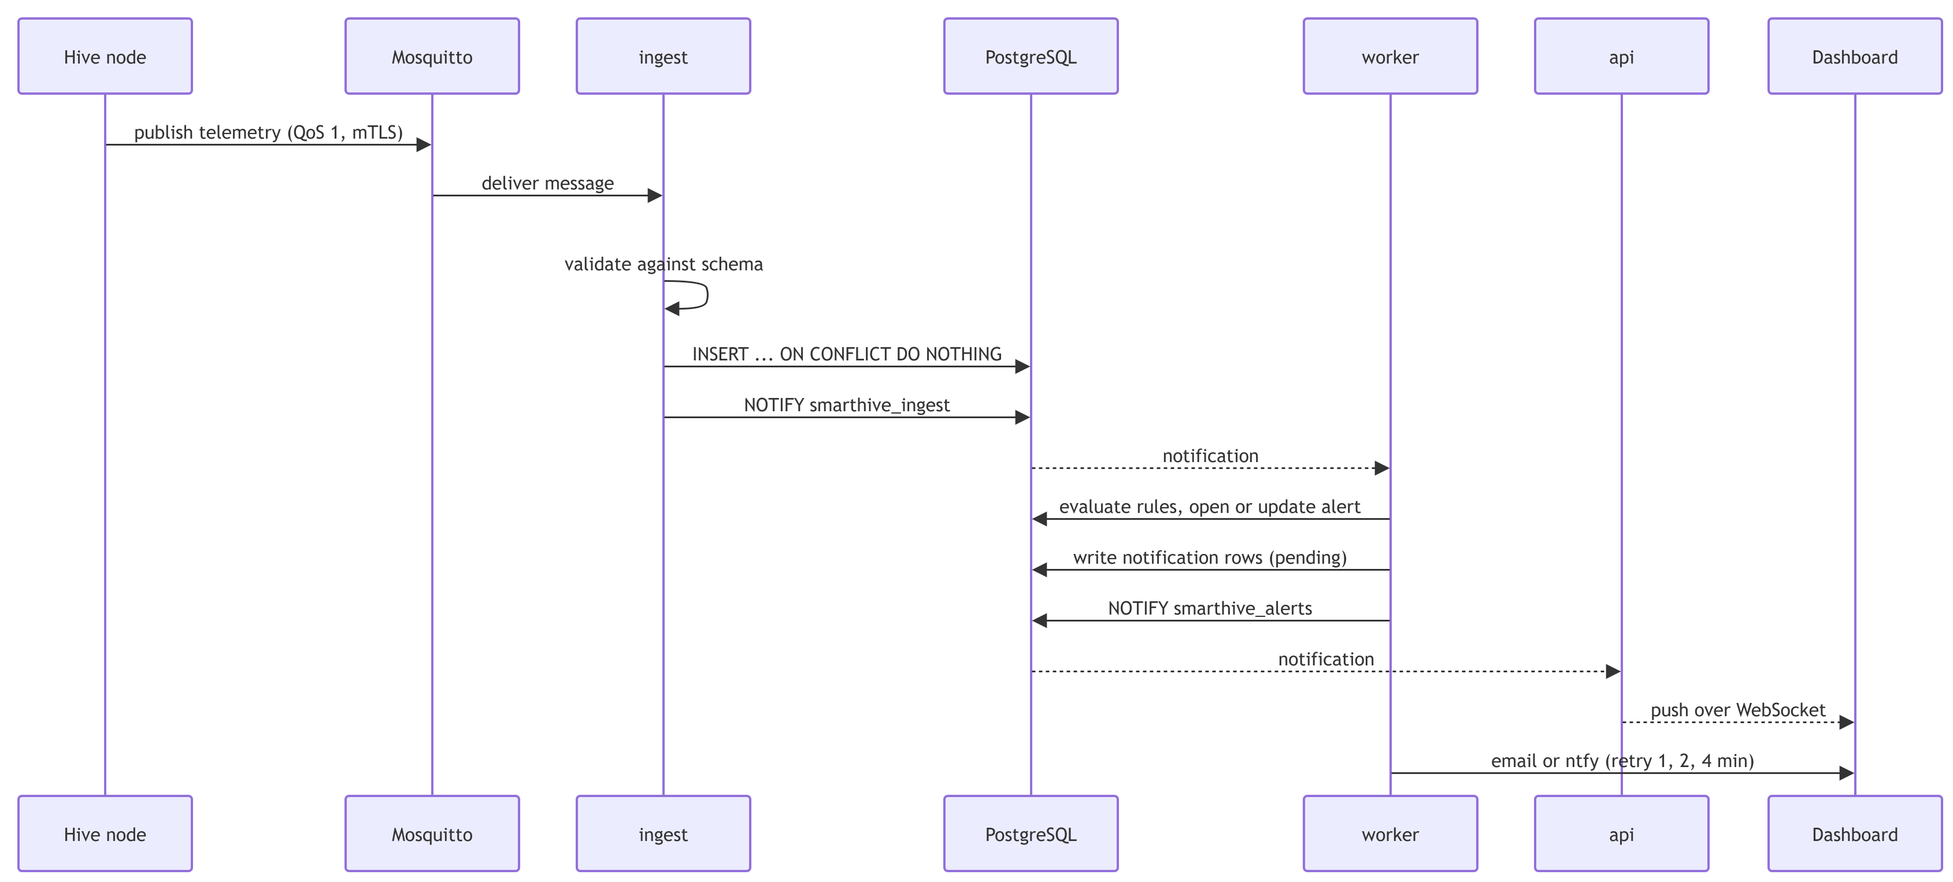
Figure 2. Path of a message from the node to the dashboard and the alert channels.

4. Messaging and ingestion
Topics follow smarthive/v1/nodes/{node_id}/{kind}. They identify the node, not the hive, so moving a box to another hive does not change topics or access rules; the server keeps the assignment history. The kinds are telemetry, events, summary, health and status, with config and cmd flowing to the node. The topic carries the major version, so a breaking change creates v2 topics and the server listens to both during the transition.
Each node authenticates to the broker with its own client certificate, and the broker's access list (pattern write smarthive/v1/nodes/%u/...) allows a node to write only to its own topics. A contract test starts a real Mosquitto with generated certificates and checks that a node can publish on its own topic and is refused on another node's topic.
A registry of handlers maps each message kind to a parser and a writer. Telemetry becomes rows in readings, events become detection_events, summaries become vision_summaries, health snapshots become node_health, and the last-will message from the broker marks the node offline. A reading is resolved to a hive through the assignment interval that contains its timestamp, so late data lands on the hive the node belonged to at capture time. If a node is assigned to a hive afterwards, the assignment call back-fills hive_id on earlier readings.
Images do not travel over MQTT. The node uploads the JPEG with POST /device/v1/images using a device token. The server checks the token, the declared SHA-256, the content type, the magic bytes and the size limit, writes the file under a content-addressed path, and records the metadata. A repeated upload with the same identifier and hash returns success without a second copy; the same identifier with a different hash returns a conflict. Threat and varroa images are kept for 365 days, others for 30.

5. Data model
Figure 3 shows the tables and their relations. Users own apiaries, apiaries contain hives, and nodes are attached to hives through node_assignments, an interval table with an exclusion constraint that rejects overlapping assignments for the same node. All measurements reference the node that produced them and, once resolved, the hive.
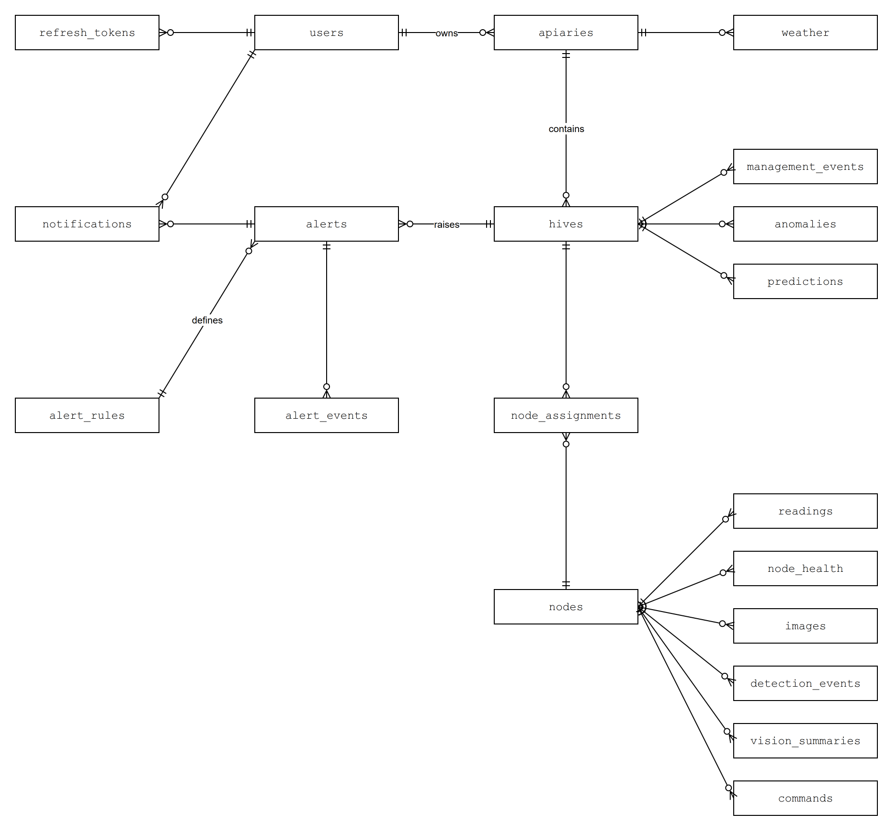
Figure 3. Entity relationships of the main tables. One-to-many relations; the crow's foot is on the many side.
readings is a TimescaleDB hypertable partitioned by time in seven-day chunks and keyed by message identifier, index and time, with a quality flag and a flag that records whether the node's clock was synchronised. Simulated nodes carry a simulated marker that propagates to every API response and is excluded from exports by default. The tables anomalies and predictions are written by the machine learning jobs through two helper functions, and the API only reads them. Migrations are forward-only Alembic files; six exist.
Retention is explicit. Node health data is kept 90 days, images follow the periods above, and readings, summaries, detections and alerts are kept indefinitely because they are small. A nightly job removes expired rows and files, including cached thumbnails, and it never removes a file that another image row still references.

6. Application interface

6.1 REST
The API lives under /api/v1. Responses are JSON with snake_case fields and ISO 8601 UTC timestamps. Lists return {items, next_cursor} with opaque cursors, and errors use RFC 9457 problem details (Nottingham and Wilde, 2023). The OpenAPI document at /api/v1/openapi.json is the reference from which the dashboard generates its client. Table 3 summarises the implemented endpoints.
Table 3. Implemented REST endpoints, relative to /api/v1 except the health checks.
Area | Endpoints
Authentication | POST /auth/login, /auth/refresh, /auth/logout; GET /me
Apiaries and hives | GET, POST /apiaries; GET /apiaries/{id}; GET, POST /apiaries/{id}/hives; GET /hives; GET, PATCH /hives/{id}
Nodes (admin) | GET, POST /nodes; GET /nodes/{id}; POST /nodes/{id}/assign, /unassign
Telemetry | GET /hives/{id}/latest; GET /hives/{id}/readings with bucket from 1 minute to 1 day and agg; GET /hives/{id}/weather
Images | GET /hives/{id}/images, /images/latest; GET /images/{id}; GET /images/{id}/file?w=160|320|640
Alerts | GET /alerts, /alerts/{id}; POST /alerts/{id}/acknowledge, /resolve; GET, PATCH /alert-rules
Beekeeper log and ML | GET, POST /hives/{id}/management-events; GET /hives/{id}/anomalies, /predictions
Export | GET /exports/readings, /exports/detections (CSV or JSON Lines, streamed)
Operations | GET /healthz, /readyz

A beekeeper sees only the apiaries they own; an administrator sees everything and manages nodes. Reading history is bucketed in the database with TimescaleDB's time_bucket, only samples with quality ok are used, gaps are returned as gaps and never interpolated, and a single response is capped at 5000 points.

6.2 WebSocket
GET /api/v1/ws upgrades to a WebSocket (Fette and Melnikov, 2011). The first message must be {"op": "auth", "token": ...} within ten seconds, otherwise the socket closes with code 4401, so the token never appears in a URL. The client then subscribes to hive identifiers; identifiers it may not see are dropped silently. The server pushes reading, detection, alert and node_status messages built from the notification payloads. Two further messages ask the client to refetch: backfill when older readings arrive, and resync when the API lost its database connection and may have missed notifications. A client that falls 100 messages behind is closed with code 4408.

7. Alerts and notifications
The alert engine runs inside the worker. Each rule is a row in alert_rules with a severity and adjustable thresholds, and an evaluator in code. Table 4 lists the rules that exist.
Table 4. Implemented alert rules.
Rule | Fires when | Severity | Clears
hornet_detected | A hornet detection event arrives | Critical | By the beekeeper
shb_detected | A small hive beetle detection arrives | Warning | By the beekeeper
varroa_high | Varroa index above 3 % over 24 h, with at least 300 bees counted | Warning | By the beekeeper
node_offline | No message for 10 minutes, or the broker's last will | Warning, critical after 24 h | Automatically on return
node_power_low | Battery below 10.2 V for 10 minutes, or repeated under-voltage flags | Warning | Automatically
temp_out_of_range | Inside temperature outside 32 to 37 degrees C for 2 h | Warning | By the beekeeper
rh_out_of_range | Inside humidity outside 40 to 85 % for 6 h | Info | By the beekeeper

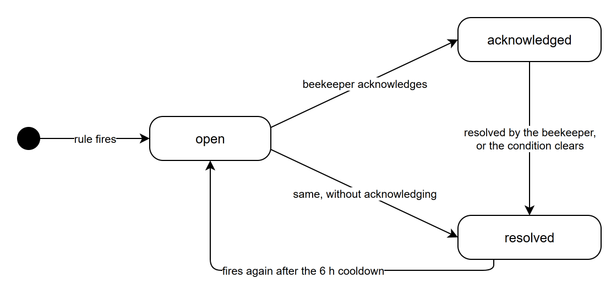
Figure 4. Alert life cycle.
An alert is identified by a deduplication key, so a rule that keeps firing updates one alert instead of creating many. Every transition writes a row to alert_events. A node_offline alert that stays open for 24 hours is raised to critical, which is recorded as an escalated event. After a manual resolution the rule is silent for six hours so that a fixed problem does not immediately reopen the same alert.
Delivery reads pending rows with FOR UPDATE SKIP LOCKED, so two workers never send the same message. A failed send waits one, two, four minutes and so on, and after five attempts the row becomes failed. More than ten sent messages per user and channel in an hour mark the rest suppressed, which protects a beekeeper's inbox during an incident. Email has a plain-text and an HTML part rendered from Jinja2 templates. When the hive has an image from the hour before the alert, a 320 pixel thumbnail is embedded inline. ntfy messages carry a priority of urgent for critical alerts.

8. Operations
The worker runs the daily weather fetch from Open-Meteo (Zippenfenig, 2023) for each apiary with coordinates, and a nightly maintenance pass that purges expired images and old health rows, writes a compressed pg_dump backup, prunes old dumps, and verifies the newest dump by restoring it into a scratch database and comparing row counts of the tables that only grow. Two commands, smarthive backup and smarthive restore-check, run the same steps by hand.
The container image installs the PostgreSQL 16 client from the PGDG repository, because the base image's default version differs from the server. Continuous integration runs ruff, mypy and the full test suite on Python 3.11 for every pull request, and a pull request may not be merged while any check fails.

9. Security
- Transport. The broker requires TLS (Rescorla, 2018) with a client certificate for each node. Caddy terminates HTTPS for users and for image uploads.
- Passwords. Stored as Argon2id hashes (Biryukov, Dinu and Khovratovich, 2016). A wrong password and an unknown email return the same response after the same amount of hashing work.
- Sessions. Access tokens are JWTs (Jones, Bradley and Sakimura, 2015) that expire after 15 minutes. The refresh token is an opaque value in an HttpOnly, Secure, SameSite=Strict cookie, and the database stores only its SHA-256. Each refresh rotates the token; presenting an already rotated token closes every session of that user.
- Brute force. Five failed logins per client address in 15 minutes return 429 with Retry-After.
- Devices. A node's upload token is shown once when the node is registered; only a hash is stored. A token cannot upload for another node.
- Authorisation. Every query that returns hive data is scoped to the caller's apiaries unless the caller is an administrator. An image of someone else's hive returns 404, not 403, so its existence is not revealed.

10. Validation
The suite has 181 passing tests and one skipped test. The unit tests cover parsing, rule evaluation and token handling. The integration tests start real services with Testcontainers: TimescaleDB for every database test, Mosquitto for the broker contract and the end-to-end ingest test, and Mailpit to check that email arrives with the expected parts and the inline image. ntfy is checked against a local HTTP server. Table 5 lists the properties that are verified and how.
Table 5. Verified properties.
Property | How it is checked
A node cannot write to another node's topics | Real broker, generated certificates, two clients
Redelivered messages are stored once | Same message identifier published twice, row count compared
Late data lands on the hive of that time | Assignment moved after capture, readings resolved and back-filled
Refresh token reuse closes all sessions | Rotated token replayed, further refresh refused
Image upload is idempotent and verified | Same upload twice (201 then 200), wrong hash (422), different hash (409), size and type limits
Thumbnails are resized, cached and validated | Real JPEG resized to 320 px, one cached file, unsupported width 422, undecodable file 422
Failed delivery backs off and gives up | SMTP port with no listener, attempts 1 to 3 at advancing clock times
Hourly limit suppresses extra notifications | Second alert for the same user, row status checked
Purge keeps files still referenced | Two rows share one file; only the unreferenced file and its thumbnail are deleted
Backup restores to the same row counts | Dump and restore into a scratch database; skipped in CI where the PostgreSQL client tools are absent

11. Limitations and future work
- Soak test. Story SCRUM-91, 48 hours with five simulated hives, needs a demonstration machine. Until it runs, long-term behaviour (connection recovery, disk use, memory) is untested.
- Backup round trip. The round trip passes with pg_dump supplied by a container, but the skipped CI test means it is not checked automatically. It has not been run against the Compose stack.
- Compose stack. The repository's Compose file defines the broker only. Services for the API, worker, database and Caddy are not yet defined, so a developer must start them by hand.
- Missing endpoints. Notification inbox (/me/notifications), notification preferences (PATCH /me), apiary create and update beyond the current routes, node commands, detections and varroa series have been designed but not built.
- Alert rules. Several rules in the catalogue are not implemented; the alerts document lists them.
- Assumptions to confirm. The key throttled.under_voltage in health snapshots, the table contract for anomalies and predictions, and per-node certificates for the simulator.

References
Banks, A. and Gupta, R. (eds.) (2014) MQTT Version 3.1.1. OASIS Standard. Available at: https://docs.oasis-open.org/mqtt/mqtt/v3.1.1/mqtt-v3.1.1.html (Accessed: 18 October 2026).
Biryukov, A., Dinu, D. and Khovratovich, D. (2016) 'Argon2: new generation of memory-hard functions for password hashing and other applications', 2016 IEEE European Symposium on Security and Privacy, pp. 292-302.
Fette, I. and Melnikov, A. (2011) The WebSocket Protocol. RFC 6455. Internet Engineering Task Force.
Fielding, R.T. (2000) Architectural styles and the design of network-based software architectures. PhD thesis. University of California, Irvine.
Jones, M., Bradley, J. and Sakimura, N. (2015) JSON Web Token (JWT). RFC 7519. Internet Engineering Task Force.
Nottingham, M. and Wilde, E. (2023) Problem Details for HTTP APIs. RFC 9457. Internet Engineering Task Force.
Rescorla, E. (2018) The Transport Layer Security (TLS) Protocol Version 1.3. RFC 8446. Internet Engineering Task Force.
Zippenfenig, P. (2023) Open-Meteo.com Weather API. Zenodo. Available at: https://open-meteo.com (Accessed: 18 October 2026).

