**Листинг проекта**

package application;  
  
import org.openqa.selenium.*;  
import org.openqa.selenium.chrome.*;  
import org.openqa.selenium.support.ui.WebDriverWait;  
import static org.openqa.selenium.support.ui.ExpectedConditions.*presenceOfElementLocated*;  
  
import java.io.IOException;  
  
  
public class EntryPoint {  
  
 private static ChromeDriverService *service*;  
  
 public static void main(String[] args) throws IOException {  
 System.*setProperty*("webdriver.chrome.driver","..\\Lab10\\src\\resources\\chromedriver.exe");  
 WebDriver driver = new ChromeDriver();  
 WebDriverWait wait = new WebDriverWait(driver, 10);  
 try {  
 driver.get("https://google.by");  
 driver.findElement(By.*name*("q")).sendKeys("iTechArt" + Keys.*ENTER*);  
  
 //TASK 1  
 WebElement firstResult = wait.until(*presenceOfElementLocated*(By.*cssSelector*("h3")));  
 System.*out*.println(firstResult.getAttribute("textContent"));  
  
 //TASK 2  
 WebElement titleResult = wait.until(*presenceOfElementLocated*(By.*cssSelector*("title")));  
 if(titleResult.getAttribute("textContent").matches(".*iTechArt.*"))  
 {  
 System.*out*.println("Title вкладки содержит: " + titleResult.getAttribute("textContent"));  
 }  
  
 } finally  
 {  
 driver.quit();  
 }  
 }  
}

**Результат работы**

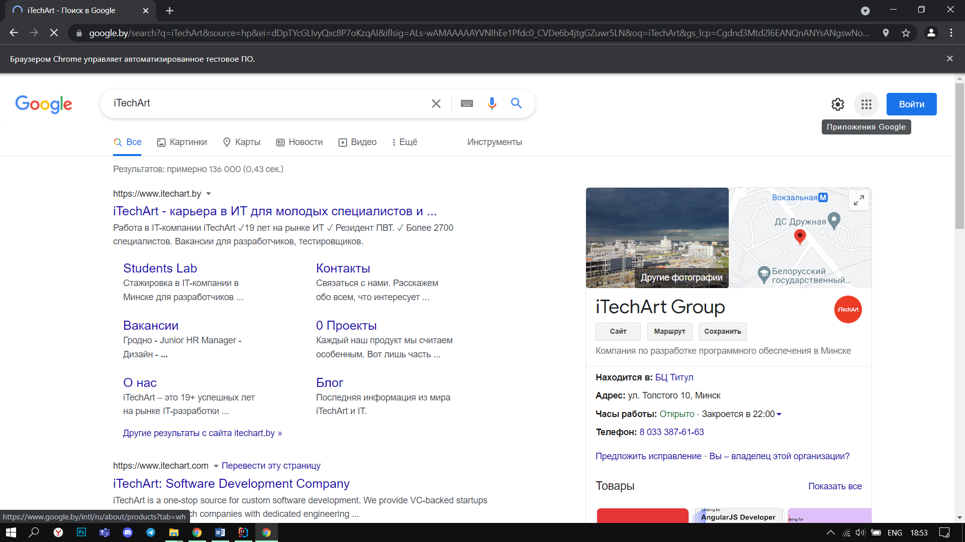

Вывод на консоль

