A Reinforcement Learning Based Educational Game with Retrieval-Augmented Riddle Generation for Personalised Learning
Srujan M Padmashali, Nikhitha S Kotian
Department of Information Science & Engineering, NMAM Institute of Technology, Nitte, India
Abstract—Most educational software gives every learner the same difficulty level and the same fixed bank of questions. The difficulty rarely fits the learner, and once the bank is used up, answers are remembered instead of worked out. This paper describes an exploration game that addresses both problems. A Q-learning engine picks one of five difficulty tiers after each riddle from two signals, whether the learner answered correctly and whether hints were used. The reward is positive only when the learner wins with the help of a hint, which is treated as the target level of challenge. A retrieval-augmented generation (RAG) pipeline writes a new riddle for each session. It searches the web for the chosen topic, embeds the scraped text, and passes the closest passages to a language model that writes the riddle from that text. In a live test on four topics, the pipeline returned a riddle in 6.67 s on average, and all four riddles were schema-valid and drawn from a retrieved web source. Over 40 episodes against a simulated learner, the engine raised the tier as the learner improved, lowered it after every loss, and learned to hold the tier once the learner was working with hints.
Index Terms—Reinforcement learning, Q-learning, dynamic difficulty adjustment, retrieval-augmented generation, large language models, procedural content generation, serious games, personalised learning.

I. Introduction
Most educational games and drill applications use a fixed difficulty level and a question bank written by hand. This causes two problems. The first is a mismatch between the difficulty on offer and what the learner can do at that moment. Work that is too easy loses the learner's attention, and work that is too hard pushes the learner to lean on hints until the hints stop teaching anything. The second problem is staleness. A fixed bank runs out, and repeated play turns practice into recall of answers already seen.
Both problems have partial remedies. Choosing a difficulty level is a sequential decision with delayed feedback, which suits reinforcement learning, and Q-learning needs no model of the environment [1], [2]. Retrieval-augmented generation lets a language model write new questions from source text it is given at run time [3], and supplying that text is one of the main practical ways to limit hallucination [4]. Few systems combine the two inside a game, and fewer report how the combination behaves when it runs.
This paper describes and evaluates such a system. Its contributions are: (i) a Q-learning difficulty engine whose state includes hint use, so that a win with help is treated differently from a win without it; (ii) a RAG pipeline that builds its index from live web search at the moment a topic is chosen, instead of from a prepared corpus; and (iii) an evaluation of both parts, with stage-level latency from the live pipeline and a full Q-value trace of the engine over 40 simulated episodes.
II. Literature Review
Difficulty adaptation. Annisa Damastuti et al. [5] combine Q-learning with fuzzy logic. The agent picks a difficulty action from recent performance and the fuzzy stage smooths the change. Rupp et al. [6] let reinforcement-learning agents play generated levels in simulation, so that difficulty and fairness can be measured before people play. Both show that difficulty set from observed play works better than a fixed ramp. Both target entertainment or competitive balance, however, and neither uses hint requests as a signal, although in a learning setting a hint shows whether an answer came from understanding or from help.
Grounded generation. Surveys of RAG describe a pipeline of indexing, retrieval and generation in which the model answers from supplied text rather than from what it memorised during training, which improves accuracy and makes answers traceable [3]. Surveys of hallucination list supplying relevant context as one of the few mitigations that work in practice [4]. Retrieval in turn depends on sentence embeddings, which place text with similar meaning close together in vector space [7].
Procedural content. Gradient noise [8] is the basis of most runtime terrain generation. Kutzias and von Mammen [9] note that noise-based methods are preferred when content must be cheap and reproducible from a seed, and that the harder problem is making generated parts fit together.
Games and adaptive learning. AI-supported gamification has been linked to higher engagement and achievement [10], and a recent review finds the best results when game mechanics are tied to the learning task itself [11]. Tutoring systems that respond to a learner's individual steps do better than fixed feedback, but their content is costly to write [12]. Santhosh et al. [13] pair a gaze-driven adaptive loop with summaries written by a language model, which is the closest prior work to the combination studied here. Westin [14] sets out accessibility patterns for games, which shaped the input design of this system.
III. Existing System
Current educational games and quiz platforms follow one of two designs. In the static design, questions are written in advance, grouped by level and served in a fixed order, sometimes with a simple rule such as moving up a level after three correct answers. In the adaptive design found in recent research [5], [6], difficulty is adjusted from performance, but the content still comes from a fixed, hand-made pool. Systems that do generate content with a language model, such as [13], mostly work outside a game and without a difficulty controller. These designs share three limitations.
1) Difficulty ignores how an answer was reached. Score-based rules count a correct answer the same way whether the learner solved it alone or after reading every hint. A learner who depends on hints is moved up anyway, and the difficulty drifts away from what that learner can actually do.
2) Content runs out. A hand-written bank has a fixed size. Once a learner has seen it, later rounds test memory rather than understanding, and every new topic means writing new questions by hand [12].
3) Generated content is not grounded. When a language model writes questions from its own parameters alone, nothing ties the output to a source. An answer can be wrong in a way the learner cannot detect, and there is no record of where a fact came from [4].
IV. Proposed Architecture
A. System Overview
The system runs as two processes that communicate over local HTTP (Fig. 1). The game client, built in the Godot engine, handles the world, input and interface. A Python FastAPI backend handles search, retrieval and generation. On the client, a Global autoload holds session state and the Learning Journal, DifficultyRL holds the Q-learning engine and saves its Q-table after every update, and AiQuestionGenerator makes the two backend calls. If either call fails, the generator falls back to a small local riddle bank, so a network fault slows play instead of stopping it. Programming riddles are checked by running the player's code on an external execution service.
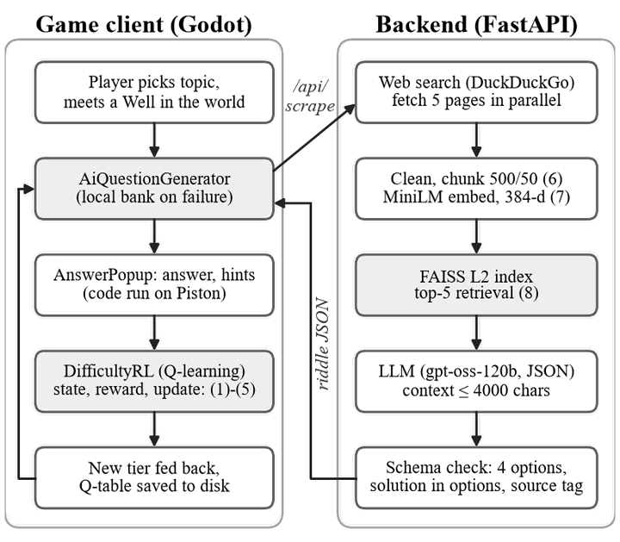
Fig. 1. System architecture. Shaded boxes are the two learning components; numbers refer to the equations in Section IV.
B. Difficulty Adjustment Engine
The engine controls a tier index d_{t} from 0 (VERY_EASY) to 4 (VERY_HARD). After riddle t, the outcome is mapped to one of three states using the win flag w_{t} and the number of hints used h_{t}:
$s_{t} = \left\{\begin{aligned}BORING, w_{t}=1, h_{t}=0 \\ CHALLENGED, w_{t}=1, h_{t}>0 \\ TOO_HARD, w_{t}=0\end{aligned}\right.$ (1)
The reward for the previous action depends on the state it led to:
$r_{t} = \left\{\begin{aligned}+2, if s_{t} = CHALLENGED \\ −2, otherwise\end{aligned}\right.$ (2)
CHALLENGED is the only rewarded state, because a win that needed a hint shows the learner was working close to the limit of their ability. Once the new state is known, the previous state-action pair (s, a) is updated with the one-step Q-learning rule [1], where s′ = s_{t} and y_{t} is the target value:
$\begin{aligned}y_{t} = r_{t} + γ\max_{a^{′}}{Q\left(s^{′}, a^{′}\right)} \\ Q\left(s, a\right) ← Q\left(s, a\right) + α\left[y_{t} − Q\left(s, a\right)\right]\end{aligned}$ (3)
with learning rate α = 0.3 and discount factor γ = 0.5. The action set is A = {DOWN, SAME, UP}. Instead of an ε-greedy policy, the engine fixes the action in the two clear states and uses the learned values only in the third:
$a_{t} = \left\{\begin{aligned}UP, if s_{t} = BORING \\ DOWN, if s_{t} = TOO_HARD \\ \underset{a∈A}{arg max}{Q\left(s_{t}, a\right)}, otherwise\end{aligned}\right.$ (4)
The tier then moves by δ(DOWN) = −1, δ(SAME) = 0 or δ(UP) = +1 and is clamped to the valid range:
$d_{t+1} = min\left(4, max\left(0, d_{t} + δ\left(a_{t}\right)\right)\right)$ (5)
Q-values are initialised so that the first decision in each state is sensible before any learning, for example Q(TOO_HARD, DOWN) = 2.0 and Q(TOO_HARD, UP) = −2.0. Fixing the action in BORING and TOO_HARD gives up some exploration, but it keeps difficulty changes predictable, which matters because a real learner feels each change immediately.
C. Retrieval-Augmented Riddle Generation
When the player picks a topic, /api/scrape clears the vector index so that no text carries over from an earlier topic. It searches the web, fetches up to five result pages in parallel with a 4 s timeout each, and keeps the first page whose cleaned text is longer than 200 characters. The text, of length L, is cut into chunks of c = 500 characters with an overlap of o = 50, which gives
$N = \left\lceil \frac{L}{c − o}\right\rceil$ (6)
chunks. Each chunk x_{i} is embedded with the all-MiniLM-L6-v2 sentence encoder f [7] and stored in an exact L2 index:
$e_{i} = f\left(x_{i}\right) ∈ ℝ^{384}, i = 1, …, N$ (7)
/api/generate_riddle embeds the topic q in the same way and returns the set of k = 5 chunks nearest to it:
$C\left(q\right) = \underset{|S|=k}{arg min}{\sum_{i∈S}{{\left\|f\left(q\right) − e_{i}\right\|}_{2}}}$ (8)
The retrieved chunks are joined, cut to 4000 characters and placed in a prompt for a hosted language model (gpt-oss-120b, temperature 0.5) in JSON mode. The prompt asks for one riddle, four options, a solution that matches one option exactly, four hints, a fact for the Learning Journal, and a source tag that records whether retrieval supplied context. A response is accepted only if the solution appears among the options. The time a player waits for one riddle is the sum of the stage times:
$\begin{aligned}T = T_{scrape} + T_{gen} \\ T_{scrape} = T_{search} + T_{fetch} + T_{embed}\end{aligned}$ (9)
where T_{gen} covers retrieval and the model call. T_{fetch} is set by the first usable page to respond, which the system does not control. The world in which riddles appear is built from layered simplex noise [8] with a radial falloff that keeps the island connected, a method chosen because it is cheap and reproducible from a seed [9].
V. Results and Discussion
A. Experimental Setup
Two experiments were run. In the first, the backend ran locally against live web search and the hosted model for four topics, three on programming and one on general knowledge, at three difficulty tiers, and the wall-clock time of each stage was recorded. In the second, the decision logic of DifficultyRL was ported line for line to Python, with the same states, rewards, initial values, α and γ, and run for 40 episodes against a simulated learner. The simulated learner's chance of winning starts low and rises linearly with practice, and its chance of needing a hint falls as its skill rises. A study with real students was not possible within the project period.
B. Comparison with Existing Systems
Table I compares the proposed system with a static question bank and with the closest adaptive approach. The proposed system is the only one of the three that uses hint use as a difficulty signal and that produces new, source-linked content for every session.
TABLE I
Comparison with Existing Approaches
Aspect | Static bank | Q-learning DDA [5] | Proposed
Difficulty control | Fixed order | Learned from performance | Learned from wins and hints
Hint use as signal | No | No | Yes
Content source | Hand-written | Fixed game content | Generated per session
Link to a source | Author only | Not applicable | Retrieved text and source tag
After content is used | Repeats | Repeats | New riddle each round

C. Pipeline Latency and Output Validity
Table II and Fig. 2 give the stage times for each topic. The scrape stage took 4.61 s on average (1.93–8.02 s) and the generation stage 2.07 s (1.73–2.47 s), for 6.67 s end to end (4.35–9.97 s). Scraping was both the larger and the more variable stage, as (9) predicts, since its time depends on which external page answers first. Generation is one model call over at most 4000 characters, so it stayed close to 2 s for every topic. Chunk count did not track scrape time: Python Decorators produced 33 chunks in 2.62 s, while Origami produced 8 chunks in 8.02 s, which points to page fetching rather than embedding as the main cost.
TABLE II
Riddle-Generation Latency by Topic (Seconds)
Topic | Tier | Scrape | Chunks | Gen. | Total
Binary search trees | Medium | 5.86 | 8 | 2.12 | 7.98
Python decorators | Hard | 2.62 | 33 | 1.73 | 4.35
Recursion | Easy | 1.93 | 27 | 2.47 | 4.40
Origami | Medium | 8.02 | 8 | 1.94 | 9.97
Mean | – | 4.61 | 19 | 2.07 | 6.67

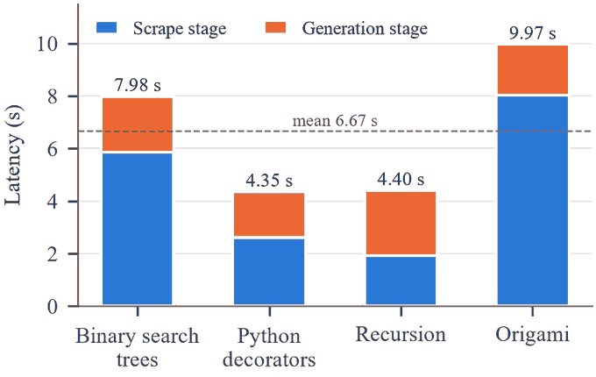
Fig. 2. End-to-end latency per topic, split into the scrape and generation stages of (9). The dashed line is the mean.
All four riddles passed the schema check on the first attempt, with the solution present among the four options, and all four carried the source tag web, so retrieval supplied context in every run. For example, the binary search trees riddle asked which traversal visits keys in ascending order, with the answer inorder, and was written from a scraped tutorial page.
D. Difficulty Engine Behaviour
Fig. 3 shows the tier chosen after each of the 40 episodes. From MEDIUM, two early losses took the learner down to VERY_EASY by episode 5. The tier then rose with the learner's skill, reached VERY_HARD at episode 12, and stayed at or returned to that tier for 20 of the 40 episodes. Each of the nine losses lowered the tier by one, and the next win without a hint raised it again.
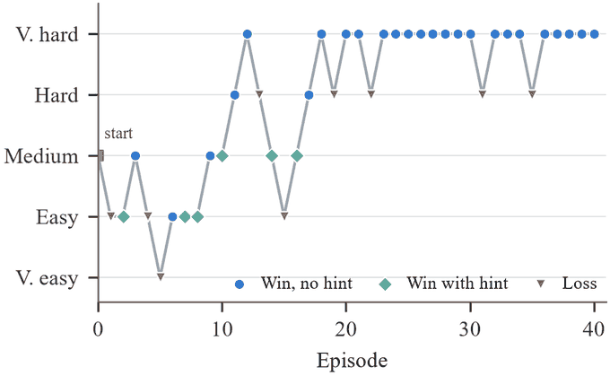
Fig. 3. Difficulty tier after each simulated episode. Marker shape shows the outcome of that episode.
Table III compares the initial and final Q-values. Of the 40 episodes, 25 ended in BORING, 9 in TOO_HARD and 6 in CHALLENGED. Because only CHALLENGED is rewarded by (2), every value for BORING and TOO_HARD ends below zero, including the actions that (4) forces the engine to take, such as BORING with UP at −2.489. These values never decide an action. The learning that matters sits in the three CHALLENGED values, traced in Fig. 4.
TABLE III
Initial and Final Q-Values After 40 Episodes
State | Action | Initial Q | Final Q | Times chosen
BORING | DOWN | −2.0 | −2.000 | 0
BORING | SAME | −1.0 | −1.000 | 0
BORING | UP | 2.0 | −2.489 | 25
CHALLENGED | DOWN | 0.5 | −0.094 | 1
CHALLENGED | SAME | 2.0 | 0.167 | 4
CHALLENGED | UP | 0.5 | −0.230 | 1
TOO_HARD | DOWN | 2.0 | −1.549 | 9
TOO_HARD | SAME | −1.0 | −1.000 | 0
TOO_HARD | UP | −2.0 | −2.000 | 0

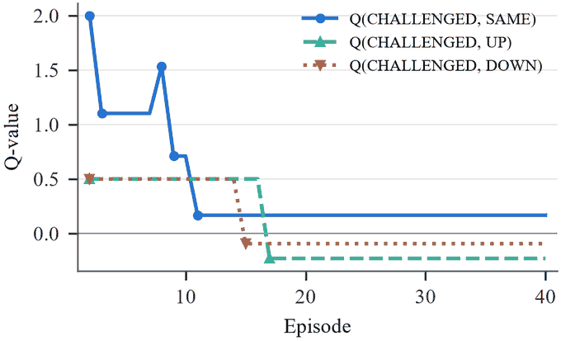
Fig. 4. Q-values of the three actions in the CHALLENGED state. Markers show the episodes in which each value was updated.
E. Discussion
Q(CHALLENGED, SAME) started at 2.0 and fell to 0.167 by episode 11, because holding the tier was often followed by a win without hints, which (2) penalises. At episode 14 the learner won with a hint and the tier still dropped. SAME had fallen below the initial 0.5 of DOWN and UP, and the tie between those two went to DOWN, the first action checked in (4). The engine then tried DOWN and UP once each, both were followed by an unrewarded state, and both values fell below SAME. The final policy therefore holds the tier when the learner is working with hints, which is the intended behaviour. The tie-break at episode 14 is an implementation detail with a visible effect, and random tie-breaking would remove it.
The clamp in (5) creates a ceiling. At VERY_HARD, a BORING outcome still selects UP but cannot raise the tier, as in episodes 23 to 30, so a learner who has mastered a topic receives no harder work. On the content side, the 9.97 s worst case is acceptable behind a progress indicator, but it is set by external web servers and will vary with the topic and the network.
VI. Conclusion and Future Scope
This paper combined a hint-aware Q-learning difficulty engine with a web-grounded RAG riddle pipeline inside a procedurally generated game. In the live test, riddles arrived in 6.67 s on average and all four were schema-valid and drawn from a retrieved source. In simulation, the tier rose with the learner's skill, fell after every loss, and the learned values settled on holding the tier in the CHALLENGED state. The evaluation has clear limits. The RAG test covered four topics, the engine was tested against a simulated learner rather than students, and every hint is treated the same regardless of how much it reveals.
Future work will cover five areas: a study with real learners that compares the learned policy with a fixed progression; a larger grounding test across many topics, with answers checked by hand; a sixth, open-ended tier that removes the ceiling at VERY_HARD; mastery tracked per concept instead of in one global state; and a server-side Q-table so that a learner's calibration follows them across devices.
References
[1] C. J. C. H. Watkins, "Learning from delayed rewards," Ph.D. dissertation, King's College, Univ. of Cambridge, Cambridge, U.K., 1989.
[2] R. S. Sutton and A. G. Barto, Reinforcement Learning: An Introduction, 2nd ed. Cambridge, MA, USA: MIT Press, 2018.
[3] M. Hindi, L. Mohammed, O. Maaz, and A. Alwarafy, "Enhancing the precision and interpretability of retrieval-augmented generation (RAG) in legal technology: A survey," IEEE Access, vol. 13, pp. 46171–46189, 2025.
[4] D. Anh-Hoang, V. Tran, and L. M. Nguyen, "Survey and analysis of hallucinations in large language models: Attribution to prompting strategies or model behavior," Front. Artif. Intell., vol. 8, 2025.
[5] F. Annisa Damastuti, K. Firmansyah, Y. Miftachul Arif, T. Dutono, A. Barakbah, and M. Hariadi, "Dynamic level of difficulties using Q-learning and fuzzy logic," IEEE Access, vol. 12, pp. 137775–137789, 2024.
[6] F. Rupp, M. Eberhardinger, and K. Eckert, "Simulation-driven balancing of competitive game levels with reinforcement learning," IEEE Trans. Games, vol. 16, no. 4, pp. 903–913, 2024.
[7] R. Patil, S. Boit, V. Gudivada, and J. Nandigam, "A survey of text representation and embedding techniques in NLP," IEEE Access, vol. 11, pp. 36120–36146, 2023.
[8] K. Perlin, "An image synthesizer," ACM SIGGRAPH Comput. Graph., vol. 19, no. 3, pp. 287–296, 1985.
[9] D. Kutzias and S. von Mammen, "Recent advances in procedural generation of buildings: From diversity to integration," IEEE Trans. Games, vol. 16, no. 1, pp. 16–35, 2024.
[10] N. Ahmed Dahri et al., "The effect of AI gamification on students' engagement and academic achievement in Malaysia: SEM analysis perspectives," IEEE Access, vol. 13, pp. 70791–70810, 2025.
[11] A. M. Kassenkhan, A. N. Moldagulova, and V. V. Serbin, "Gamification and artificial intelligence in education: A review of innovative approaches to fostering critical thinking," IEEE Access, vol. 13, pp. 98699–98728, 2025.
[12] P. Arnau-Gonzalez, A. Serrano-Mamolar, S. Katsigiannis, T. Althobaiti, and M. Arevalillo-Herraez, "Toward automatic tutoring of math word problems in intelligent tutoring systems," IEEE Access, vol. 11, pp. 67030–67039, 2023.
[13] J. Santhosh, A. Dengel, and S. Ishimaru, "Gaze-driven adaptive learning system with ChatGPT-generated summaries," IEEE Access, vol. 12, pp. 173714–173733, 2024.
[14] T. Westin, "Game accessibility course design modules in higher education," Front. Comput. Sci., vol. 6, 2024.

