Contents
Possible Topics 1
Map Generation 1
Image Processing: Noise Filtering 2
To Do 2
Research Question 2
Sources 2
Notes 2
(2026) Kong Choi – CA based Method for SPN Removal 2
General – Noise Filtering 2
General 4
Primary Eval of Sources 4
(No Date) Xavier et al – Img Noise Reduction based on CA Filter 4
(2001) Morena Paletta – Evolving CA for Noise Reduction in Images 4
(2002) Popovici – CA in Image Processing 4
(2006) rosin – CA Training for Image Processing 4
(2009) Selvapeter Hordijk – CA for Img Noise Filtering 4
(2022) Chandra Et Al - Noise Reduction Using CA 4
(2023) Smolka et al – Reduction Mixed Gaussian and Impulsive Noise in Color Imgs 4
(2024) Proozmandan – SPN Removal Using Fuzzy CA and ANfis 5
(2025) Twinkle et al – Despeckling Images using elementary CA 5
(2025/26) Kong Choi – Salt Pepper Noise Removal CA Based 5
Web Sources 5

13.05. Presentation Notes
- Unclear if implementation is suitable to time frame, might instead become survey of existing CA filters that were found and slight comparison
- Need to define entry point: wikipedia, Hadeler and then maybe one good CA filter

Image Processing: Noise Filtering

To Do
- Formally define noise (look at CA noise filter papers for sources)
- Define CA (Hadeler) und applications/advantages
- Check two or three traditional noise filters (e.g. mean, median, gaussian)
  - Alt: use Chan et al. filter for non-CA approach that works similarly well
- PSNR (Peak Signal to Noise Ratio): Bovik Handbook
- SSIM (Structural Similarity Index)

Research Question
Research Question: An Analysis of Cellular Automata based Noise Reduction Filters
- List of CA filters that remove/reduce noise and their analysis
  - Most yield better results than traditional methods
- Papers mostly look at salt and pepper noise (4), with gaussian and speckle present in one paper each
- Comparison between filters?
- Approaches to implementing CA into the noise reduction process shown by paper example
- Minimal implementation to show effectiveness even in simple implementations
- Keep to salt and pepper noise since this is just a short paper not a doctorate

Sources

Notes

(2026) Kong Choi – CA based Method for SPN Removal
- CA rules are similar to Conway in that general rules are defined and neighborhoods evaluated based on those, need to crossreference Conway’s method, i.e. did he define all rules (doesn’t seem like it) like Rosin or did he really just use his four general rules and eval neighborhoods?

(2005) Rosin – Training CA
- Due to the emergent nature of CA, it is difficult to build up CA ruleset combinations and evaluate them properly
- Rating singular rules and optimizing those rating is not possible due to interrule relations and emergence that governs CA

General – Noise Filtering
Noise Reduction: https://en.wikipedia.org/wiki/Noise_reduction#In_images
Salt and pepper noise (sparse light and dark disturbances, alt: impulse noise) have no relation to surrounding pixels and are simply either black or white, affects small number of image pixels
Gaussian noise is a small change in pixel value from its original; plotting pixel value against frequency results in a normal distribution
Removal Tradeoffs: available computer power and time available, tradeoff between real detail and noise reduction, noise characteristics and image detail
Chroma and luminance detail and noise separation: highest spatial frequency consists of variations in brigthness (luminance) rather than hue (chroma), reduction algorithms split into chroma and luminance comps and apply reduction separately or to the former
Filter: linear smoothing, anisotropic diffusion, non-local means, nonlinear (e.g. median), wavelet transfoorm, statistical methods, block-matching algorithms, random
Img Noise Type: https://medium.com/@zar_373/understanding-image-noise-exploring-different-kinds-of-noises-in-image-processing-dcd26c6c9e5a
Noise is a significant problem in computer vision, field of artificial intelligence that enables machiens to interpret and understand visual data > image processing (images are enhanced, transformed, and analyzed to extract meaningful insights)
“Noise is any unwanted variation in an image that reduces its quality”, introduces randoom distortioons such as unwanted pixels or fluctuations in color and brightness
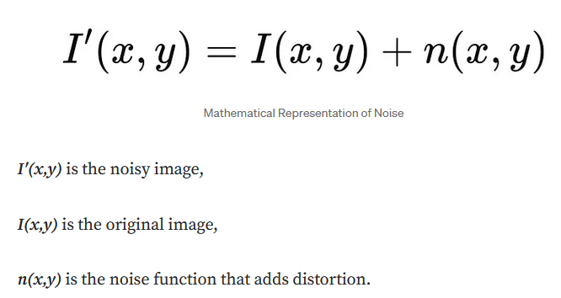 | Noise sources: capture noise (lighting condition, sensor issues, lens problems)  Sampling noise (loss of details during conversion such as aliasing effects)  Processing noise (errors due to limitations in numerical precision)  Image compression noise (lossy compression)
Types and Characteristics
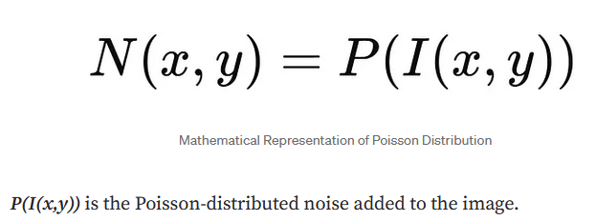  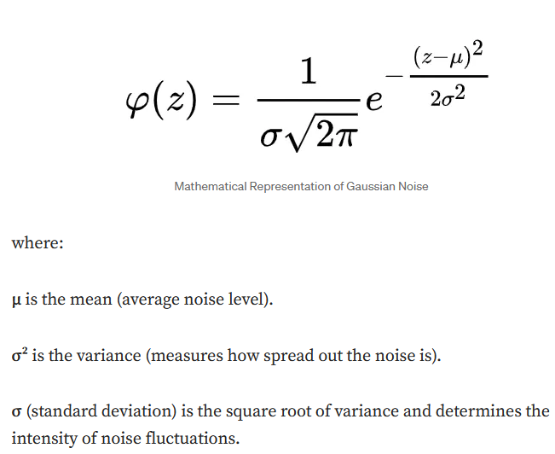  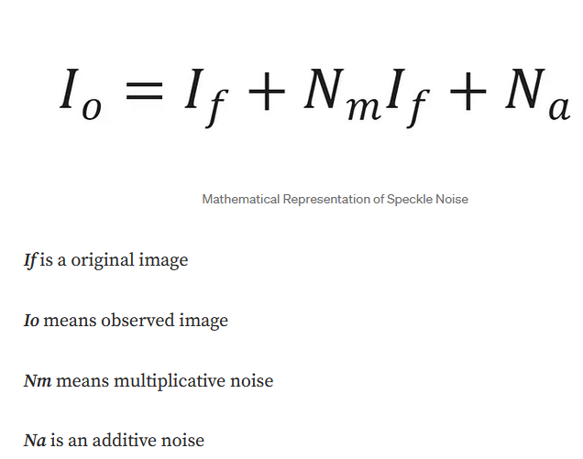 | 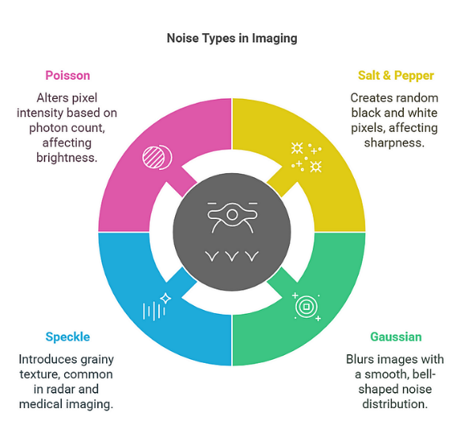  SPN: random white/black pixels  Gaussian: spread smoothly across all pixels, pixel deviate randomly from expected intensity but most remain close to mean  Speckle: granular, high frequency distortion that commonly affects radar, ultrasound, medical imaging, caused by interference between coherent waves reflected from multiple scatterer, results in grainy texture reduces image clarity  Poisson Noise: (alt: shot noise) due random variation in number of photons that reach camera sensor during image capture  Naturally occurs instead of added, depends on area brightness (more brightness = more noise)

General Knowledge
Img Noise Type: https://medium.com/@zar_373/understanding-image-noise-exploring-different-kinds-of-noises-in-image-processing-dcd26c6c9e5a
Cayleyrgaph: https://de.wikipedia.org/wiki/Cayleygraph

Web Sources
Edge Detection: https://en.wikipedia.org/wiki/Edge_detection
Img Processing: https://medium.com/@serbu.claudiaa/cellular-automaton-ca-in-image-processing-8114324eb297
https://medium.com/@anishaswain/noise-filtering-in-digital-image-processing-d12b5266847c
Img Noise Types: https://medium.com/@zar_373/understanding-image-noise-exploring-different-kinds-of-noises-in-image-processing-dcd26c6c9e5a
Modern Cellular Automata: https://link.springer.com/book/10.1007/978-1-4899-0393-8
Liquid Sim: https://www.jgallant.com/2d-liquid-simulator-with-cellular-automaton-in-unity/
Wikipedia: https://en.wikipedia.org/wiki/Cellular_automaton
https://de.wikipedia.org/wiki/Kantendetektion
https://en.wikipedia.org/wiki/Ising_model
https://de.wikipedia.org/wiki/Conways_Spiel_des_Lebens
https://de.wikipedia.org/wiki/Zellul%C3%A4rer_Automat
https://natureofcode.com/
Hexagons: https://www.redblobgames.com/grids/hexagons/
Neural Cellular Automata: https://distill.pub/2020/growing-ca/
Map Gen: https://christianjmills.com/posts/procedural-map-generation-techniques-notes/#map-generation-algorithms
https://excaliburjs.com/blog/Cellular%20Automata/#uses-in-game-development
https://medium.com/universe-factory/this-post-is-about-a-world-building-tool-ive-been-working-on-5d9560844ff5
https://bronsonzgeb.com/index.php/2022/01/30/procedural-generation-with-cellular-automata/
https://www.roguebasin.com/index.php/Cellular_Automata_Method_for_Generating_Random_Cave-Like_Levels
https://medium.com/@JelloRanger/random-and-procedural-map-generation-part-1-noise-and-maps-cc78fc776172
https://www.reddit.com/r/roguelikedev/comments/11d659z/what_are_essential_procedural_generation/

Primary Eval of Sources

(No Date) Xavier et al – Img Noise Reduction based on CA Filter
- Basic CA filter (neighbor assimilation) to reduce SPN
- Comparison with other methods, CA filter has “excellent” results

(2001) Morena Paletta – Evolving CA for Noise Reduction in Images
- Noise reduction (white noise) via CA with evolutionary programs
- Performance comparable or better than traditional methods

(2002) Popovici – CA in Image Processing
- Application of 2D CA to problems of noise removal and border detection
- Intrinsic parallelism due to being CA
- Does not say which type of noise

(2006) rosin – CA Training for Image Processing
- Not directly related to noise filtering
- Investigates the possibility of training CA too perform several img processing tasks

(2009) Selvapeter Hordijk – CA for Img Noise Filtering
- Removal of impulse noise via CA
- Uses uniform CA rules to filter impulse noise from binary and gray scale
- Modifies CA (random rules to solve noise propagation, mirrored for boundary problem)
- Shows significant improvement

(2022) Chandra Et Al - Noise Reduction Using CA
- Works on SPN and gaussian
- Superior to “past model” and almost on par with median channel

(2023) Smolka et al – Reduction Mixed Gaussian and Impulsive Noise in Color Imgs
- Based on Non-Local Means technique (efficiently suppresses gaussian) with robust similarity measure to counteract limitations of NLM
- Applies blockwise NLM implementation
- “instead of generating a stack of output images that are finally averaged, an aggregation strategy combining all weights assigned to pixels from the processing block was developed and proved to be more efficient”
- Yields satisfactory results, edges well preserved and details retained, impulsive noise efficiently removed

(2024) Proozmandan – SPN Removal Using Fuzzy CA and ANfis
- Restoration of images corrupted by impulse noise
- Uses fuzzy CA and an adaptive neural fzzy inference system (anfis)
- Two phases: identify and then remove SPN
  - First phase, identification (two steps): SPN pixels are detected via avg and min vals of neighborhood pixels, then non-detected pixels are reevaluated via algorithm
  - Second phase, removal: Anfis based on Moore neighborhood
- Robust for 10 – 19% noise, better preservation of edges

(2025) Twinkle et al – Despeckling Images using elementary CA
- Speckles in medical images
- Proposes algorithm using ECA to reduce speckle noise
- Results surpass traditional methods

(2025/26) Kong Choi – Salt Pepper Noise Removal CA Based
- Novel image denoising method based on CA for salt and pepper noise
- Iterative removal of SPN
- Achieves higher peak signal to noise ratio and structural similarity index measure compared to existing techniques
- Stable performance even under severe noise conditions

Possible Topics
- Post Processing Filter
- Image Processing
- Fluid Simulation
- Map Generation
- Maze Generation

Map Generation
- Comparison between Map Generation Techniques
- List of evaluation criteria (what is a good map?)
Source count: 3

