 Template
July 2025

About arc42
arc42, the template for documentation of software and system architecture.
Template Version 9.0-EN. (based upon AsciiDoc version), July 2025
Created, maintained and © by Dr. Peter Hruschka, Dr. Gernot Starke and contributors. See https://arc42.org.
This version of the template contains some help and explanations. It is used for familiarization with arc42 and the understanding of the concepts. For documentation of your own system you use better the plain version.

Introduction and Goals
Describes the relevant requirements and the driving forces that software architects and development team must consider. These include
- underlying business goals,
- essential features,
- essential functional requirements,
- quality goals for the architecture and
- relevant stakeholders and their expectations

Requirements Overview
Contents
Short description of the functional requirements, driving forces, extract (or abstract) of requirements. Link to (hopefully existing) requirements documents (with version number and information where to find it).
Motivation
From the point of view of the end users a system is created or modified to improve support of a business activity and/or improve the quality.
Form
Short textual description, probably in tabular use-case format. If requirements documents exist this overview should refer to these documents.
Keep these excerpts as short as possible. Balance readability of this document with potential redundancy w.r.t to requirements documents.
Further Information
See Introduction and Goals in the arc42 documentation.

Quality Goals
Contents
The top three (max five) quality goals for the architecture whose fulfillment is of highest importance to the major stakeholders. We really mean quality goals for the architecture. Don’t confuse them with project goals. They are not necessarily identical.
Consider this overview of potential topics (based upon the ISO 25010 standard):
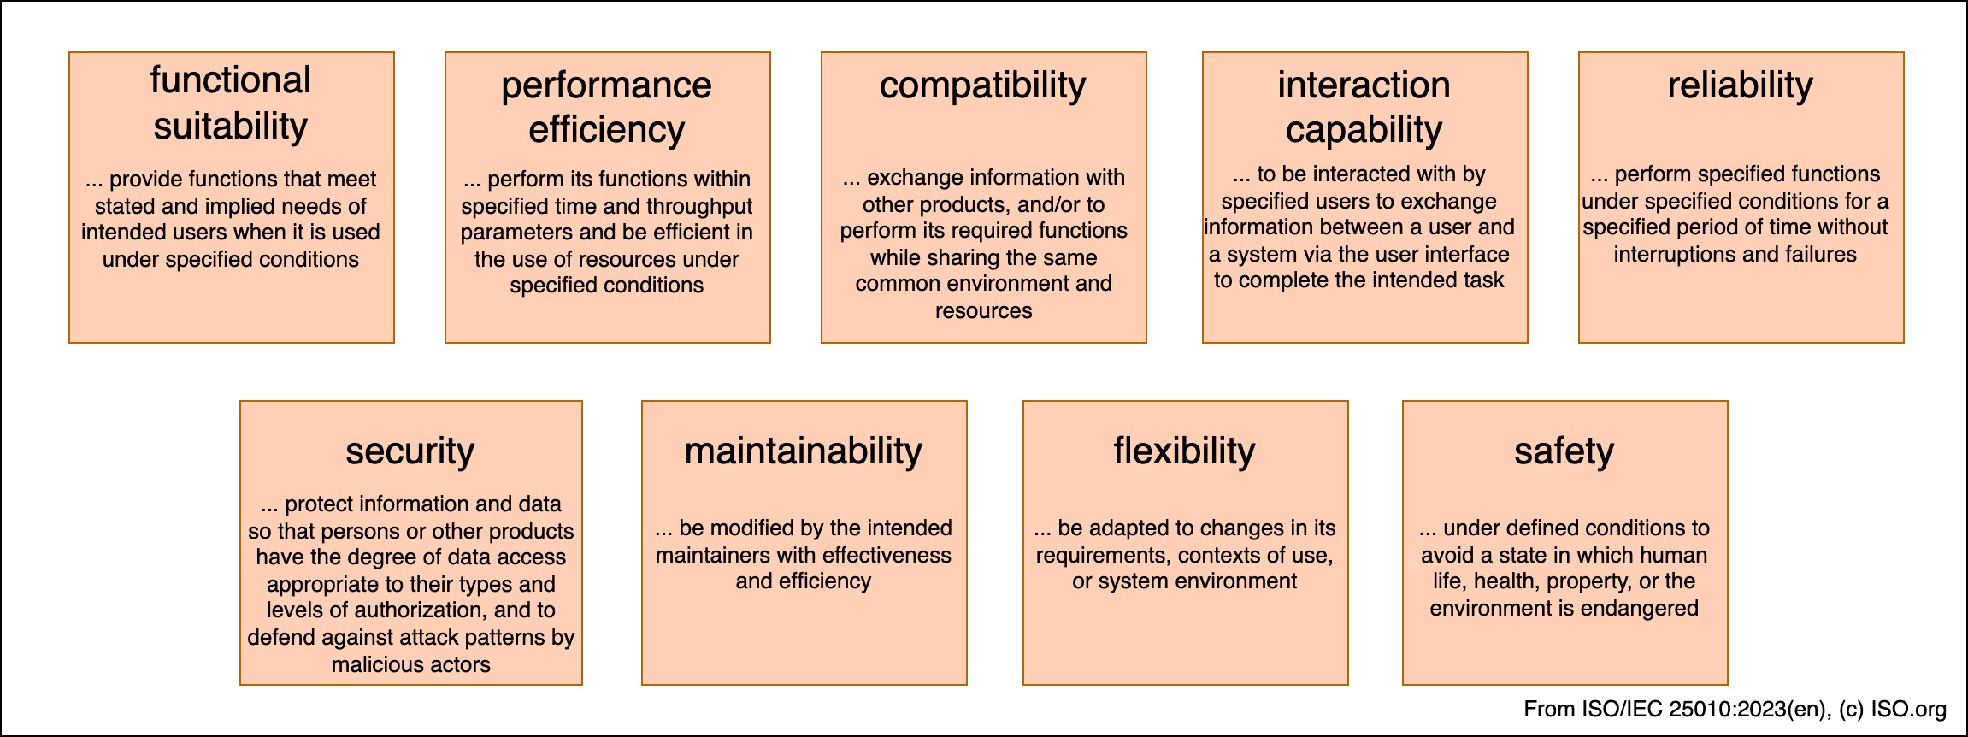
Motivation
You should know the quality goals of your most important stakeholders, since they will influence fundamental architectural decisions. Make sure to be very concrete about these qualities, avoid buzzwords. If you as an architect do not know how the quality of your work will be judged…​
Form
A table with quality goals and concrete scenarios, ordered by priorities

Stakeholders
Contents
Explicit overview of stakeholders of the system, i.e. all person, roles or organizations that
- should know the architecture
- have to be convinced of the architecture
- have to work with the architecture or with code
- need the documentation of the architecture for their work
- have to come up with decisions about the system or its development
Motivation
You should know all parties involved in development of the system or affected by the system. Otherwise, you may get nasty surprises later in the development process. These stakeholders determine the extent and the level of detail of your work and its results.
Form
Table with role names, person names, and their expectations with respect to the architecture and its documentation.
Role/Name | Contact | Expectations
<Role-1> | <Contact-1> | <Expectation-1>
<Role-2> | <Contact-2> | <Expectation-2>

Architecture Constraints
Contents
Any requirement that constraints software architects in their freedom of design and implementation decisions or decision about the development process. These constraints sometimes go beyond individual systems and are valid for whole organizations and companies.
Motivation
Architects should know exactly where they are free in their design decisions and where they must adhere to constraints. Constraints must always be dealt with; they may be negotiable, though.
Form
Simple tables of constraints with explanations. If needed you can subdivide them into technical constraints, organizational and political constraints and conventions (e.g. programming or versioning guidelines, documentation or naming conventions)
Further Information
See Architecture Constraints in the arc42 documentation.

Context and Scope
Contents
Context and scope - as the name suggests - delimits your system (i.e. your scope) from all its communication partners (neighboring systems and users, i.e. the context of your system). It thereby specifies the external interfaces.
If necessary, differentiate the business context (domain specific inputs and outputs) from the technical context (channels, protocols, hardware).
Motivation
The domain interfaces and technical interfaces to communication partners are among your system’s most critical aspects. Make sure that you completely understand them.
Form
Various options:
- Context diagrams
- Lists of communication partners and their interfaces.
Further Information
See Context and Scope in the arc42 documentation.

Business Context
Contents
Specification of all communication partners (users, IT-systems, …​) with explanations of domain specific inputs and outputs or interfaces. Optionally you can add domain specific formats or communication protocols.
Motivation
All stakeholders should understand which data are exchanged with the environment of the system.
Form
All kinds of diagrams that show the system as a black box and specify the domain interfaces to communication partners.
Alternatively (or additionally) you can use a table. The title of the table is the name of your system, the three columns contain the name of the communication partner, the inputs, and the outputs.
<Diagram or Table>
<optionally: Explanation of external domain interfaces>

Technical Context
Contents
Technical interfaces (channels and transmission media) linking your system to its environment. In addition a mapping of domain specific input/output to the channels, i.e. an explanation which I/O uses which channel.
Motivation
Many stakeholders make architectural decision based on the technical interfaces between the system and its context. Especially infrastructure or hardware designers decide these technical interfaces.
Form
E.g. UML deployment diagram describing channels to neighboring systems, together with a mapping table showing the relationships between channels and input/output.
<Diagram or Table>
<optionally: Explanation of technical interfaces>
<Mapping Input/Output to Channels>

Solution Strategy
Contents
A short summary and explanation of the fundamental decisions and solution strategies, that shape system architecture. It includes
- technology decisions
- decisions about the top-level decomposition of the system, e.g. usage of an architectural pattern or design pattern
- decisions on how to achieve key quality goals
- relevant organizational decisions, e.g. selecting a development process or delegating certain tasks to third parties.
Motivation
These decisions form the cornerstones for your architecture. They are the foundation for many other detailed decisions or implementation rules.
Form
Keep the explanations of such key decisions short.
Motivate what was decided and why it was decided that way, based upon problem statement, quality goals and key constraints. Refer to details in the following sections.
Further Information
See Solution Strategy in the arc42 documentation.

Building Block View
Content
The building block view shows the static decomposition of the system into building blocks (modules, components, subsystems, classes, interfaces, packages, libraries, frameworks, layers, partitions, tiers, functions, macros, operations, data structures, …​) as well as their dependencies (relationships, associations, …​)
This view is mandatory for every architecture documentation. In analogy to a house this is the floor plan.
Motivation
Maintain an overview of your source code by making its structure understandable through abstraction.
This allows you to communicate with your stakeholder on an abstract level without disclosing implementation details.
Form
The building block view is a hierarchical collection of black boxes and white boxes (see figure below) and their descriptions.
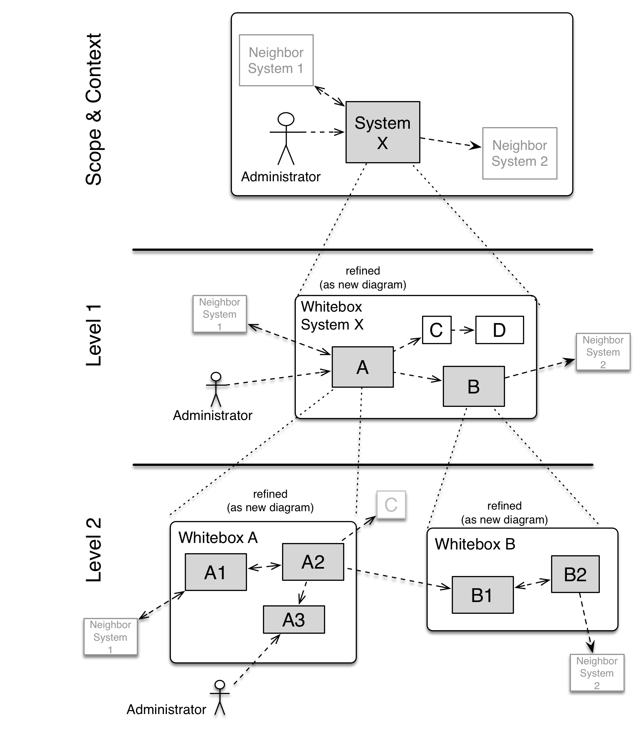
Level 1 is the white box description of the overall system together with black box descriptions of all contained building blocks.
Level 2 zooms into some building blocks of level 1. Thus it contains the white box description of selected building blocks of level 1, together with black box descriptions of their internal building blocks.
Level 3 zooms into selected building blocks of level 2, and so on.
Further Information
See Building Block View in the arc42 documentation.

Whitebox Overall System
Here you describe the decomposition of the overall system using the following white box template. It contains
- an overview diagram
- a motivation for the decomposition
- black box descriptions of the contained building blocks. For these we offer you alternatives:
  - use one table for a short and pragmatic overview of all contained building blocks and their interfaces
  - use a list of black box descriptions of the building blocks according to the black box template (see below). Depending on your choice of tool this list could be sub-chapters (in text files), sub-pages (in a Wiki) or nested elements (in a modeling tool).
- (optional:) important interfaces, that are not explained in the black box templates of a building block, but are very important for understanding the white box. Since there are so many ways to specify interfaces why do not provide a specific template for them. In the worst case you have to specify and describe syntax, semantics, protocols, error handling, restrictions, versions, qualities, necessary compatibilities and many things more. In the best case you will get away with examples or simple signatures.
<Overview Diagram>
Motivation
<text explanation>
Contained Building Blocks
<Description of contained building block (black boxes)>
Important Interfaces
<Description of important interfaces>
Insert your explanations of black boxes from level 1:
If you use tabular form you will only describe your black boxes with name and responsibility according to the following schema:
Name | Responsibility
<black box 1> | <Text>
<black box 2> | <Text>
If you use a list of black box descriptions then you fill in a separate black box template for every important building block . Its headline is the name of the black box.

<Name black box 1>
Here you describe <black box 1> according the the following black box template:
- Purpose/Responsibility
- Interface(s), when they are not extracted as separate paragraphs. This interfaces may include qualities and performance characteristics.
- (Optional) Quality-/Performance characteristics of the black box, e.g.availability, run time behavior, …​.
- (Optional) directory/file location
- (Optional) Fulfilled requirements (if you need traceability to requirements).
- (Optional) Open issues/problems/risks
<Purpose/Responsibility>
<Interface(s)>
<(Optional) Quality/Performance Characteristics>
<(Optional) Directory/File Location>
<(Optional) Fulfilled Requirements>
<(optional) Open Issues/Problems/Risks>

<Name black box 2>
<black box template>

<Name black box n>
<black box template>

<Name interface 1>
…​

<Name interface m>

Level 2
Here you can specify the inner structure of (some) building blocks from level 1 as white boxes.
You have to decide which building blocks of your system are important enough to justify such a detailed description. Please prefer relevance over completeness. Specify important, surprising, risky, complex or volatile building blocks. Leave out normal, simple, boring or standardized parts of your system

White Box <building block 1>
…​describes the internal structure of building block 1.
<white box template>

White Box <building block 2>
<white box template>
…​

White Box <building block m>
<white box template>

Level 3
Here you can specify the inner structure of (some) building blocks from level 2 as white boxes.
When you need more detailed levels of your architecture please copy this part of arc42 for additional levels.

White Box <_building block x.1_>
Specifies the internal structure of building block x.1.
<white box template>

White Box <_building block x.2_>
<white box template>

White Box <_building block y.1_>
<white box template>

Runtime View
Contents
The runtime view describes concrete behavior and interactions of the system’s building blocks in form of scenarios from the following areas:
- important use cases or features: how do building blocks execute them?
- interactions at critical external interfaces: how do building blocks cooperate with users and neighboring systems?
- operation and administration: launch, start-up, stop
- error and exception scenarios
Remark: The main criterion for the choice of possible scenarios (sequences, workflows) is their architectural relevance. It is not important to describe a large number of scenarios. You should rather document a representative selection.
Motivation
You should understand how (instances of) building blocks of your system perform their job and communicate at runtime. You will mainly capture scenarios in your documentation to communicate your architecture to stakeholders that are less willing or able to read and understand the static models (building block view, deployment view).
Form
There are many notations for describing scenarios, e.g.
- numbered list of steps (in natural language)
- activity diagrams or flow charts
- sequence diagrams
- BPMN or EPCs (event process chains)
- state machines
- …​
Further Information
See Runtime View in the arc42 documentation.

<Runtime Scenario 1>
- <insert runtime diagram or textual description of the scenario>
- <insert description of the notable aspects of the interactions between the building block instances depicted in this diagram.>

<Runtime Scenario 2>

…​

<Runtime Scenario n>

Deployment View
Content
The deployment view describes:
- technical infrastructure used to execute your system, with infrastructure elements like geographical locations, environments, computers, processors, channels and net topologies as well as other infrastructure elements and
- mapping of (software) building blocks to that infrastructure elements.
Often systems are executed in different environments, e.g. development environment, test environment, production environment. In such cases you should document all relevant environments.
Especially document a deployment view if your software is executed as distributed system with more than one computer, processor, server or container or when you design and construct your own hardware processors and chips.
From a software perspective it is sufficient to capture only those elements of an infrastructure that are needed to show a deployment of your building blocks. Hardware architects can go beyond that and describe an infrastructure to any level of detail they need to capture.
Motivation
Software does not run without hardware. This underlying infrastructure can and will influence a system and/or some cross-cutting concepts. Therefore, there is a need to know the infrastructure.
Form
Maybe a highest level deployment diagram is already contained in section 3.2. as technical context with your own infrastructure as ONE black box. In this section one can zoom into this black box using additional deployment diagrams:
- UML offers deployment diagrams to express that view. Use it, probably with nested diagrams, when your infrastructure is more complex.
- When your (hardware) stakeholders prefer other kinds of diagrams rather than a deployment diagram, let them use any kind that is able to show nodes and channels of the infrastructure.
Further Information
See Deployment View in the arc42 documentation.

Infrastructure Level 1
Describe (usually in a combination of diagrams, tables, and text):
- distribution of a system to multiple locations, environments, computers, processors, .., as well as physical connections between them
- important justifications or motivations for this deployment structure
- quality and/or performance features of this infrastructure
- mapping of software artifacts to elements of this infrastructure
For multiple environments or alternative deployments please copy and adapt this section of arc42 for all relevant environments.
<Overview Diagram>
Motivation
<explanation in text form>
Quality and/or Performance Features
<explanation in text form>
Mapping of Building Blocks to Infrastructure
<description of the mapping>

Infrastructure Level 2
Here you can include the internal structure of (some) infrastructure elements from level 1.
Please copy the structure from level 1 for each selected element.

<Infrastructure Element 1>
<diagram + explanation>

<Infrastructure Element 2>
<diagram + explanation>
…​

<Infrastructure Element n>
<diagram + explanation>

Cross-cutting Concepts
Content
This section describes crosscutting concepts (practices, patterns, regulations or solution ideas). Such concepts are often related to multiple building blocks. They may include many different topics, such as the topics shown in the following diagram:
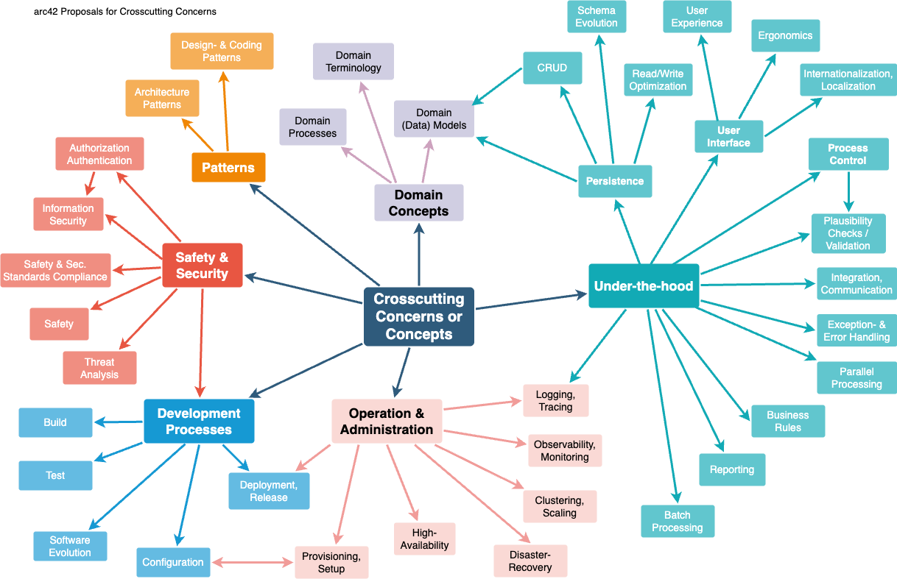
Motivation
Concepts form the basis for conceptual integrity (consistency, homogeneity) of the architecture. Thus, they are an important contribution to achieve inner qualities of your system.
This is the place in the template that we provided for a cohesive specification of such concepts.
Many of these concepts relate to or influence several of your building blocks.
Form
The form can be varied:
- concept papers with any kind of structure
- example implementations,especially for technical concepts
- cross-cutting model excerpts or scenarios using notations of the architecture views
Structure
Pick only the most-needed topics for your system and assign each a level-2 heading in this section (e.g. 8.1, 8.2 etc).
DO NOT ATTEMPT to cover all of the topics of the aforementioned diagram.
Further Information
Some topics within systems often concern multiple building blocks, hardware elements or development processes. It might be easier to communicate or document such cross-cutting topics at a central location, instead of repeating them in the description of the concerned building blocks, hardware elements or development processes.
Certain concepts might concern all elements of a system, others might only be relevant for a few. In the diagram above, logging concerns all three components, whereas security is relevant only for two components.
See Concepts in the arc42 documentation.

<Concept 1>
<explanation>

<Concept 2>
<explanation>
…​

<Concept n>
<explanation>

Architecture Decisions
Contents
Important, expensive, large scale or risky architecture decisions including rationales. With "decisions" we mean selecting one alternative based on given criteria.
Please use your judgement to decide whether an architectural decision should be documented here in this central section or whether you better document it locally (e.g. within the white box template of one building block).
Avoid redundancy. Refer to section 4, where you already captured the most important decisions of your architecture.
Motivation
Stakeholders of your system should be able to comprehend and retrace your decisions.
Form
Various options:
- ADR (Documenting Architecture Decisions) for every important decision
- List or table, ordered by importance and consequences or:
- more detailed in form of separate sections per decision
Further Information
See Architecture Decisions in the arc42 documentation. There you will find links and examples about ADR.

Quality Requirements
Content
This section contains all relevant quality requirements.
The most important of these requirements have already been described in section 1.2. (quality goals), therefore they should only be referenced here. In this section 10 you should also capture quality requirements with lesser importance, which will not create high risks when they are not fully achieved (but might be nice-to-have).
Motivation
Since quality requirements will have a lot of influence on architectural decisions you should know what qualities are really important for your stakeholders, in a specific and measurable way.
- See Quality Requirements in the arc42 documentation.
- See the extensive Q42 quality model on https://quality.arc42.org.

Quality Requirements Overview
Content
An overview or summary of quality requirements.
Motivation
Often we encounter dozens (or even hundreds) of detailed quality requirements. In this overview section you should try to summarize, e.g. by describing categories or topics (as suggested by ISO 25010:2023 or Q42)
If these summary descriptions are already precise, specific enough and measurable, you may skip section 10.2.
Form
Use a simple table in which each line contains a category or topic and a short description of the quality requirement. Alternatively, you may use a mindmap to structure these quality requirements. In literature, the idea of a quality attribute tree has also been described, which puts the generic term "quality" as the root and uses a tree-like refinement of the term "quality". [Bass+21] introduced the term "Quality Attribute Utility Tree" for this purpose.

Quality Scenarios
Content
Quality scenarios make quality requirements concrete and allow to decide whether they are fulfilled (in the sense of acceptance criteria). Ensure that your scenarios are specific and measurable.
Two kinds of scenarios are especially useful:
- Usage scenarios (also called application scenarios or use case scenarios) describe the system’s runtime reaction to a certain stimulus. This also includes scenarios that describe the system’s efficiency or performance. Example: The system reacts to a user’s request within one second.
- Change scenarios describe the desired effect of a modification or extension of the system or of its immediate environment. Example: Additional functionality is implemented or requirements for a quality attribute change, and the effort or duration of the change is measured.
Form
Typical information for detailed scenarios include the following:
In short form (favoured in the Q42 model):
- Context/Background: What kind of system or component, what is the envirionment or situation?
- Source/Stimulus: Who or what initiates or triggers a behaviour, reaction or action.
- Metric/Acceptance Criteria: A response including a measure or metric
The long form of scenarios (favoured by the SEI and [Bass+21]) is more detailed and includes the following information:
- Scenario ID: A unique identifier for the scenario.
- Scenario Name: A short, descriptive name for the scenario.
- Source: The entity (user, system, or event) that initiates the scenario.
- Stimulus: The triggering event or condition the system must address.
- Environment: The operational context or condition under which the system experiences the stimulus.
- Artifact: The building-blocks or other elements of the system affected by the stimulus.
- Response: The outcome or behavior the system exhibits in reaction to the stimulus.
- Response Measure: The criteria or metric by which the system’s response is evaluated.
Examples
See the Q42 quality model website for detailed examples of quality requirements.
- Len Bass, Paul Clements, Rick Kazman: "Software Architecture in Practice", 4th Edition, Addison-Wesley, 2021.

Risks and Technical Debts
Contents
A list of identified technical risks or technical debts, ordered by priority
Motivation
“Risk management is project management for grown-ups” (Tim Lister, Atlantic Systems Guild.)
This should be your motto for systematic detection and evaluation of risks and technical debts in the architecture, which will be needed by management stakeholders (e.g. project managers, product owners) as part of the overall risk analysis and measurement planning.
Form
List of risks and/or technical debts, probably including suggested measures to minimize, mitigate or avoid risks or reduce technical debts.
Further Information
See Risks and Technical Debt in the arc42 documentation.

Glossary
Contents
The most important domain and technical terms that your stakeholders use when discussing the system.
You can also see the glossary as source for translations if you work in multi-language teams.
Motivation
You should clearly define your terms, so that all stakeholders
- have an identical understanding of these terms
- do not use synonyms and homonyms
Form
A table with columns <Term> and <Definition>.
Potentially more columns in case you need translations.
Further Information
See Glossary in the arc42 documentation.
Term | Definition
<Term-1> | <definition-1>
<Term-2> | <definition-2>

