1. การทดสอบ การจับคู่ Network Traffic ICMP
ทำการทดสอบจากไฟล์ /test_pcap/ICMP Test 2.pcap ซึ่งมาจากการทดลอง ping จาก 192.168.182.146 -> 192.168.182.150 ในเครือข่ายจำลอง GNS3 และใช้ Wireshark จับ Traffic และนำมาสร้างตารางที่ 1.1 จากนั้นนำเข้าระบบที่ได้พัฒนาได้ผลลัพธ์ดังภาพ 0.1

ตารางที่ 1.1 การวัด ICMP Response Time ใน Wireshark
No. | Time (s) | Src | Dst | Type | Response To (No.) | Response Time (ms)
99 | 1.250717 | .146 | .150 | Echo (ping) request
100 | 1.25153 | .150 | .146 | Echo (ping) reply | 99 | 0.813
195 | 2.252316 | .146 | .150 | Echo (ping) request
196 | 2.253197 | .150 | .146 | Echo (ping) reply | 195 | 0.881
252 | 3.254226 | .146 | .150 | Echo (ping) request
253 | 3.255311 | .150 | .146 | Echo (ping) reply | 252 | 1.085
299 | 4.256227 | .146 | .150 | Echo (ping) request
300 | 4.256934 | .150 | .146 | Echo (ping) reply | 299 | 0.707
408 | 5.259391 | .146 | .150 | Echo (ping) request
409 | 5.260623 | .150 | .146 | Echo (ping) reply | 408 | 1.232
442 | 6.26265 | .146 | .150 | Echo (ping) request
443 | 6.264355 | .150 | .146 | Echo (ping) reply | 442 | 1.705
525 | 7.263072 | .146 | .150 | Echo (ping) request
526 | 7.264144 | .150 | .146 | Echo (ping) reply | 525 | 1.072
596 | 8.26532 | .146 | .150 | Echo (ping) request
597 | 8.266502 | .150 | .146 | Echo (ping) reply | 596 | 1.182
636 | 9.267621 | .146 | .150 | Echo (ping) request
637 | 9.269257 | .150 | .146 | Echo (ping) reply | 636 | 1.636
670 | 10.268336 | .146 | .150 | Echo (ping) request
671 | 10.269202 | .150 | .146 | Echo (ping) reply | 670 | 0.866
724 | 11.270287 | .146 | .150 | Echo (ping) request
725 | 11.270903 | .150 | .146 | Echo (ping) reply | 724 | 0.616
771 | 12.274119 | .146 | .150 | Echo (ping) request
772 | 12.275976 | .150 | .146 | Echo (ping) reply | 771 | 1.857
805 | 13.276676 | .146 | .150 | Echo (ping) request
806 | 13.278633 | .150 | .146 | Echo (ping) reply | 805 | 1.957
836 | 14.276492 | .146 | .150 | Echo (ping) request
837 | 14.277273 | .150 | .146 | Echo (ping) reply | 836 | 0.781
870 | 15.279791 | .146 | .150 | Echo (ping) request
871 | 15.28174 | .150 | .146 | Echo (ping) reply | 870 | 1.949
901 | 16.283351 | .146 | .150 | Echo (ping) request
902 | 16.285391 | .150 | .146 | Echo (ping) reply | 901 | 2.04
935 | 17.285716 | .146 | .150 | Echo (ping) request
936 | 17.288078 | .150 | .146 | Echo (ping) reply | 935 | 2.362
977 | 18.285914 | .146 | .150 | Echo (ping) request
978 | 18.287095 | .150 | .146 | Echo (ping) reply | 977 | 1.181
1015 | 19.288886 | .146 | .150 | Echo (ping) request
1016 | 19.290612 | .150 | .146 | Echo (ping) reply | 1015 | 1.726
1049 | 20.29336 | .146 | .150 | Echo (ping) request
1050 | 20.294945 | .150 | .146 | Echo (ping) reply | 1049 | 1.585
1081 | 21.293669 | .146 | .150 | Echo (ping) request
1082 | 21.295304 | .150 | .146 | Echo (ping) reply | 1081 | 1.635
1172 | 22.294379 | .146 | .150 | Echo (ping) request
1173 | 22.295232 | .150 | .146 | Echo (ping) reply | 1172 | 0.853
1283 | 23.298133 | .146 | .150 | Echo (ping) request
1284 | 23.299957 | .150 | .146 | Echo (ping) reply | 1283 | 1.824

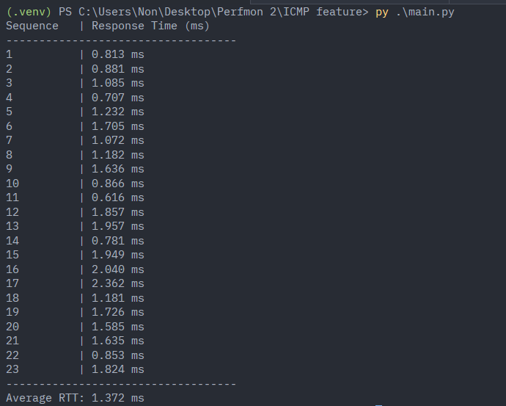
0.1 การทดสอบวัดครั้งที่ 1 ICMP Response Time ของระบบ

