Field notes
The survey covered three regions over six weeks. Details are on the project page.
The totals below are provisional.

Steps
- Plan the route
- Visit each site
  - Morning count
  - Evening count
- Write the report
- Bring water
- Charge the camera

Results
Counts by region
Region | Morning | Evening
North | 42 | 37
North | 40 | 35
South | 28 | 31
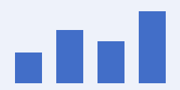
현장 기록: 북부 지역의 아침 집계가 가장 많았다.
The last page closes the notes.

Counted from the first visit.

