Evaluating the Predictive Reliability, Probability Calibration, and Explainability of Machine Learning Frameworks in Soccer Match Forecasting

Alunge Hlubi

Abstract. Reliable soccer forecasting requires more than selecting the most likely outcome. This study develops a reproducible notebook framework for chronological data preparation, probabilistic modelling, recalibration, explanation and prediction selection. XGBoost and a Dixon–Coles score model are compared with historical-frequency and available margin-adjusted closing-odds benchmarks. The original Premier League pilot examined 1X2, over/under 2.5 goals and both teams to score; subsequent experiments examined over/under 1.5 goals, league-specific selection and lagged expected goals (xG). The revised league evaluation included 746 eligible fixtures across the Premier League and LaLiga. League-specific selection achieved a 79.14% hit rate at 50.13% coverage, but matched its frequency baseline and did not demonstrate superiority over the common policy. In a paired Premier League ablation, adding lagged xG reduced 1X2 log loss by 0.0416 in 2024/25 and 0.0468 in 2025/26. Descriptive block-bootstrap intervals remained positive across the tested block lengths; BTTS and goal-total changes were inconclusive. TreeSHAP rankings were stable across seasons, although forecast quality changed and residual miscalibration remained. These findings support market-specific evaluation rather than a universal accuracy target. The revised Premier League analysis is retrospective, independent validation of aggregated team xG remains pending, and the user-facing prototype is future work.

Keywords: Soccer forecasting; probability calibration; XGBoost; Dixon–Coles; expected goals; TreeSHAP.

1 Introduction and Background
1.1 Motivation and forecasting context
Soccer forecasting is difficult because the observable result compresses a complex match into a small number of goals and three possible outcomes. A model can identify the more likely winner without assigning a reliable probability to that outcome. Conversely, a forecast can be sensible even when its most likely outcome does not occur. The practical objective is therefore to estimate uncertainty before kickoff, evaluate those probabilities on later fixtures and explain how the model uses the available history. Recent soccer prediction research illustrates the importance of the relationship between feature construction and evaluation design. Berrar et al. (2024) develop a framework for modelling the interdependent histories of competing teams, while Yeung et al. (2024) examine deep learning and feature optimisation for gradient-boosted trees within the Soccer Prediction Challenge. These studies motivate the present use of explicit chronological features and probabilistic evaluation rather than reliance on one headline accuracy figure.

This project began with the practical goal of building an end-to-end system that learns from previous matches and identifies supported predictions across several markets. An initial aspiration of exceeding 60% correct selections was treated as a validation target, not an assumed result. Changing the market can change the prevalence of its most common outcome substantially. A high hit rate on over 1.5 goals, for example, must be compared with a baseline that predicts that same market on the same fixtures. The completed implementation is a research pipeline rather than a deployed forecasting service. It prepares historical fixtures, trains statistical and machine-learning models, evaluates raw and recalibrated probabilities, examines feature attributions and applies validation-defined selection rules. Its contribution is an integrated empirical assessment of these components, including outcomes that do not support the initial expectations.
1.2 Research problem and questions
The research problem is that apparent forecasting success can arise from common outcomes, selective coverage, overconfident probabilities or decisions made after viewing evaluation results. These mechanisms cannot be separated by accuracy alone. An adequate framework must preserve information availability, compare probability forecasts against relevant references, measure uncertainty and distinguish explanations of the model from explanations of the sport. The primary research question is: How reliably can an end-to-end machine-learning framework trained on historical soccer matches generate calibrated and explainable pre-match forecasts across supported markets? Five secondary questions guide the experiments. First, how do XGBoost and Dixon–Coles compare in probability quality and calibration? Second, how do post-hoc calibration and lagged xG affect later-fixture performance? Third, how do model probabilities compare with historical frequencies and margin-adjusted bookmaker probabilities on common fixtures? Fourth, which features influence XGBoost predictions, and how stable are their aggregate contributions across seasons and outcomes? Fifth, can a validation-defined selection policy improve held-out hit rate, and at what fixture coverage?
1.3 Aim and objectives
The aim is to design, implement and evaluate a soccer forecasting system that transforms historical match data into reliable, calibrated and explainable pre-match probability forecasts. The implemented objectives are to construct a chronological data pipeline; fit and compare the two forecasting approaches; evaluate probability quality and recalibration; generate local and aggregate TreeSHAP explanations; and assess selection rules with coverage and uncertainty. Integrating these outputs into a user-facing prototype remains the final development objective. The original market scope comprised 1X2, over/under 2.5 goals and both teams to score (BTTS). The later league-selection and xG experiments replace the 2.5-goal threshold with 1.5 goals. Both stages are retained in this report because they answer different empirical questions. Results from different market lines, fixture sets or calibration stages are not treated as interchangeable.

2 Literature Review and Related Work
2.1 Statistical structure and machine-learning flexibility
Score models provide a compact connection between team strength and several outcome markets. The Dixon–Coles approach extends a Poisson formulation with a correction for low-scoring results, providing a principled statistical benchmark (Dixon & Coles, 1997). Gradient boosting instead learns nonlinear relationships in engineered inputs and can fit separate classifiers for each market (Chen & Guestrin, 2016). These approaches differ in both representation and assumptions; a comparison should therefore consider the information supplied to each model as well as its algorithmic family. Recent challenge-based studies reinforce the importance of the data representation. Berrar et al. (2024) emphasise team histories and domain knowledge, whereas Yeung et al. (2024) examine ratings, gradient-boosted trees and deep learning. Their approaches show why a flexible algorithm alone is not a sufficient explanation for forecasting performance. The gap addressed here is a controlled comparison of a score-distribution model and a compact form-based classifier across several markets, with a shared evaluation pool and explicit reporting of model-specific information.
2.2 Calibration and the meaning of predictive reliability
Calibration concerns agreement between stated probabilities and observed frequencies. It differs from discrimination and from the accuracy of the single most probable class. The survey by Silva Filho et al. (2023) distinguishes calibration concepts, diagnostic measures and post-hoc procedures, supporting the use of both scoring rules and reliability diagrams. An aggregate probability score can improve while a particular outcome, such as a draw, remains poorly calibrated. The distinction also matters in decision applications. Walsh and Joshi (2024) compare accuracy-based and calibration-based model selection in an NBA betting experiment. Their findings motivate evaluation of probability quality, but neither the sport nor the reported returns can be transferred directly to soccer. The relevant gap is whether a calibration method fitted on an earlier period retains value on later soccer fixtures and across different markets. This study therefore evaluates raw and temperature-scaled forecasts separately and retains cases where recalibration worsens performance.
2.3 Expected goals and historical performance information
Expected goals measures the quality of scoring opportunities through estimated shot-conversion probabilities. It can represent information that realised goals alone omit, but its values depend on the underlying provider and model definition. Hewitt and Karakuş (2023) develop player- and position-adjusted xG models, illustrating that feature and population choices affect the resulting metric. An xG number should therefore be treated as a model-derived measurement rather than an interchangeable physical quantity. Importantly, explaining or predicting a shot is different from forecasting a future match. A useful historical input must be shifted so that the target match cannot contribute its own opportunities. The gap addressed here is the incremental value of lagged xG beyond the same recent-form inputs on identical training and evaluation fixtures. A paired ablation isolates that feature addition more clearly than a comparison between unrelated datasets. External verification of the aggregated team totals is also necessary to distinguish extraction correctness from predictive usefulness.
2.4 Bookmaker benchmarks and prediction selection
Bookmaker probabilities provide a demanding reference, but forecasting and decision performance are separate questions. Hubáček et al. (2019) explicitly consider the relationship between model forecasts and bookmaker forecasts in a system designed around betting decisions. This makes clear why high classification accuracy alone is insufficient evidence of a profitable advantage. The probability of the selected outcome, the price offered and the chosen decision rule all matter. For this project, the immediate task is a probability and hit-rate comparison rather than a profitability claim. Closing odds are evaluated only where the matching market and fixture records exist. The research gap addressed is whether league-specific market qualification adds value beyond a common-market policy after controlling the forecasting setup and reporting abstention. Comparing raw hit rates across markets without a frequency reference would favour prevalent outcomes and obscure whether the model contributes useful information.
2.5 Explainability and stability across evaluation periods
Tree-based explanations can decompose individual model outputs and then be aggregated to describe broader behaviour. Lundberg et al. (2020) provide the methodological basis for efficient local explanations of tree ensembles and their aggregation. Cavus et al. (2026) extend the football discussion to grouped explanations of xG models, including team- and player-level analyses. Together, these studies support inspecting explanations at more than one level, while keeping the explained target explicit. A stable feature ranking does not establish that a prediction is correct, that its probability is calibrated or that the attributed feature has a causal effect. Moreover, explanations of shot-level xG models are not automatically explanations of pre-match outcome models. The gap addressed here is the joint assessment of attribution additivity, seasonal ranking stability and forecasting performance for the same XGBoost models. SHAP is used as the implemented explanation method; LIME is not included as an additional experiment.
2.6 Synthesis of the research gaps
The literature supports statistical score models, machine learning, calibration, xG and feature attribution as useful components of soccer analytics. Their integration creates several measurable questions rather than one universal success criterion. A model may improve log loss without improving its selected labels; xG may help one market while adding little to another; stable attributions may coexist with deteriorating forecasts; and selective coverage may increase hit rate without beating a matched baseline. The present study addresses these relationships within one chronological workflow. It does not claim novelty for the individual algorithms or establish that this combination is absent from all prior research.

3 Methods and Techniques
3.1 Experimental stages and information boundaries
The research comprises three connected stages. The first is a Premier League pilot using 2023/24 training data and 2024/25 evaluation data, initially covering 1X2, O/U 2.5 and BTTS. A later calibration analysis divides the 371 eligible 2024/25 fixtures into 220 calibration fixtures and 151 evaluation fixtures, with evaluation beginning on 1 February 2025. The second stage studies league-specific market selection in the Premier League and LaLiga with O/U 1.5. The third stage uses matched Premier League data to examine lagged xG and TreeSHAP stability over two evaluation seasons. These stages are not independent confirmatory replications. Earlier Premier League 2025/26 results informed the change from the 2.5-goal to the 1.5-goal market. The revised Premier League and pooled evaluations are therefore retrospective even though their code uses chronological fitting and selection windows. LaLiga should be described as untouched only if its outcomes did not influence any design choices; that independent provenance is not established by the saved outputs alone. The report is based on inspected source cells and saved outputs in the executed research-check and league-export notebooks, supplemented by the earlier results recorded during the project. No model training was rerun to prepare this report. Computational success is distinguished from external data validation and prospective confirmation.
3.2 Data preparation and supported markets
Season CSVs contain fixture dates, kickoff times, home and away teams, full-time goals and available closing-odds columns. A fixture identifier combines season, home team and away team; league is retained when combining competitions. The loader checks duplicate identifiers, nonnegative integer scores, distinct team names and consistency between the recorded result and the score-derived result. Date and time parsing is explicit, and downstream joins use uniqueness checks. Full-time goals support three markets. The 1X2 labels are H, D and A for home win, draw and away win. Over 1.5 is one when the two teams score at least two goals; the original over 2.5 label requires at least three. BTTS is one when each team scores at least once. Cards, corners and player markets are outside the evaluated scope. Availability of their names at a bookmaker is insufficient without matching outcome data and historical predictors. The Premier League xG join contains 1,140 fixtures across three 380-match seasons. Requiring three prior recorded matches for both teams leaves 349 training fixtures in 2023/24, 371 evaluation fixtures in 2024/25 and 374 in 2025/26. The league-selection evaluation contains 374 eligible Premier League fixtures and 372 LaLiga fixtures, from 380 supplied fixtures per league. Coverage denominators refer to eligible fixtures unless otherwise stated.
3.3 Lagged form and expected-goals features
For each team, form consists of sums over its previous three recorded league matches: points earned, goals scored and goals conceded. Applying these quantities to the home and away teams yields six features. Points are coded as three for a win, one for a draw and zero for a defeat. Home and away historical matches both contribute, and recorded history carries across seasons. A returning team can therefore have old history; this implementation does not guarantee a fixed recency interval in calendar time. Only matches on earlier calendar dates contribute to a target fixture. This deliberately excludes same-day results because the source records do not provide final-whistle and publication timestamps. The code keeps incomplete-history rows with readiness flags and excludes them from model-ready comparisons. Manual checks on known fixtures and result-perturbation checks verify that a target result cannot alter its own inputs, while later fixtures can respond to the changed history.

The xG input was assembled from the available player-match records by aggregating player expected goals to team totals and mapping home and away sides to the score fixtures. The preparation workflow removed exact duplicates and excluded non-player assistant-manager records. The subsequent research notebook verifies unique fixture identities, agreement with full-time scores and finite nonnegative xG values. This provides internal consistency evidence; it does not independently certify the provider’s totals. Four additional features sum xG for and against each team's previous three matches. The target fixture's xG is never used in its own predictors. Missing xG in the required history prevents entry into the matched sample rather than being silently converted to zero. In this run, all form-ready fixtures also have complete lagged xG, so full-form and matched-form samples coincide. Publication and revision timestamps for xG are unavailable, leaving a residual historical-availability limitation.
3.4 Forecasting models and references
The historical-frequency reference estimates class proportions from the relevant training sample and repeats that vector for later fixtures. Its most frequent class supplies the matched selection baseline. It is simple, but it captures the market prevalence that a useful model must improve upon. The Dixon–Cole’s implementation models home and away goal rates through an intercept, team attack and defence effects, and home advantage. Team effects are centred for identifiability, with constrained optimisation using L-BFGS-B. A dependence parameter adjusts the 0–0, 0–1, 1–0 and 1–1 score probabilities. The implementation is a static low-score-corrected Poisson model; no exponential time-decay weighting is applied. Unseen teams receive neutral effects. These choices are important limitations relative to more elaborate dynamic score models.

The joint score grid is expanded sufficiently far into the Poisson tail, checked for probability mass and normalised. Market probabilities are obtained by summing the score cells satisfying each event. This gives a common score distribution for 1X2, totals and BTTS before any market-specific calibration. Dixon–Coles uses all earlier valid score fixtures, whereas XGBoost requires complete form; thus, this is a comparison of practical forecasting pipelines, not an identical-input algorithm contest. Each XGBoost market classifier uses 100 estimators, maximum depth two, learning rate 0.05, random seed 42 and one worker. The implementation uses multiclass or binary log-loss evaluation as appropriate. These fixed compact settings were not selected through a comprehensive hyperparameter search. The six-feature form model is compared with a ten-feature form-plus-xG model using the same settings and matched rows. The xG experiment fits on 2023/24 once and evaluates the same fitted models in both later seasons.
3.5 Calibration and probability evaluation
Temperature scaling transforms a probability vector p using qₖ = pₖ^(1/T) / Σⱼpⱼ^(1/T), after numerical clipping. A single positive temperature is fitted per model and market by minimising calibration-period log loss, with T constrained to [0.25, 4]. A temperature above one softens confidence, while one below one sharpens it. The operation preserves the within-fixture ordering of classes and therefore does not ordinarily change top-class accuracy. It can nevertheless alter which market provides the highest confidence in a selection policy. For n fixtures and K outcomes, log loss is −(1/n)Σᵢ log pᵢ,yᵢ. Brier score is (1/n)ΣᵢΣₖ(pᵢₖ − yᵢₖ)², where y is one-hot encoded. Lower values are better. The reported binary Brier values use the sum over both outcomes and are therefore twice the common single-event binary Brier convention. Raw losses are compared within the same market and fixture sample, not used directly to rank markets with different outcome spaces.

Reliability diagrams use fixed probability intervals of width 0.1, separately for each outcome. Mean probability is plotted against observed event frequency, with corresponding bin counts. Empty bins provide no evidence, and sparsely occupied bins can yield unstable event rates. Proper scores evaluate overall probability quality; they are not pure measurements of calibration. The later xG checks evaluate raw probabilities and do not fit an additional xG-specific calibrator. For decimal bookmaker odds oₖ, the reference probability is qₖ = (1/oₖ)/Σⱼ(1/oⱼ). This proportional adjustment removes the summed overround but is not the only possible margin-removal model. Closing odds remain separate from training features. They may contain information unavailable at the earlier feature cutoff, so they are an informative external benchmark rather than a perfectly time-aligned information set. Market-average closing odds also do not necessarily represent one executable betting offer.
3.6 Chronological league selection
The league experiment separates model fitting, calibration, two ranking windows, threshold selection and evaluation. Table 1 documents the implemented boundaries. Intervals include their start and exclude their end. Fixtures between the threshold block and the evaluation start are not used to retune the frozen rules, although completed earlier matches can contribute to later lagged form.

Table 1. Chronological blocks and eligible fixture counts in the league experiment
Block | Date interval | Premier League | LaLiga
Model fit | Before 1 Aug 2024 | 349 | 350
Calibration | 1 Aug–1 Dec 2024 | 117 | 135
Ranking 1 | 1 Dec 2024–15 Jan 2025 | 77 | 48
Ranking 2 | 15 Jan–15 Feb 2025 | 38 | 41
Threshold | 15 Feb–1 Apr 2025 | 48 | 58
Evaluation | 1 Aug 2025–1 Jun 2026 | 374 | 372
Within each league and market, skill is defined as 1 − Lmodel/Lfrequency. The raw or scaled model variant with the highest mean skill across the two ranking windows is chosen. A league-specific market qualifies only if that variant has positive skill in both windows. A common market qualifies if its equal-league average skill is positive in both windows, retaining the same chosen forecasts within each league. All windows must contain at least 25 eligible fixtures. Selecting variants and assessing their qualification on the same ranking windows introduces selection uncertainty that is not removed by this minimum-support rule.

Each policy takes at most one pick per fixture: the highest eligible outcome probability, with alphabetical market order resolving ties. A grid from 0.50 to 0.90 in steps of 0.025 is searched on pooled threshold-validation fixtures. A supported threshold requires at least 15 picks and 20% coverage. Among thresholds reaching 60% hit rate, the rule prioritises coverage; otherwise it uses the best supported hit rate or abstains when none is supported. A shared 0.625 cutoff provides a sensitivity comparison. This is confidence-based selection, not expected-return optimization. Hit rate, correct count, selection count and eligible-fixture coverage are reported together. The frequency baseline is evaluated on the same selected fixtures and markets, while retaining its own preferred outcome. A retrospective top-k comparison equalises selection counts within league as a descriptive diagnostic. It is not a deployable threshold policy because the count-matching operation uses the evaluation pool.
3.7 TreeSHAP explanations and uncertainty analysis
Native XGBoost contribution predictions provide TreeSHAP attributions for raw model margins. For each fixture and output, the feature contributions plus the bias term must reproduce that raw margin. The pilot records maximum additivity errors below 10⁻⁶; the later ablation uses explicit numerical assertions with absolute tolerance 2 × 10⁻⁵ and relative tolerance 10⁻⁵. These checks verify the decomposition in the stated output space, not the truth of the model's prediction. Global importance is the mean absolute contribution for each feature, market, outcome and season. Spearman correlation compares complete importance rankings across the two seasons, and top-three overlap measures agreement among leading features. Local pilot cases include high draw probabilities and confident errors. Binary explanations refer to the positive outcome, and multiclass explanations are output-specific. Raw-margin contributions must not be read as additive probability-point contributions to a temperature-scaled forecast.

Uncertainty is assessed by 5,000 paired bootstrap draws with seed 42. Non-overlapping calendar blocks of two, four or six weeks are formed from the earliest date in each analysis, and whole blocks are sampled with replacement. Fixture-level loss differences and counts are aggregated within blocks; their resampled ratios yield percentile 95% intervals. The xG analyses have 21, 11 and 7 blocks respectively. Policy differences use the common calendar-block sampling structure, preserving within-block relationships between policies. These intervals are descriptive and conditional on the fitted models, chosen features and policies. They do not include model-refitting uncertainty, compensate for previous experiment selection or establish prospective validity. The six-week analysis has few blocks, so robustness across all three lengths is more informative than treating one interval as definitive. No multiplicity-adjusted confirmatory hypothesis test is claimed.

4 Results and Discussions
4.1 Initial model comparison
The original 371-fixture Premier League pilot showed that the best top-class accuracy did not necessarily identify the best probability model. For 1X2, XGBoost accuracy was 44.74%, slightly above Dixon–Coles at 43.94%, but its log loss and Brier score were worse. Table 2 retains this original market definition and evaluation sample.
Table 2. Original pilot probability scores on 371 fixtures per available model and market
Market | Model | Log loss | Brier | Accuracy %
1X2 | Frequency | 1.0852 | 0.6587 | 40.70
1X2 | Dixon–Coles | 1.0488 | 0.6327 | 43.94
1X2 | XGBoost | 1.0980 | 0.6624 | 44.74
1X2 | Closing market | 0.9721 | 0.5789 | 55.26
O/U 2.5 | Frequency | 0.6969 | 0.5030 | 56.87
O/U 2.5 | Dixon–Coles | 0.6798 | 0.4863 | 57.95
O/U 2.5 | XGBoost | 0.7065 | 0.5108 | 56.33
O/U 2.5 | Closing market | 0.6753 | 0.4825 | 57.41
BTTS | Frequency | 0.6871 | 0.4938 | 57.14
BTTS | Dixon–Coles | 0.6903 | 0.4963 | 56.06
BTTS | XGBoost | 0.7112 | 0.5156 | 54.99
The closing-market reference had the strongest 1X2 probability scores. Dixon–Coles improved on the frequency reference for 1X2 and O/U 2.5, while the BTTS frequency reference outperformed both fitted models. The result is evidence against assuming that machine learning must dominate a simple statistical or prevalence-based alternative. It also reflects the limited training history and compact XGBoost feature set; it is not a general ranking of the two model families.
4.2 Temperature scaling and reliability
On the later 151-fixture pilot subset, temperature scaling reduced XGBoost log loss in all three original markets. The estimated temperatures were 1.9287 for 1X2, 1.8449 for O/U 2.5 and 2.2569 for BTTS, indicating that a softer probability distribution improved evaluation scores in this run. Table 3 reports the paired raw-to-scaled changes.
Table 3. Calibration comparison on 151 later pilot fixtures
Market | Model | T | Log loss raw → scaled | Brier raw → scaled
1X2 | Dixon–Coles | 1.4984 | 1.0385 → 1.0319 | 0.6246 → 0.6205
1X2 | XGBoost | 1.9287 | 1.1071 → 1.0716 | 0.6658 → 0.6463
O/U 2.5 | Dixon–Coles | 1.0403 | 0.7171 → 0.7146 | 0.5213 → 0.5192
O/U 2.5 | XGBoost | 1.8449 | 0.7353 → 0.7012 | 0.5389 → 0.5078
BTTS | Dixon–Coles | 0.9309 | 0.7369 → 0.7426 | 0.5408 → 0.5457
BTTS | XGBoost | 2.2569 | 0.7312 → 0.6989 | 0.5354 → 0.5057
Calibration was not uniformly beneficial: sharpening the Dixon–Coles BTTS probabilities worsened both scores. Accuracy stayed unchanged within each model-market pair, as expected from temperature scaling. The closing-market 1X2 log loss of 0.9512 remained better than either calibrated model. For O/U 2.5, scaled XGBoost log loss of 0.7012 was only slightly below the closing reference of 0.7023; this small difference on 151 fixtures is not evidence of a general market advantage. The later xG reliability figures address a separate question because they show raw ablation forecasts. Figure 1 illustrates class-specific behaviour in 2025/26. Several home-win bins improve visually after adding xG, but the curves do not consistently follow the diagonal. Extreme bins contain few fixtures, limiting interpretation. Consequently, the study supports improvements in selected probability scores without claiming complete calibration across outcomes or seasons.
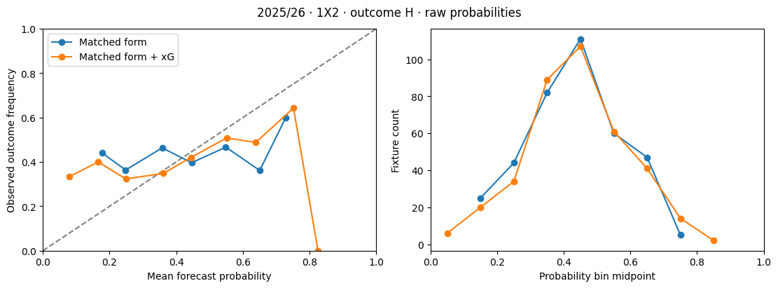
Fig. 1. Raw home-win reliability in 2025/26 for matched form and matched form plus xG. The right panel shows bin support. Saved notebook output; no new calibration was fitted.
4.3 League qualification and selected markets
The revised ranking stage selected Dixon–Coles for all three Premier League markets, with scaling for 1X2 and O/U 1.5 and raw probabilities for BTTS. Each had positive skill in both windows. LaLiga selected scaled XGBoost for 1X2, raw Dixon–Coles for O/U 1.5 and scaled Dixon–Coles for BTTS, but each failed one of the two positive-skill requirements. Table 4 shows the qualification evidence.
Table 4. Chosen variants and validation skill by league
League and market | Model variant | Window 1 | Window 2 | Local eligible
EPL 1X2 | DC scaled | 0.0335 | 0.0418 | Yes
EPL O/U 1.5 | DC scaled | 0.0465 | 0.0841 | Yes
EPL BTTS | DC raw | 0.0084 | 0.0379 | Yes
LaLiga 1X2 | XGB scaled | 0.0121 | −0.0010 | No
LaLiga O/U 1.5 | DC raw | −0.0189 | 0.0872 | No
LaLiga BTTS | DC scaled | −0.0042 | 0.0138 | No
All three markets qualified for the common policy after equal-league averaging. The league-specific policy therefore abstained on every LaLiga fixture. This is a valid outcome of the specified rule and should not be interpreted as a software failure. It shows that the criterion demanded repeated improvement and did not find it in the small LaLiga ranking windows. Conversely, it does not establish that every LaLiga market is intrinsically unpredictable.
4.4 Selection performance and coverage
The earlier selection pilot, before the market revision, chose a 0.625 threshold using 60 validation fixtures. It selected 19 of 91 later pilot fixtures, with 12 correct (63.16%) and the same matched-baseline hit rate; its reported hit-rate interval was 41.04–80.85%. The subsequent original-market season evaluation selected 98 of 374 eligible fixtures, with 56 correct (57.14%) versus 54 correct for the matched baseline (55.10%). The descriptive block-bootstrap hit-rate interval was 45.94–65.32%, and the paired advantage interval was 0–5.75 percentage points. Only two discordant pairs favoured the model and none favoured the baseline. By market, 1X2 achieved 24/30, BTTS 5/7 and O/U 2.5 27/61. These exploratory results motivated the later market-selection experiment and are not independent confirmation of it. Both policies selected a threshold of 0.50 on validation data. In the 746-fixture evaluation pool, the league-specific policy selected 374 fixtures and achieved 296 correct predictions. All its selections were Premier League O/U 1.5. The common policy made 746 picks with 581 correct. Table 5 summarises the pooled operating points.
Table 5. Revised 2025/26 pooled policy performance
Policy and mode | Picks | Correct | Coverage % | Hit rate % | Baseline %
League specific, selected | 374 | 296 | 50.13 | 79.14 | 79.14
Common, selected | 746 | 581 | 100.00 | 77.88 | 78.02
League specific, 0.625 | 374 | 296 | 50.13 | 79.14 | 79.14
Common, 0.625 | 675 | 532 | 90.48 | 78.81 | 78.81
The higher league-specific hit rate did not beat its matched frequency reference. Its pooled advantage over the common policy was 1.26 percentage points, with a four-week block-bootstrap interval from −1.26 to +4.26 points. Under the shared threshold, the advantage was 0.33 points, with interval −1.95 to +2.97 points. All tested block lengths included zero. These comparisons do not establish superiority of league-specific selection, particularly because the coverage and league composition differ. Within the Premier League, both policies made identical selections and had identical results. In LaLiga, the common validation-selected policy achieved 285/372 correct (76.61%), compared with 76.88% for its matched frequency baseline. Its picks comprised 359 O/U 1.5 selections with 280 correct and 13 BTTS selections with five correct. The retrospective matched-count check returned identical Premier League results and zero selections for both LaLiga policies, leaving no informative LaLiga hit-rate comparison at that coverage. The experiment therefore achieved the numerical 60% aspiration by selecting a prevalent market, but it did not establish incremental selection skill. Qualification by probability-score improvement and selection by maximum confidence serve different objectives. A market can improve its probability estimates relative to a frequency model while retaining the same most likely outcome on every fixture. This explains how positive validation skill can coexist with an identical baseline hit rate.
4.5 Comparison with closing bookmaker probabilities
The revised evaluation contains matched closing odds for 1X2. Table 6 compares each league's selected forecast, training-frequency reference and proportionally adjusted market-average closing probabilities on the same fixtures. These results concern the chosen form-based league models, not the later raw xG ablation.
Table 6. Matched 1X2 probability benchmarks in 2025/26
League | Forecast | Fixtures | Log loss | Brier
Premier League | Chosen model | 374 | 1.0280 | 0.6169
Premier League | Frequency | 374 | 1.0905 | 0.6603
Premier League | Closing market | 374 | 1.0123 | 0.6081
LaLiga | Chosen model | 372 | 1.0568 | 0.6368
LaLiga | Frequency | 372 | 1.0512 | 0.6331
LaLiga | Closing market | 372 | 0.9673 | 0.5730
The Premier League model improves on frequency but remains behind the closing-market reference. In LaLiga, the chosen model is slightly worse than frequency and clearly worse in average scores than the closing reference. These descriptive results provide no evidence of outperforming bookmakers. O/U 1.5 and BTTS bookmaker comparisons remain unavailable; O/U 2.5 odds cannot substitute for the revised total-goals market. No staking returns, transaction costs, closing-line value or profitability experiments were completed.
4.6 Paired lagged-xG ablation
The ablation uses identical training and evaluation rows for form-only and form-plus-xG models. Because xG coverage was complete for the form-ready sample, the matched-form results equal the full-form results. Table 7 reports all six season-market comparisons using raw probabilities.
Table 7. Matched xG ablation scores
Season and market | n | Log loss form | Log loss +xG | Brier form | Brier +xG
2024/25 1X2 | 371 | 1.0980 | 1.0564 | 0.6624 | 0.6376
2024/25 BTTS | 371 | 0.7112 | 0.7070 | 0.5156 | 0.5116
2024/25 O/U 1.5 | 371 | 0.5126 | 0.5208 | 0.3167 | 0.3203
2025/26 1X2 | 374 | 1.1352 | 1.0884 | 0.6924 | 0.6613
2025/26 BTTS | 374 | 0.7054 | 0.6997 | 0.5107 | 0.5052
2025/26 O/U 1.5 | 374 | 0.5644 | 0.5651 | 0.3546 | 0.3547
The clearest benefit is in 1X2. Adding xG reduces log loss by 0.0416 and 0.0468 in the two seasons, with corresponding Brier improvements of 0.0248 and 0.0311. The four-week intervals in Table 8 remain above zero for both metrics, and this conclusion is unchanged for the two- and six-week blocks. This is consistent evidence of incremental probability information within the evaluated configuration, subject to the retrospective design and pending external xG check.
Table 8. Paired improvements and descriptive 95% intervals with four-week blocks
Season and market | Log-loss improvement [interval] | Brier improvement [interval]
2024/25 1X2 | 0.0416 [0.0111, 0.0773] | 0.0248 [0.0053, 0.0485]
2024/25 BTTS | 0.0043 [−0.0147, 0.0221] | 0.0039 [−0.0130, 0.0201]
2024/25 O/U 1.5 | −0.0082 [−0.0230, 0.0064] | −0.0035 [−0.0103, 0.0029]
2025/26 1X2 | 0.0468 [0.0161, 0.0786] | 0.0311 [0.0099, 0.0535]
2025/26 BTTS | 0.0056 [−0.0089, 0.0252] | 0.0055 [−0.0081, 0.0238]
2025/26 O/U 1.5 | −0.0007 [−0.0149, 0.0131] | −0.0001 [−0.0067, 0.0061]
BTTS improves slightly in both seasons, but every tested interval includes zero. O/U 1.5 worsens slightly, particularly in 2024/25, but its intervals also include zero. It would therefore be inappropriate to claim either a reliable BTTS benefit or a reliable goal-total deterioration. The defensible conclusion is that xG adds useful 1X2 information in these experiments, while its incremental value for the other markets remains unresolved. The xG arm does not eliminate season-to-season deterioration. Its 1X2 log loss rises from 1.0564 to 1.0884, while the form-only model rises from 1.0980 to 1.1352. Both O/U 1.5 arms also deteriorate. This highlights the distinction between improvement relative to another model and stability of absolute performance over time. A fixed model can benefit from an extra predictor yet still require later retraining or recalibration.
4.7 Explanation fidelity and seasonal stability
The original pilot's leading attributions were outcome-dependent. Home points over the last three games had the largest reported mean absolute contribution for away-win forecasts (0.3119), away goals scored led the draw output (0.1246), and away goals conceded led the home-win output (0.1915). Home goals conceded was prominent for the positive BTTS and original O/U 2.5 outputs. These magnitudes are in raw-margin units and indicate reliance, not a universal direction of effect or a causal explanation. Cross-season rankings were highly consistent. For the form-only model, correlations were 1.0000 for away wins and draws and 0.9429 for home wins, BTTS and O/U 1.5. With xG, they ranged from 0.9758 to 1.0000. Every comparison retained the same three leading features. Table 9 summarises the results, and Figures 2 and 3 show representative saved attributions for the xG model.
Table 9. Spearman correlation of mean absolute TreeSHAP rankings across seasons
Market and outcome | Form only | Form plus xG | Top-three overlap
1X2 away win | 1.0000 | 1.0000 | 3 of 3 in both arms
1X2 draw | 1.0000 | 0.9879 | 3 of 3 in both arms
1X2 home win | 0.9429 | 1.0000 | 3 of 3 in both arms
BTTS yes | 0.9429 | 0.9758 | 3 of 3 in both arms
O/U 1.5 over | 0.9429 | 1.0000 | 3 of 3 in both arms
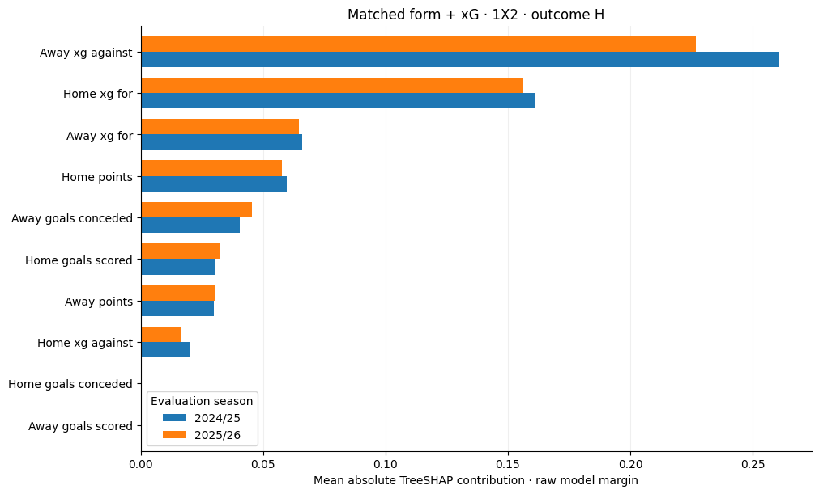
Fig. 2. Home-win feature contributions for the matched form-plus-xG model in 2024/25 and 2025/26. Bars show mean absolute TreeSHAP values in raw-margin units.
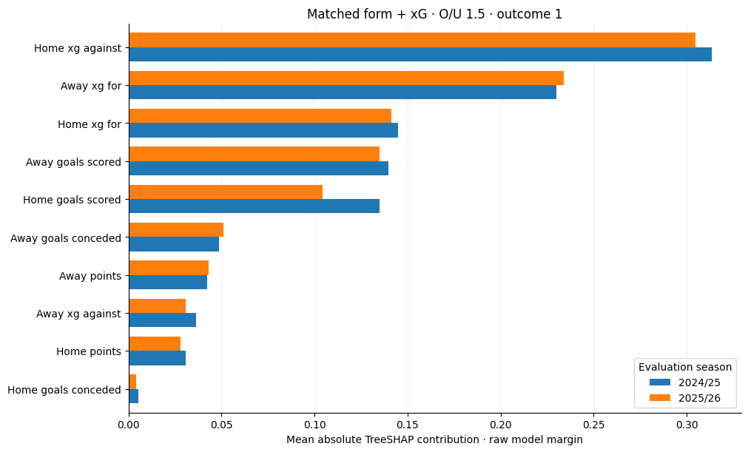
Fig. 3. Over 1.5 feature contributions for the matched form-plus-xG model. Stable aggregate reliance is not evidence that adding xG improved this market's probability scores.
In the xG-enhanced home-win model, away xG against and home xG for are the leading contributions in both seasons. For over 1.5, home xG against is the leading feature. The latter is a useful counterexample: an added feature can dominate model explanations without improving held-out probability scores. Attribution importance and incremental predictive value answer different questions. The seasonal stability experiment applies the same fitted model to different seasons. It therefore measures the stability of aggregate attributions under changing inputs, not the stability of independently retrained models. Correlation over six or ten features also provides a coarse summary. Rank agreement can conceal changes in contribution magnitude, sign, individual-case explanations and correlated-feature substitution. The additivity checks and rankings are useful computational evidence, but human usefulness and causal validity were not evaluated.
4.8 Integrated interpretation and limitations
The primary research question receives a qualified answer. The implemented pipeline produces auditable pre-match probability forecasts, supports recalibration and explains XGBoost margins consistently. It does not establish a universally reliable forecasting system: performance depends on league, market, season and the specific comparison. The statistical benchmark is competitive, closing 1X2 probabilities remain stronger in the reported comparisons, and high selection accuracy can be explained by baseline prevalence. For the secondary questions, the original pilot favours Dixon–Coles over raw XGBoost in probability quality, while temperature scaling improves XGBoost's later-subset scores. Lagged xG improves 1X2 in the paired ablation, with uncertain effects elsewhere. TreeSHAP rankings are stable across seasons, but forecast scores are not equally stable. The league-specific selection rule raises pooled hit rate by excluding LaLiga, yet does not demonstrate incremental value relative to the matched baseline or a superior coverage-adjusted policy.

Several limitations constrain generalization. Training uses approximately one season per league, features cover only three prior matches, and no systematic hyperparameter optimisation or broad model-family search was conducted. The two ranking windows are short, and a positive skill rule is not a significance test. Fixed team effects and neutral handling of unseen teams simplify promotion and changing team strength. Only two leagues support the selection comparison, and the xG evidence concerns the Premier League alone. The xG data has been internally checked, but independently published team totals have not yet been supplied. The optional published_team_xg.csv requires fixture_id, home_xg, away_xg, source_url and provider. It must contain separately published totals for verified matches using a compatible provider definition. The notebook's 0.15 screening tolerance is configurable and is not a universal validation standard. Without that file, external validation remains explicitly pending; comparing different xG providers would not by itself reveal aggregation errors.

Finally, chronological implementation does not erase the effects of adaptive research decisions. The revised Premier League evaluation was inspected in earlier stages, the bootstrap does not repeat the full model-selection process, and multiple markets and variants were explored. The present evidence should be reported as retrospective research with descriptive uncertainty. A genuinely future, preregistered evaluation is needed before claiming prospective reliability or deploying confidence-based selections as a validated decision service.
5 Conclusions and Future Work
5.1 Conclusions
This study implemented a reproducible research workflow connecting historical fixture preparation, XGBoost and Dixon–Coles modelling, temperature scaling, bookmaker and frequency references, TreeSHAP explanations and validation-based market selection. Its central finding is that forecasting quality must be measured separately from selection hit rate and explanation stability. Three substantive conclusions follow. First, statistical and prevalence-based references remain essential: Dixon–Coles was competitive with the compact XGBoost models, and the reported 1X2 bookmaker comparisons did not demonstrate a model advantage. Second, lagged xG produced consistent improvements in 1X2 log loss and Brier score across two Premier League seasons, while effects on BTTS and O/U 1.5 remained inconclusive. Third, stable TreeSHAP rankings and a 79.14% selection hit rate did not establish general predictive superiority. Attributions remained stable while some forecast scores worsened, and the league-specific selections matched their frequency baseline. The research objectives relating to pipeline construction, model comparison, calibration analysis, explanation checks and selection evaluation have been substantially addressed within the stated scope. Independent team-xG verification remains unfinished, and the joint effect of recalibration on the xG-enhanced models has not been separately tested. The end-to-end user-facing prototype has not yet been implemented or evaluated.
5.2 Future work and prototype requirements
The first priority is to complete external xG verification using a documented sample of independently published match totals. The comparison should report sample size, provider identity, absolute home and away discrepancies and all flagged matches. The validated data snapshot, mapping rules and source versions should then be frozen so later changes are traceable. The next experimental phase should register market lines, feature definitions, model settings, recalibration schedules and selection criteria before genuinely future fixtures are observed. More seasons and leagues would support rolling-origin evaluation, refitting uncertainty and assessment of promoted teams. An xG-by-calibration experiment should separate form-only and xG models under both raw and recalibrated forecasts using matched information cutoffs. Bookmaker totals and BTTS comparisons require correctly matched historical odds rather than substitutes from another goal line.

Explanation work should extend from fixed-model ranking stability to independently refitted models, contribution magnitude and sign, correlated-feature groups and repeated local cases. A later user study could assess whether explanations help readers distinguish model confidence, supporting evidence and uncertainty. Any displayed attribution must identify its model and output space; a SHAP explanation of XGBoost must not be presented as the explanation for a Dixon–Cole’s selection. The final prototype should accept upcoming fixtures, build features from completed history, load versioned models and calibrators, display the complete market probability vectors and surface only selections allowed by the frozen policy. It should show the forecast cutoff, model identity, calibration status, data completeness and the appropriate explanatory basis. Leagues or fixtures without sufficient support should display an explicit abstention. Operational latency, data refresh behaviour, failure handling and usability will require separate evaluation. These development steps build on the completed research without treating retrospective results as a guarantee of future success.

References
Berrar, D., Lopes, P., & Dubitzky, W. (2024). A data- and knowledge-driven framework for developing machine learning models to predict soccer match outcomes. Machine Learning, 113, 8165–8204. https://doi.org/10.1007/s10994-024-06625-9
Cavus, M., Stańdo, A., & Biecek, P. (2026). Glocal explanations of expected goal models in football. In R. Guidotti, U. Schmid, & L. Longo (Eds.), Explainable artificial intelligence (Communications in Computer and Information Science, Vol. 2580, pp. 3–26). Springer. https://doi.org/10.1007/978-3-032-08333-3_1
Chen, T., & Guestrin, C. (2016). XGBoost: A scalable tree boosting system. In Proceedings of the 22nd ACM SIGKDD International Conference on Knowledge Discovery and Data Mining (pp. 785–794). Association for Computing Machinery. https://doi.org/10.1145/2939672.2939785
Dixon, M. J., & Coles, S. G. (1997). Modelling association football scores and inefficiencies in the football betting market. Journal of the Royal Statistical Society: Series C (Applied Statistics), 46(2), 265–280. https://doi.org/10.1111/1467-9876.00065
Hewitt, J. H., & Karakuş, O. (2023). A machine learning approach for player and position adjusted expected goals in football (soccer). Franklin Open, 4, Article 100034. https://doi.org/10.1016/j.fraope.2023.100034
Hubáček, O., Šourek, G., & Železný, F. (2019). Exploiting sports-betting market using machine learning. International Journal of Forecasting, 35(2), 783–796. https://doi.org/10.1016/j.ijforecast.2019.01.001
Lundberg, S. M., Erion, G., Chen, H., DeGrave, A., Prutkin, J. M., Nair, B., Katz, R., Himmelfarb, J., Bansal, N., & Lee, S.-I. (2020). From local explanations to global understanding with explainable AI for trees. Nature Machine Intelligence, 2, 56–67. https://doi.org/10.1038/s42256-019-0138-9
Silva Filho, T., Song, H., Perello-Nieto, M., Santos-Rodriguez, R., Kull, M., & Flach, P. (2023). Classifier calibration: A survey on how to assess and improve predicted class probabilities. Machine Learning, 112, 3211–3260. https://doi.org/10.1007/s10994-023-06336-7
Walsh, C., & Joshi, A. (2024). Machine learning for sports betting: Should model selection be based on accuracy or calibration? Machine Learning with Applications, 16, Article 100539. https://doi.org/10.1016/j.mlwa.2024.100539
Yeung, C., Bunker, R., Umemoto, R., & Fujii, K. (2024). Evaluating soccer match prediction models: A deep learning approach and feature optimization for gradient-boosted trees. Machine Learning, 113, 7541–7564. https://doi.org/10.1007/s10994-024-06608-w

