Shell feature

line editing, history, file completion,  
wildcards, environment variable expansion, and programing constructions

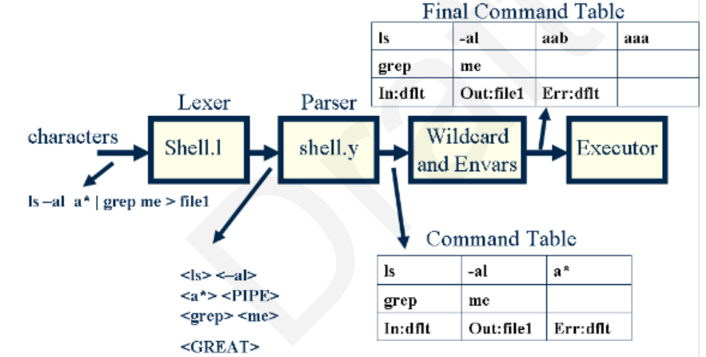

Shell grammar

