Bash is the reference

Type of shell command:

- Simple cmd
- Pipelines
- compound cmd:
* grouping cmd
* subshell
- Local variable declaration

Rules that shell handle

- command history
- handle single quote ‘’
- handle double quote “”
- handle redirection >, < , >>
- handle heredoc (doesn`t update the history)
- pipeline command
- handle (expand) environment varibale $ and (local variable?)
- handle (expand) $? the exit status of the last command
- Handle ctrl-C, ctrl-D and ctrl-\ which should behave like in bash
- implement built-in like cd, echo (with -n), pwd, export, unset, env, exit

Rules that minishell doesn`t handle
- arithmetic operation
- function declaration
- programming keyword like if, while, let
- parentheses
- grouping command
- subshell (backtick, $())

danger

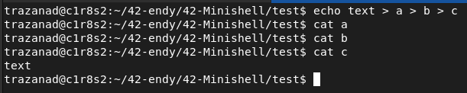
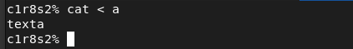

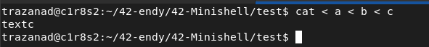
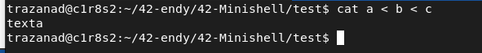

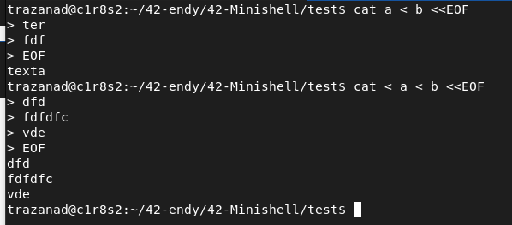
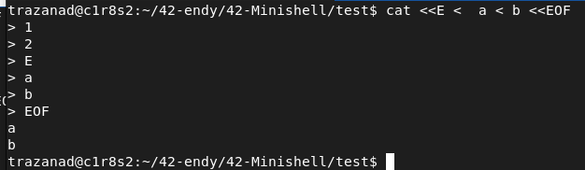
in bash we always execute all heredoc but it take the last redirection and heredoc as entry or exit

but redirection (not heredoc) take also fd

note that operator can be stick to an unquoted word

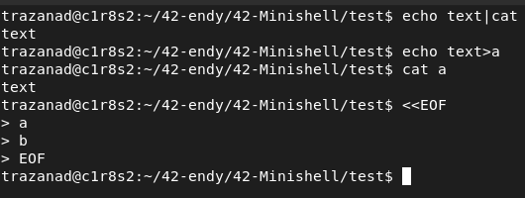

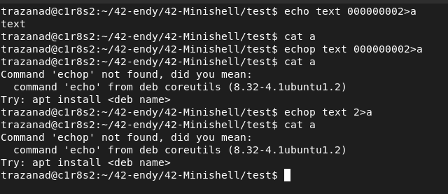

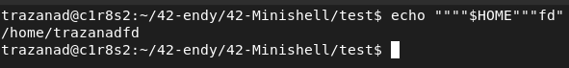

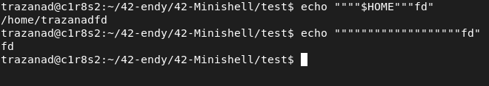

heredoc always expand variable if the delimiter is not quoted

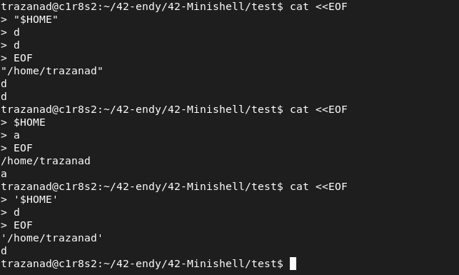

if quoted, no expansions

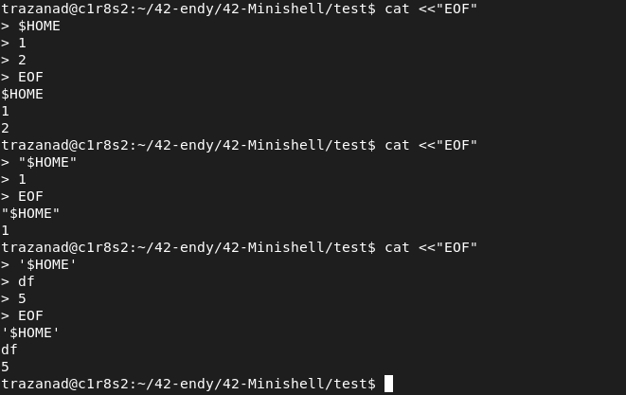

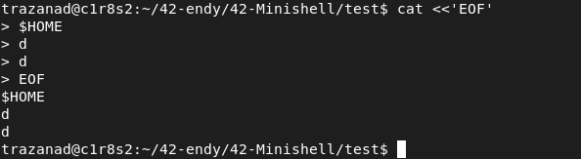
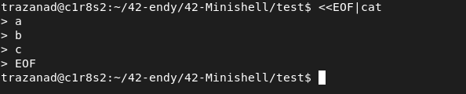
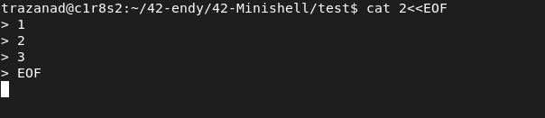

operator at the end

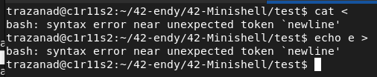
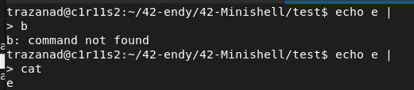
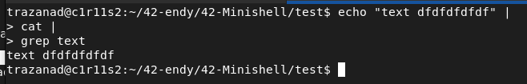
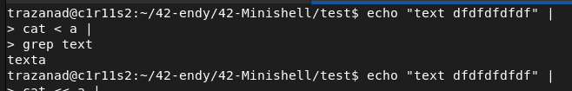

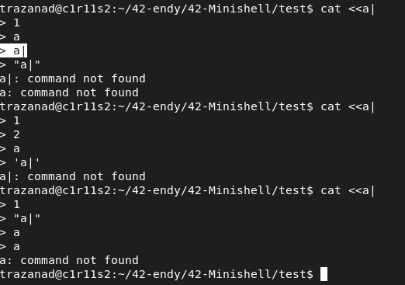
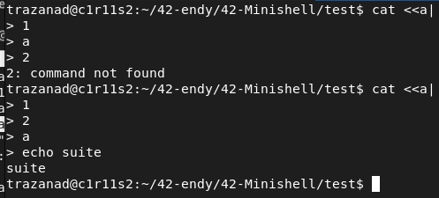
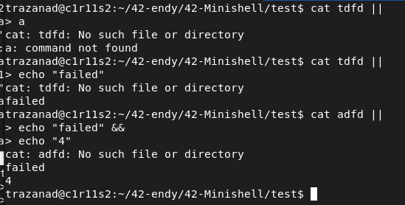
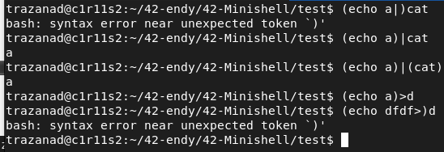

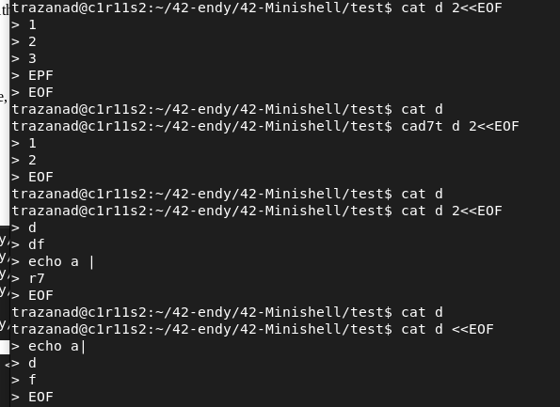

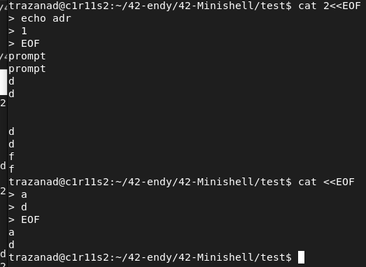

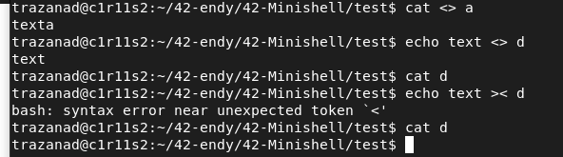
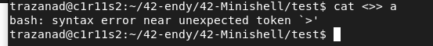

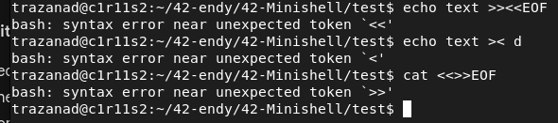
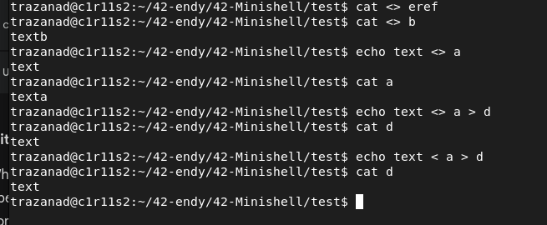
<> is equivalent to <

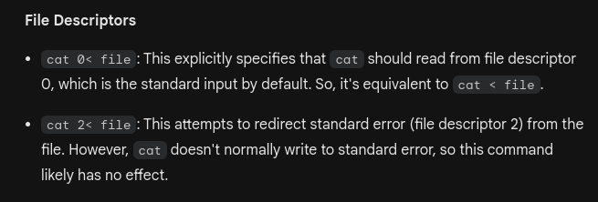

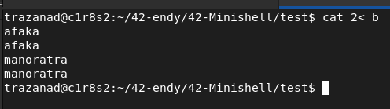
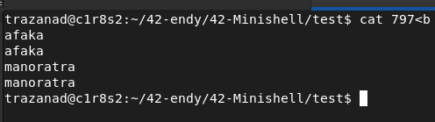

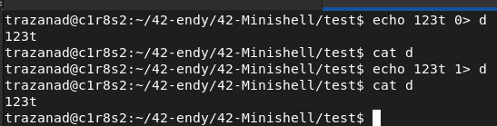
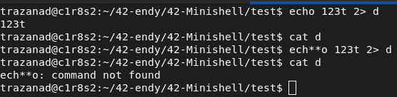
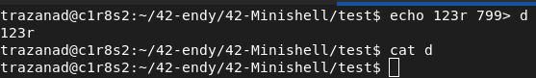
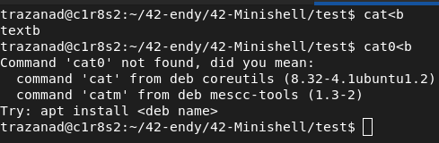

quoting

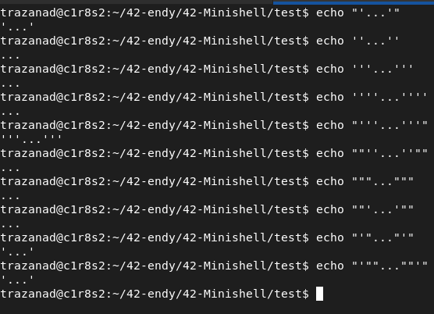
we doesn`t print double quote until escaping and everything in “”

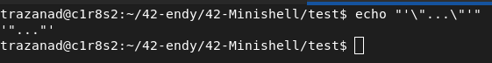

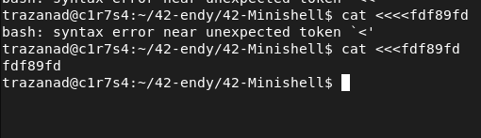
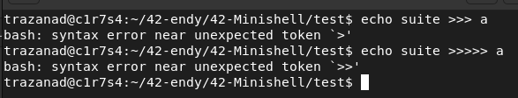

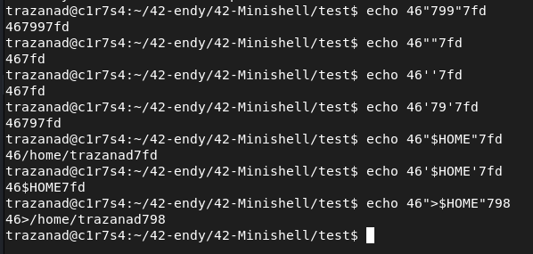

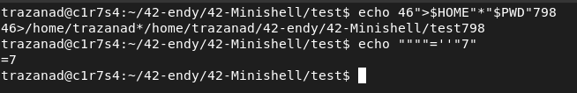
tsy mila gerena
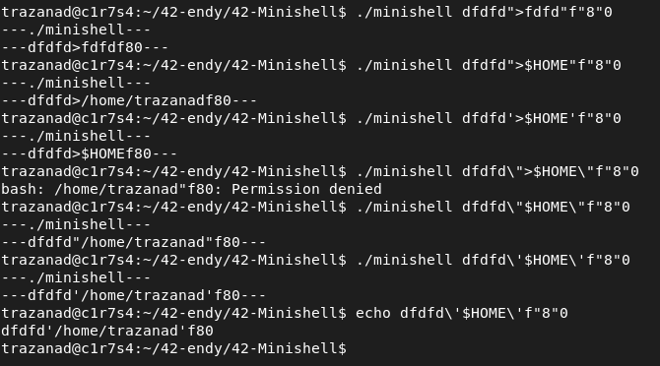

operator

| pipe
[n]> redir_out
[n]< redir_in
[n]>> redir_out2
[n]<<DELIMITER or [n]<<-DELIMITER heredoc
&& AND
|| OR

word

cmd
“…”
‘…’
(…)
$HOME
vt=zvt
${HOME}
‘’...’’
“”...””

error

expansions

type of token:

typedef enum {
TK_WORD,
TK_PIPE,
TK_REDIR,
TK_REDIR_IN,
TK_REDIR_OUT,
TK_REDIR_OUT2,
TK_HEREDOC,
TK_OR,
TK_AND,
TK_WILDCARD,
TK_L_PAREN,
TK_R_PAREN
} token_type;

type of token that expand:

- tk_word:

. $HOME
word ($+char) like $HOME, $?, $1…
it can represent env variable, local var, …

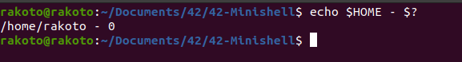
. “$HOME”
variable inside double quote “”

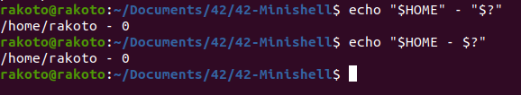
for this double quote may regroup a n length of char but expand all variable inside it

. void and space in “”
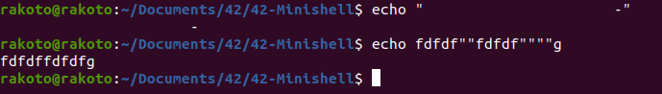

. path element (may be if not handle by exerve for cmd like cd)
we have ~, *, ., ..

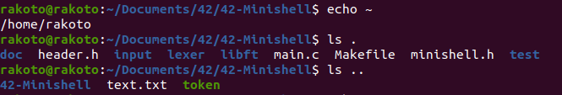
. wildcard *
for this we have to check if a tk_word is a tk_wildcard

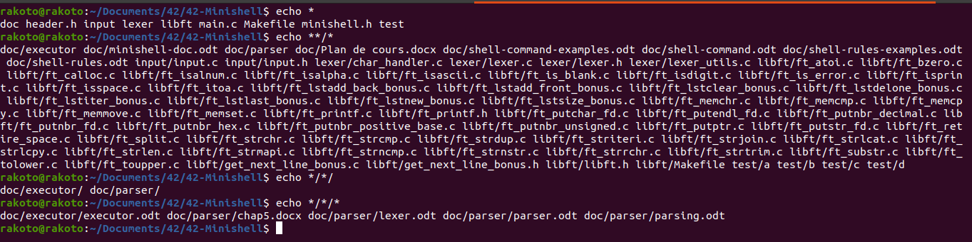
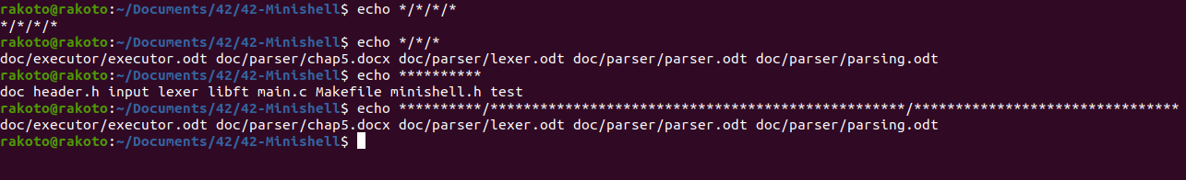
note that for single quote , no expand

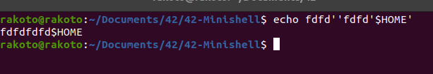

note also that no “” and ‘’ after expansion in they are not already inside double and single quote

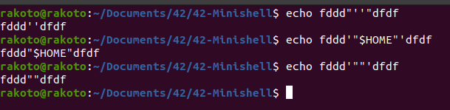

escaped quote and special char

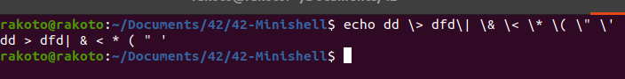
we don’t handle this so

heredoc expansions

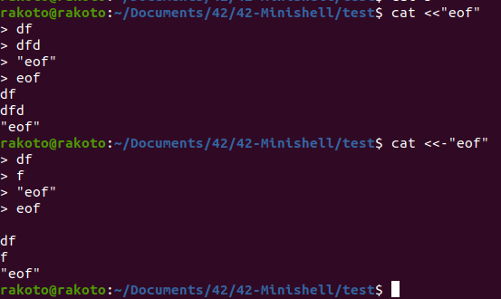

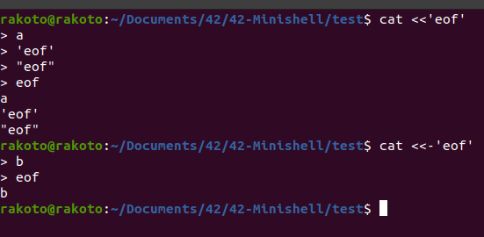

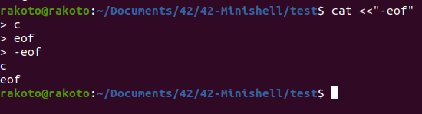
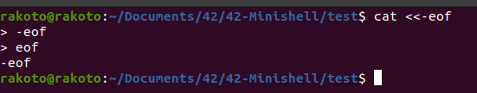
something interesting in heredoc expansions

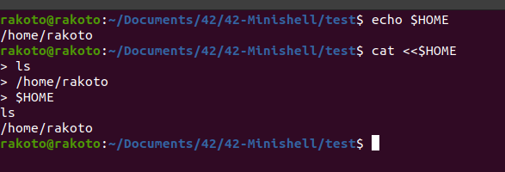

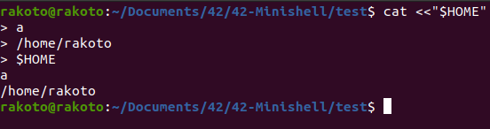

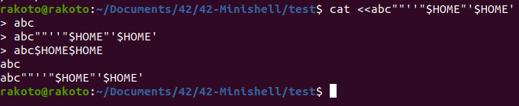
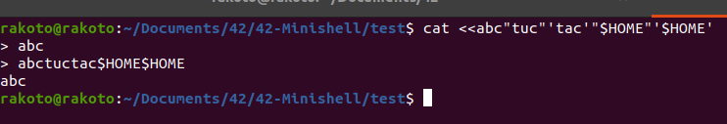
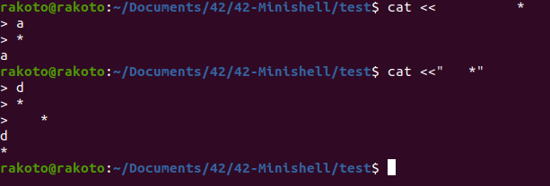
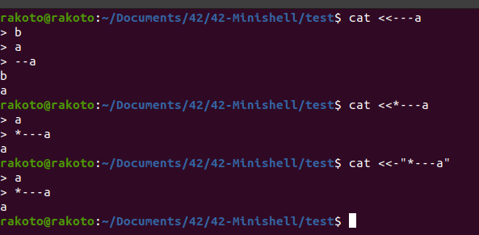
we don’t handle << - heredoc because it only work in shell

shell rules and error

**the input shouldn't begin with | or || or && or )

the first token must be:
- redir out
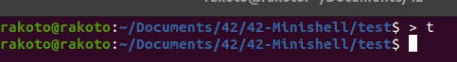

- redir in

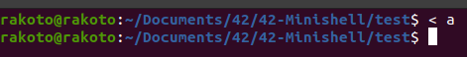

-heredoc

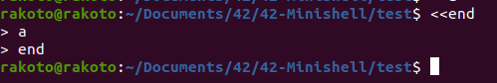
- left parenthesis

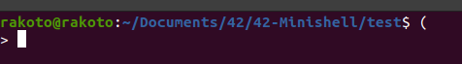

-word (cmd

**the end of a file shouldn't be a

- redir out, in , out2
- left parentheses
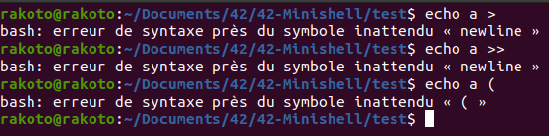
** combinaison error
syntaxique error or combinaison error

-word
no rule

-pipe

pipe can’t be followed by |, &&, || , * or )

but can be followed by word, redir, heredoc

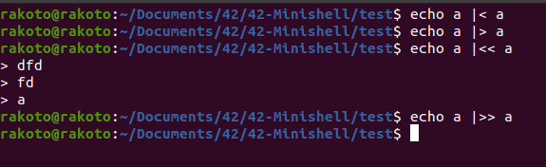

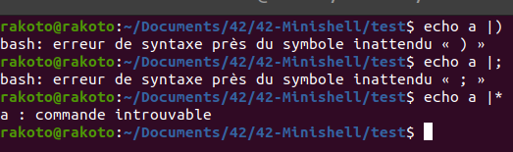

- wildcard
no rule

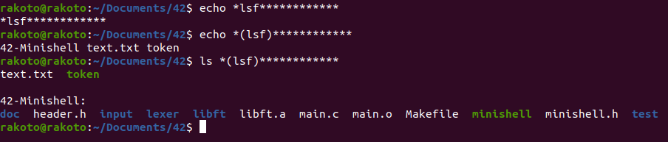
- and or

doesn’t support pipe, * and or but redir is ok

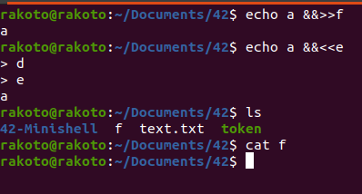

-l parentheses (

no operator , only for this case (at the beginning heredoc and redir

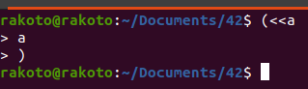

- r parentheses )
no rule

- redirect
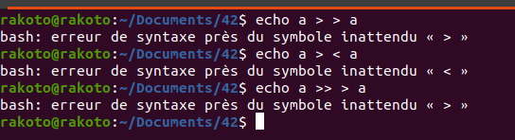
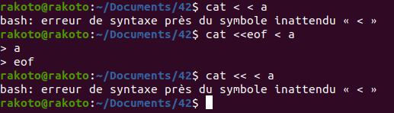

can ‘t be follow by another redir token (not heredoc)

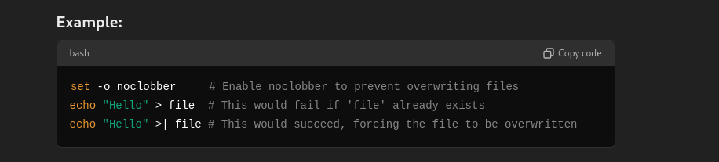

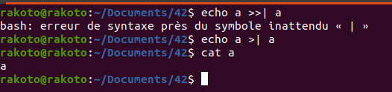
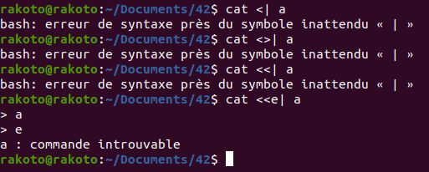

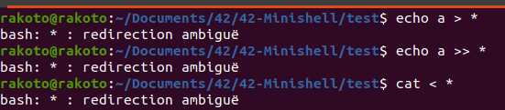
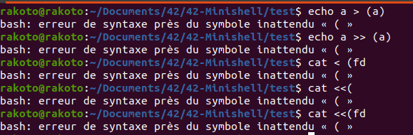
ft_strrch

-heredoc

void delimiter heredoc

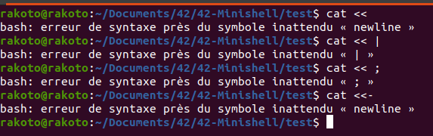
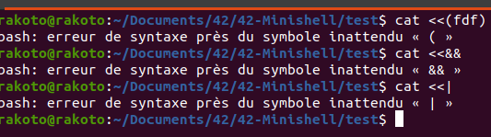

special char delimiter

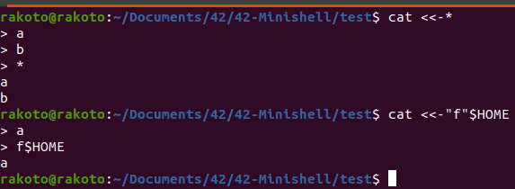

there is also error for multiple <> above

Note that we handle parentheses in executor like (echo a) : retire them

note that heredoc need expansion

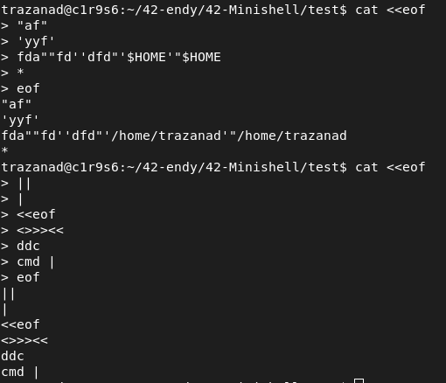
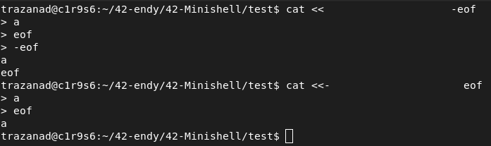

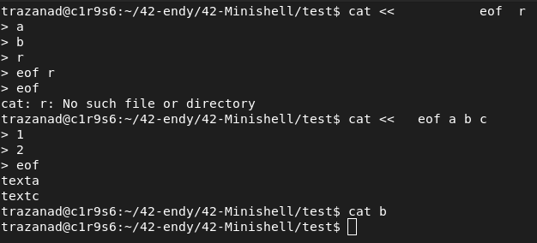

Note for execution that for arg and redir

we need to take redir value then arg and the end

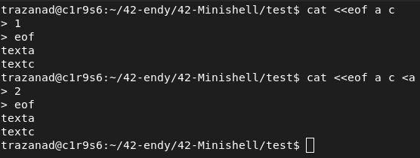

AND OR

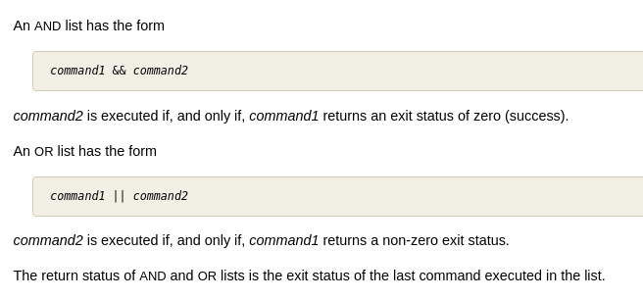
WILDCARD

it will expand using pattern matching

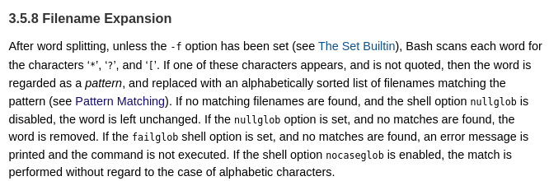
REDIRECT

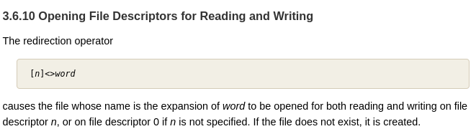
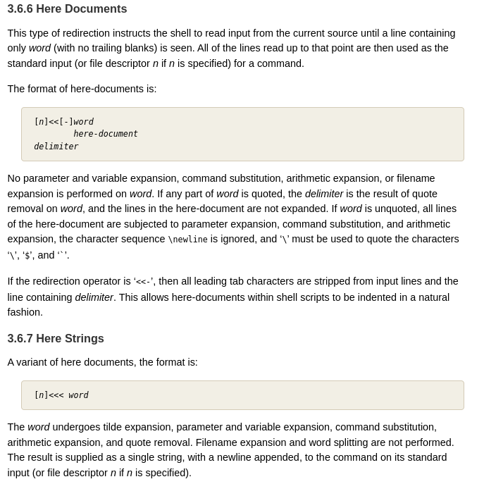
handle expansion for $ and quote

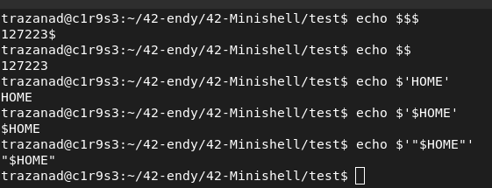

note that if it is only void or ‘ or “ , $ this is error or

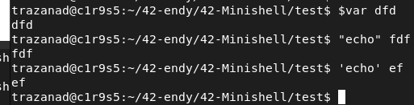

all case expansions

error
only quote
if no arg

$ d
“$ dd”

special cmd to test

Commands that require you to keep quotes intact (i.e., the shell should not remove or expand them) are often those that need to interpret the quoted text as a single argument or string. Here are some common examples:

1. eval
- Use Case: To evaluate a command that is stored as a string.
- Example: eval 'echo "Hello, World!"'
- Reason: eval executes the command within the string, requiring the quotes to ensure proper command interpretation during execution.

2. ssh
- Use Case: To execute a remote command where arguments include special characters or spaces.
- Example: ssh user@host 'echo "Hello, World!"'
- Reason: Quotes are needed to pass the exact string to the remote shell without local shell expansion.

3. sed
- Use Case: To execute substitution or other operations involving special characters.
- Example: sed -e 's/old/new/g'
- Reason: Quotes ensure that the entire sed command (including any special characters) is passed as a single argument.

4. awk
- Use Case: To perform text processing using patterns and actions.
- Example: awk '{print $1, $2}'
- Reason: The script (within quotes) is passed as a single argument to awk.

5. find with -exec
- Use Case: To execute commands on found files or directories.
- Example: find . -type f -exec bash -c 'echo "File: $1"' _ {} \;
- Reason: Quotes are necessary to pass the command correctly to bash -c.

6. xargs
- Use Case: To build and execute commands using input from standard input.
- Example: echo "file1 file2" | xargs -I {} echo 'Processing: {}'
- Reason: Quotes ensure that xargs correctly interprets and substitutes the placeholder.

7. bash -c
- Use Case: To execute a string as a command.
- Example: bash -c 'echo "Hello, World!"'
- Reason: Quotes are necessary to treat the string as a complete command.

8. echo with special characters
- Use Case: To display text with special characters that need to be preserved.
- Example: echo 'This is a single argument'
- Reason: Quotes ensure that the entire string is treated as a single argument.

9. grep with patterns containing spaces or special characters
- Use Case: To search for patterns that include spaces or special characters.
- Example: grep 'pattern with spaces' file.txt
- Reason: Quotes are necessary to pass the entire pattern as one argument.

10. curl or wget with complex URLs or headers
- **Use Case**: To fetch data from URLs that contain special characters or spaces.
- **Example**: `curl 'http://example.com?search="query string"'`
- **Reason**: Quotes ensure the entire URL is treated as a single argument.

11. rsync with special characters in filenames or paths
markdown
- **Use Case**: To sync files with names or paths containing spaces or special characters.
- **Example**: `rsync -av 'source directory/' 'destination directory/'`
- **Reason**: Quotes preserve the integrity of the paths being passed to `rsync`.

12. tar with special characters in filenames
- **Use Case**: To create or extract archives where filenames include spaces or special characters.
- **Example**: `tar -cvf archive.tar 'my file.txt'`
- **Reason**: Quotes ensure that the filename is treated as a single entity.

Summary:
These commands require quotes to ensure that the arguments or strings are passed correctly and interpreted as intended by the command itself, not by the shell. When working with these commands, it's crucial to maintain the quotes where needed to avoid errors or unexpected behavior.

