Launch binary

Input

no error just give a new prompt:
→ isspace input or just enter key

token error

→ pipe error (cut)

cut execution but launch the heredoc

if there is pipe and the cmd before the pipe is ok then launch heredoc but else error

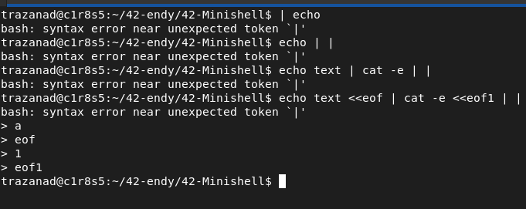
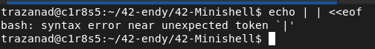

→ redir error

if there is pipe and the cmd before the pipe is ok then launch heredoc but else error
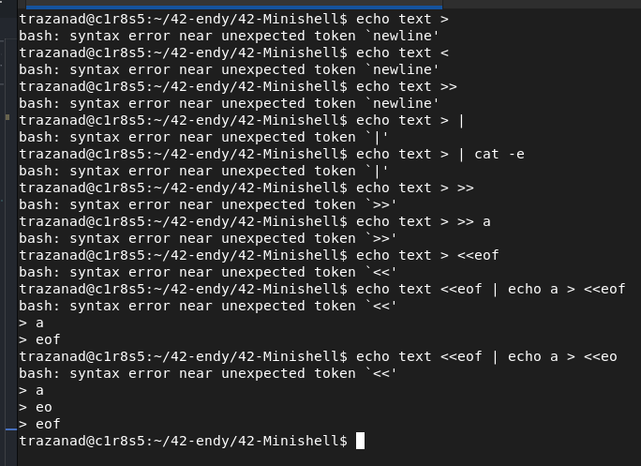

if heredoc before then launch heredoc

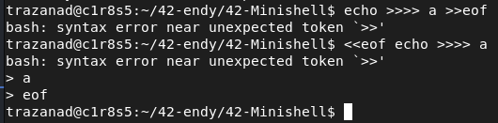

→heredoc error

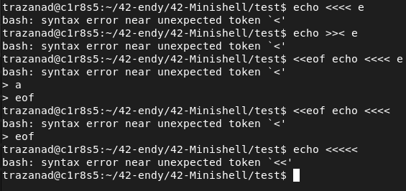

execution error

→ command not found

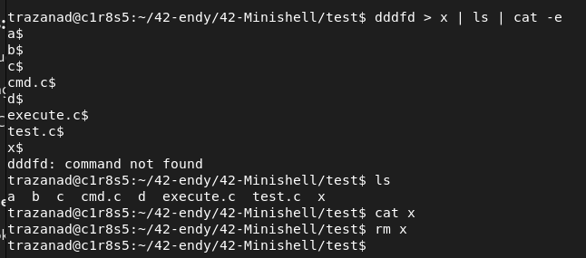
→ permission denied

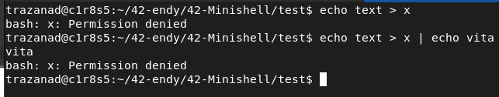
→ file not found

