Recursive Descent Parsers: A Simplified Overview
Recursive Descent Parsers are a type of top-down parser that directly implements the grammar rules as recursive functions.
Key Concepts:
- Grammar: Defines the structure of the language, specifying how tokens can be combined to form valid expressions.
- Parser Functions: One function for each grammar rule, recursively calling other functions to parse sub-expressions.
- Peek and Pop: Used to look ahead at the next token without consuming it, allowing for decision-making before proceeding.
- Tokenization: The process of breaking the input into tokens, which are then fed to the parser.
- Abstract Syntax Tree (AST): A tree-like representation of the parsed input, used for further processing.
Parsing Process:
- Tokenization: The input is converted into a sequence of tokens.
- Parsing: The parser starts at the top-level rule (e.g., parse_input) and recursively calls functions for sub-rules based on the current token.
- AST Construction: As the parser progresses, it builds an AST to represent the parsed structure.
- Error Handling: If the input doesn't match the grammar, the parser should handle the error gracefully.
Example:
Consider the grammar:
input = and_or EOF ;
and_or = pipe { ( '&&' | '||' ) pipe } ;
pipe = command { '|' command } ;
command = WORD { WORD } ;
The corresponding parser functions would be:
parse_input() {
// Parse and_or rule
// Check for EOF
}

parse_and_or() {
// Parse pipe rule
// Check for '&&' or '||' and recursively call parse_and_or
}

parse_pipe() {
// Parse command rule
// Check for '|' and recursively call parse_pipe
}

parse_command() {
// Parse one or more WORD tokens
}
Advantages of Recursive Descent Parsers:
- Easy to understand and implement.
- Good for simple grammars.
Limitations:
- Can be inefficient for complex grammars.
- Left-recursive grammars can lead to infinite re

For example, the figure below shows how the AST of a simple command looks like.

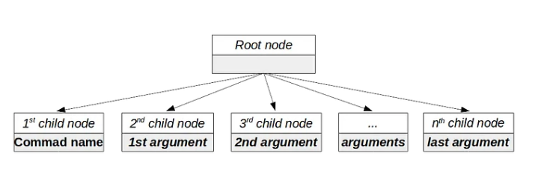

Core Components
- parser.h and parser.c: These files define and implement the parse_simple_command function, which is responsible for parsing a simple command.
- node.h and node.c: These files define the node_s structure to represent nodes in the AST. They also provide functions for creating, manipulating, and freeing nodes.

Process
- Tokenization: The parser repeatedly calls the lexical scanner to obtain tokens until a newline or end-of-file is encountered.
- AST Creation: For each token, a new node is created and added as a child to the command node. The token's text is stored in the node's value.
- Return AST: The constructed AST is returned by the parse_simple_command function.

Key Points
- The parser handles only simple commands in this phase. More complex commands (loops, conditionals) will be added later.
- The AST is a tree-like structure where nodes represent command components and their relationships.
- The node_s structure provides flexibility for storing different types of values (currently only strings are used).

Understanding Context-Free Grammars and Their Role in Your Shell
This section introduces the concept of context-free grammars (CFGs) as a tool for defining the structure of your shell's language.
Key Points:
- Lexemes vs. Tokens: Lexemes are raw character sequences, while tokens are enriched with type, value, and location information.
- Context-Free Grammars: A formalism for defining the structure of a language using rules (productions).
- Productions: Consist of a head (nonterminal) and a body (sequence of terminals and nonterminals).
- Terminals: Symbols that represent the basic elements of the language (tokens in this case).
- Nonterminals: Symbols that represent larger syntactic constructs.
- Recursion: Nonterminals can refer to themselves, allowing for the definition of recursive structures.
Explanation:
The text compares lexical grammars (used by scanners) with syntactic grammars (used by parsers). It introduces the concept of a CFG as a way to define the structure of a language using rules. The example of breakfast menus demonstrates how a CFG can generate various combinations of elements.
Key Takeaways:
- CFGs provide a formal way to define the structure of a language.
- CFGs allow for recursion, enabling the definition of nested structures.
- CFGs can generate an infinite number of valid strings based on a finite set of rules.
Next Steps:
While this section provides a conceptual overview, the next step would be to define a CFG for your shell's syntax. This will involve identifying the nonterminals (e.g., expression, statement, command) and defining the rules for combining them.
In this section, the author enhances the notation for defining grammars, making it more concise and readable. Here's a breakdown of the key enhancements and concepts:

Representing code

1. **Simplified Productions**:
- Instead of repeating the rule name for each production, productions can be separated by a pipe (`|`):
```plaintext
bread → "toast" | "biscuits" | "English muffin" ;
```

2. **Grouping with Parentheses**:
- Parentheses can be used to group options, and the pipe (`|`) can be used within those groups:
```plaintext
protein → ( "scrambled" | "poached" | "fried" ) "eggs" ;
```

3. **Repetition with Postfix Operators**:
- Postfix `*` allows a symbol or group to be repeated zero or more times:
```plaintext
crispiness → "really" "really"* ;
```
- Postfix `+` requires the preceding production to appear at least once:
```plaintext
crispiness → "really"+ ;
```
- Postfix `?` denotes an optional production that can appear zero or one time:
```plaintext
breakfast → protein ( "with" breakfast "on the side" )? ;
```

4. **Example Grammar**:
- With these enhancements, a grammar for breakfast items is defined:
```plaintext
breakfast → protein ( "with" breakfast "on the side" )?
| bread ;

protein → "really"+ "crispy" "bacon"
| "sausage"
| ( "scrambled" | "poached" | "fried" ) "eggs" ;

bread → "toast" | "biscuits" | "English muffin" ;
```
- This notation should be familiar to those who have used regular expressions, though symbols here represent entire tokens, not single characters.

5. **Lox Grammar**:
- The grammar for Lox expressions includes literals, unary expressions, binary expressions, and grouping:
```plaintext
expression → literal
| unary
| binary
| grouping ;

literal → NUMBER | STRING | "true" | "false" | "nil" ;
grouping → "(" expression ")" ;
unary → ( "-" | "!" ) expression ;
binary → expression operator expression ;
operator → "==" | "!=" | "<" | "<=" | ">" | ">="
| "+" | "-" | "*" | "/" ;
```
- Terminals are in quotes, and variable lexemes like `NUMBER` and `STRING` are capitalized.

By adopting this enhanced notation, the grammar becomes clearer and easier to work with. This approach not only simplifies the syntax definition but also helps in the practical implementation of parsers and interpreters.

Parsing: The process of converting a sequence of tokens into a syntax tree.

### Parsing and Ambiguity in Grammars

**Context-Free Grammar and Parsing:**
- A context-free grammar (CFG) can be "played" like a game to generate strings. Parsers do the reverse by taking a string of tokens and mapping them to grammar rules to determine which rules could have produced that string.
- Ambiguity in a grammar means multiple ways of parsing the same string, leading to different syntax trees and potentially different evaluations of the code.

**Lox Expression Grammar Example:**
- The expression grammar allows multiple interpretations of an expression like `6 / 3 - 1`. This ambiguity can lead to different syntax trees and evaluation results.

**Precedence and Associativity:**
- **Precedence:** Determines the order in which different operators are evaluated. Higher precedence operators bind tighter and are evaluated first.
- **Associativity:** Determines the order of evaluation for operators of the same precedence. Left-associative operators are evaluated from left to right (e.g., `-`), while right-associative operators are evaluated from right to left (e.g., `=`).

**Stratifying the Grammar:**
- To eliminate ambiguity, the grammar is stratified by defining separate rules for each precedence level. This ensures that each rule matches expressions at its specific precedence level or higher.

### Example Grammar for Lox:

1. **Expression:**
```plaintext
expression → equality ;
```

2. **Equality:**
```plaintext
equality → comparison ( ( "!=" | "==" ) comparison )* ;
```

3. **Comparison:**
```plaintext
comparison → term ( ( ">" | ">=" | "<" | "<=" ) term )* ;
```

4. **Term:**
```plaintext
term → factor ( ( "-" | "+" ) factor )* ;
```

5. **Factor:**
```plaintext
factor → unary ( ( "/" | "*" ) unary )* ;
```

6. **Unary:**
```plaintext
unary → ( "!" | "-" ) unary
| primary ;
```

7. **Primary:**
```plaintext
primary → NUMBER | STRING | "true" | "false" | "nil"
| "(" expression ")" ;
```

### Parsing Techniques:

- **Left-Recursion:** Rules like `factor → factor ( "/" | "*" ) unary | unary ;` are left-recursive and problematic for some parsing techniques.
- **Right-Recursion:** In contrast, rules like `unary → ( "!" | "-" ) unary | primary ;` are right-recursive and handle unary operator nesting effectively.
- **Flat Sequence for Binary Operators:** To avoid left recursion, binary operator rules are restructured as a flat sequence:
```plaintext
factor → unary ( ( "/" | "*" ) unary )* ;
```

### Resulting Grammar:
The final grammar ensures clarity and eliminates ambiguity by clearly defining precedence and associativity levels for different operators. This structure is ready for parsing and ensures consistent and predictable parsing of expressions.

The improved grammar for Lox, structured for clarity and unambiguity, looks like this:
```plaintext
expression → equality ;
equality → comparison ( ( "!=" | "==" ) comparison )* ;
comparison → term ( ( ">" | ">=" | "<" | "<=" ) term )* ;
term → factor ( ( "-" | "+" ) factor )* ;
factor → unary ( ( "/" | "*" ) unary )* ;
unary → ( "!" | "-" ) unary
| primary ;
primary → NUMBER | STRING | "true" | "false" | "nil"
| "(" expression ")" ;
```
This grammar is more complex but ensures unambiguous parsing, setting the stage for implementing the parser.

Recursive Descent Parsing
Overview:
- Recursive descent parsing is a straightforward, top-down parsing technique where each grammar rule is implemented as a function. It's a practical choice for building parsers manually without the need for complex tools like Yacc, Bison, or ANTLR.
Key Characteristics:
- Top-Down Parsing: Starts from the outermost grammar rule and works down into nested subexpressions.
- Literal Translation: Each grammar rule is directly translated into imperative code.
- Fast and Robust: Despite its simplicity, recursive descent parsing is efficient and capable of handling sophisticated error scenarios.
Class Structure:
- Parser Class: The parser consumes a list of tokens. Each grammar rule is represented as a method.
- Token Management: Methods like match(), check(), advance(), peek(), and previous() manage the current token being parsed.

Recursive Descent Parsing Process:
- Grammar Rules to Methods: Each grammar rule (like expression, equality, comparison, etc.) becomes a method in the parser class.
- Parsing Logic: Methods call each other according to the grammar rules, building a syntax tree for the given input.
- Token Handling: Helper methods manage token consumption and matching, ensuring the parser reads and processes tokens correctly.
Recursive descent parsing is an intuitive and powerful approach to building parsers, suitable for many programming languages and applications, including your shell.
When building a parser for your shell, handling syntax errors effectively is crucial. Here’s a summary of the main points about syntax error handling from the text:

Two Main Jobs of a Parser:
- Producing a Syntax Tree: Given a valid sequence of tokens, the parser should produce the correct syntax tree.
- Detecting and Reporting Errors: Given an invalid sequence of tokens, the parser should detect errors and inform the user.

Importance of Error Handling:
- User Guidance: When users make mistakes, especially in modern IDEs, the parser should help them correct their errors. Good error handling is an essential part of the user interface for a programming language.
- Robustness: The parser must be robust and should not crash or hang when encountering errors.

Requirements for Error Handling:
- Detect and Report Errors: If an error is present, it should be detected and reported to avoid malformed syntax trees reaching the interpreter.
- Avoid Crashing: The parser must handle errors gracefully without crashing or getting stuck in infinite loops.

Additional Goals for a Decent Parser:
- Speed: The parser should be fast enough to reparse code in milliseconds after every keystroke.
- Report Multiple Errors: Instead of stopping at the first error, the parser should try to report as many distinct errors as possible.
- Minimize Cascaded Errors: After the first error, subsequent errors may be false positives caused by the parser’s confusion. Minimizing these cascaded errors helps users focus on real issues.

Error Recovery:
- Error Recovery: The process of handling an error and continuing to parse the remaining code to find more errors.
- Panic Mode Error Recovery: A common and effective technique. When an error is detected, the parser enters panic mode, tries to synchronize its state by discarding tokens until it finds a suitable point to resume parsing, and avoids reporting misleading cascaded errors.

Implementation of Error Recovery:
- Synchronization Points: Typically, synchronization points are between statements. The parser fixes its state by jumping out of nested productions to reach a point where it can resume parsing correctly.

Practical Steps for Your Parser:
- Detect Errors: Implement logic to identify when a sequence of tokens doesn’t match the expected grammar rules.
- Report Errors: Provide meaningful error messages to the user.
- Panic Mode: Implement panic mode error recovery to handle errors gracefully and minimize cascaded errors.
- Synchronization: Choose appropriate synchronization points in your grammar where the parser can resume parsing after an error

Entering Panic Mode
Panic mode is a technique used to recover from syntax errors by skipping over parts of the input until a suitable point is found to resume parsing. Here's how you can implement this in your shell:

Key Methods and Concepts
- Consume Method: This method checks if the next token is of the expected type. If so, it consumes the token. If not, it throws an error.
Error Reporting: This method reports an error by calling another method to show the error message to the user.
ParseError Class: A simple class used to handle parsing errors.
Error Productions: These are grammar rules that match erroneous syntax but report an error instead of producing a syntax tree. They help keep the parser in a stable state when encountering common mistakes.
For example, if your language doesn't support unary +, you can extend the unary rule:
Synchronize Method: This method discards tokens until it finds a point where it can resume parsing correctly.

Handling Syntax Errors
When a syntax error is detected:
- Report the Error: Display an error message to the user.
- Enter Panic Mode: Discard tokens until reaching a synchronization point.
- Synchronize State: Reset the parser’s state by unwinding the call stack using exceptions.

Practical Steps
- Implement consume(): Check and consume the expected token or throw an error.
- Implement error(): Report the error and create a ParseError.
- Use ParseError Class: Handle errors without crashing the parser.
- Add Error Productions: Extend grammar rules to match common errors and report them without destabilizing the parser.
- Implement synchronize(): Discard tokens until a synchronization point is found, allowing the parser to continue from a stable state.

Example in wikipedia of ast

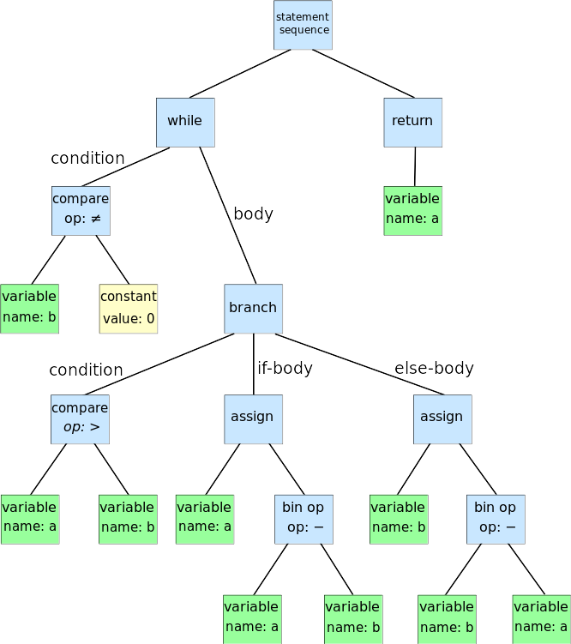

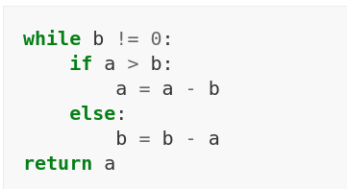

Recursive descent parser

Suppose you have a grammar like this:
expression → term (("+" | "-") term)*
term → factor (("*" | "/") factor)*
factor → NUMBER | "(" expression ")"
A recursive descent parser would have methods like parseExpression(), parseTerm(), parseFactor(), and so on. Each method would call others as needed to match the input against the grammar rules.
- parseExpression() would try to parse a term and then look for optional "+" or "-" followed by another term.
- parseTerm() would do similarly for factors and "*" or "/".
- parseFactor() would handle numbers and parentheses.

To create a parse tree for a shell, you need to follow a series of steps that involve tokenizing the input, defining grammar rules, and implementing parsing functions. Here's a summarized explanation of the process:

1. Tokenizing the Input
The first step is to transform the text input into tokens. Tokens represent the smallest units of the syntax, such as commands, arguments, and operators. Each token has a value (the actual text) and a type (like command or operator).
Example: For the input ls | cat -e, the tokens would be:
- ls -> WORD
- | -> PIPE
- cat -> WORD
- -e -> WORD

2. Defining the Grammar
A grammar is a set of rules that defines how tokens can be combined to form valid commands. The grammar helps the parser understand the structure of the commands and how to build the parse tree.
Example Grammar Rules:
pipe_sequence : simple_command
| pipe_sequence '|' simple_command
;
cmd_suffix : cmd_word
| cmd_word cmd_word
;
simple_command : cmd_name
| cmd_name cmd_suffix
;
cmd_name : WORD
;
cmd_word : WORD
;
This grammar specifies:
- A pipe_sequence can be a simple_command or a pipe_sequence followed by | and another simple_command.
- A cmd_suffix is one or more cmd_word.
- A simple_command is a cmd_name optionally followed by a cmd_suffix.
- A cmd_name or cmd_word is a WORD token.

3. Implementing the Parsing Functions
Each rule in the grammar is implemented as a function in the parser. These functions process the tokens and build the corresponding nodes in the parse tree.
Example Parsing Functions:
- cmd_word() Function: Parses a cmd_word if the current token is a WORD.
struct s_cmd_word *cmd_word(struct s_parser *p) {
struct s_cmd_word *w = NULL;
if (p->tokens->type == T_WORD) {
w = malloc(sizeof(struct s_cmd_word));
w->data = strdup(p->tokens->data);
p->tokens = p->tokens->next;
return w;
} else {
return NULL;
}
}
- pipe_sequence() Function: Parses a pipe_sequence which consists of one or more simple_commands separated by |.
struct s_pipe_sequence *pipe_sequence(struct s_parser *p) {
struct s_pipe_sequence *ps = malloc(sizeof(struct s_pipe_sequence));
struct s_simple_command *sc;

while ((sc = simple_command(p))) {
ft_lstpush(sc, &ps->simple_commands);
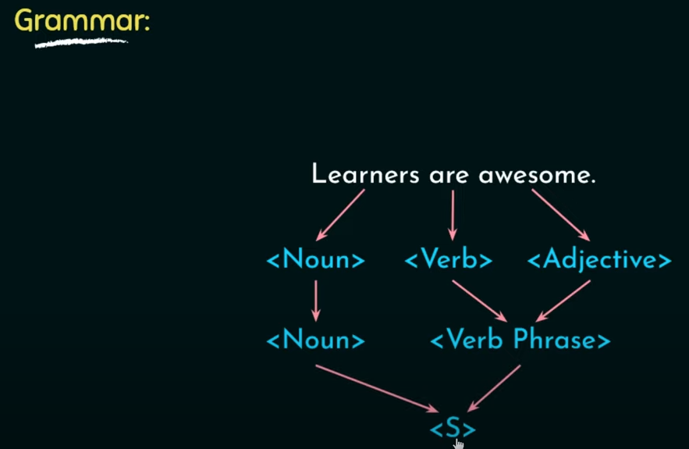
if (p->tokens->type == T_PIPE)
p->tokens = p->tokens->next;
}
if (ps->simple_commands)
return ps;
free(ps);
return NULL;
}

4. Building the Parse Tree
Using these functions, the parser processes the input tokens and builds the parse tree according to the grammar rules. The tree represents the syntactic structure of the input command.
Example Parse Tree for ls | cat -e:
pipe_sequence
/ \
simple_command simple_command
| / \
cmd_name cmd_name cmd_suffix
| | |
'ls' 'cat' cmd_word
|
'-e'

Conclusion
By tokenizing the input, defining grammar rules, and implementing parsing functions, you can build a parse tree that represents the syntactic structure of shell commands. This parse tree is crucial for executing the commands correctly in your custom shell.





